OARD OF INTERMEDIATE & SECONDARY EDUCATION SUKKUR-SINDH

NO:BISE/HSC(S)/SUK/- Dated: 06-08-2013

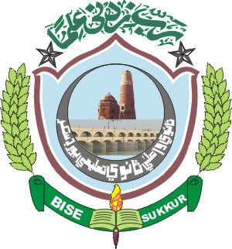

NOTIFICATION
Website: www.bisesuksindh.edu.pk
Email: mail@bisesuksindh.edu.pk

The positions secured by the Candidates at the Higher Secondary Certificate Part-II (Class XII) Annual Examination 2013, (Commerce Group), held by the Board of Intermediate & Secondary Education, Sukkur are declared provisionally, as under:-

- FIRST THREE CANDIDATES in order of Merit (Boys)

Sr# | Seat  No: | Photograph | Name in Full (With Institution) | POSITION | MARKS  OBTAINED | Grade
1 | 115315 | 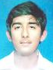 | Muhammad Faraz  S/o  Sadiq Abbas Syed  Govt: Mumtaz College, Khairpur | 1st | 798 | A
2 | 115463 | 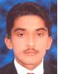 | Ihsan Ali  S/o  Allah Obhayo Keeryo  Govt: Degree College,  Bozdar Wada | 2nd | 772 | A
3 | 115899 | 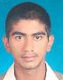 | Soman Sajid  S/o  Sajid Mahmood Awan  Govt: Islamia Arts & College, Sukkur | 3RD | 749 | B

- FIRST THREE CANDIDATES in order of Merit (Girls)

Sr# | Seat  No: | Photograph | Name in Full (With Institution) | POSITION | MARKS  OBTAINED | Grade
1 | 115751 | 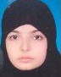 | Khadija Anees  D/o  Anees – Ur – Rehman Sheikh  Govt: Girls Degree College, Sukkur | 1st | 909 | A – I
2 | 115750 | 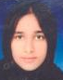 | Kainat Munir  D/o  Muhammad Muneer Rana Rajput  Govt: Girls Degree College, Sukkur | 2nd | 872 | A
3 | 115421 | 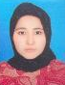 | Majida Parveen  D/o  Muhammad Ayoob Shaikh  Govt: College For Women, Khairpur | 3RD | 851 | A

Continued On Page # 2

Page # 2

MERIT POSITION Boys & Girls (Over all)

Sr# | Seat  No: | Photograph | Name in Full (With Institution) | POSITION | MARKS  OBTAINED | Grade
1 | 115751 |  | Khadija Anees  D/o  Anees – Ur – Rehman Sheikh  Govt: Girls Degree College, Sukkur | 1st | 909 | A – I
2 | 115750 |  | Kainat Munir  D/o  Muhammad Muneer Rana Rajput  Govt: Girls Degree College, Sukkur | 2nd | 872 | A
3 | 115421 |  | Majida Parveen  D/o  Muhammad Ayoob Shaikh  Govt: College For Women, Khairpur | 3RD | 851 | A

The Board reserves the right of rectifying the mistakes/errors and omissions in the Positions / Results at any time on the basis of original record of the Board.

( Waqar Hussain Jokhio ) ( Rafique Ahmed Palh ) (Mahmood-Ul-Hassan Khokhar)
Asstt: Controller of Examinations Dy: Controller of Examinations Controller of Examinations
HSC (Secret) (Secret)

- Zafar Lashari

