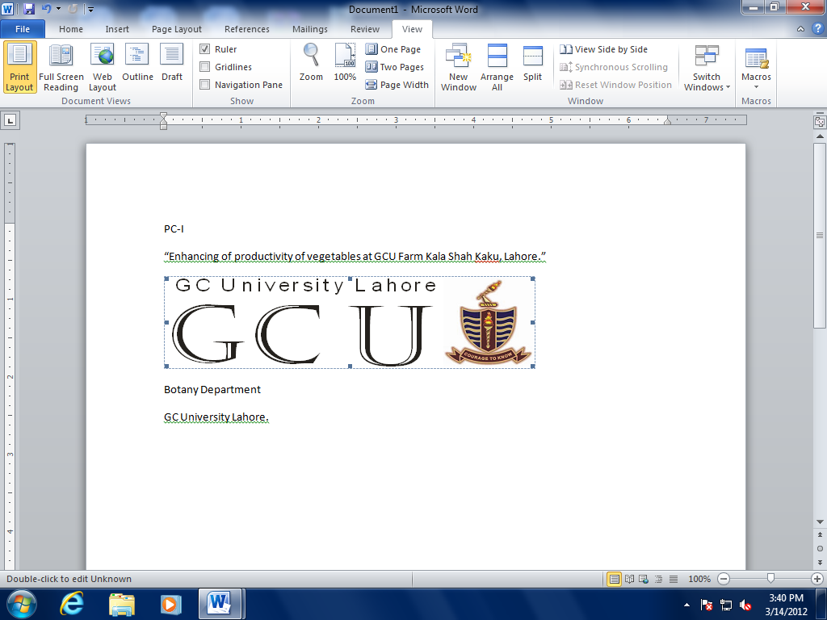 | Department of Fine Arts  GC University Lahore

FINAL LIST OF APPLICANTS ELIGIBLE FOR INTERVIEW

BFA-GD (EVENING) ADMISSIONS 2020
Dated: 03-11-2020
Sr. # | Form # | Name | Father's Name
1 | 2201220 | Rabab Fatima** | Nazir Ahmad
2 | 4573220 | Bisma* | Muhammad Abbas
3 | 2733220 | Umm e Ruman* | Khalid Hussain
4 | 2777320 | Maryam Ghulam* | Ghulam Muhammad
5 | 2209420 | Filza Khan* | Abdul Gayyum Khan
6 | 3225320 | Mehreen Hayat | Hayat Nasir
7 | 2972720 | Iswa Busbus* | Abdul Ghaffar
8 | 2527520 | Kashaf Javed* | Javed Iqbal
9 | 2332120 | Mahnoor Shafqat | Shafqat Mehmood
10 | 2320220 | Nimra Amjad* | Muhammad Amjad
11 | 4004220 | Asifa Shabbir* | Muhammad Shabbir
12 | 4153620 | Muhammad Ahmad Javed* | Javed Akhtar
13 | 2360720 | Muqaddas Naz* | Muhammad Ashraf
14 | 3696020 | Muhammad Abubakar | Muhammad Mushtaq
15 | 4311820 | Waqar Ahmad | Afzal Ahmad
16 | 3719220 | Ayesha Habib | Habib ur Rehman
17 | 2248720 | Saqlain Javed* | Javed Iqbal
18 | 2882620 | Anila Razzaq | Abul Razzaq
19 | 3783420 | Hina Baqir | Muhammad Baqir
20 | 3263720 | Sana Aman* | Amanullah
21 | 3454520 | Eman Mohsin Qazi | Muhammad Mohsin Qazi
22 | 3181720 | Mubarika | Latafat
23 | 4110220 | Hamdiya Najam | Syed Najam Nisar
24 | 4023720 | Zulaikha | Ghulam Sarwar
25 | 2866720 | Muhammad Hassan Nadeem | M. Nadeem Khan
26 | 3811520 | Sawaira Sultana* | Muhammad Shahzad
27 | 3252120 | Qurat ul Ain | Arif Butt
28 | 3387220 | Abdurehman | Rahim Khalid
29 | 3752020 | Fakhara Anwaar | Muhammad Anwaar
30 | 3636920 | Ahsaan Bajwa* | Amjad Hameed Bajwa
31 | 3957620 | Momna Tahir | Tahir Saleem
32 | 2278920 | Noor Fatima* | Nisar Ahmad
33 | 3844020 | Hiba Khan | Shakeel Ahmad
34 | 2918420 | M ahmad Naveed | Naveed Ul hassan
35 | 3867720 | Anas Fayaz** | Fayaz Asghar

NOTE:
- Interview will be conducted on 04-11-2020 at 09:30 a.m. at Department of Fine Arts, New Block GCU Lahore

- Candidates should bring their art work / portfolio and original documents at the time of interview

- Wearing the Mask at the time of Interview is Mandatory

Prof. Dr. Erfan Ullah Babar
Chairperson

