BOARD OF INTERMEDIATE & SECONDARY EDUCATION SUKKUR-SINDH

NO:BISE/HSC(S)/SUK/-2833 Dated: 04-10-2019

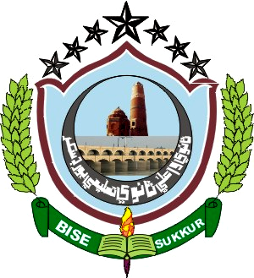

Website: www.bisesuksindh.edu.pk
Email: mail@bisesuksindh.edu.pk

NOTIFICATION

The Positions secured by the candidates at the Higher Secondary Certificate Part-II (Class XII) Annual Examination-2019, (Commerce Group), held by the Board of Intermediate & Secondary Education, Sukkur, are declared provisionally, as under:-

- FIRST THREE CANDIDATES in order of Merit (Boys)Boys

Sr# | Seat  No: | Photograph | Name in Full (With Institution) | POSITION | MARKS  OBTAINED | Grade
01 | 123514 | 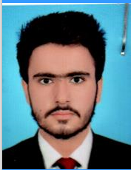 | Mir Illahi Bux  S/o  Mir Khadim Hussain, Talpur  Govt: Mumtaz College, Khairpur | 1st | 873 | A
02 | 123517 | 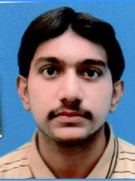 | Rizwan Ahmed  S/o  Abdul Latif, Soomro  Govt: Mumtaz College, Khairpur | 2nd | 867 | A
03 | 124055 | 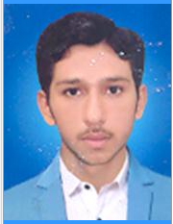 | Kashif Ali  S/o  Ali Nawaz, Malik  Govt: Degree College, Mehrabpur | 3rd | 807 | A

- FIRST THREE CANDIDATES in order of Merit (Girls) irls

Sr# | Seat  No: | Photograph | Name in Full (With Institution) | POSITION | MARKS  OBTAINED | Grade
01 | 123107 | 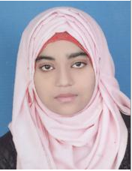 | Anusha Gul  D/o  Nasir Ali, Siddiqui  Govt: Girls Degree College, Sukkur | 1st | 828 | A
02 | 123145 | 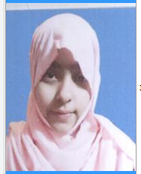 | Syeda Manahil Shaheed  D/o  Syed Hassan Shaheed, Syed  Govt: Girls Degree College, Sukkur | 2nd | 825 | A
03 | 123130 | 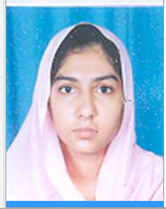 | Maheen  D/o  Muhammad Khalil-Ur-Rehman, Khan  Govt: Girls Degree College, Sukkur | 3rd | 820 | A

Continued on Page # 2

Page # 2
Commerce Group

- OVER ALL FIRST THREE POSITIONS (Boys & Girls) IN ORDER OF MERIT

Sr# | Seat  No: | Photograph | Name in Full (With Institution) | POSITION | MARKS  OBTAINED | Grade
01 | 123514 |  | Mir Illahi Bux  S/o  Mir Khadim Hussain, Talpur  Govt: Mumtaz College, Khairpur | 1st | 873 | A
02 | 123517 |  | Rizwan Ahmed  S/o  Abdul Latif, Soomro  Govt: Mumtaz College, Khairpur | 2nd | 867 | A
03 | 123107 |  | Anusha Gul  D/o  Nasir Ali, Siddiqui  Govt: Girls Degree College, Sukkur | 1st | 828 | A

Note:
The Positions of HSC Part – II (Humanities Group) Annual Examination 2019, will be declared later on.

(Waqar Hussain Jokhio) ( Ghulam Qadir Channa ) ( Abdul Sami Soomro )
Asstt: Controller of Examinations Dy: Controller of Examinations Controller of Examinations
(HSC-Secret) (Secret)

- Zafar Lashari

123107 | 123145 | 123130

123514 | 123517 | 124055

