
KHYBER PAKHTUNKHWA BOARD OF TECHNICAL EDUCATION BUILDING-22, PHASE-5,HAYATABAD, PESHAWAR

PHONE:091-9217435, FAX:091-9217658



No. BTE/ACE/24055-24250 Dated: 09/12/2019
To
All the Principals,
GCTs/GPIs (Boys & Women)/GTIs/GCMS (Boys & Women)/GTVCs (Boys & Women),
__________________________________________________________________.

Subject: BIO-DATA OF TEACHING STAFF

I am directed to inform you that DIT 1st Term / 2nd Term Exam 2020, D.Com/DBA and DAE Annual Exam 2020 shall be held tentatively in the month of February, March and April 2020 respectively.

I shall be grateful if you could kindly provide detail of the teaching staff of your respective college / institute duly recommended on your part for performing duties in the above mentioned examinations. The said information may please facilitated within TEN DAYS as per following format.
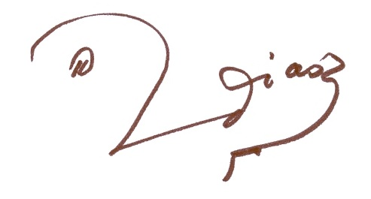
Controller of Examinations
Name of College / Institute _________________________________________ Department _________

S.No | Name | Designation with BPS | Regular/ Contract | Trade/  Technology | Email/ WhatsApp | Mobile No. | IBAN No.  (24 digits) | CNIC No.

PRINCIPAL
(Signature)

C.C:
1. The Managing Director KP-TEVTA.
2. The Director General Commerce Education KP.
3. PS to Chairman KP BTE Peshawar.
4. PS to Secretary KP BTE Peshawar.
5. The Asstt: Controller of Examinations, KP BTE Peshawar.

