
KHYBER PAKHTUNKHWA BOARD OF TECHNICAL EDUCATION 22, SECTOR B-1, PHASE-5, HAYATABAD PESHAWAR

APPLICATION FORM FOR CORRECTION IN NAME (STUDENT / FATHER NAME) TO BE FILLED IN BLOCK (CAPITAL) LETTERS (ALSO AVAILABLE ON WEBSITE WWW.KPBTE.EDU.PK)

Name of College / Institute
In block (capital) letters
Contact No of College / Institute
Mobile No of student concerned
Incorrect Name of Student (if any)
(As per Technical Board record)
Incorrect Name of Student’s Father (if any)
(As per Technical Board record)
Correct Name of Student (as per Matric/CNIC)
(this column is essential to be filled)
Correct Name of Student’s Father (as per Matric/CNIC)
(this column is essential to be filled)
Technology / Class (D AE/D.Com/DIT/TSC) 1st/2nd/3rd year
Registration No
Deposited Rs. 800 / Rs. 1500 (Tick ✓one) vide Draft/Slip No _________________ Dated ______________

Note: Incorrect / Changed Name of student or his/her Father Name (as the case may be) is to be underlined.

It is certified that the above particulars have been checked / tallied with the CNIC, Matric (SSC) and BTE Registration card / Diploma / Certificate / DMCs of student concerned, found correct in all respects, nothing has been concealed thereof and that photo copy of all the required documents mentioned below have also been attached duly attested by the Principal concerned.

Signature of student |  | Name and Signature of Principal of college / institute concerned with college stamp
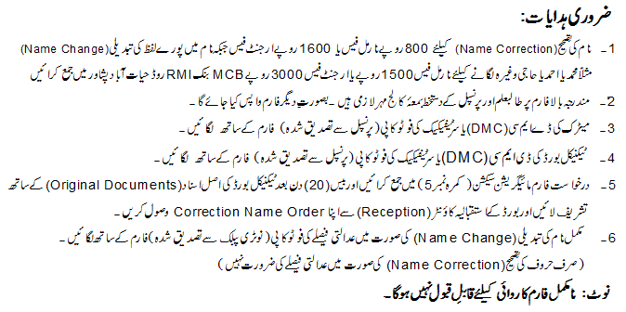
APPROVAL OF CORRECTION NAME
Date of Receipt | Dealing Clerk /  Computer Operator | Superintendent Migration Section | Assistant Secrecy | Secretary / Chairman

