
KHYBER PAKHTUNKHWA BOARD OF TECHNICAL EDUCATION
22, SECTOR B-1, PHASE-5, HAYATABAD, PESHAWAR  091-9217435

APPLICATION FORM FOR ISSUANCE OF MIGRATION CERTIFICATE/ N.O.C/ VERIFICATION OF DIPLOMA/CERTIFICATE/DMC/ISSUANCE OF ATTEMPT / EQUIVALENCY CERTIFICATE

Mr./Miss ______________________________________________________________________________ Son/Daughter of ________________________________________________________________________ Course (DAE/DCom/TSC/DIT)___________ Roll No _______________ Annual/Supply(Year) _________ College _____________________________________________________Mobile No _________________
Deposited Rs._________ (as Normal / Urgent) fee in KP BTE Account, Slip No ______ Dated___________
Required (Please Tick one) 1. Migration 2. Verification 3. Equivalency Certificate 4. Attempt Certificate

SIGNATURE OF STUDENT __________________________________
----------------------------------------------------------------------------------------------------------------------------------
For Office Use Only (Certificate Section – I / II)
The particulars with regard to Diploma/Certificate/DMC, were checked with the relevant record of Gazette Copy/Award Register and found correct. The particulars for entitlement of issuance of Equivalency Certificate (as per Equivalence Book) and Attempt Certificate were also checked with the record and found correct.
Dealing Clerk | Superintendent | Assistant Secretary
----------------------------------------------------------------------------------------------------------------------------------
S.NO | NATURE OF CASE | NORMAL FEE | TIME FRAME/ DELEVERY | URGENT FEE | TIME FRAME/ DELEVERY
1. | Board to University Migration Certificate | Rs. 1000/- | 05 working days | Rs. 1500/- | Same Day  (From 12:00 PM to 3:00 PM)
2. | Board to University Migration Certificate (Duplicate) | Rs. 1500/- | 05 working days | Rs. 2200/- | Same Day  (From 12:00 PM to 3:00 PM)
3. | Verification of DMC/Diploma/ Certificate (Original / Photocopy) | Rs. 350/- | 05 working days | Rs. 500/- | Same Day  (From 12:00 PM to 3:00 PM)
4. | Equivalency Certificate | Rs. 400/- | 05 working days | Rs. 600/- | Same Day  (From 12:00 PM to 3:00 PM)
5. | Attempt Certificate | Rs. 700/- | 05 working days | Rs. 1100/- | Same Day  (From 12:00 PM to 3:00 PM)
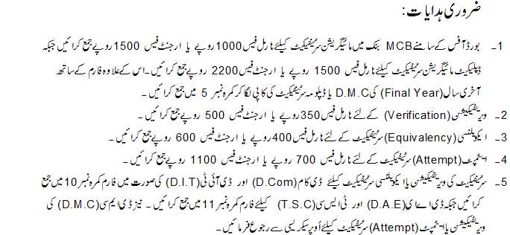
----------------------------------------------------------------------------------------------------------------------------
ACKNOWLEDGMENT RECEIPT (TO BE FILLED IN BY THE STUDENT CONCERNED)
Deposited Rs. _________ in K.P. B.T.E Accounts vide Bank Draft/Bank Deposit Slip No _______ dated __________ by the student namely ___________________ s/o _________________ for issuance of Board to Board/University Migration Certificate.
Dealing Clerk (BTE Reception) Name __________________ Designation ____________ Signature ________________________
Date and Time of Receipt: Date: ________________ after 11:00 A.M

