**Balochistan Board of Intermediate and Secondary Education, Quetta.**

Model Paper for SSC Examination 2018 and Onwards

Subject: English Total Marks = 75 Class 10th

**PART – I**

**Q. No. 1:** **(A) Complete the following blanks with appropriate options given in the** **brackets. (10)**

1. We need to use _____ for the welfare and betterment of humanity.

(a) Modern invention (b) Phones (c) Transport (d) Food

2. Naeem was showing Faheem the _____ of facilities in that area.

(a) Plenty (b) Lack (c) Excess (d) Abundance

3. We do not try to get on or off a ____ while it is still moving.

(a) Bus (b) Aero plane (c) Horse (d) Ship

4. Discipline teaches us ____.

(a) Justice (b) Friendship (c) Certain rules of conduct (d) No rule of conduct

5. Balochistan is famous for its_____.

(a) Sports goods (b) handicrafts (c) furniture (d) Leather jackets

6. Band _ aids are good for dressing small.

(a) Wounds (b) Burns (c) In function (d) Germs

7. His mother advised him to go the village and check.

(a) If animals were fine (b) If everything was going on well (c) If Jamal was sick

(d) If their house was sold

8. Minor cuts and scrapes _____ stop bleeding on their own.

(a) Hardly (b) Usually (c) Sometime (d) Never

9. Thing crafted out of marble adds to the glamour.

a) Of the houses and offices. b) Of the people. c) Of the trees d) Of the Mountains

10) The daffodils were dancing ____________.

a) By the side of the lake b) By the side of the river c) By the side of canal

d) By the side of Trees.

**B) Fill in the blanks according to your text:-**

I) Allah _____________ Hazrat Muhammad (Peace be upon him) to show the right path to the world.

II) The modern _____________is the age of science and technology.

III) Road safety is a _______________responsibility of the government and people.

IV) The Muslims of the sub-continent ___________hard for the creation of

Pakistan.

V) Balochistan has a long ____________in the production of handicrafts.

**(C) Write the Comparative and superlative degrees of the following adverbs. (05)**

|  |  |  |
| --- | --- | --- |
| **Positive** | **Comparative** | **Superlative** |
| Late |  |  |
| Hard |  |  |
| Carefully |  |  |
| Seriously |  |  |
| Quietly |  |  |

**D)** **Write type of the following sentences in the given spaces. (02)**

1) What a tall man! _________________.

2) Where are you from _________________?

**PART – II**

**Q No.2: Translate any ten of the following sentences into Urdu? (10)**

1. They were over joyed to see him.
2. These inventions have brought happiness and comforts for us.
3. There were packs of stray dogs wondering at barking here and there.
4. Some of us take bus to school.
5. Road safety is a collective responsibility of the government and people.
6. They have their own social, economic and cultural codes of life.
7. This work is done by the women and girls.
8. Trees help regulate the atmosphere.
9. Cleaning reduces the risk of infection and tetanus.
10. A Book guides us in different ways.
11. He gave Jamal no chance to deceive him.
12. The amount of water will increase in the oceans and thus raise their level.

**Q NO. 3: Write short answers of any eight of the following Question. (2x8=16)**

1. How does the Holy Quran guide us?
2. How has modern age made our world a global village?
3. How did Faheem explain his views?
4. Write main theme of the Poem “the Daffodils”?
5. How should we cross a road?
6. What are the basic corner stones of Muslim idealogy?
7. What is the importance of Balochistan Silver ornaments?
8. Why should we be kind to our brothers?
9. What do you mean by Greenhouse effect?
10. How do books stay with us during the whole life?

**Q NO.4: Write Summary of the Poem “The Daffodils” Or Paraphrase the following stanza? Marks = 07**

Be kind to thy brother; wherever you are,

The love of a brother shall be

An ornament purer and richer by far,

Then pearls from the depths of the seas.

**PART – III**

**Q No.5 Write an essay on any one of the following topics? Marks=10**

1. Struggle is key to success.
2. A visit to a historic place.

**Q No.6: Change the narration. (Any five) Marks=05**

1. Ali said to me, “Try your luck again”.
2. I will say, “I have spoken the truth”.
3. I said to him, “What did you eat yesterday”?
4. We said, “May the Police arrest the Thieves!”
5. He said to him, “What a beautiful flower it is!”
6. He said, “IT must be very cold in Ziarat”.
7. He said, “God is one”.

**Q No.7: Write translation of the given passage into English? Marks= 07** 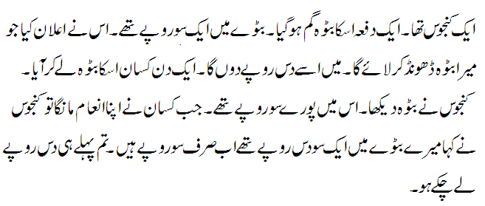

**Note: Alternate to Question No.2 and Q No. 7 for English Medium students only.**

**Q. No.2: Define the following terms and give examples of each? Marks: 2x5=10**

1. Transitive verb
2. Declarative sentence
3. Clause
4. Similes
5. Adverb

**Q No.7:** **Make sentences of the given words? Marks=07**

1. Council
2. Enough
3. Spectacle
4. Before
5. Shine
6. Early
7. Never