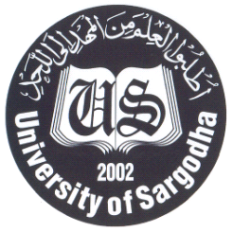
UNIVERSITY OF SARGODHA, SARGODHA

Notification

No. UOS/CE/TS/ Dated:03.05.2018

It is notified for the information to all concerned that admission forms for Final Examinations of Odd Terms i.e: 3rd, 5th & 7th Terms (alongwith Re-take students of 1st Term, if any) of Undergraduate & Graduate programs being offered in the affiliated colleges may be submitted in the office of Controller of Examinations latest by 10.05.2018 positively. The prescribed examination fee rates are given below:-
Sr.# | Programme / Discipline | Single Fee
1. | Undergraduate Programs BS(4-Years), BBA(Hons) & B.Com etc… | Rs. 3500/- per student
2. | Graduate Programme M.Com, MBA, MBA Executive, MA/M.Sc. | Rs. 4500/- per student
3. | Retake/Repeat Course | Rs. 1200/- per course

2. Admission Forms can be downloaded from University Website www.uos.edu.pk. No admission form will be accepted after the due dates in any case. If any Principal / student deposits less than the prescribed fee within due dates, he/she will have to deposit three times of the less fee otherwise Roll No. Slips will not be issued.
3. Moreover, examination fee must be deposited in the examination account No. 00427991796403 on computer generated challan form available at University of Sargodha website www.uos.edu.pk. No. of students and Discipline / Term must be clearly mentioned on challan form. Hand written challan forms / Bank Draft / Bankers Cheque will not be accepted.
4. The odd term exams will commence w.e.f 25th May, 2018.
5. Admission forms dully filled in Excel format (attached & available at UOS website) must also be emailed on termbranchuos@gmail.com latest by 10.05.2018.

Controller of Examinations
University of Sargodha

Note: Retake allowed for failed courses only having less than 2.00 GP / less than 50 marks.

