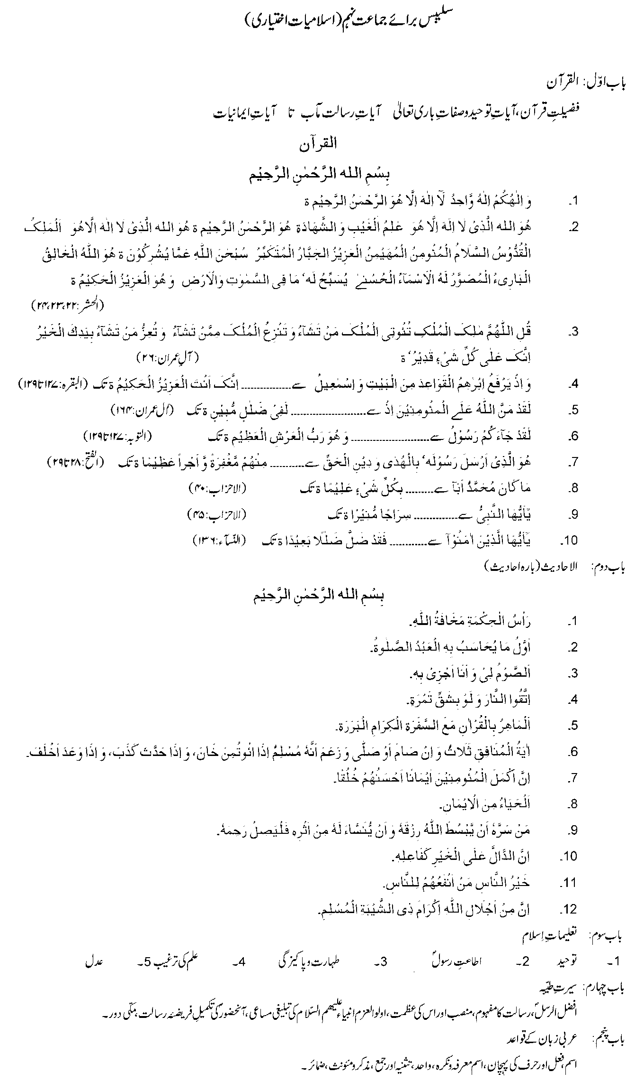

**[RECOMMENDED REFERENCE BOOKS FOR CLASS IX](http://www.result.pk)**

[The question paper will be syllabus oriented. However, the following books are recommended for reference and supplementary reading:](http://www.result.pk)

[1. Islamic Studies (Elective)](http://www.result.pk)

[Punjab Textbook Board, Lahore](http://www.result.pk)

[2. Islamic Studies](http://www.result.pk)

[Baluchistan Textbook Board, Quetta](http://www.result.pk)