SCHEME OF STUDIES
FOR HSSC (CLASSES XI–XII)

COMPULSORY FOR ALL (500 marks)
1. English (Compulsory)/ English (Advance) 2 papers 200 marks

2. Urdu (Compulsory)/ Urdu Salees In lieu of Urdu 2 papers 200 marks
(Compulsory)/ Pakistan Culture for Foreign
Students Part – I and Pakistan Culture Paper-II

3. Islamic Education/Civics (for Non-Muslims) 1 paper 50 marks

4. Pakistan Studies 1 paper 50 marks

SCIENCE GROUP (600 marks)
The students will choose one of the following (A), (B) and (C) Groups carrying 600 marks:

(A) Pre-Medical Group:
Physics, Chemistry, Biology

(B) Pre-Engineering Group:
Physics, Chemistry, Mathematics

(C) Science General Group:
1. Physics, Mathematics, Statistics
2. Mathematics, Economics, Statistics
3. Economics, Mathematics, Computer Science
4. Physics, Mathematics, Computer Science
5. Mathematics, Statistics, Computer Science

HUMANITIES GROUP (600 marks)
Select three subjects of 200 marks each from the following:
S. No. | Subject | S. No. | Subject
1. | Arabic/Persian/French/English (Elective)/Urdu (Elective) | 10.  11. | Sindhi (Elective)  Civics
2. | Economics | 12. | Education
3. | Fine Arts | 13. | Geography
4. | Philosophy | 14. | Sociology
5. | Psychology | 15. | Mathematics
6. | Statistics | 16. | Computer Science
7. | History of Modern World/Islamic History/ History of Muslim India/ History of Pakistan | 17.  18. | Islamic Culture  Library Science
8. | Islamic Studies | 19. | Outlines of Home Economics
9. | Health and Physical Education | 19. | Outlines of Home Economics

COMMERCE GROUP (600 marks)

HSSC – I
1. Principles of Accounting paper – I 100 marks
2. Principles of Economics paper – I 75 marks
3. Principles of Commerce paper – I 75 marks
4. Business Mathematics paper – I 50 marks

HSSC – II
1. Principles of Accounting paper – II 100 marks
2. Commercial Geography paper – II 75 marks
3. Computer Studies/Typing/Banking paper – II 75 marks
4. Statistics paper – II 50 marks

MEDICAL TECHNOLOGY GROUP (600 marks each)
1. Medical Lab Technology Group
2. Dental Hygiene Technology Group
3. Operation Theater Technology Group
4 Medical Imaging Technology Group
5. Physiotherapy Technology Group
6. Ophthalmic Technology Group

AIMS AND OBJECTIVES OF EDUCATION POLICY
(1998 – 2010)

AIMS

Education is a powerful catalyzing agent which provides mental, physical, ideological and moral training to individuals, so as to enable them to have full consciousness of their mission, of their purpose in life and equip them to achieve that purpose. It is an instrument for the spiritual development as well as the material fulfillment of human beings. Within the context of Islamic perception, education is an instrument for developing the attitudes of individuals in accordance with the values of righteousness to help build a sound Islamic society.

After independence in 1947 efforts were made to provide a definite direction to education in Pakistan. Quaid-i-Azam Muhammad Ali Jinnah laid down a set of aims that provided guidance to all educational endeavours in the country. This policy, too has sought inspiration and guidance from those directions and the Constitution of Islamic Republic of Pakistan. The policy cannot put it in a better way than the Quaid’s words:

“You know that the importance of Education and the right type of education, cannot be overemphasized. Under foreign rule for over a century, sufficient attention has not been paid to the education of our people and if we are to make real, speedy and substantial progress, we must earnestly tackle this question and bring our people in consonance with our history and culture, having regard for the modern conditions and vast developments that have taken place all over the world.”

“There is no doubt that the future of our State will and must greatly depend upon the type of education we give to our children, and the way in which we bring them up as future citizens of Pakistan. Education does not merely mean academic education. There is immediate and urgent need for giving scientific and technical education to our people in order to build up our future economic life and to see that our people take to science, commerce, trade and particularly well-planned industries. We should not forget, that we have to compete with the world which is moving very fast towards growth and development.”

“At the same time we have to build up the character of our future generation. We should try, by sound education, to instill into them the highest sense of honour, integrity, responsibility and selfless service to the nation. We have to see that they are fully qualified and equipped to play their part in various branches of national life in a manner which will do honour to Pakistan.”

These desires of the Quaid have been reflected in the Constitution of the Islamic Republic of Pakistan and relevant articles are:

The state shall endeavour, in respect of the Muslims of Pakistan:
- to make the teachings of the Holy Quran and Islamiat compulsory and encourage and facilitate the learning of Arabic language to secure correct and exact printing and publishing of the Holy Quran;

- to promote unity amongst them and the observance of Islamic moral standards;

Provide basic necessities of life, such as food, clothing, housing, education and medical relief for all such citizens irrespective of sex, caste, creed or race as are permanently or temporarily unable to earn their livelihood on account of infirmity, sickness or unemployment;

Remove illiteracy and provide free and compulsory secondary education within minimum possible period.

Enable the people of different areas, through education, training, agricultural and industrial development and other methods, to participate fully in all the forms of national activities including employment in the service of Pakistan;

The State shall discourage parochial, racial, tribal, sectarian and provincial prejudices among the citizens.

Reduce disparity in the income and earnings of individuals, including persons in various classes of the service of Pakistan.

Steps shall be taken to ensure full participation of women in all the spheres of national life.

The vision is to transform Pakistani nation into an integrated, cohesive entity, that can compete and stand up to the challenges of the 21st Century. The Policy is formulated to realize the vision of educationally well-developed, politically united, economically prosperous, morally sound and spiritually elevated nation.

OBJECTIVES

To make the Qur’anic principles and Islamic practices as an integral part of curricula so that the message of the Holy Quran could be disseminated in the process of education as well as training. To educate and train the future generation of Pakistan as true practicing Muslims who would be able to usher in the 21st century and the next millennium with courage, confidence, wisdom and tolerance.

To achieve universal primary education by using formal and informal techniques to provide second opportunity to school drop-outs by establishing basic education community schools all over the country.

To meet the basic learning needs of a child in terms of learning tools and contents.

To expand basic education qualitatively and quantitatively by providing the maximum opportunities to every child of free access to education. The imbalances and disparities in the system will be removed to enhance the access with the increased number of more middle and secondary schools.

To ensure that all the boys and girls, desirous of entering secondary education, get their basic right through the availability of the schools.

To lay emphasis on diversification of curricula so as to transform the system from supply-oriented to demand oriented. To attract the educated youth to world-of-work from various educational levels is one of the policy objectives so that they may become productive and useful citizens and contribute positively as members of the society.

To make curriculum development a continuous process; and to make arrangements for developing a uniform system of education.

To prepare the students for the world of work, as well as pursuit of professional and specialized higher education.

To increase the effectiveness of the system by institutionalizing in-service training of teachers, teacher trainers and educational administrators. To upgrade the quality of pre-service teacher training programmes by introducing parallel programmes of longer duration at post-secondary and post-degree levels.

To develop a viable framework for policy, planning and development of teacher education programmes, both in-service and pre-service.

To develop opportunities for technical and vocational education in the country for producing trained manpower, commensurate with the needs of industry and economic development goals.

To improve the quality of technical education so as to enhance the chances of employment of Technical and Vocational Education (TVE) graduates by moving from a static, supply-based system to a demand-driven system.

To popularize information technology among students of all ages and prepare them for the next century. To emphasize different roles of computer as a learning tool in the classroom learning about computers and learning to think and work with computers and to employ information technology in planning and monitoring of educational programmes.

To encourage private sector to take a percentage of poor students for free education.

To institutionalize the process of monitoring and evaluation from the lowest to the highest levels. To identify indicators for different components of policy, in terms of quality and quantity and to adopt corrective measures during the process of implementation.

To achieve excellence in different fields of higher education by introducing new disciplines/emerging sciences in the universities, and transform selected disciplines into centres of advanced studies, research and extension.

To upgrade the quality of higher education by bringing teaching, learning and research process in line with international standards.

RATIONALE FOR PHYSICS SYLLABUS

Physics at intermediate level provides students with a contemporary and coherent understanding of energy, matter, and their interrelationship. It focuses on investigating natural phenomena and then applying patterns, models, problem solving techniques, principles, theories and laws to explain the physical behaviour of the universe. It uses an understanding of simple system to make predictions about a range of objects from subatomic particles to the entire universe and aims to reveal the simplicity underlying complexity.

The study of physics relies on the understanding and application of a small number of basic laws and principles that govern the microscopic and macroscopic worlds. The study of physics provides students with an understanding of systems that is the basic of the development of technological applications.

Physics at intermediate level draws and builds on the knowledge and understanding, skills, values and attitudes developed in high school. It further develops students’ understanding of science as a continually developing body of knowledge, the inter disciplinary nature of science, the role of science in deciding between competing theories, the provisional nature of scientific explanations and the complex interrelationship between evidence, ideas and impact of science on society.

The study of physics facilitates learning about the natural environment and man made environment, exploring phenomenon and patterns of events, acquiring scientific skills and relating science to everyday life.

It is expected that students studying physics will apply investigations and problem solving skills, effectively communicate the theoretical concepts, and appreciate the contribution that the study of physics makes to our understanding of the world.

AIMS AND OBJECTIVES OF PHYSICS SYLLABUS

AIMS

The broad aims of the Physics syllabus are to:
- inculcate among the students the habit of scientific and rational thinking and an attitude to search for order and symmetry in diverse phenomena of nature and thereby to appreciate the supreme wisdom and creative powers of the creator;
- lay a foundation for research and development by stimulating interest and developing attitudes relevant to scientific methods;
- equip the students with the knowledge and understanding of concepts rather than the ability to remember facts so that they may have a reasonably comprehensive and complete grasp of principles of physics;
- develop observational skills and relate the student’s knowledge of concepts to quantitative measurements by including a well-balanced practical course;
- make it possible for the students to acquire knowledge, skills, working methods and ways of expression which will contribute to an all round development of individual student;
- promote an awareness that the application of science may be both beneficial and detrimental to the individual, the community and the environment.

GENERAL OBJECTIVES

On the completion of the course the student should be able to:
- acquire the knowledge and understanding of physical concepts rather than the ability to remember facts;
- develop the habit of scientific and rational thinking and an attitude to search order and symmetry in apparently diverse phenomena of nature;
- understand and interpret scientific information presented in verbal, mathematical or graphical form and to translate such information from one form to another;
- describe physical phenomena in terms of models, laws and principles;
- recognize the operation of the scientific principles in established practical applications to apply acquired knowledge, experience and skills to new situations in a novel manner;
- develop observational skills, confidence in using scientific equipment and relate the knowledge of scientific concepts to quantitative and physical measurement;
- understand and appreciate the inter relationship and balance that exists in nature, the problems associated with the over exploitation of the environmental resources and disturbance because of the human activities in the ecological balance, thus taking care of the environment;
- acquire knowledge, skills, working methods and ways of expression which will reflect on all round development of the students’ attitudes towards scientific thinking and its applications;
- help the students feel that the advancement in physics and its extended applications are essential for the healthy growth of national economy and to appreciate that physics is a major part of the modern world;
- develop attitudes such as concern for accuracy and precision, objectivity, and enquiry.

SPECIFIC OBJECTIVES

The specific objectives of the intermediate level physics course are as follows:

A. Knowledge and understanding
Students should be able to recall and show understanding of:
- Physics terminology, definitions and conventions.
- Selected factual knowledge and phenomena.
- Selected experimental methods and related practical techniques.
- Concepts, laws and models.
- Relevant applications of physics in society and everyday life.

B. Practical skills
Students should be able to:
- Plan and execute experiments.
- Handle scientific equipment safely and to the appropriate limit of accuracy.
- Observe, analyze and present experimental results accurately.
- Handle simple treatment of errors.

C. Application
Students should be able to:
- Identify problems in a given situation.
- Apply the knowledge of physics in problem solving and experimental investigation using quantitative, numerical, theoretical and practical techniques.
D. Communication skills
Students should be able to:
- Compile clear and concise accounts of experimental work and theoretical treatments.
- Interpret the recorded data.
- Use modes to explain phenomena and discuss issues relating to the social, economic, environmental and technological implications of physics.

E. Attitudes
Students should acquire
- Inquisitiveness and interest in their study of physics.
- An appreciation of the role of experimental work in the field of science.
- An objective attitude towards judgment of evidence.
- Concern for accuracy and precision.
- Awareness of contribution of physics to society and the consequences of application of physics to meet human needs.

CONTENTS AND SCOPE OF PHYSICS SYLLABUS

Contents | Scope
1. Electrostatics (18 periods)
Electric Field  Electric intensity  Electric Flux, Gauss’s law and its application  Electric potential  Capacitors | Coulomb’s law, example of fields of force. Fields of like and unlike charges. Field strength (intensity) Principle of inkjet printer and photostat copier.  Electric intensity in a free space, and in other media. Determination of electronic charge by Millikan’s method (Description and derivation of expression of electronic charge)  Explanation of electric flux, Statement and proof of Guass’s law, simple applications for the determination of electric field inside a hollow charged spherical conductor, near charged plane surface and between two oppositely charged plates.  Definition of electric potential in terms of work done in bringing a unit positive charge from infinity, electric field as potential gradient. Expression of potential at a point due to point charge, electron volt. Analogy between qualitative and quantitative aspects of electric and gravitational forces in the case of inverse square law.  Capacitance of a parallel plate capacitor, effect of dielectric on its capacitance, electric polarization of dielectric, charging and discharging of a capacitor through a resistance, RC time constant, Energy of a charged capacitor.
2. Current Electricity (15 periods)
Steady currents  Resistance  Resistivity and conductivity  Internal resistance  Kirchhoff’s Laws  The Potential divider  Balanced potentials | Steady currents, sources of current, effect of currents (Brief account only)  Current voltage Ohmic relationship for metallic conductor at constant temperature. Non-Ohmic relationship between current voltage for semiconductor diode and a filament lamp.  Simple explanation of resistivity, conductance and conductivity, calculation of the variation of resistance with temperature. Characteristic of the thermistor, colour code for carbon resistances.  e.m.f. and p.d. description of internal resistance of sources. Its simple consequences for external circuits, conditions for maximum power transfer.  Kirchhoff’s laws. Application of Ist law as conservation of charge and 2nd law as conservation of energy (application restricted to simple circuits only)  Rheostat, its working and use in the potential divider circuit.  The Wheatstone bridge and its use to measure the resistance. The potentiometer and its use as the measurement and comparison of emf’s.
3. Electromagnetism (16 periods)
Current carrying conductor in a magnetic field  Force on moving charged particle  Cathode Ray Oscilloscope (C.R.O)  Current carrying rectangular coil in a uniform magnetic field  Electric Instruments | Derivation of expression for force F = ILB sin Ө, Tesla.  Experimental study of factors governing field produced by long straight wire.  Magnetic Flux Ø = $\overline{B}\text{.}\overline{A}$ Flux density. Ampere’s Circuital law and its use to find magnetic flux density inside a solenoid.  Derivation of the expression of force on a moving charged particle in a uniform magnetic field and in an electric field. Deflection of beams of charge particles. Measurement of e/m.  Basic principle and use of C R O  Derivation of expression of torque due to couple acting on a coil.  Principle, Construction, working of galvanometer and its conversion into a voltmeter and an ammeter Description and use of Avometer/Multimeter. Analogue scales and digital displays (Brief account).
4. Electromagnetic Induction (12 periods)
Law of electromagnetic induction  Inductance  Energy stored in inductor  Simple A.C generator, D.C generator and D.C Motor  Transformer | Review of electromagnetic induction. Faraday’s law to determine the magnitude and Lenz’s law to determine the direction of induced e.m.f.  Self and mutual induction Є_{L} = - L Δ I/ Δ t and Є_{S} = -M Δ I_{p} / Δ t . Unit of inductance.  Knowledge and use of formula E = ½ L I²  Motional e.m.f, Principle, construction and working of AC generator, DC generator, DC motor, back emf in motors and back motor effect in generators.  Principle, Construction and operation of a transformer. Use of N_{s}/N_{p} = V_{s}/V_{p} and V_{s}I_{s} = V_{p}I_{p} or V_{s}/V_{p} = I_{p}/I_{s} for an ideal transformer, eddy currents and use of laminated core, Hysterics loss and prevention.
5. Alternating Current (18 periods)
Root mean square (r.m.s) value  AC circuits  Impedance  Power in AC circuits  Resonant circuit  Three phase AC supply  Electromagnetic waves | Explanation of peak and r.m.s. values of current and voltage, knowledge and use of the relationship for the sinusoidal case  Flow of AC through resistors, capacitors and inductors treated separately. Phase lag and lead. Reactances of capacitors and inductors. Vector (phaser) diagram.  Impedance as vector summation of resistances and reactances: quantitative treatment of resister and capacitor in series ( R – C circuit)  Knowledge and use of formulae for AC power  P = VI cos θ (power factor).  Quantitative understanding of the properties of circuits containing inductors and capacitors in series and parallel Principle of metal detectors for security checks, the choke coil.  Descriptive treatment.  Electromagnetic waves (ranging from radio waves to γ rays)  Production, transmission and reception of electromagnetic waves (Simple treatment) Amplitude Modulation and frequency Modulation.
6. Physics of Solids (8 periods)
Classification of solids  Mechanical properties of solids  Electric properties of solids  Magnetic properties of solids | Broad description and differences between crystalline, glassy amorphous and polymeric solids. Idea of lattice and unit cell.  Elastic and plastic deformations in solids. Tensile and compression stress. Young’s modulus. Shear modulus and bulk modulus. Elastic limit and yield strength. Determination of strain energy in the deformed material form area under force extension graph.  Classification of conductors, semiconductors and insulators, energy bands in solids (description only).Energy gap in insulators, intrinsic and extrinsic semiconductors. Electrical conduction by electrons and holes in solids. Superconductors (description only)  Description of dia, para and ferro magnetic solids, description of ferro magnets as a special case of para magnets, magnetic dipoles and domains. Curie point, hard and soft ferro magnetic substances, description of hystersis loss.
7. Electronics (10 periods)
Semi conductor devices  Operational amplifiers  Digital system | Forward and reverse based characteristics of p-n junction. Half and full wave rectification, uses of specially designed p-n junctions. (Light emitting diode, Photodiode, Photo-Voltaic cell) Transistor and its operations, Current equations Ie = Ib + Ic , Ic = $β$ Ib where $β$ is current gain. Use of transistors as a switch and an amplifier.  Introduction of operational amplifier by a black box approach, description of its characteristics, its applications as inverting and non-inverting amplifiers using virtual earth concept. Use of operational amplifier as comparator e.g. night switch or thermostat.  Function of basic logic gates limited to a maximum of two inputs, combinations of AND, NOT, OR and NAND gates to form EX – OR and EX –NOR gates and their applications to logic control functions.
8. Dawn of Modern Physics (18 periods)
Special theory of relativity  Quantum theory of radiation  Photo electric effect  Compton’s effect, pair production, pair annihilation and wave nature of particles  Uncertainty principle | Inertial and non-inertial frames of reference, postulates of special theory of relativity and its results (no derivation), the NAVSTAR navigation system.  Simple account of black body radiation, intensity distribution diagrams, Stephan – Boltzmann law , Planck’s assumptions. The origin of quantum theory. The photon.  Photo electric effect and its explanation on quantum theory Einstein’s photoelectric equation, Photocell and its uses.  Simple account of Compton’s effect, pair production, pair annihilation. Dual nature of light , De-Broglie’s hypothesis of wave nature of particles. Davission and Germer experiment electron microscope (simple working principle)  Simple treatment
9. Atomic Spectra (15 periods)
Spectrum of hydrogen, Bohr model of Hydrogen atom. Excitation and Ionization potentials  Uncertainty within the atom  X-rays  Laser | Known experimental facts of hydrogen spectrum. Bohr’s postulates of atomic model of Hydrogen. Expressions for the quantized radii and energies. Explanation of hydrogen spectrum in terms of energy levels. De-Broglie’s interpretation of Bohr’s orbits. Excitation and ionization potentials  Uncertainty regarding position of electron in the atom  Production, properties and uses of X-rays.  Spontaneous emission, stimulated emission, metastable states, population inversion, laser principle, simple treatment of He – Ne laser. Applications of lasers.
10. Nuclear Physics (20 periods)
The Atomic Nucleus  Mass defect and Nuclear binding energy  Radioactivity  Decay law and Half life  Detection of Ionising radiation  Nuclear reaction  Nuclear reactors  Medical Physics  Modern view of the building blocks of matter | Qualitative understanding of Rutherford’s scattering experiment. Charge and mass of a nucleus, Atomic number and relative isotopic mass, Isotopes, use of mass spectrograph to demonstrate the existence of isotopes and to measure their relative abundance.  Mass defect. Calculation of binding energy using Einstein’s equation, variation of binding energy per nucleon with the mass number.  Radioactivity as a random phenomenon; statistical nature of the process.  Decay law ΔN - NΔt and N = N₀e^{-λt} half life.  Interaction of nuclear radiations with matter. Simple treatment of cloud chamber, Geiger counter and Solid state detector.  Nuclear reaction, conservation of charge and mass number. Energy and mass conservation in simple reactions and in Radioactive decay. Nuclear fission and critical mass. Nuclear fusion reactions.  Working principle of nuclear reactor. Mention of various types of reactors.  Nuclear radiation exposure. Biological effects of radiation medical diagnostics, radiography, radiotherapy and tracer techniques.  Basic forces of nature. Basic idea of building locks of matter: hadrons, leptons and quarks.

LEARNING – TEACHING GUIDELINES
FOR STUDENTS AND TEACHERS

This set of instructional objectives has been compiled to show the level of achievement that is expected of an average pupil on completing the study of specific parts of the syllabus. It aims at assisting the teachers in their selection of course materials, learning activities and instructional methods. It can serve as the learning guidelines for the pupils and the basis of an evaluation program.

In stating the specific objectives there are two groups of terms having very similar meaning. The first group is on achievement in recalling facts, which include ‘define’, describe’, and state. Define refers to a rather formal definition of terms which involves their fundamental concept. ‘Describe’ refers to the recall of phenomena or processes, ‘State’ is used when the objective requires the recall of only some aspects of a phenomenon or a process; it limits the scope of teaching.

The second group is on achievement relating to science experiments. This group includes ‘design’, ‘perform’, ‘demonstrate’. ‘Design’ an experiment would be used when there are more than one acceptable ways of doing it. Pupils are expected to be able to set up the experiment by applying what they have previously learned. These experiments may require the taking of quantitative data or long term observation. ‘Perform’ an experiment, would be used when the objective emphasizes on the demonstration of experimental skill; the detail of the experiment could be found in the teachers’ notes or textbooks. ‘Demonstrate’ a phenomenon by simple experiments is used when the objective emphasizes on the result of the experiment and the experimental skill involved is very simple, such as passing some gas into a solution ‘Describe’ an experiment is used when pupils are expected to know, in principle, how the experiment could be carried out and the expected result.

1. Electrostatics
- Understand and describe Coulomb’s law in the form F = $\frac{1}{4{\text{πε}}_{0}}$$\frac{q_{1}q_{2}}{r^{2}}$ for the force between two point charges in free space and air.
- Describe that a charge has a field of force around it.
- Represent and sketch electric field by means of field lines.
- Understand fields of like and unlike charges.
- Calculate electric field strength of the uniform field between charged parallel plates in terms of potential difference and separation.
- Appreciate the principle of inkjet printers and photostat copier as an application of electrostatic phenomena.
- Explain the electric intensity in a free space and in other media.
- Describe and derive the value of electric charge by Millikan’s method.
- State and prove Gauss’s Law.
- Appreciate the applications of Gauss’s Law.
- Explain electric potential at a point in terms of work done in bringing a unit positive charge from infinity to that point.
- Relate electric field strength and potential gradient.
- Find expression for potential at a point due to a point charge.
- Define electron volt (eV).
- Recognize the analogy between quantitative aspects of electric and gravitational forces in case of inverse square law.
- Calculate the capacitance of parallel plate capacitor.
- Recognize the effect of dielectric on the capacitance of parallel plate capacitor.
- Understand and describe electric polarization of dielectric.
- Know the process of charging and discharging of a capacitor through a resistance.
- Calculate the time constant and find energy expression of a charged capacitor.

2. Current Electricity
- Understand the concept of steady current
- Describe some sources of current
- Recognize effects of currents.
- Understand and describe Ohm’s law.
- Sketch and explain the current –voltage characteristics of (a metallic conductor at constant temperature, diode and filament lamp)
- Understand resistivity and explain its dependence upon temperature.
- Understand and elaborate conductance and conductivity of conductor.
- Calculate problem relating the variation of resistance with temperature for one dimensional current flow.
- Describe the characteristics of thermistor.
- Know the value of resistance by reading colour code on it.
- Use the energy considerations to distinguish between e.m.f and p.d.
- Understand the internal resistance of sources and its consequences for external circuits.
- Describe the conditions for maximum power transfer.
- Know and use the application of Kirchhoff’s first law as conservation of charge.
- Know and use the application of Kirchhoff’s second law as conservation of energy.
- Know the working and use of rheostat in the potential divider circuit.
- Describe the function of Wheatstone Bridge to measure the unknown resistance.
- Describe the function of potentiometer to measure and compare potentials without drawing any current from the circuit.

3. Electromagnetism
- Appreciate that a force might act on a current carrying conductor placed in a magnetic field.
- Define magnetic flux density and the Tesla.
- Derive and use the equation F = ILB Sin Ө with directions.
- Understand how the force on a current carrying conductor can be used to measure the magnetic flux density of a magnetic field using a current balance.
- Describe and sketch flux patterns due to a long straight wire.
- Define magnetic flux and the Weber.
- Derive and use the relation Ø = $B\text{.}A$
- Understand and describe Ampere’s circuital law
- Appreciate the use of Ampere’s circuital law to find magnetic flux density inside a solenoid.
- Appreciate that there acts a force on a charged particle moving in a uniform magnetic field.
- Understand and describe method to measure e/m.
- Know the basic principle of Cathode ray oscilloscope (CRO).
- Appreciate the use of CRO.
- Derive the expression of torque due to couple acting on a coil.
- Know the principle, construction and working of a galvanometer.
- Know how a galvanometer is converted into a Voltmeter and an Ammeter.
- Describe Avometer/Multimeter.
- Read through analogue scale and digital display on electrical meters.

4. Electromagnetic Induction
- Recall that a change magnetic flux through a circuit causes an e.m.f. to be induced in the circuit.
- Know that the induced e.m.f. lasts as long as the magnetic flux keep changing.
- Use Faraday’s law of electromagnetic induction to determine the magnitude of induced e.m.f.
- Apply Lenz’s law to determine the direction of induced e.m.f.
- Recognize self and mutual induction.
- Define mutual inductance and self inductance.
- Define Henry
- Know and use the formula E = ½ LI².
- Calculate the energy stored in an inductor.
- Describe the principle, construction and operation of an AC generator and DC generator.
- Describe the principle construction and operation of DC motor.
- Recognize back e.m.f in motors and back motor effect in generators.
- Describe the structure and principle of operation of transformer.
- Use $\frac{N_{s}}{N_{p}}=\frac{V_{s}}{V_{p}}$ and V_{s}I_{s} = V_{p}I_{p} for an ideal transformer.
- Apply transformer equation to solve the problem.
- Understand and describe eddy current, use of laminated core and Hystersis loss.

5. Alternating Current
- Understand and describe time period, frequency, the peak and root mean square values of an alternating current and voltage.
- Know and use the relationship for the sinosidal case.
- Understand the flow of A. C. through resistor, capacitors and inductors.
- Understand how phase lags and leads in the circuit.
- Apply the knowledge to calculate reactance of capacitors and inductors.
- Describe impedance as vector summation of resistance.
- Know and use the formulae of A.C. Power to solve the problems.
- Understand the function of resonant circuits.
- Appreciate the principle of metal detectors used for security checks.
- Describe the three phases of A. C. supply.
- Become familiar with electromagnetic spectrum (ranging from radio waves to γ rays.)
- Know the production, transmission and reception of electromagnetic waves.

6. Physics of Solids
- Distinguish between the structure of crystalline, glassy, amorphous and polymeric solids.
- Understand the idea of lattice and unit cell.
- Appreciate that deformation is caused by a force and that, in one dimension, the deformation can be tensile or compressive.
- Define and use the terms Young’s modulus, bulk modulus and shear modulus.
- Describe an experiment to determine elastic limit and yield strength.
- Distinguish between elastic and plastic deformation of a material.
- Synthesis and deduce the strain energy in a deformed material from the area under the force-extension graph.
- Describe the energy bands in solids.
- Classify insulators, conductors, semiconductors on the basis of energy bands.
- Distinguish between intrinsic and extrinsic semiconductors.
- Explain how electrons and holes flow across a junction.
- Describe superconductors.
- Distinguish between dia, para and ferro magnetic materials.
- Understand and describe the concept of magnetic domains in material.
- Know the Curie point.
- Classify hard and soft ferro magnetic substances.
- Understand Hystersis loss.
- Synthesis from Hystersis loop how magnetic field strength varies with magnetizing current.

7. Electronics
- Describe forward and reverse biasing of a PN junction.
- Understand half and full wave rectification.
- Know the uses of LED, photodiode and photo voltaic cell.
- Describe the operations of transistor.
- Know current equation and solve problems.
- Understand the use of transistors as a switch and an amplifier.
- Understand operational amplifier and its characteristics.
- Know the applications of an operational amplifier as inverting and non inverting amplifier using virtual earth concept.
- Understand the use of an operational amplifier as a comparator e.g. night switch or thermostat.
- Understand the function of each of the following logic gates: AND, NOT, OR and NAND gates and represent these functions by means of truth tables (limited to a maximum of tow inputs)
- Describe how to combine AND, NOT and OR gates, or NAND gates only, to form EX-OR and EX-NOR gates.
- Understand combinations of logic gates to perform control functions.

8. Dawn of Modern Physics
- Distinguish between inertial and non inertial frames of references.
- Describe the postulates of special theory of relativity and its results.
- Understand the NAVSTAR navigation system.
- Understand the concept of black body radiation.
- Understand and describe how energy is distributed over the wave length range for several values of source temperature.
- Know Planck’s assumptions.
- Know the origin of quantum theory.
- Show an appreciation of the particular nature of electromagnetic radiation.
- Describe the phenomena of photoelectric effect.
- Explain photoelectric effect in terms of photon energy and work function energy.
- Explain the function of photocell and describe its uses.
- Describe Compton’s effect.
- Explain the phenomena of pair production and pair annihilation.
- Describe De-Broglie’s hypotheses of wave nature of particles.
- Describe and interpret qualitatively the evidence provided by electron diffraction for the wave nature of particles.
- Understand the working principle of electron microscope.
- Understand and describe uncertainty principle.

9. Atomic Spectra
- Know experimental facts of hydrogen spectrum.
- Describe Bohr’s postulates of hydrogen atom.
- Explain hydrogen atom in terms of energy levels.
- Describe De-Broglie’s interpretation of Bohr’s orbits.
- Understand excitation and ionization potentials.
- Describe uncertainty regarding position of electron in the atom.
- Understand the production, properties and uses of X-rays.
- Describe the terms spontaneous emission, stimulated emission, metastable states and population inversion.
- Understand laser principle.
- Describe the He-Ne gas laser.
- Describe the application of laser including holography.

10. Nuclear Physics

- Understand the qualitative treatment of Rutherford’s scattering experiment and the evidence it provides for the existence and small size of nucleus.
- Distinguish between nucleon number (mass number) and atomic number.
- Understand that an element can exist in various isotopic forms each with a different number of neutrons.
- Understand the use Mass Spectrograph to demonstrate the existence of isotopes and to measure their relative abundance.
- Understand mass defect and calculate binding energy using Einstein’s equation.
- Illustrate graphically the variation of binding energy per nucleon with the mass number.
- Appreciate the spontaneous and random nature of nuclear decay.
- Explain the meaning of half life.
- Recognize and use decay law.
- Understand and describe the interaction of nuclear radiation with matter.
- Understand the use of Wilson cloud chamber, Geiger Muller counter and solid state detectors to detect the radiations.
- Appreciate that atomic number and mass number is conserved in nuclear process.
- Describe energy and mass conservation in simple reactions and in radioactive decay.
- Understand and describe the phenomena of nuclear fission and nuclear fusion.
- Explain the working principle of nuclear reactor.
- Beware of various types of nuclear reactors.
- Show an awareness about nuclear radiation exposure and biological effects of radiation.
- Describe in simple terms the use of radiations, for medical diagnosis and therapy.
- Understand qualitatively the importance of limiting exposure to ionizing radiation.
- Outline the use of trace technique to obtain diagnostic information about internal structures.
- Describe examples of the use of radioactive tracers in diagnosis.
- Describe basic forces of nature.
- Describe the modern view of the building blocks of matter based on hadrons, leptons and quarks.

OBJECTIVES OF PRACTICAL WORK

Through experimental work the students are expected to develop the following skills:

A. Planning B. Implementing C. Interpreting and concluding

Students are required to carry out practical work as an integral part of the course. They are advised to maintain a laboratory record book in which they record, for all their practical work, the experimental arrangements used, the observations made and the analysis of these observations. Particular attention should be placed on the following:

1. Techniques:
i. Reading to the maximum accuracy of linear and angular scales; use of vernier scales; timing by stop-watch or stop-clock.
ii. Accurate focusing and location of images.
iii. Connecting up and checking electrical circuits from a circuit diagram, drawing a circuit diagram for a given simple circuit already connected up.

2. Graphical Methods
i. Display of results in tabular and graphical form.
ii. Translate information between graphical, numerical, algebraic and verbal forms.
iii. Accurate plotting with suitable choice of scales.
iv. For linear graph, determine the slope, intercept and intersection.
v. Choose, by inspection, a straight line which will serve as the best straight line through a set of data points presented graphically.
vi. Recall standard line form y = mx + c and rearrange relationships into linear form where appropriate.
vii. Understand and use of area below a curve where the area has physical significance.
Note: Use of centimeter graph be made compulsory.

3. Procedures:
i. Making rough preliminary measurements and calculations where appropriate, e.g. to assess the best range for accurate measurements.
ii. Careful recording of all actual measurements made.

4. Order of Accuracy
i. Significant figures and decimal places.
ii. Meaning of absolute and relative (or percentage) error.
iii. Estimates of maximum error in simple cases.
iv. Common-sense appreciation of orders of accuracy of common measurements (not merely of scale readings) and ability to quote results to a number of significant figures reasonably in keeping with their estimated accuracy.

5. Error Estimates
Rules for combination of maximum errors in the simple cases:
X + y, xy, x/y, x^{n}.

PHYSICS PRACTICALS

A. Standard experiments

- To find the resistance of a wire by slide wire bridge
- To find the resistance of a Galvanometer by half deflection method
- To find the resistance of a voltmeter by drawing graph between R and I/V
- Variation of resistance of thermister with temperature
- Conversion of Galvanometer into Ammeter
- Conversion of Galvanometer into Voltmeter
- To find the internal resistance of a cell using a Potentiometer
- To determine the e.m.f of a cell using Potentiometer
- Relation between current passing through a tungsten filament lamp and the potential applied across it
- Variation of magnetic field along the axis of a circular coil
- Charging and discharging of a capacitor and to measure time constant
- Relation between current and capacitance when different capacitors are used in A.C. circuit
- Characteristics of a semi-conductor diode and calculation of forward and reverse current resistance
- Characteristics of a N.P.N. transistor
- Study of the variation of electric current with intensity of light using a photocell
- To estimate the value of Plancks constant by using photo cell tube and coloured light filters
- Measurement of D.C and A.C voltage by cathode Ray Oscilloscope
- To verify truth table for logic gates
- To make burglar alarm using NAND gate
- To make a fire alarm using NOT gate
- Characteristics of a G.M. tube
- Determination of high resistance by Neon flash lamp
- To determine the e/m of electrons by deflection method (teltron tube)

B. Exercises
At least one exercise based on each of the above mentioned standard experiments making the total experiments equal to 46.

N.B. Pre-assembled circuits/experimental set up should he discouraged. The students must themselves assemble the electrical/electronic circuits from various components. Use of centimeter graph be made compulsory.
TEACHING STRATEGIES

Physics should not be taken as a collection of facts, and teaching of physics should not emphasize memorization of formal statements by rote, mechanical solution of problems by formulae or carrying out measurements by following given detailed instructions.

The teachers should be well acquainted with the aims and objectives of the course. To present physics in a lively, exciting and intelligible way, emphasis should be placed on teaching for understanding by organized investigation, learning and discussion. A good demonstration can be used to stimulate learning. It is intended that consideration of everyday industrial and technological applications should pervade the course. Social, economic and environmental issues should also be considered where appropriate.

Quantitative treatment is a feature of physics. However, teacher must keep the emphasize on the understanding of the physical interpretation of theoretical formulae and experimental data.

An investigation approach to practical work is essential. Individual student project promote creativity and demonstrate the students mastery of scientific principles involved. Independent use of apparatus by the students develop manipulative skills. The development of psychomotor skills such as correctly manipulating various instruments is an important objective of physics course.

Practical work is essential for students to gain personal experience of physics through doing and finding out. Another important objective of science teaching is to develop attitude of thinking in students. Teachers are encouraged to design their lessons in such a way that suitable questions avid activities are incorporated in order to develop various types avid levels of thinking in students, including analysis, evaluation, critical thinking and creative thinking.

Teachers capable in content areas may opt the teaching strategy that matches with psychology of the students. The strategy like posing problems, discussion, investigations, and solving the problems with the involvement of the students may provide an ample opportunity in conceptual clearance of a content.

In general student centred and interactive approaches are useful in providing suitable learning experiences for stimulating and developing higher level thinking and are highly recommended. Teachers may consider to adopt a variety of strategies from the following spectrum which ranges from very teacher-centred methods to very-students centred methods.

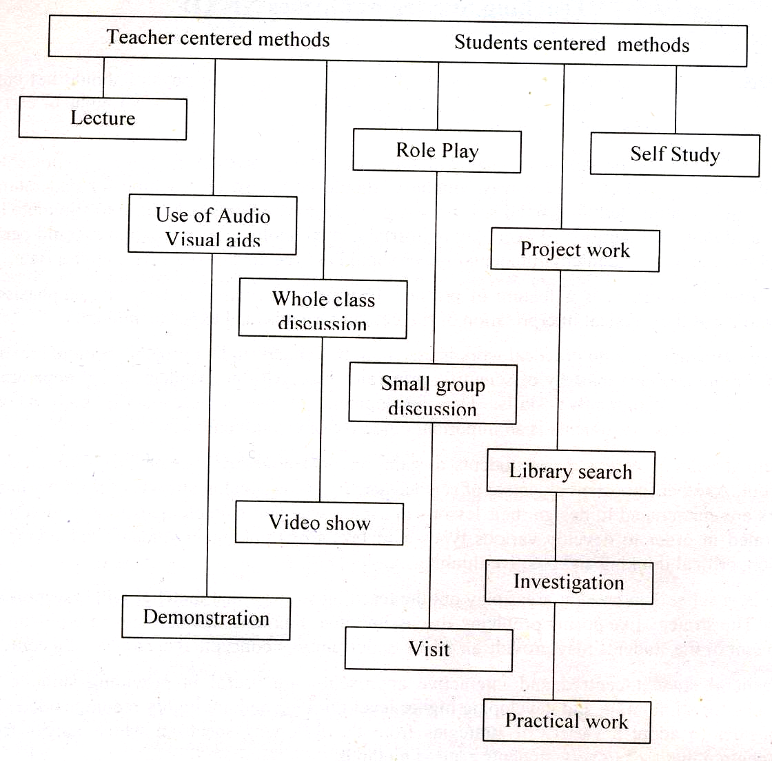

SPECTRUM OF TEACHING METHODS

Teachers should choose appropriate teaching methods in accordance with the topic/skill to be taught as well as the interest and abilities of their students. The following are some factors to be considered when deciding on the teaching methods for a particular topic:
- Learning objectives to be achieved
- Ability of students
- Subject matter
- Availability of resources
- Amount of time available

ASSESSMENT AND EVALUATION

Assessment, appraisal, or evaluation is a means of determining how far the objectives of the curriculum have been realized. What really matters is the methodology employed for such determination. As is now recognized, performance on the basis of content-oriented tests alone does not provide an adequate measure of a student’s knowledge and ability to use information in a purposeful or meaningful way; the implication, then, is that effective and rewarding techniques should be developed for evaluating the kind and content of teaching and learning that is taking place and for bringing about improvement in both. The following points, while developing the tests/questions may be kept in view:

1. Proper care should be taken to prepare the objective-type and constructed-response questions relating to knowledge, comprehension, application, analysis and synthesis, keeping in view the specific instructional objectives of the syllabus and the command words for the questions.

2. There should be at least two periodic/monthly tests in addition to routine class/tests. Teachers are expected to develop and employ assessment strategies which are dynamic in approach and diverse in design. When used in combination, they should properly accommodate every aspect of a student’s learning.

3. In addition to the final public examination, two internal examinations should be arranged during the academic year for each class.

4. Classroom examinations offer the best and most reliable evaluation of how well students have mastered certain information and achieved the course objectives. Teachers should adopt innovative teaching and assessment methodologies to prepare the students for the revised pattern of examination. The model papers, instructional objectives, definitions of cognitive levels and command words and other guidelines included in this book must be kept in view during teaching and designing the test items for internal examination.

DEFINITION OF COGNITIVE LEVELS

Knowledge:

This requires knowing and remembering facts and figures, vocabulary and contexts, and the ability to recall key ideas, concepts, trends, sequences, categories, etc. It can be taught and evaluated through questions based on: who, when, where, what, list, define, describe, identify, label, tabulate, quote, name, state, etc.

Understanding:

This requires understanding information, grasping meaning, interpreting facts, comparing, contrasting, grouping, inferring causes/reasons, seeing patterns, organizing parts, making links, summarizing, solving, identifying motives, finding evidence, etc. It can be taught and evaluated through questions based on: why how, show, demonstrate, paraphrase, interpret, summarize, explain, prove, identify the main idea/theme, predict, compare, differentiate, discuss, chart the course/direction, report, solve, etc.

Application:

This requires using information or concepts in new situations, solving problems, organizing information and ideas, using old ideas to create new one and generalizing from given facts, analyzing relationships, relating knowledge from several areas, drawing conclusions, evaluating worth, etc. It can be taught and evaluated through questions based on: distinguish, analyze, show relationship, propose an alternative, prioritize, give reasons for, categorize, illustrate, corroborate, compare and contrast, create, design, formulate, integrate, rearrange, reconstruct/recreate, reorganize, predict consequences etc.

DEFINITION OF COMMAND WORDS

The purpose of command words given below is to direct the attention of the teachers as well as students to the specific tasks that students are expected to undertake in the course of their subject studies. Same command words will be used in the examination questions to assess the competence of the candidates through their responses. The definitions of command words have also been given to facilitate the teachers in planning their lessons and classroom assessments.

Analyse: Describe with the use of graphs how information on two or more variables is related to other variables.

Apply: Demonstrate the solution of problems by using the specified procedures.

Associate: Show the inter connection of phenomena or facts.

Calculate: Is used when a numerical answer is required. In general, working should be shown, especially where two or more steps are involved.

Define (the term Only a formal statement or equivalent paraphrase is required.
or terms): No examples need to be given.

Demonstrate: Implies that the candidate is expected to show how one thing is related to another, usually it is a reference to theory but sometimes it is physical manipulation or experiment.

Derive: Deduce stepwise of formula from a general from principle or rule.

Describe: To state in words (using diagrams where appropriate) the main points of the topic. It is often used with reference either to particular phenomena or to particular experiments. In the former instance, the term usually implies that the answer should include reference to (visual) observations associated with the phenomena.

Determine: Often implies that the quantity concerned cannot be measured directly but is obtained by calculation, substituting measured or known values of other quantities into a standard formula, e.g. relative molecular mass.

Differentiate: Identify those characteristics which are the defining features of two concepts or phenomena.

Discuss: To give a critical account of the points involved in the topic.

Draw/Sketch: implies a simple freehand sketch or diagram. Care should be taken with proportions and clear labeling of parts.

Explain: May imply reasoning or some reference to theory, depending on the context.
Give examples: Name specific instances or cases to demonstrate the occurrence of an event or existence of a situation or phenomenon.

Identify: Describe with specific examples how a given term or concept is applied in daily life.

List: Requires a number of points, generally each of one word, with no elaboration. Where the number of points are specified, this should not be exceeded.

Name: Mention the commonly used word for an object.

Prove: Demonstrate by logical or numerical evidence.

Recognize: Involves looking at a given example and stating what it most probably is.

Relate: Describe how facts or phenomena depend upon, follow from or are part of another.

Represent: Draw a graph to show the connection between two variables.

Show: Demonstrate with evidence.

Solve: Deduce in simple numerical terms.

State: Implies a concise answer with little or no supporting argument, e.g. a numerical answer that can be obtained ‘by inspection’.

Use: Apply the given information to solve a problem.

RECOMMENDED REFERENCE BOOKS

In contrast to the previous practice the examination will not be based on a single textbook, but will now be curriculum based to support the examination reforms. Therefore, the students and teachers are encouraged to widen their studies and teaching respectively to competitive textbooks and other available material.

Following books are recommended for reference and supplementary reading:

1. Physics 12
Punjab Textbook Board, Lahore

2. A Textbook of Physics class XII
Sindh Textbook Board, Jamshoro

3. A Textbook of Physics class XII
NWFP Textbook Board, Peshawar.

4. A Textbook of Physics class XII
Baluchistan Textbook Board, Quetta

5. A Textbook of Physics class XII
National Book Foundation, Islamabad


Federal Board HSSC-II Examination  Physics Model Question Paper | Roll No:  Answer Sheet No: ___________  Signature of Candidate: ___________  Signature of Invigilator: ___________

SECTION – A

Time allowed: 25 minutes Marks: 17

Note: Section-A is compulsory and comprises pages 1-5. All parts of this section are to be answered on the question paper itself. It should be completed in the first 25 minutes and handed over to the Centre Superintendent. Deleting/overwriting is not allowed. Do not use lead pencil.

Q.1 Insert the correct option i.e. A/B/C/D in the empty box opposite each part. Each part carries one mark.

i. Which of the following is the unit of electric intensity?

A. Nm
B. NC
C. NC⁻¹
D. NS⁻¹

ii. Two point charges -10µc and +10µc are placed 10cm apart. What is the potential at the centre of the line joining the two charges?

A. -2V
B. -1V
C. Zero
D. 2V

iii. For which of the following AC can NOT be used?

A. Heating
B. Lighting
C. Transforming voltage
D. Electroplating

Page 1 of 5 Turn Over

DO NOT WRITE ANYTHING HERE

iii. A square sheet of side ‘a’ is held perpendicular to a uniform electric field of strength E. What is the electric flux linked with the surface?

A. Zero
B. Ea
C. Ea²
D. 4Ea

v. A cylindrical metal wire of length ‘l’ and cross-sectional area ‘A’ has resistance ‘R’, conductance ‘G’, resistivity ‘ρ’ and conductivity ‘σ’. Which of the following expressions for ‘σ’ is valid?

A. GR/ρ
B. Rl/A
C. ρR/G
D. GA/l

vi. If a charge of 1µC experiences a force of 10⁻⁶N at a point, what will be the electric intensity at that point?

A. 10⁻¹²NC⁻¹
B. 10⁻⁶NC⁻¹
C. 1NC⁻¹
D. 10⁶NC⁻¹

Page 2 of 5 Turn Over
vii. What will be the magnitude of gain of an inverting op-amp having resistances R₁= 5kΩ and R₂ = 20kΩ?

A. -5
B. -4
C. 4
D. 5

viii. A number of capacitors each of 2µF are connected as shown in the figure given below:

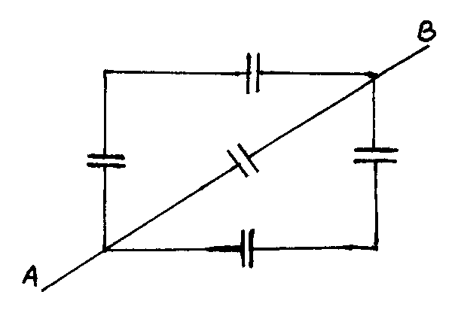

What is the net capacitance between A & B?

A. 2µF
B. 4µF
C. 6µF
D. 10µF

ix. Two copper wires A and B of lengths 1m and 9m respectively are found to have same resistance. What is the ratio $\frac{d_{A}}{d_{B}}$ between their diameters?

A. 1:9
B. 1:3
C. 3:1
D. 9:1

x. What is the rest mass energy of an object of mass 0.1g?

A. 3 x 10⁸J
B. 3 x 10¹³J
C. 9 x 10¹³J
D. 9 x 10¹⁶J

Page 3 of 5 Turn Over
xi. A current flows in a wire of circular cross-section with the free electrons traveling with a mean drift velocity ‘v’. If an equal current flows in a wire of the same material but of twice the radius, what is the new drift velocity?

A. v/4
B. v/2
C. v
D. 2v

xii. Three resistors are connected as shown in the diagram using connecting wires of negligible resistance.

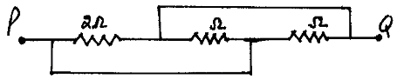
3
6

What is the resistance between points P and Q?

A. 1.0 Ω
B. 1.6 Ω
C. 3.7 Ω
D. 11 Ω

xiii. The half life of a radioactive element is such that 7/8 of a given quantity decays in 12 days. What fraction remains un-decayed after 24 days?

A. 1/128
B. 1/64
C. 1/16
D. 1/8

xiv. Which one of the following bulbs has the least resistance?

A. 100 w
B. 200 w
C. 300 w
D. 400 w

Page 4 of 5 Turn Over
xv. The peak value of an AC is 2$\sqrt{2}$A. What will be its RMS value?

A. zero
B. $\sqrt{2}$A
C. 2A
D. 2$\sqrt{2}$A

xvi. In the figure given below, what is the potential drop across the resistor R₃?

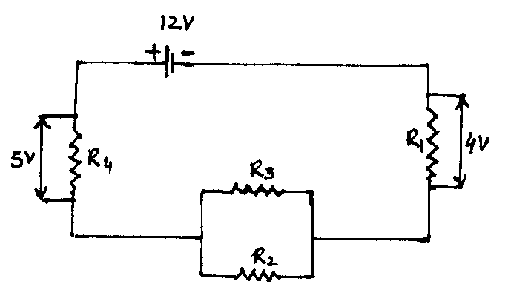

A. 3V
B. 4V
C. 9V
D. 12V

xvii. In a transformer, laminated sheets with insulation in between are used to minimize:

A. Hysteresis loss
B. Voltage loss
C. Eddy currents
D. Magnetic flux

____________________
For Examiner’s use only
17
Q. No.1: Total Marks:

Marks Obtained:

Page 5 of 5
Federal Board HSSC-II Examination
Physics Model Question Paper

Time allowed: 2.35 hours Total Marks: 68

Note: Sections ‘B’ and ‘C’ comprise pages 1-5 and questions therein are to be answered on the separately provided answer book. Answer all the questions from section ‘B’ and section ‘C’. Use supplementary answer sheet i.e., sheet B if required. Write your answers neatly and legibly.

SECTION – B
(42 marks)

NOTE: Attempt ALL the questions. The answer to each question should not exceed 3 to 4 lines.

Q.2 Apply KVL, what are the equations for voltage changes in the two loops as shown in the figure below? (2)

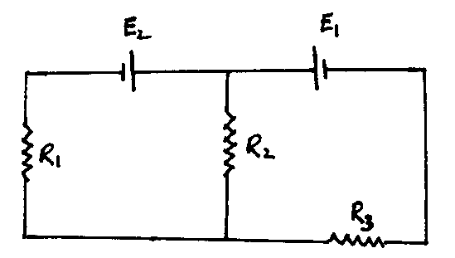

Q.3 Why is soft iron preferred as the core material for making transformers? (2)

Q.4 How does the frequency response of a capacitor differ from that of an inductor when subjected to a source of AC voltage? (2)

Q.5 Draw the impedance diagram for an RLC series circuit at resonance and show why its power factor is equal to one. (2)

Page 1 of 5 Turn Over
Q.6 Write Boolean expression for XNOR gate. What will be its output when both inputs are made zero? (2)

Q.7 Why is Vcc made high in comparison to V_{BB} as shown in the figure. (2)

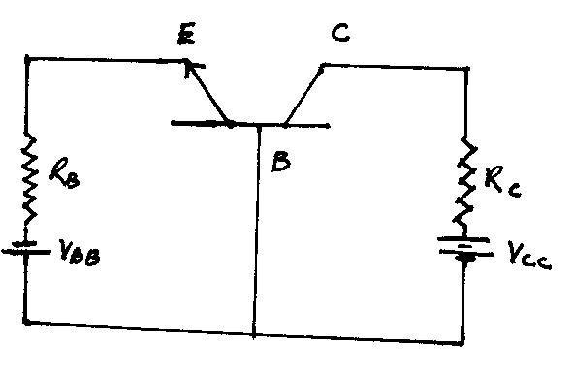

Q.8 Are de-Broglie waves associated with all moving objects? Why is it not significant for macroscopic objects? (2)

Q.9 Why should the target material in the production of x-ray unit have high melting point? (2)

Q.10 Why is the mass of a nucleus always less than the total mass of all the protons and neutrons making up the nucleus? (2)

Q.11 Why do charged particles follow circular paths when projected at a right angle to the magnetic field? (2)

Q.12 What is the origin of γ-rays compared to the origin of x-rays? (2)

Q.13 What is the absolute potential at a distance of 20cm from a point charge of -4µC? (2)

Q.14 A conductor with a cross-sectional area 10⁻⁴ m² carries an electric current of 1.2 A. If the number of free electrons be 5 x 10²⁸ m⁻³, calculate the electron drift velocity. (3)
(OR)
An electron and a proton possessing equal momenta are injected into a region at right angles to a uniform magnetic filed. What is the ratio of their radii of curvature while moving inside the magnetic field? (3)

Page 2 of 5 Turn Over
Q.15 A circuit has a resistance of 100Ω. What should be the value of another resistor to be connected to it so as to reduce the total circuit resistance to 60 Ω. Also show by circuit diagram. (3)
(OR)
A proton is moving under the influence of a perpendicular magnetic field (B) and possesses energy E. What will be the energy of the proton if the magnetic filed is increased to 4B while it is compelled to move in a circular path of same radius? (3)

Q.16 Three equal resistors connected in series across a source of e.m.f together dissipate a power of 10w. What should be the power dissipation if the same resistors are connected in parallel across the same source of e.m.f? (3)
(OR)
The eye can detect as little as 1 x 10⁻¹⁸J of electromagnetic energy. How many photons of orange light whose wavelength is 600 nm does this energy represent? (3)

Q.17 A load of 20 Ω with a power rate of 5.0 watt is to be connected to a 24v battery. What is the minimum resistance of the series resistor that will prevent the power rate from increasing? (3)
(OR)
Derive an expression for the inductance of a solenoid of length ‘l’, cross-sectional area ‘A’ and having number of turns ‘N’. (3)

Q.18 Circuit diagram shows a network of resistors each of resistance 2Ω. (3)
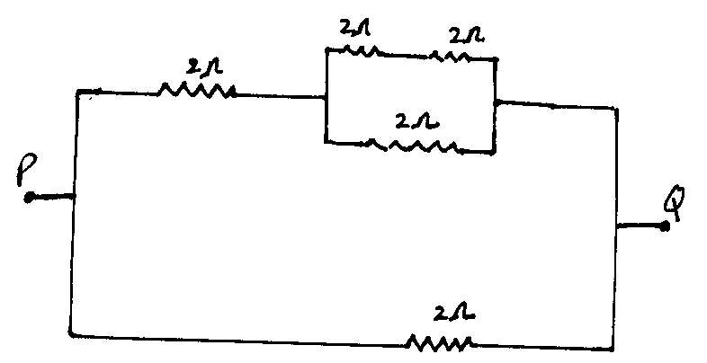

What is the effective resistance between the points P & Q?
(OR)
Two wires ‘X’ and ‘Y’ each of the same length and the same material are connected in parallel to a battery. The diameter of ‘X’ is half that of ‘Y’. What fraction of the total current passes through ‘X’? (3)

Page 3 of 5 Turn Over
Q.19 How much charge is stored in a 3.0µF capacitor and a 6.0µF capacitor when joined in series with an 18V battery? (3)
(OR)
Calculate the wavelength of electrons that have been accelerated from rest through a P.D of 100V. What kind of electromagnetic radiation has wavelength similar to this value? (3)

SECTION – C
(Marks: 26)

Note: Attempt ALL the questions.

Q.20 What is the need of using a transformer in an electrical network? Explain its working principle. How can this transformer be made to step up and to step down? Discuss power losses in a transformer, how can they be minimized? (8)

Q.21 a. State and explain Gauss’s law, also derive $\vec{E}=\frac{σ}{2ε_{0}}\overset{}{r}$, for an electric field $\vec{E}$ due to an infinite sheet of charge. Where ‘σ’ is the surface charge density, ε_{o} is permittivity of free space and $\overset{}{r}$ is a unit vector. (1+2+2)
b. Two point charges q = -1.010⁻⁶C and q₂ = +4.010⁻⁶C, are separated by a distance of 3.0m. Find and justify zero field location. (3)

Q.22 a. What is a galvanometer? Explain its construction and basic principle of working. (5)
b. What is meant by sensitivity of a galvanometer? How can a galvanometer be made more sensitive? (3)
c. Show by diagrams how a galvanometer can be transformed into an ammeter and a voltmeter? (2)
(OR)
a. Explain the experiment photoelectric effect, discuss its important results. (3+3)
b. A sodium surface is illuminated with light of wavelength 300nm. The work function of sodium metal is 2.46ev. Calculate:
(i) The max KE of the ejected electron. (2)
(ii) The cut-off wavelength for sodium. (2)

____________________

Page 4 of 5 Turn Over
DATA

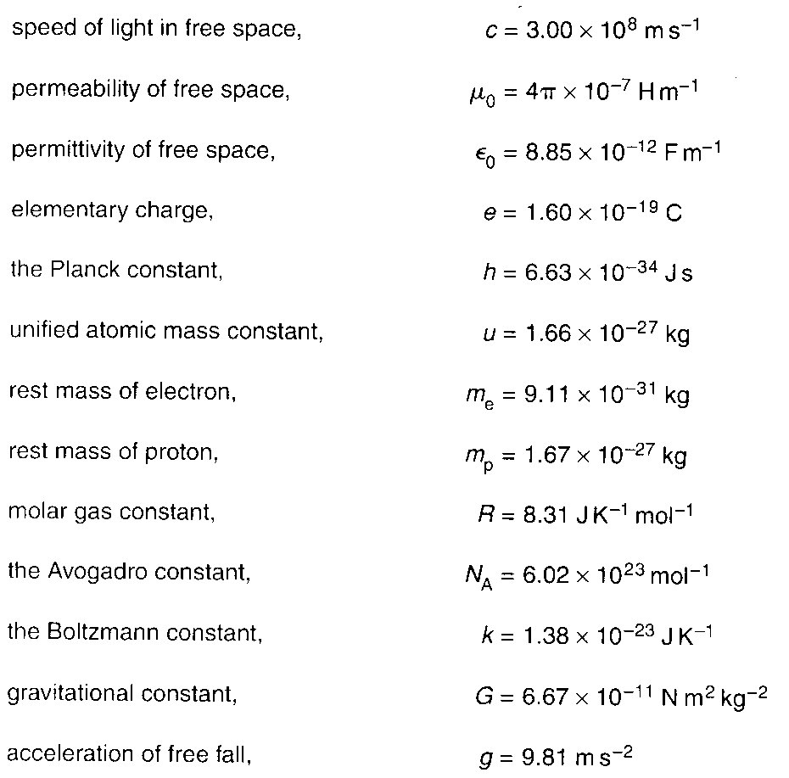

Page 5 of 5
Federal Board HSSC-II Examination
Physics Practical Model Question Paper

Time allowed: 3 hours Marks: 15

NOTE: Perform ONE experiment, as allotted by the examiner. Plot a graph where necessary.

1. Find the resistance of a voltmeter by drawing a graph between R and I/V. (10)

2. Find the characteristics of a semi-conductor diode and calculate its forward and reserve current resistance. (10)

3. Determine the e/m of an electron by deflection method (teltron tube). (10)

Practical Notebook (2)

Viva voce (3)

____________________

Page 1 of 1
Federal Board HSSC – II Examination
Physics – Mark Scheme

SECTION A

Q.1
i. C ii. C iii. D
iv. C v. A vi. C
vii. C viii. B ix. B
x. C xi. A xii. A
xiii. B xiv. D xv. C
xvi. A xvii. C
(17 1=17)

SECTION B

Q.2 (2)
Circuit
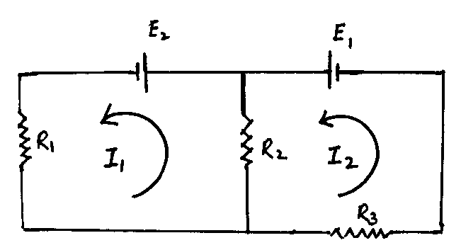 (1 mark)
–I₁R₁–E₂–(I₁–I₂)R₂ = 0
(OR)
–I₁R₁+E₂–(I₁–I₂)R₂ = 0
and
–(I₂–I₁)R₂–I₂R₃+E₁ = 0
(OR)
–(I₂–I₁)R₂–I₂R₃–E₁ = 0 (1 mark)

Q.3 (2)
i. Soft iron can be magnetized and demagnetized easily. (1 mark)
ii. Hysteresis loss for soft iron is small. . (1 mark)
Q.4 (2)
X_{c} = $\frac{1}{ωc}=\frac{1}{2π\text{fc}}$
$⇒$X_{c} $\frac{1}{f}$
and X_{L} = $ωL$ = $2π\text{fL}$
$⇒$ X_{L} $f$ (1 mark)
With the increase of frequency, reactance of a capacitor decreases whereas reactance of an inductor increases and vice versa (1 mark)

Q.5 (2)

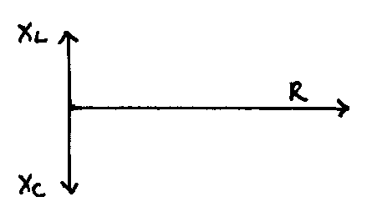 | $$⇒$$ | 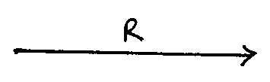
(1 mark)
At resonance the impedance of the circuit is resistive. Therefore current and voltage are in phase i.e. θ = o⁰. The power factor (Cosθ = coso⁰) is 1. (1 mark)

Q.6 (2)
X = $A\overline{B}+\overline{A}B$ (1 mark)
When
A = 0 & B = 0
Then X = 01 + 10 = 1 (1 mark)

Q.7 (2)
In a transistor E – B Junction is always forward biased, so, small V_{BB} is required (1 mark)
and B – C Junction is reverse biased, so V_{CC} is taken high. (1 mark)

Q.8 (2)
Equation for de-Broglie wavelength
$λ=\frac{h}{P}=\frac{h}{\text{mv}}$ (1 mark)
For macroscopic objects ‘$λ$’ is v.v. small which cannot be observed.
(1 mark)

Q.9 (2)
In the production of x-rays, electrons are incident on the target material, which gives a large amount of KE to the target and target material will become very hot which may melt, so we use a target of high M.P. (2 marks)

Q.10 (2)
Mass defect
∆M = M_{p} + M_{N} – M (nucleus) (1 mark)
According to Einstein’s equation
E = ∆MC²
This additional mass changes into B.E of the atom. (1 mark)

Q.11 (2)
Magnetic force on a charged particle when projected at right angles into a magnetic field is
$\vec{F}=q(\vec{V}×\vec{B})$ (i.e. θ = 90°)
or F = q V B sin90°
F = q V B (1 mark)
‘F’ provides necessary centripetal force to the charged particles. Therefore they follow a circular path. (1 mark)

Q.12 (2)
γ-rays are coming out from the nucleus of an unstable atom. (1 mark)
X-rays are obtained by the inner shell transition of electrons. (1 mark)

Q.13 (2)
As V = $\frac{1}{4{\text{πε}}_{0}}×\frac{q}{r}$ (1 mark)
q = –4µC = –410⁻⁶C
r = 20cm = 0.2m
$\frac{1}{4{\text{πε}}_{0}}$= 910⁹Nm²C⁻²
V = $\frac{9×{\text{10}}^{9}{\text{Nm}}^{2}C^{−2}×(−4×{\text{10}}^{−6}C)}{(0\text{.}2m)^{2}}=−9×{\text{10}}^{5}\text{Volt}$ (1 mark)
Q.14 (3)
I = 1.2A
A = 10⁻⁴m²
n = 510²⁸m⁻³
q = e= 1.610⁻¹⁹C
υ = ?
I = nqAυ (1 mark)
υ = $\frac{I}{\text{nqA}}= \frac{1\text{.}2}{5×{\text{10}}^{\text{28}}×1\text{.}6×{\text{10}}^{−\text{19}}×{\text{10}}^{−4}}=1\text{.}5×{\text{10}}^{−6}{\text{ms}}^{−1}$ (2 marks)
(OR)
Since the electron and proton possess same momentum
m_{e}υ_{e} = m_{p}υ_{p}
$\frac{υ_{e}}{υ_{p}}=\frac{m_{p}}{m_{e}}$ (1)
Force (F_{B}) due to magnetic field provides Fc i.e. F_{c} = F_{B}
$\frac{{mυ}^{2}}{r}$ = Beυ
υ = $\frac{\text{Ber}}{m}$ (1 mark)
Then $\frac{υ_{e}}{υ_{p}}=\frac{B_{e}r_{e}}{m_{e}}\frac{B_{e}r_{p}}{m_{p}}$
$\frac{υ_{e}}{υ_{p}}=\frac{r_{e}}{r_{p}}×\frac{m_{p}}{m_{e}}$
$⇒$$\frac{r_{e}}{r_{p}}=\frac{υ_{e}}{υ_{p}}×\frac{m_{e}}{m_{p}}$
$\frac{r_{e}}{r_{p}}$=1 using equation (1) (2 marks)

Q.15 (3)
To get a resultant of 60Ω, which is less than 100Ω, a resistor R₂ is connected in parallel to R₁ = 100Ω
Then
$\frac{1}{R}=\frac{1}{R_{1}}+\frac{1}{R_{2}}⇒\frac{1}{R_{2}}=\frac{1}{R}−\frac{1}{R_{1}}$
$\frac{1}{R_{2}}=\frac{1}{\text{60}}−\frac{1}{\text{100}}=\frac{5−3}{\text{300}}=\frac{2}{\text{300}}=\frac{1}{\text{150}}$
R₂ = 150Ω (2 marks)
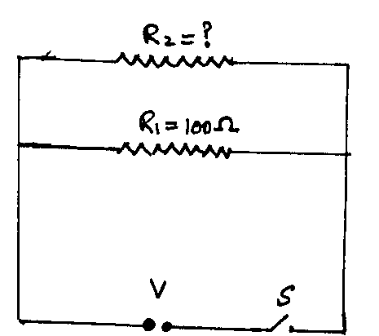 (1 mark)
(OR)
F = qυB = Beυ (θ = 90°)
$\frac{{mυ}^{2}}{r}=\text{Be}υ$
υ = $\frac{\text{Ber}}{m}$ (1 mark)
ύ = $\frac{(4B)\text{er}}{m}=4υ$ ($∵$$B^{'}=4B$)
As E = $\frac{1}{2}{mυ}^{2}$
É = $\frac{1}{2}m(v^{'})^{2}=\frac{1}{2}m(4υ)^{2}$
É = 16 $\left(\frac{1}{2}{mυ}^{2}\right)$
É = 16E (2 marks)

Q.16 (3)
P = $\frac{V^{2}}{R_{e}}$
P = $\frac{V^{2}}{3R}$= 10W $∵$($R_{e}$= 3R) (1 mark)
When connected in parallel
$R_{e}$= $\frac{R}{3}$
$P^{'}$= $\frac{V^{2}}{R3}$= $3×\frac{V^{2}}{R}=9\left(\frac{V^{2}}{3R}\right)⇒P^{'} = 9P$
$P^{'}$= 910W ($∵$P=10W)
$P^{'}$=90W (2 marks)
(OR)
Energy of light = # of photons Energy of one photon
E = $\text{nhf}$ (1 mark)
$n$= $\frac{E}{\text{hf}}$= $\frac{Eλ}{\text{hc}}$ (1 mark)
$n$= $\frac{1×{\text{10}}^{−\text{18}}×\text{600}×{\text{10}}^{−9}}{6\text{.}\text{63}×{\text{10}}^{−\text{34}}×3×{\text{10}}^{8}}$= 3 (1 mark)

Q.17 (3)
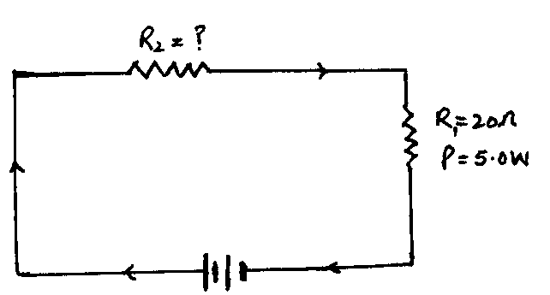
Since
P = I²R₁
I² = $\frac{P}{R_{1}}⇒I=\sqrt{\frac{P}{R_{1}}}$=$\sqrt{\frac{5}{\text{20}}}$=0.5A (1 mark)
As R = $\frac{V}{I}=\frac{\text{24}V}{0\text{.}5A}=\text{48}Ω$
R = R₁ + R₂ $⇒$R₂ = R – R₁
R₂ = $\text{48}Ω−\text{20}Ω$
R₂ = $\text{24}Ω$ (2 marks)
(OR)
For a solenoid of length ‘$l$’, cross-sectional area ‘A’ & # of turns ‘N’
$ε=−N\frac{\text{ΔΦ}}{Δt}=−N\frac{Δ(\text{BA})}{Δt}$
$ε=−\text{NA}\frac{ΔB}{Δt}$ (1 mark)
$B$ = µ_{o}nI = µ_{o}$\frac{N}{l}$I (for a solenoid)
$ε=−\text{NA}\frac{Δ(μ_{o}\frac{N}{l}I)}{Δt}$
$ε=\frac{−\text{NA}μ_{o}}{l}×\frac{ΔI}{Δt}$ (1)
Using
$ε=−L\frac{ΔI}{Δt}$ (2) (1 mark)
Comparing equation (1) and (2)
$−L\frac{ΔI}{Δt}$=$\frac{−μ_{o}N^{2}A}{l}\frac{ΔI}{Δt}$
$L=μ_{o}\frac{N^{2}}{l}A=μ_{o}n^{2}\text{lA}=μ_{o}\text{nNA}$ (1 mark)
Which is the required expression
Q.18 (3)
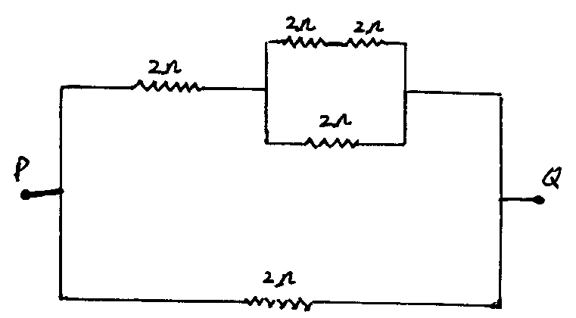

For R₁ & R₂ let their resultant be $R^{'}=4Ω$
Resultant of $R^{'}∧R_{3}$connected in parallel is $R^{''}=\frac{4×2}{4+2}=\frac{4}{3}Ω$ (1 mark)
$R^{''}$& R₄ are in series their resultant is $R^{'''}=\left(\frac{4}{3}+2\right)= \frac{\text{10}}{3}Ω$
Resultant of $R^{'''}$& R₅ connected in parallel is R = $\frac{ 2×\frac{\text{10}}{3}}{\frac{\text{10}}{3}+2}=\frac{\text{20}3}{\text{16}3}=\frac{\text{20}}{\text{16}}=1\text{.}\text{25}Ω$ (2 marks)
(OR)
R = $ρ\frac{L}{A}=ρ\frac{4L}{{πd}^{2}}$
V = IR = I$ρ\frac{4L}{{πd}^{2}}$ (1 mark)
For the wire ‘x’ V_{x} = I_{x}$ρ\frac{4L}{{πd}_{x}^{2}}$
For the wire ‘y’ V_{y} = I_{y}$ρ\frac{4L}{{πd}_{y}^{2}}$
V_{x} = V_{y} (as the wires are connected in parallel)
I_{x}. $ρ\frac{4L}{{πd}_{x}^{2}}$=I_{y}$ρ\frac{4L}{{πd}_{y}^{2}}$
$\frac{I_{x}}{d_{x}^{2}}=\frac{I_{y}}{d_{y}^{2}}$
$\frac{4I_{x}}{d_{y}^{2}}=\frac{I_{y}}{d_{y}^{2}}$ as d_{x} = $\frac{d_{y}}{2}$
$⇒I_{y}=4I_{x}$
Fraction of current which passes
through ‘x’ = $\frac{I_{x}}{\text{total} \text{current}}=\frac{I_{x}}{I_{x}+I_{y}}=\frac{I_{x}}{5I_{x}}=\frac{1}{5}=0\text{.}\text{20}$ (2 marks)
Q.19 (3)
The combined capacitance ‘C’ is given by
C = $\frac{C_{1}×C_{2}}{C_{1}+C_{2}}=\left(\frac{3\text{.}0×6\text{.}0}{3\text{.}0+6\text{.}0}\right)μF=2\text{.}0μF=2\text{.}0×{\text{10}}^{−6}F$ (1 mark)
Net charge stored
Q = CV = 2.010⁻⁶18
Q = 3610⁻⁶C (1 mark)
For capacitors connected in series, charge is same. (1 mark)
(OR)

(KE)_{max} = Ve
$\frac{1}{2}{\text{mv}}^{2}=\text{Ve}$
$\text{mv}=\sqrt{2\text{mVe}}$
Now $λ=\frac{h}{P}=\frac{h}{\text{mv}}=\frac{h}{\sqrt{2\text{mVe}}}$ (1 mark)
$λ=\frac{6\text{.}\text{63}×{\text{10}}^{−\text{34}}}{\sqrt{2×9\text{.}\text{11}×{\text{10}}^{−\text{31}}×\text{100}×1\text{.}6×{\text{10}}^{−\text{19}}}}$ $λ=1\text{.}\text{22}×{\text{10}}^{−\text{10}}m$ (1 mark)
In the electromagnetic spectrum this would be X–Radiation. (1 mark)

SECTION C

Q.20 (8)
- Need of transformer (1 mark)
- Explanation and working principle + figure (2 marks)
- Transformer equation + step up + step down (3 marks)
- Power losses and their remedies (2 marks)

Q.21 (8)
a. Statement of Gauss’s law (1 mark)
Explanation of Gauss’s law using spherical body + figure (2 marks)
Derivation for electric field $\vec{E}$ = $\frac{σ}{2ε_{o}}\overset{}{r}$+ Figure (2 marks)
b.
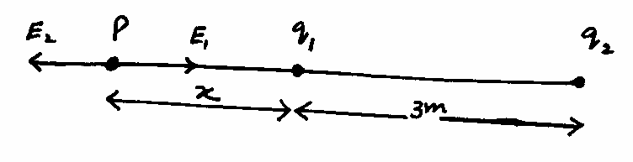 (1 mark)
Obviously, the zero field location will be at pt. P
E₁ = E₂
$\frac{1}{4{\text{πε}}_{o}}\frac{q_{1}}{x^{2}}=\frac{1}{4{\text{πε}}_{o}}×\frac{q_{2}}{(x+3)^{2}}$ (1 mark)
$\frac{1×{\text{10}}^{−6}}{xυ}=\frac{4×{\text{10}}^{−6}}{(x+3)^{2}}$
(x+3)² = 4x²
x+3 = 2x
x = 3m (1 mark)

Q.22 (10)
a. Definition (1 mark)
Construction + figure + working (1+1+2 = 4 marks)
b. Sensitivity factor + methods to increase the sensitivity
(1+2 = 3 marks)
c. Diagram for ammeter (1 mark)
Diagram for voltmeter (1 mark)
(OR)
a. Definition (1 mark)
Explanation + figure (2 marks)
Results (1 mark for each result) (3 marks)
b. $λ$= 300nm = 300 10⁻⁹m
$φ$ = 2.46ev = 2.46 1.6 10⁻¹⁹J
(KE)_{max} = hf – $φ=\frac{\text{hc}}{λ}−φ$
(KE)_{max} = $\frac{6\text{.}\text{63}×{\text{10}}^{−\text{34}}×3×{\text{10}}^{8}}{\text{300}×{\text{10}}^{−9}}−2\text{.}\text{46}×1\text{.}6×{\text{10}}^{−\text{19}}$
(KE)_{max} = (6.6310⁻¹⁹ – 3.93610⁻¹⁹)J
(KE)_{max} = 2.69310⁻¹⁹J
(KE)_{max} = 1.68ev (2 marks)
$φ$ = hf_{o} = $\frac{\text{hc}}{λ_{o}}$
$λ_{o}=\frac{\text{hc}}{φ}=\frac{6\text{.}\text{63}×{\text{10}}^{−\text{34}}×3×{\text{10}}^{8}}{2\text{.}\text{46}×1\text{.}6×{\text{10}}^{−\text{19}}}$
$λ_{o}=5\text{.}\text{05}×{\text{10}}^{−7}m$
$λ_{o}=\text{505}\text{nm}$ (2 marks)

____________________

