SCHEME OF STUDIES
FOR HSSC (CLASSES XI–XII)

COMPULSORY FOR ALL (500 marks)
1. English (Compulsory)/ English (Advance) 2 papers 200 marks

2. Urdu (Compulsory)/ Urdu Salees In lieu of Urdu 2 papers 200 marks
(Compulsory)/ Pakistan Culture for Foreign
Students Part – I and Pakistan Culture Paper-II

3. Islamic Education/Civics (for Non-Muslims) 1 paper 50 marks

4. Pakistan Studies 1 paper 50 marks

SCIENCE GROUP (600 marks)
The students will choose one of the following (A), (B) and (C) Groups carrying 600 marks:

(A) Pre-Medical Group:
Physics, Chemistry, Biology

(B) Pre-Engineering Group:
Physics, Chemistry, Mathematics

(C) Science General Group:
1. Physics, Mathematics, Statistics
2. Mathematics, Economics, Statistics
3. Economics, Mathematics, Computer Science
4. Physics, Mathematics, Computer Science
5. Mathematics, Statistics, Computer Science

HUMANITIES GROUP (600 marks)
Select three subjects of 200 marks each from the following:
S. No. | Subject | S. No. | Subject
1. | Arabic/Persian/French/English (Elective)/Urdu (Elective) | 10.  11. | Sindhi (Elective)  Civics
2. | Economics | 12. | Education
3. | Fine Arts | 13. | Geography
4. | Philosophy | 14. | Sociology
5. | Psychology | 15. | Mathematics
6. | Statistics | 16. | Computer Science
7. | History of Modern World/Islamic History/ History of Muslim India/ History of Pakistan | 17.  18. | Islamic Culture  Library Science
8. | Islamic Studies | 19. | Outlines of Home Economics
9. | Health and Physical Education | 19. | Outlines of Home Economics

COMMERCE GROUP (600 marks)

HSSC – I
1. Principles of Accounting paper – I 100 marks
2. Principles of Economics paper – I 75 marks
3. Principles of Commerce paper – I 75 marks
4. Business Mathematics paper – I 50 marks

HSSC – II
1. Principles of Accounting paper – II 100 marks
2. Commercial Geography paper – II 75 marks
3. Computer Studies/Typing/Banking paper – II 75 marks
4. Statistics paper – II 50 marks

MEDICAL TECHNOLOGY GROUP (600 marks each)
1. Medical Lab Technology Group
2. Dental Hygiene Technology Group
3. Operation Theater Technology Group
4 Medical Imaging Technology Group
5. Physiotherapy Technology Group
6. Ophthalmic Technology Group

AIMS AND OBJECTIVES OF EDUCATION POLICY
(1998 – 2010)

AIMS

Education is a powerful catalyzing agent which provides mental, physical, ideological and moral training to individuals, so as to enable them to have full consciousness of their mission, of their purpose in life and equip them to achieve that purpose. It is an instrument for the spiritual development as well as the material fulfillment of human beings. Within the context of Islamic perception, education is an instrument for developing the attitudes of individuals in accordance with the values of righteousness to help build a sound Islamic society.

After independence in 1947 efforts were made to provide a definite direction to education in Pakistan. Quaid-i-Azam Muhammad Ali Jinnah laid down a set of aims that provided guidance to all educational endeavours in the country. This policy, too has sought inspiration and guidance from those directions and the Constitution of Islamic Republic of Pakistan. The policy cannot put it in a better way than the Quaid’s words:

“You know that the importance of Education and the right type of education, cannot be overemphasized. Under foreign rule for over a century, sufficient attention has not been paid to the education of our people and if we are to make real, speedy and substantial progress, we must earnestly tackle this question and bring our people in consonance with our history and culture, having regard for the modern conditions and vast developments that have taken place all over the world.”

“There is no doubt that the future of our State will and must greatly depend upon the type of education we give to our children, and the way in which we bring them up as future citizens of Pakistan. Education does not merely mean academic education. There is immediate and urgent need for giving scientific and technical education to our people in order to build up our future economic life and to see that our people take to science, commerce, trade and particularly well-planned industries. We should not forget, that we have to compete with the world which is moving very fast towards growth and development.”

“At the same time we have to build up the character of our future generation. We should try, by sound education, to instill into them the highest sense of honour, integrity, responsibility and selfless service to the nation. We have to see that they are fully qualified and equipped to play their part in various branches of national life in a manner which will do honour to Pakistan.”

These desires of the Quaid have been reflected in the Constitution of the Islamic Republic of Pakistan and relevant articles are:

The state shall endeavour, in respect of the Muslims of Pakistan:
- to make the teachings of the Holy Quran and Islamiat compulsory and encourage and facilitate the learning of Arabic language to secure correct and exact printing and publishing of the Holy Quran;

- to promote unity amongst them and the observance of Islamic moral standards;

Provide basic necessities of life, such as food, clothing, housing, education and medical relief for all such citizens irrespective of sex, caste, creed or race as are permanently or temporarily unable to earn their livelihood on account of infirmity, sickness or unemployment;

Remove illiteracy and provide free and compulsory secondary education within minimum possible period.

Enable the people of different areas, through education, training, agricultural and industrial development and other methods, to participate fully in all the forms of national activities including employment in the service of Pakistan;

The State shall discourage parochial, racial, tribal, sectarian and provincial prejudices among the citizens.

Reduce disparity in the income and earnings of individuals, including persons in various classes of the service of Pakistan.

Steps shall be taken to ensure full participation of women in all the spheres of national life.

The vision is to transform Pakistani nation into an integrated, cohesive entity, that can compete and stand up to the challenges of the 21st Century. The Policy is formulated to realize the vision of educationally well-developed, politically united, economically prosperous, morally sound and spiritually elevated nation.

OBJECTIVES

To make the Qur’anic principles and Islamic practices as an integral part of curricula so that the message of the Holy Quran could be disseminated in the process of education as well as training. To educate and train the future generation of Pakistan as true practicing Muslims who would be able to usher in the 21st century and the next millennium with courage, confidence, wisdom and tolerance.

To achieve universal primary education by using formal and informal techniques to provide second opportunity to school drop-outs by establishing basic education community schools all over the country.

To meet the basic learning needs of a child in terms of learning tools and contents.

To expand basic education qualitatively and quantitatively by providing the maximum opportunities to every child of free access to education. The imbalances and disparities in the system will be removed to enhance the access with the increased number of more middle and secondary schools.

To ensure that all the boys and girls, desirous of entering secondary education, get their basic right through the availability of the schools.

To lay emphasis on diversification of curricula so as to transform the system from supply-oriented to demand oriented. To attract the educated youth to world-of-work from various educational levels is one of the policy objectives so that they may become productive and useful citizens and contribute positively as members of the society.

To make curriculum development a continuous process; and to make arrangements for developing a uniform system of education.

To prepare the students for the world of work, as well as pursuit of professional and specialized higher education.

To increase the effectiveness of the system by institutionalizing in-service training of teachers, teacher trainers and educational administrators. To upgrade the quality of pre-service teacher training programmes by introducing parallel programmes of longer duration at post-secondary and post-degree levels.

To develop a viable framework for policy, planning and development of teacher education programmes, both in-service and pre-service.

To develop opportunities for technical and vocational education in the country for producing trained manpower, commensurate with the needs of industry and economic development goals.

To improve the quality of technical education so as to enhance the chances of employment of Technical and Vocational Education (TVE) graduates by moving from a static, supply-based system to a demand-driven system.

To popularize information technology among students of all ages and prepare them for the next century. To emphasize different roles of computer as a learning tool in the classroom learning about computers and learning to think and work with computers and to employ information technology in planning and monitoring of educational programmes.

To encourage private sector to take a percentage of poor students for free education.

To institutionalize the process of monitoring and evaluation from the lowest to the highest levels. To identify indicators for different components of policy, in terms of quality and quantity and to adopt corrective measures during the process of implementation.

To achieve excellence in different fields of higher education by introducing new disciplines/emerging sciences in the universities, and transform selected disciplines into centres of advanced studies, research and extension.

To upgrade the quality of higher education by bringing teaching, learning and research process in line with international standards.
PHILOSOPHY AND OBJECTIVES OF MATHEMATICS SYLLABUS

PHILOSOPHY
Mathematics at the higher secondary school level is the gateway for entry not only to the field of higher Mathematics but also to the study of Physics, Engineering, Business and Economics. It provides logical basis of Set Theory, introduction to probability and problems of Trigonometry of oblique triangles. This is to be a standard course in Differential and Integral Calculus and Analytical Geometry which go a long way in making Mathematics as the most important subject in this age of science and technology.

OBJECTIVES
- To provide the student with sound basis for studying Mathematics at higher stage.
- To enable the student to apply Mathematics in scientific and Technological fields.
- To enable the student to apply mathematical concepts specifically in solving computational problems in Physics, Chemistry and Biology.
- To enable the student to understand and use mathematical language easily and efficiently.
- To enable the students to reason consistently, to draw correct conclusion from given hypotheses.
- To inculcate in him the habit of examining any situation analytically.

CONTENTS AND SCOPE OF MATHEMATICS SYLLABUS

Contents | Scope
Functions and Limits (07 periods)
- Revision of the work done in the previous classes.  Exercises.  - Kinds of Functions  Examples and Exercises.  - Composition and Inversion of Functions.  Examples and Exercises.  - Limits of Functions and Theorems on limits.  Examples and Exercises.  - Limits of important functions  Examples and Exercises.  - Continuous and Discontinuous Functions  Examples and Exercises.  - Graph  Examples and Exercises. | - Function, its domain and range; series (geometric series and binomial series); graphs of algebraic linear function, trigonometric functions and inverse trigonometric functions.  - To know the following types of functions:  algebraic, trigonometric, inverse trigonometric, hyperbolic; explicitly and implicitly defined functions, parametric representation of functions, even and odd functions.  - To know the meaning of the identity and constant functions and the techniques of composing and inverting the functions by algebraic methods.  - a) explanation of the terms $x→a$ and $x→0$ and $x→a$  b) intuitive notion of limit of a function at a point and at α, illustration with suitable examples.  c) theorems on sum, difference, product and quotient of function.  - a) limit of the following functions at  x = a  $\frac{( x^{n}−a^{n})}{(x−a)},\frac{(x−a)}{(\sqrt{x}−\sqrt{a})}$  b) limit of the ${\left(1+\frac{1}{x}\right)}^{x}$at α  c) limits of the following functions at  x = 0  $\frac{\sqrt{x+a}−\sqrt{a}}{a} ; (1+x)^{1+x}; \left(\frac{ a^{x}−1}{x}\right)$  $\frac{\text{sin} x}{x}$  and their application in evaluation of the limits of algebraic, exponential and trigonometric functions.  - To understand the concept of continuity of a function at a point and in an interval intuitively, explanation of continuity and discontinuity through graphs.  - To draw the graphs of  a) Explicitly defined functions like  y = f (x) , where f(x) =e^{x}, a^{x} , log_{a} x, log_{e} x  b) Implicitly defined functions such as  x² +y² = a²; x²/a²+y²/b² =1  distinction between graph of a function and graph of an equation must be stressed.  c) Parametric equations of functions such as  x = at² , y= 2at; x = a sec θ , y = b tan θ  d) Discontinuous functions of the type.  $y=\begin{aligned}\left\{x,\text{when} 0≤x≤ \text{and} \frac{x−4}{2}, x≠2 | \right\}\end{aligned}\left\{\right\}$  and solve the following equations graphically:  cos x = x ; sin x = x; tan x = x;
Differentiation (28 periods)
- Introduction  Examples and Exercises.  - Differentiation of Algebraic Expressions  Examples and Exercises.  - Theorems of Differentiation  Examples and Exercises.  - Chain Rule  Examples and Exercises.  - Differentiation of Functions other than algebraic.  Examples and Exercises.  - Successive differentiation.  Examples and Exercises.  - Maclaurin’s and Taylor’s Theorems.  Examples and Exercises.  - Extreme Values.  Examples and Exercises. | - Concept of dependent and independent variables, average rate of change of a variable w.r.t another variable, instantaneous rate of change of variable w.r.t another variable, definition of derivative (differential coefficient)  - Calculation of derivatives from definition, average rate of change.  - Instantaneous rate of change.  - To be able to calculate the derivatives of  $\begin{aligned}y=(\text{ax}+b)^{n}, n=1,2,3\text{.}\text{.}\text{.}\text{.}\text{.}\text{.}\text{.}\text{.}\text{.}\text{.}\text{.}\text{.}\text{.}\text{.}\text{.}\text{.}\text{.}\text{.} \\ y=\frac{1}{(\text{ax}+b)^{n}}, n=1,2,3\text{.}\text{.}\text{.}\text{.}\text{.}\text{.}\text{.}\text{.}\text{.}\text{.}\text{.}\text{.}\text{.}\text{.}\text{.}\text{.}\text{.}\text{.}\end{aligned}$  by definition (ab-initio)  - To establish the theorems on differentiation sum, difference, product and quotients of functions and their application, differentials of y = (ax+b)^{n} where n is negative integer, using quotient theorem.  - Explanation and application of chain rule for composite function and functions defined by parametric equations.  - To find the derivatives of trigonometric, inverse trigonometric, exponential, logarithmic, hyperbolic and inverse hyperbolic functions using chain and other rules. Derivation of y = x^{n} where n = p/q, q≠0.  - To have the concept of successive differentiation.  - To find 2nd, 3rd and 4th derivatives of algebraic, trigonometric, exponential and logarithmic functions.  - To find 2nd derivatives of implicit, inverse trigonometric and parametric functions defined by parametric equations.  - To know the Maclaurin’s and Taylor’s theorems with application in simple cases only.  - To know the geometrical interpretation of the derivative of a function, (as a slope of the tangent line at a point to graph of y = f(x).  - To find whether a function is increasing or decreasing at a point and in an interval.  - To have the concept of turning point (extreme point)  - To have the concepts of maximum and minimum values and critical points of a function.  - To know the second derivative test of maxima and minima.  - To solve simple word problems of maxima and minima.
Integration (40 periods)
- Differentials  Examples and Exercises  - Introduction to Integration.  Examples and Exercises  - Theorems on Antiderivatives.  Examples and Exercises  - Integration by Substitution  Examples and Exercises  - Integration by Substitution  Examples and Exercises.  - Integration involving Partial Fractions  Examples and Exercises  - Definite Integrals  Examples and Exercises  - Application of definite Integrals  Examples and Exercises  - Differential Equations  Examples and Exercises | - To have the concept of differentials and to  a) distinguish between dy and δy,  b) find dy/dx using differentials.  c) simple application of differentials in finding approximate values of irrational numbers and sin x, cos x, when x = 29º, 46 º, 62 º, etc.  - To define integration as anti-deterivative (inverse of derivative) and to know simple standard integrals which directly follow from standard differentiation formulas and to apply them in the integration of functions of the same types.  - To know the theorems (without proof) on antiderivatives of  a) constant multiple of a function  b) sum and difference of functions and their applications.  - To know and be able to integrate by applying the method of substitution in the integration of functions including the following standard forms:  $\frac{1}{\sqrt{x^{2}−a^{2}}}, \frac{1}{\sqrt{x^{2}+a^{2}}}$  - To know and be able to find the antiderivitives of functions by parts including the following standard forms.  $\sqrt{a^{2}−x^{2}} , \sqrt{x^{2}+a^{2}} , \sqrt{x^{2}−a^{2}}$  - To be able to use partial fractions in integration of rational functions having denominators consisting of:  a) linear factors.  b) repeated linear factors (up to 3)  c) linear and non-repeated quadratic factors.  - To be able to differentiate between definite and indefinite integrals and to know and apply the following theorems of definite integrals.  a) Definite integral:  $\int_{a}^{b}{f}(x)\text{dx}$as the area under the curve.  y = f(x) from x = a to x= b and the x –axis.  b) Fundamental theorems of calculus  c) $\int_{a}^{b}{f}(x)\text{dx}= −\int_{a}^{b}{f}(x)\text{dx}$  $\int_{a}^{b}{f}(x)\text{dx}= \int_{a}^{c}{f}(x)\text{dx}+\int_{c}^{a}{f}(x)\text{dx}$  - To be able to calculate areas bounded by the curve and x-axis.  - To have the concept of a differential equations and its order.  - To be able to solve differential equations of first order with variables separable in the forms; dy/dx=f(x)/g(y) or dy/dx = g(y)/ f(x) concept of initial conditions and simple applications.
Introduction to Analytic Geometry (13 periods)
- Coordinate System  Examples and Exercises  - Translation and Rotation of Axes  - Equations of straight lines.  Examples and Exercises  - Two and three Straight lines.  Examples and Exercises.  - Homogeneous Equations of 2nd Degree in two Variables x and y.  Examples and Exercises. | - Be able to :  a) locate a point in a Cartesian Plane,  b) derive the distance formula,  c) divide the line segment in given ratio (internally and externally), find the mid-point of a line segment.  d) Apply the above results in proving concurrency of the right bisectors, bisectors of the angles, medians and altitudes of a triangle.  - Be able to find the coordinates of a point under transition and rotation of axes.  - a) Concept of the slope of a line.  b) To find the slope of a line passing through two points; the equations of the x-axis and y-axis.  c) The equations of the straight lines parallel and perpendicular to the coordinate axes.  d) Derivation of the following standard forms of the equations of straight lines; slope-intercept; point- slope ; two points; intercepts; normal and symmetric.  e) To establish the fact that a linear equation in two variables x and y represents a straight line.  f) To transform the linear equation ax + by +c=0 in the standard form listed in (d) above.  g) To know the position of a point with respect to a line and to find the distance of a point from a line and between two parallel lines.  h) To find the area of a triangle whose vertices are given.  - Be able to find:  a) the point of intersection of two straight lines.  b) the condition of concurrency of three straight lines and their point of concurrency.  c) acute angle between two straight lines, condition of their parallelism and perpendicularty.  d) the equation of lines through the point of intersection of two lines with a given condition (including parallelism and perpendicularity).  e) the equation of the right bisector of a line segment.  f) the equation of the medians, altitude and right bisectors of a triangle when its vertices or equations of sides are given.  g) area of triangle when equations of it sides are given.  h) Equations of one, two or three straight line/s and the condition of concurrency of three straight lines in matrix form.  - Concept of homogeneous equations in one or two variables  - To show that a 2nd degree homogenous equation in two variables x and y represents a pair of straight lines through the origin.  - To find the angle between these lines.  - To find the condition of coincidence and perpendicularity of these lines and their applications.
Linear Inequalities and Linear Programming (12 periods)
- Linear Inequalities and their Graphs  Examples and Exercises.  - Feasible Solution Set  Examples and Exercises.  - Linear Programming.  Examples and Exercises. | - To know the meaning of linear inequalities in two variables and their solutions be graphically illustrated; determine graphically the region bounded by 2 or 3 simultaneous inequalities of non negative variables and shading the regions bounded by them.  - To know feasible solution set and graphically find the feasible solution sets of the problems from every day life.  - To have the concepts of simple linear programming and of optional solution of the linear objective functions and to find the optional solution of the linear objective functions by graphical methods.
Conic Sections (28 periods)
- Introduction  - Circle  Examples and Exercises.  - Tangents and Normals.  Examples and Exercises.  - Analytic proofs of important properties of a circle.  Examples and Exercises.  Parabola  - Parabola and its elements.  Examples and Exercises  - Equation of a Parabola with given elements.  Examples and Exercises  - Tangents and Normals to a Parabola.  Examples and Exercises  Ellipse  - Ellipse and its elements.  Examples and Exercises  - Equation of an Ellipse with given elements.  Examples and Exercises  - Tangents and Normals to an ellipse.  Examples and Exercises  Hyperbola  - Hyperbola and its elements.  Examples and Exercises  - Equation of hyperbola with given examples.  Examples and Exercises  - Tangents and Normals to Hyperbola.  Examples and Exercises  General equation of Conics  - Translation and rotation of axes.  Examples and Exercises  - Intersection of two Conics.  Examples and Exercises. | - To know that circle, Parabola, ellipse and hyperbola are sections and of cones.  - a) To know the definition of a circle.  b) to derive the equation of circle in the form  (x-h)² + (y-k)² = r²  c) to know the general form of equation of circle as x² + y² + 2gy + 2fy + c = 0 and be able to find its centre and radius.  d) to find the equation of a circle:  1. Passing through three non collinear points  2. Passing through two points and having its centre on a given line.  3. Passing through two points and equation of tangent at one of these points is known  4. Passing through two points and touching a given line.  - To find:  a) the points of intersection of a circle with a line including the condition of tangency.  b) the equation of a tangent to a circle in slope form.  c) the equations of tangent and a normal to a circle at a point.  d) the equation of Tangent to the circle when parallel and perpendicular of tangents are given  e) when the length of tangent to a circle from an external point is given.  f) to prove that two tangents drawn to a circle from an external point are equal in length.  - To prove analytically the following properties of a circle:  a) the perpendicular from the centre to a chord bisects it and its two converses.  b) the congruent chords of a circle are equidistant from its centre and its converse.  c) the measure of the central angle of a minor arc is double the measure of the angle subtended in the corresponding major arc.  d) the angle in a semi-circle is a right angle and its converse.  e) the perpendicular at the outer end of a radial segment is tangent to the circle and its two converses.  - to know the concept of a parabola and its elements (focus, directrix, eccentricity, vertex, axis, focal chord, latus rectum).  - to derive the standard forms of equations of parabolas and to draw their graphs and to find the elements.  - a) to find the equation of a parabola with the following given elements.  - focus and vertex  - focus and directrix  - vertex and directrix  - To find:  a) points of intersection of a parabola with a line including the condition of tangency  b) the equation of a tangent in slope form  c) the equation of a tangent and a normal to a parabola at a point.  - Applications, suspension and reflection properties of parabola.  - To know the concept of an ellipse and its elements (centre, foci, eccentricity, vertices, major and minor axes, focal chords, latera racta and directories).  - To derive the standard forms of equations of an ellipse, find its elements and to draw the graphs of ellipses.  - To know that circle is a special case of an ellipse.  - a) to find the equation of an ellipse with the following given elements.  - major and minor axes  - two points  - faci, vertices or lengths of a latera recta  - faci, minor axis or length of a latus rectum.  - To find  a) the points of intersection of an ellipse with a line including the condition of tangency.  b) the equation of a tangent in slope form.  c) the equations of tangents and normals to an ellipse at point.  - To know the concept of a hyperbola and its elements (centre, foci, eccentricity, focal chord, latera recta, directrices, transverse and conjugate axes.  - To derive the standard forms of an equation of hyperbola, find its elements and draw the graphs.  - To find the equation of a hyperbola with the following elements:  - transverse and conjugate axes with centre at origin.  - eccentricity, latera recta and transerverse axis  - focus eccentricity and centre.  - focus, centre and directrix.  - To convert equation of a hyperbola to the standard form by translation of axes and be able to find the elements.  - To find  a) the points of intersection of a hyperbola and a line including condition of tangency.  b) the equation of a tangent in slope form.  c) the equations of tangents and normals to a hyperbola at a point.  - a) to know that the general form of the equation ax² + 2hxy + by² + 2gx + 2fy + c = 0  represents a conic. Statement of the relevant theorem without proof.  b) be able to find the conditions that general equation of 2nd degree represents a particular conic in the standard form when:  1. a = b , h = 0 (circle)  2. a ≠ b (both having same signs),  h = 0 (ellipse)  3. a ≠ b (both having opposite signs), h = 0 (hyperbola)  4. a = 0 or b= 0 and h = 0 (parabola)  c) be able to convert general equation of 2nd degree in the form of equation of a particular conic (circle, parabola, ellipse and hyperbola) in standard form by translation and rotation of axes and find their elements.  d) be able to find equations of a tangent at a point to a conic represented by general equation of second degree.  e) to know that the general equation of 2nd degree represents a hyperbola from a = b = g = f= 0 and h ≠0, c ≠ = 0.  - Be able to know that two conics intersects in  1) four real points.  2) two real points.  3) two coincident real points.  4) one real point.  5) no real point.
Vectors (18 periods)
- Introduction of vector in a plane.  Examples and Exercises  - Introduction of Vector in Space.  Examples and Exercises  - Scalar Product of two vectors.  Examples and Exercises  - Vector Product of two Vectors.  Examples and Exercises.  - Scalar Triple Product of Vectors  Examples and Exercises. | - To know  a) definitions of scalar and vector quantities (and their notations); vector as an ordered pair of real numbers and as a directed line segment; position vector of a point, magnitude of a vector, unit vector, negative of a vector, zero vector; equal vectors and parallel vectors.  b) to add and subtract two vectors (triangle law of addition of two vectors ); commutative and associative properties of addition of vectors; multiplication of a vector by a scalar;  c) to find $\vec{\text{AB}}$if position vectors of points A and B are given; ratio formula (position vector of the point which divides $\vec{\text{AB}}$in a given ratio); position vector of mid-point of a line segment (when position vectors of end points are given).  d) application of vectors in proving problems of geometry.  - a) To know location of a point in space using Cartesian system; concept of vectors in space; fundamental unit vectors (i.j.k) components of a vector ā = a₁i = a₂J + a₃k, magnitude of a vector, unit vector; parallel, collinear and coplanar vectors.  b) To know direction angles, direction cosines and direction ratios of a vector; distance between two points; addition and subtraction of vectors and multiplication of a vector by a scalar in components form and their applications in geometry.  - a) To know the definition of scalar (dot) product of two vectors i.e.  $\overline{a}\text{.}\overline{b}=\text{ab} \text{cos}θ$deducing the facts  $\begin{aligned}\underline{i}\text{.}\underline{i}=1, \underline{j}\text{.}\underline{j}=1, \underline{k}\text{.}\underline{k}=1, \underline{i}\text{.}\underline{j}=0, \underline{j}\text{.}\underline{k}=0, \\ \underline{k}\text{.}\underline{i}=0, \underline{a}\text{.}\underline{b}=\underline{b}\text{.}\underline{a}\end{aligned}$  b) to know analytical expression of $\overline{a}\text{.}\overline{b}$  i.e. if $\underline{a}=a_{1}\underline{i}+a_{2}\underline{j} i+a_{3}\underline{k}$ and  $\underline{b}=b_{1}\underline{i}+b_{2}\underline{j}+b_{3}\underline{k}$  then  $\underline{a}\text{.}\underline{b}=a_{1}b_{1}+a_{2}b_{2}+a_{3}b_{3}$  angle between two vectors; projection of one vector on another vector; properties of scalar product (parallel vectors, perpendicular vectors)  c) Application of scalar product in solving problems of geometry and trigonometry;  i.e. to prove that  cos(α ± β) = cos α cos β ± sin α sin β  a² = a² + b² -2ab cos γ  a = b cos γ + cos β etc.  - a) To know the definition of vector (cross) product of two vectors, i.e. a  b = |a| |b| sinθ$\hat{n}$ where θ is the measure of the angle between vectors a and b and $\hat{n}$ is the unit vector perpendiucluar to both a and b;  b) derivation of following results:  i x i = 0 , J x J = 0 , k x k = 0  i x j = k , j x k = i , k x i = J  a b = – (b  a) ,  a b = 0  c) To know deteminantal espression of the vector product of two vectors.  d) To know properties of vector product of two vectors;  1) a x b = 0 if and only if a is parallel to b  2) |ab| = area of a parallelogram where a and b represent its adjacent sides.  3) 1/2 $\left|\underline{a}×\underline{b}\right|=$area of a triangle where a and b represent two sides.  e) Application of cross product of vectors in trigonometry:  i.e. to prove:  sin (α ± β) = sin α cos β ± cos α sin β  $\frac{a}{\text{sin}a}=\frac{b}{\text{sin}B}=\frac{c}{\text{sin}y}$  - a) To know definition of scalar triple product of vectors.  (a x b). c , (b x c) . a , (c x a) . b  b) To know that  (a x b). c = a . (b x c)  i.e. dot and cross are inter-changeable.  c) To know the determinental expression for scalar triple product.  d) To find the volume of a parallelepiped and regular tetrahedron.  e) Applications of vectors in solving simple problems of mechanics.

LEARNING – TEACHING GUIDELINES
FOR STUDENTS AND TEACHERS

This set of instructional objectives has been compiled to show the level of achievement that is expected of an average pupil on completing the study of specific parts of the syllabus. It aims at assisting the teachers in their selection of course materials, learning activities and instructional methods. It can serve as the learning guidelines for the pupils and the basis of an evaluation program.

In stating the specific objectives there are two groups of terms having very similar meaning. The first group is on achievement in recalling facts, which include ‘define’, describe’, and state. Define refers to a rather formal definition of terms which involves their fundamental concept. ‘Describe’ refers to the recall of phenomena or processes, ‘State’ is used when the objective requires the recall of only some aspects of a phenomenon or a process; it limits the scope of teaching.

The second group is on achievement relating to science experiments. This group includes ‘design’, ‘perform’, ‘demonstrate’. ‘Design’ an experiment would be used when there are more than one acceptable ways of doing it. Pupils are expected to be able to set up the experiment by applying what they have previously learned. These experiments may require the taking of quantitative data or long term observation. ‘Perform’ an experiment, would be used when the objective emphasizes on the demonstration of experimental skill; the detail of the experiment could be found in the teachers’ notes or textbooks. ‘Demonstrate’ a phenomenon by simple experiments is used when the objective emphasizes on the result of the experiment and the experimental skill involved is very simple, such as passing some gas into a solution ‘Describe’ an experiment is used when pupils are expected to know, in principle, how the experiment could be carried out and the expected result.

Functions and Limits
i. Define the function as a binary relation.
ii. Find the domain and range of a given function.
iii. Define differentiate between following types of functions:
Algebraic, trigonometric, Inverse trigonometric, exponential, logarithmic, hyperbolic, inverse hyperbolic, explicit, parametric, even, odd and rational functions.
iv. Be able to draw the graphs of above mentioned functions.
v. Understand the concept of limit through the process of area of circle by inscribing polygons inside it.
vi. Understand the concept of limit by half of a Unit, and then half of the remainder and repeating the process indefinitely.
vii. Evaluate limits of various algebraic rational expressions.
viii. Define the theorems on addition, subtraction, multiplication and division of limits without proof and be able to solve problems involving these theorem.
ix. Evaluate $\begin{aligned} \text{Lim} \\ x →0\end{aligned}$ $\frac{\text{sin} x}{x}$and $\begin{aligned} \text{Lim} \\ x →0\end{aligned}$${\left(1+\frac{1}{x}\right)}^{x}$and be able to apply them in
the evaluation of limits of trigonometric and logarithmic functions.
x. Be able to draw graphs of:
a. explicit functions like y = f (x), when f (x) = e^{y}, a^{x} , log_{a}x, loge^{x}
b. implicit functions like x² + y² = a²; x²/a² +y²/b² =1
c. Parametric equations of functions like x = at2, y = 2at
x = a sec θ , y = b tan θ
d. Functions of the type
$y=\begin{aligned}\left\{x,\text{when}0≤x≤1\text{and}\frac{x^{2}−4}{x−2},x≠2 | \right\}\end{aligned}\left\{\right\}$
xi. Differentiate between the meaning of continuity and discontinuity of function at a point and in an interval.
xii. Understand that continuous function has an ungroup graph and a discontinuous function has a broken graph.

Differentiation
i. Define and give geometrical interpretation of a derivative.
ii. Be able to find derivatives from first principle (simple eases only).
iii. Establish theorems derivatives of sum, difference, product and quotient of functions.
iv. Be able to differentiate algebraic, trigonometric, inverse trigonometric, logarithmic, exponential, hyperbolic and inverse hyperbolic functions and implicit functions.
v. Solve problem relating to velocity and acceleration.
vi. Apply chain rule in differentiating parametric functions and composite functions.
vii. Prove Maclaurin’s and Taylor’s theorems and their applications.
viii. Be able to calculate derivatives of second, third and fourth orders.
ix. Define increasing and decreasing functions.
x. Find maxima and minima and their simple problems.
xi. Bring as use derivative in solving problems of physical and biological sciences.

Integration
i. Define differentials.
ii. Be able to understand the process of finding the anti-derivatives is the inverse of the process of finding derivatives.
iii. Be able to find the anti-derivative of simple algebraic trigonometric and exponential functions.
iv. State and use theorems on integration.
v. Solve problems with the help of following techniques of integration:
a. By substitution.
b. By partial fractions
c. By parts
vi. Define Definite Integral.
vii. Be able to find the area under a curve above x-axis and between two ordinates.
viii. Use anti-derivatives in solution of simple first order differential equations.

Introduction to Analytic Geometry
i. Understand that a homogeneous equation of second degree in two variable is of the form:
ax² + 2hxy +by² = 0 where a, b & h ,Є R and that it always represents a pair of straight line passing through the origin.
ii. Be able to find the angle between the pair of lines given by ax² + 2hxy +by² = 0 and to derive the condition of perpendicular there from.
iii. Derive distance formula.
iv. Use the formula of division of line segment in a given ratio internally & externally.
v. Be able to derive the different standard forms of the equations of a straight line.
vi. Prove that.:
a. right bisectors of sides.
b. bisectors of angles.
c. medians and altitudes of types.
vii. Define translation and rotation of axes.
viii. Transfer the linear equation ax + by + c = 0 in the standard forms of equations of straight line.
ix. Derive the distance of a point from a line.
x. Find area of a triangle in terms of coordinates of its vertices.
xi. Find the angle between two given lines in terms of their slopes and deduce the conditions of parallelism and perpendicular of two lines.
xii. Find the equation of straight line, parallel/perpendicular, to a given line.
xiii. Find the point of intersection of two given straight lines and the pint of concurrency of three lines.
xiv. Express the equation of one, two three, straight lines in the matrix form.
xv. Derive that three lines given by: AX = 0 are concurrent, if A is a singular matrix.

Linear Inequalities and Linear Programming
i. Illustrate linear inequations in two variables graphically.
ii. Find region bonded by 2 or 3 simultaneous inequations of non-negative variables.
iii. Know and find feasible region and feasible solution.
iv. Have concept of linear programming.
v. Find optional solution of linear objective function algebraically and graphically.

Conic Sections
i. Derive the following equations of circles.
a. x² + y² = a²
b. (x – a) ² + (y – b ) ²= r²
and be able to find the centres and radii of circle with equations of the above form.
ii. Know that x² +y² + 2gx +2fy + c = 0 represent circle with center at (-g, -f) and radius
$\sqrt{g^{2}+f^{2}−c}$
iii. In general a straight line intersects a circle in two points; the points may be real, distinct or coincident of both complex, and to identify the line intersecting in coincident points as tangent to the circle.
iv. Prove some important properties of circle (specially those of the secondary school stage) by analytical method.
v. Know that the two tangents drawn to a circle from external point are equal in length.
vi. Be able to drive the standard equations of parabola, ellipse and hyperbola, namely:
a. y² = 4ax (or x² = 4 by ) a , b , εR.
b. $\frac{x^{2}}{a^{2}}+\frac{y^{2}}{b^{2}}=1$
c. $\frac{x^{2}}{a^{2}}−\frac{y^{2}}{b^{2}}=1$
vii. Write the equations of the tangents and normals to conic sections at given point.
viii. Be able to know that a line intersects a conic section (equations given in the standard form), in general , in two points.
ix. Know that in general two conic sections intersect in four points.
x. Write the general form of equation.
ax² + 2hxy + by² + 2gx + 2fy + c =0
xi. Establish the following facts about general equation of conic:
a. a = b , h = 0 (circle)
b. a ≠ b (both having same signs), and h = 0 (Ellipse)
c. c ≠ b (both having opposite signs), and h = 0 (hyperbola)
d. a = 0 or b = 0 and h = 0 (parabola)
xii. Covert general form to the form of equation of a particular conic b translation and rotation of axes.
xiii. Apply that two conic intersect in:
a. Four real points
b. Two coincident real pints.
c. One real point
d. No real point.

Vectors
i. Know the quantities such as volume, time, change, mass, distance, energy potential have magnitude only and are called scalar quantities. Know that quantities such as displacement, force, acceleration, momentum have both magnitude and direction and are called quantities.
ii. Know about the frame of reference in rectangular Cartesian system for three dimensional space, coordinates of a point, the xy, yz and xz planes.
iii. Know the definition of magnitude, direction cosines and direction ratio of a vector.
iv. Know the definition of unit vector.
v. Know two basic unit vectors.
$\underline{i}=\left[1,0,0\right] , \underline{J}=\left[0, 1, 0\right] ,\text{and}\underline{k}=\left[0,0,1\right]$
vi. Prove that the unit vector along a vector a1i + a2j = a₃k is
$\frac{a_{1}\underline{i}}{\sqrt{a_{1}^{2}+a_{2}^{2}+a_{3}^{2}}} +\frac{a_{2}\underline{j}}{\sqrt{a_{1}^{2}+a_{2}^{2}+a_{3}^{2}}} +\frac{a_{3}\underline{k}}{\sqrt{a_{1}^{2}+a_{2}^{2}+a_{3}^{2}}}$
vii. Apply the position vector of a point w.r. t. the orgin.
viii. Apply the triangle and parallelogram laws of vectors.
ix. Be able to define the scalar product of vectors that is:
a . b = ab cosθ where θ is the angle between a and b
x. Prove that:
a. a. b = b . a
b. i . i = j . j = k . k = 1 and i. j = j . k = k . i = 0
c. If a = a1i = a2j + a3k and b = b1i + b2j + b3k
then a . b = a1b1 + a2b2 + a3 b3
xi. Prove scalar product obeys distributive laws.
xii. Prove a . b = 0 if a and b are orthogonal.
xiii. Be able to define the vector product of vectors a and b as a x b = ab sin θ n to both a and b in the direction from a to b.
xiv. Prove that:
a. a x b = - ( b x a )
b. i x j = k , i x k = i , k x i = j and i x i = j x j = k x k = 0
c. a x b = 0 if a is parallel to b.
d. If a = a1i = a2j + a3k and b = b1i + b2j + b3k

i j k
then a x b = a1 a2 a3
b1 b2 b3

xv. Calculate scalar triple product a . (b x c ) represents the volume of a parallelepiped.
a1 a2 a3
b1 b2 b3
c1 c2 c3

xvi. Calculate a . (b x c ) = b . (c x a ) = c . (a x b ) = c . (a x b ) =

xvii. Find volume of regular tetrahedron.
xviii. Apply vectors in proving some geometrical facts, trigonometric identities and sine cosine formulas.
xix. Apply vectors in solving simple problems of physics & engineering.

ASSESSMENT AND EVALUATION

Assessment, appraisal, or evaluation is a means of determining how far the objectives of the curriculum have been realized. What really matters is the methodology employed for such determination. As is now recognized, performance on the basis of content-oriented tests alone does not provide an adequate measure of a student’s knowledge and ability to use information in a purposeful or meaningful way; the implication, then, is that effective and rewarding techniques should be developed for evaluating the kind and content of teaching and learning that is taking place and for bringing about improvement in both. The following points, while developing the tests/questions may be kept in view:

1. Proper care should be taken to prepare the objective-type and constructed-response questions relating to knowledge, comprehension, application, analysis and synthesis, keeping in view the specific instructional objectives of the syllabus and the command words for the questions.

2. There should be at least two periodic/monthly tests in addition to routine class/tests. Teachers are expected to develop and employ assessment strategies which are dynamic in approach and diverse in design. When used in combination, they should properly accommodate every aspect of a student’s learning.

3. In addition to the final public examination, two internal examinations should be arranged during the academic year for each class.

4. Classroom examinations offer the best and most reliable evaluation of how well students have mastered certain information and achieved the course objectives. Teachers should adopt innovative teaching and assessment methodologies to prepare the students for the revised pattern of examination. The model papers, instructional objectives, definitions of cognitive levels and command words and other guidelines included in this book must be kept in view during teaching and designing the test items for internal examination.

DEFINITION OF COGNITIVE LEVELS

Knowledge:

This requires knowing and remembering facts and figures, vocabulary and contexts, and the ability to recall key ideas, concepts, trends, sequences, categories, etc. It can be taught and evaluated through questions based on: who, when, where, what, list, define, describe, identify, label, tabulate, quote, name, state, etc.

Understanding:

This requires understanding information, grasping meaning, interpreting facts, comparing, contrasting, grouping, inferring causes/reasons, seeing patterns, organizing parts, making links, summarizing, solving, identifying motives, finding evidence, etc. It can be taught and evaluated through questions based on: why how, show, demonstrate, paraphrase, interpret, summarize, explain, prove, identify the main idea/theme, predict, compare, differentiate, discuss, chart the course/direction, report, solve, etc.

Application:

This requires using information or concepts in new situations, solving problems, organizing information and ideas, using old ideas to create new one and generalizing from given facts, analyzing relationships, relating knowledge from several areas, drawing conclusions, evaluating worth, etc. It can be taught and evaluated through questions based on: distinguish, analyze, show relationship, propose an alternative, prioritize, give reasons for, categorize, illustrate, corroborate, compare and contrast, create, design, formulate, integrate, rearrange, reconstruct/recreate, reorganize, predict consequences etc.

DEFINITION OF COMMAND WORDS

The purpose of command words given below is to direct the attention of the teachers as well as students to the specific tasks that students are expected to undertake in the course of their subject studies. Same command words will be used in the examination questions to assess the competence of the candidates through their responses. The definitions of command words have also been given to facilitate the teachers in planning their lessons and classroom assessments.

Analyse: To go beyond using the information for relating different characteristics of the components in the given material and drawing conclusions on the basis of common characteristics.

Apply: To use the available information in different contexts to relate and draw conclusions.

Arrange: To put different components in an appropriate and systematic way.

Calculate: Is used when a numerical answer is required. In general, working should be shown, especially where two or more steps are involved.

Classify: To state a basis for categorization of a set of related entities and assign examples to categories.

Compare: To list the main characteristics of two entities clearly identifying similarities (and differences).

Compute: To calculate an answer or result using different mathematical methods.

Conceptualize: To form or prove a concept through observation, experience, facts or given data.

Construct: To bring together given elements in a connected or coherent whole.

Convert: To change or adapt from one system or units to another.

Define (the Only a formal statement or equivalent paraphrase is required. No examples
term or terms) need to be given.

Demonstrate: To show by argument, facts or other evidences the validity of a statement or phenomenon.

Describe: To state in words (using diagrams where appropriate) the main points of the topic. It is often used with reference either to a particular phenomenon or experiments. In the former instance, the term usually implies that the answer should include reference to (visual) observations associated with the phenomenon.

Develop: To expand a mathematical function or expression in the form of series.

Distinguish: To identify those characteristics which always or sometimes distinguish between two categories.

Discuss: To give a critical account of the points involved in the topic

Draw/Sketch: To make a simple freehand sketch or diagram. Care should be taken with proportions and the clear labeling of parts.

Derive: To arrive at a general formula by calculating step by step.

Eliminate: To remove a variable from two or more simultaneous equations.

Establish to prove correct or true on the basis of the previous examples.

Evaluate: To judge or assess on the basis of facts, argument or other evidence to come to conclusion.

Explain: To reason or sue some reference to theory, depending on the context.

Express: Use appropriate vocabulary, language structure and intonation to communicate thoughts and feelings.

Factorize: To resolve or break integers or polynomials into factors.

Find: Is a general term that may variously be interpreted as calculate, measure, determine, etc.

Identify: Pick out, recognizing specified information from a given content or situation.

Illustrate: To give clear examples to state, clarify or synthesize a point of view.

Investigate: Thoroughly and systematically consider a given problem, statement in order to find out the result or rule applied.

Locate: To determine the precise position or situation of an entity in a given context.

Measure: To determine extent, quantity, amount or degree of something as determined by measurement or calculation.

Plot: To locate and mark one or more points, on a graph by means of coordinates and to draw a graph through these points.

Present: To write down in a logical and systematic way inorder to make a conclusion or statement.

Prove: To establish a rule or law by using an accepted sequence of procedures on statements.

Simplify: To reduce (an equation, fraction, etc.) to a simple form by cancellation of common factors, regrouping of terms in the same variables, etc.

Solve: To work out systematically the answer of a given problem.

Use: To deploy the required attribute in a constructed response.

Verify: To prove, check or determine the correctness and accuracy of laws, rules or references given in the set task.

Visualize: To form a mental image of the concept according to the facts and then write down about that image.

RECOMMENDED REFERENCE BOOKS

In contrast to the previous practice the examination will not be based on a single textbook, but will now be curriculum based to support the examination reforms. Therefore, the students and teachers are encouraged to widen their studies and teaching respectively to competitive textbooks and other available material.

Following books are recommended for reference and supplementary reading:

- Calculus and Analytical Geometry
Mathematics 12
Punjab Textbook Board, Lahore

2. A Textbook of Mathematics for class XII
Sindh Textbook Board, Jamshoro

3. A Textbook of Mathematics for class XII
NWFP Textbook Board, Peshawar

4. A Textbook of Mathematics for class XII
Baluchistan Textbook Board, Quetta

5. A Textbook of Mathematics for class XII
National Book Foundation, Islamabad


Federal Board HSSC-II Examination  Mathematics Model Question Paper | Roll No:  Answer Sheet No: _____________  Signature of Candidate: ____________  Signature of Invigilator: ____________

SECTION – A

Time allowed: 20 minutes Marks: 20

Note: Section-A is compulsory and comprises pages 1-6. All parts of this section are to be answered on the question paper itself. It should be completed in the first 20 minutes and handed over to the Centre Superintendent. Deleting/overwriting is not allowed. Do not use lead pencil.

Q.1 Insert the correct option i.e. A/B/C/D in the empty box provided opposite each part. Each part carries one mark.

i. If f(x) = x and g(x) = x² + 1 what is the composition of f and g?

A. x
B. x² + 1
C. x(x² + 1)
D. $\frac{x}{x^{2}+1}$

ii. What is the Value of $\begin{matrix}\text{Limit} \\ x→1\end{matrix} \frac{\sqrt{x}−1}{x−1}$?

A. 0
B. $\frac{0}{0}$
C. 1/2
D. -1

Page 1 of 6 Turn Over

DO NOT WRITE ANYTHING HERE

iii. What is the domain of $2+\sqrt{x−1}$?

A. R
B. $(1, ∞)$
C. $[1, ∞)$
D. $(−∞, 0]$

iv. What is the derivative of cos$h^{−1}\left(\frac{x}{2}\right)$?
A. $\frac{4}{\sqrt{x^{2}4−1}}$
B. $\frac{4}{\sqrt{1+\frac{x^{2}}{4}}}$
C. $\frac{−4}{\sqrt{\frac{x^{2}}{4}−1}}$
D. $\frac{−4}{1−x^{2}4}$

Page 2 of 6 Turn Over
v. What is the maximum value of $(\sqrt{3}\text{Sin} x + \text{Cos} x)$?

A. 30°
B. 60°
C. 90°
D. 45°

vi. What is the value of $1+x+\frac{x^{2}}{2!}+\frac{x^{3}}{3!}$?

A. e^{x}
B. Sin x
C. (1+x)^{n}
D. Cos x

vii. What is the value of $\int_{−1}^{1}{(x^{13}+1)\text{dx}}$?

A. $\frac{1}{2}$
B. 2
C. $34$
D. $43$

viii. What is the value of $\int_{a}^{c}{(2x+3)\text{dx}}+\int_{c}^{b}{(2x+3)\text{dx}}$?

A. $\int_{−a}^{b}{(2x+3)\text{dx}}$
B. $\int_{b}^{a}{(2x+3)\text{dx}}$
C. $\int_{a}^{b}{(2x+3)\text{dx}}$
D. $\int_{a}^{b}{(2x±3)\text{dx}}$

Page 3 of 6 Turn Over
ix. What is the value of $\int{\text{Sec}(\text{Px}+q)\text{tan}(\text{Px}+q)\text{dx}}$?

A. tan (Px + q) + C
B. –tan (Px + q) +C
C. –P Sec (Px + q) – C
D. $\frac{1}{P}$Sec (Px + q) + C

x. Which of the following points is at a distance of 15 units from (0, 0)?

A. $(\sqrt{\text{176}}, 7)$
B. (10, -10)
C. (1, 15)
D. (7, 176)

xi. When would the pair of lines represented by ax² + 2hxy + by² = 0 be imaginary?

A. When h² = ab
B. When h²>ab
C. When h² < ab
D. When ab = b

xii. What would be the slope of any line perpendicular to 3x – 4y + K = 0

A. –1
B. $34$
C. $\frac{4}{3}$
D. $−43$

xiii. Which of the following lines passes through (–5, –6) & (3, 0)?

A. 2x – y + 4 = 0
B. 3x – 4y – 9 = 0
C. 2y – x + 7 = 0
D. 2x + y + 4 = 0

Page 4 of 6 Turn Over
xiv. What is the number of order pairs that satisfy the expression 5x + 3y 10?

A. Finite many
B. Infinite many
C. Two
D. Three

xv. What is the length of the latus rectum of parabola 2x² = – 32y?

A. 16
B. – 16
C. – 4
D. 32

xvi. For what value of C would the line y = mx + C be tangent to ellipse $\frac{x^{2}}{9}+\frac{y^{2}}{4}=1$?

A. 0
B. $\frac{3}{x}$
C. $\sqrt{9m^{2}+4}$
D. $3\sqrt{1+m^{2}}$

xvii. What is the radius of circle x² + y² + 2x Cosθ + 2y Sinθ = 8?

A. 1
B. 3
C. $2\sqrt{3}$
D. $\sqrt{\text{10}}$

xviii. What is the condition for ellipse $\frac{x^{2}}{a^{2}}+\frac{y^{2}}{b^{2}}=1$ to be a circle?

A. a > b
B. a = b
C. a < b
D. a = 0, b = 0

Page 5 of 6 Turn Over
xix. What does the expression $\underline{a}×(\underline{b}\text{.}\underline{c})$ represent?

A. Vector quantity
B. Scalar quantity
C. Area of parallelogram
D. Nothing

xx. Which of the following vectors is perpendicular to both vectors $\underline{a}∧\underline{b}$?

A. $\underline{a}$
B. $\underline{b}$
C. $\underline{a}×\underline{b}$
D. $\underline{a}\text{.}\underline{b}$

____________________

For Examiner’s use only
20
Q. No.1: Total Marks:

Marks Obtained:

Page 6 of 6
Federal Board HSSC-II Examination
Mathematics Model Question Paper

Time allowed: 2.40 hours Total Marks: 80

Note: Sections ‘B’ and ‘C’ comprise pages 1-3 and questions therein are to be answered on the separately provided answer book. Answer any ten questions from section ‘B’ and attempt any five questions from section ‘C’. Use supplementary answer sheet i.e., sheet B if required. Write your answers neatly and legibly.

SECTION-B
(Marks: 40)

Note: Attempt any TEN questions.

Q.2 Evaluate $\begin{matrix}\text{Limit} \\ x→0\end{matrix}$ $\frac{\sqrt{x+a}−\sqrt{a}}{x}$ (4)

Q.3 Discuss the continuity of function at y = 3 if
$f(y)=\left\{\begin{matrix}y−1 \\ 2y+1\end{matrix},\begin{matrix}y<3 \\ y≥3\end{matrix}\right.$ (4)

Q.4 If y = tan (2tan⁻¹ $\frac{x}{2}$) then show that $\frac{\text{dy}}{\text{dx}}=\frac{4(1+y^{2})}{4+x^{2}}$ (4)

Q.5 Differentiate log_{a}x by ab – initio method. (4)

Q.6 Find the coordinates of the turning point of the curve y = 8x + $\frac{1}{2x^{2}}$and determine whether this point is the maximum or the minimum point. (4)

Q.7 Find the value of K if $\int_{2}^{K}{6(1−x)^{2}\text{dx}=\text{52}}$ (4)

Page 1 of 3 Turn Over
Q.8 Find the area bounded by curve y = 4 – x² and the x –axis. (4)

Q.9 Using the differential find $\frac{\text{dy}}{\text{dx}}$when $\frac{y}{x}$ - ln x = ln c. (4)

Q.10 Determine the value of K for which the lines 2x – 3y – 1 = 0, 3x – y – 5 = 0 and 3x + Ky + 8 = 0 would meet at a point. (4)

Q.11 Find the equation of the perpendicular bisector of the line segment joining the points (3, 5) and (9, 8). (4)

Q.12 Find the mid point of chord cut off the line 2x + 3y = 13 by circle x² + y² = 26. (4)

Q.13 Find the equation of the parabola having its focus at the origin and directrix parallel to y – axis. (4)

Q.14 Find the equation of the hyberbola with given data: (4)
foci (±5, 0) vertices (±3, 0)

Q.15 Show that Cos² + Cos²β + Cos²γ = 1. (4)

SECTION – C
(Marks: 40)

Note: Attempt any FIVE questions. Each question carries equal marks.
(Marks 5 8=40)

Q.16 Find the graphical solution of the functions x = Sin2x (8)

Q.17 If y = a Cos (ln x) + b Sin (ln x); prove that
$x^{2}\frac{d^{2}y}{{\text{dx}}^{2}}+x\frac{\text{dy}}{\text{dx}}+y=0$ (8)

Q.18 The line y = ax + b is parallel to line y = 2x – 6 and passes through point (-1, 7). Find the value of a & b and fined the Eq of line passing through (7, -1) and perpendicular to line $\frac{x}{3}−y=7$. (8)

Q.19 If $\underline{a}+\underline{b}+\underline{c}=0$ then prove that
$\underline{a}×\underline{b}=\underline{b}×\underline{c}=\underline{c}×\underline{a}$ (8)

Page 2 of 3 Turn Over
Q.20 Show that $\frac{d}{\text{dx}}[x\text{ln}x−x]=\text{ln} x$. The diagram shows part of the curve y = ln x. Find the area of shaded region, correct to two decimal places. (8)

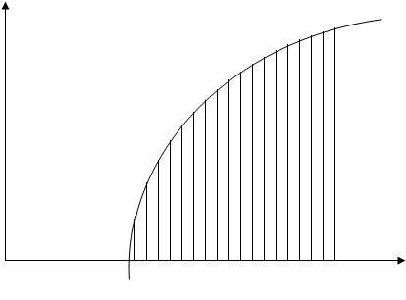
y
y = ln x
1
3

l
'

Q.21 Maximize Z = 2x + 3y subject to the constraints 3x + 4y 12, 2x + y 4, 2x – y 4, x 0, y 0 (8)

Q.22 Find the equation of a tangent to the parabola y² = -6x which is parallel to the line 2x + y + 1 = 0. Also find the tangency. (8)

____________________

Page 3 of 3
Federal Board HSSC – II Examination
Mathematics – Mark Scheme

SECTION A

Q.1
i. B ii. C iii. C
iv. B v. B vi. A
vii. C viii. C ix. D
x. A xi. C xii. D
xiii. B xiv. B xv. A
xvi. C xvii. B xviii. B
xix. D xx. C
(20 1 = 20)

SECTION B

Q.2 (4)
$\begin{matrix}\text{Limit} \\ x→0\end{matrix} \frac{\sqrt{x+a}−\sqrt{a}}{x} \left(\frac{0}{0}\right)$ (1 mark)
$\begin{matrix}\text{Limit} \\ x→0\end{matrix} \frac{\sqrt{x+a}−\sqrt{a}}{x}×\frac{\sqrt{x+a}+\sqrt{a}}{\sqrt{x+a}+\sqrt{a}}$ (1 mark)
$\begin{matrix}\text{Limit} \\ x→0\end{matrix} \frac{x+a−a}{x\sqrt{x+a}+\sqrt{a}}$
$\begin{matrix}\text{Limit} \\ x→0\end{matrix} \frac{x}{x(\sqrt{x+a}+a)}$ (1 mark)
$= \frac{1}{\sqrt{0+a}+\sqrt{a}} =\frac{1}{2\sqrt{a}}$ (1 mark)

Q.3 (4)
L.H. Limit
$\begin{matrix}\text{Limit} \\ y→\overline{3}\end{matrix} f(y) = \begin{matrix}\text{Limit} \\ y→\overline{3}\end{matrix} y−1$
= 3 – 1 = 2 (I) (1 mark)

R.H. Limit
$\begin{matrix}\text{Limit} \\ y→3^{+}\end{matrix} \text{fy} = \begin{matrix}\text{Limit} \\ y→3^{+}\end{matrix}2 y+1$
= 6 + 1 = 7 (II) (1 mark)
Direct Limit
Put y = 3
f(y) = 2y + 1
f(3) = 2(3) + 1 = 7 (III) (1 mark)
From I, II & III L.H. Limit ≠ R.H. Limit = Direct Limit
So f(y) is not continuous at y = 3 (1 mark)

Q.4 (4)
$y=\text{tan}(2{\text{tan}}^{−1}\frac{x}{2})$
${\text{tan}}^{−1}y=2{\text{tan}}^{−1}x2$ (1 mark)
Diff w.r.t. x
$\frac{1}{1+y^{2}}\frac{\text{dy}}{\text{dx}}=2\text{.}\frac{2}{1+\frac{x^{2}}{4}}\text{.}\frac{1}{2}$ (2 marks)
$\frac{\text{dy}}{\text{dx}}=\frac{4(1+y^{2})}{4+x^{2}}$ (1 mark)

Q.5 (4)
Let y = log_{a}x
y + Δy = log_{a}(x + Δx)
Δy = log_{a}(x + Δx) – log_{a}x (1 mark)
Δy = log_{a}$\left(\frac{x+Δx}{x}\right)=\text{log}\left(1+\frac{Δx}{x}\right)$
$\frac{Δy}{Δx}=\frac{1}{x}\frac{x}{Δx}\text{log}\left(1+\frac{Δx}{x}\right)$ (1 mark)
$\frac{Δy}{Δx}=\frac{1}{x}{\text{log}}_{a}{\left(1+\frac{Δx}{x}\right)}^{xΔx}$ (1 mark)
$\begin{matrix}\text{Limit} \\ Δx→0\end{matrix}\frac{Δy}{Δx}=\frac{1}{x}{\text{log}}_{a}\left[\begin{matrix}\text{Limit} \\ Δx→0\end{matrix}{\left(1+\frac{Δx}{x}\right)}^{xΔx}\right]$
$\frac{\text{dy}}{\text{dx}}=\frac{1}{x}{\text{log}}_{a}e$ (1 mark)

Q.6 (4)
$y=8x+\frac{1}{2x^{2}}$
$y=8x+\frac{1}{2}x^{−2}$
Difference with reference to x
$\frac{\text{dy}}{\text{dx}}=8+\frac{1}{2}(−2x^{−3})$
$\frac{\text{dy}}{\text{dx}}=8−\frac{1}{x^{3}},\text{Put} \frac{\text{dy}}{\text{dx}}=0$ (1 mark)
$8−\frac{1}{x^{3}}=0⇒8=\frac{1}{x^{3}}$
$x^{3}=\frac{1}{8}⇒x=\frac{1}{2}$ (1 mark)
$$\frac{\text{dy}}{\text{dx}}=8−x^{−3}$$
Difference again
$\frac{d^{2y}}{{\text{dx}}^{2}}=3x^{−4}=\frac{3}{x^{4}}$
$\frac{d^{2y}}{{\text{dx}}^{2}}|=\frac{3}{{\left(\frac{1}{2}\right)}^{4}}=3×\text{16}=\text{48}>0$ (1 mark)
$$x=\frac{1}{2}$$
So y will be minimum at $x=\frac{1}{2}$
Put $x=\frac{1}{2}$ = y
$y=8\left(\frac{1}{2}\right)+\frac{1}{2\left(\frac{1}{4}\right)}=4+2=6$ (1 mark)

Q.7 (4)
$\int_{2}^{K}{6(1−x)^{2}\text{dx}=\text{52}}$
${\left|\frac{6(1−x)^{3}}{−3}\right|}_{2}^{K}=\text{52}$ (1 mark)
$−2(1−x^{3})|_{2}^{K}=\text{52}$
$(1−x^{3})|_{2}^{K}=−\text{26}$ (1 mark)
(1–K)³ – (1–2)³ = –26
(1–K)³ + 1 = –26
(1–K)³ = –27 (1 mark)
1–K = –3 $⇒$ K = +4 (1 mark)

Q.8 (4)
y = 4–x²
Put y = 0 $⇒$ 4–x² = 0 x = ±2 (1 mark)
A = $\int_{−2}^{2}{\text{ydx}}$
A = $\int_{−2}^{2}{(4−x^{2})\text{dx}}=4\int_{−2}^{2}{\text{dx}}−\int_{−2}^{2}{x^{2}\text{dx}}$
A = $4{\left[x\right]}_{−2}^{2}−{\left[\frac{x^{3}}{3}\right]}_{−2}^{2}$ (1 mark)
A = $4\left[2+2\right]−13\left[8+8\right]$
A = $\text{16}−\frac{\text{16}}{3}$
A = $\frac{\text{48}−\text{16}}{3}$ (1 mark)
A = $\frac{\text{32}}{3}$ Square Units (1 mark)

Q.9 (4)
$\frac{y}{x}−\text{ln} x=\text{ln} c$
y – x ln x=x ln c (1 mark)
Taking Differential
$\text{dy}−\text{dx} \text{ln} x−x1x\text{dx}=\text{dx} \text{ln} c$ (1 mark)
dy = dx ln c + dx ln x + dx
dy = dx [ln c + ln x + 1] (I) (1 mark)
Dividing by dx by (I)
$\frac{\text{dy}}{\text{dx}}=\text{ln} c+\text{ln} x+1$ (1 mark)

Q.10 (4)
2x – 3y – 1 = 0
3x – y – 5 = 0
3x + Ky + 8 = 0
Since lines are concurrent so the det. of their coeff. will be zero (1 mark)
$\left|\begin{matrix}2 & −3 & −1 \\ 3 & −1 & −5 \\ 3 & K & 8\end{matrix}\right|=0$ (1 mark)
Exp. by R₁
2(-8+5K)+3(24+15)-1(3K+3) = 0
-16+10K+117-3K-3 = 0
7K+98 = 0
K = -14 (2 marks)

Q.11 (4)
Line is perpendicular to AB & A(3, 5) B(9, 8)
mid point of AB = (6, $\frac{\text{13}}{2})$ (1 mark)
slope of AB = m₁ = $\frac{y_{2}−y_{1}}{x_{2}−x_{1}}$
m₁ = $\frac{8−5}{9−3}$
m₁ = $36=12$ (1 mark)
Line perpendicular to AB has slope, m₂ = -2
Required line passes through (6, $\frac{\text{13}}{2})$ So its equation is:
y–y₁ = m(x–x₁) (1 mark)
$y−\frac{\text{13}}{2}=−2(x−6)$
2y–13 = –4(x–6)
2y–13 = –4x+24
4x+2y–37 = 0 (1 mark)

Q.12 (4)
x²+y² = 26 (I)
2x+3y = 13 (II)
From (II) x = $\frac{\text{13}−3y}{2}$ putting in (I)
${\left(\frac{\text{13}−3y}{2}\right)}^{2}+y^{2}=\text{26}$
169+9y²-78y+y² = 104
13y²-78y+65 = 0 (1 mark)
$$\text{by} \text{13}, y^{2}−6y+5=0$$
y²-5y-y+5 = 0
y(y-5)-1(y-5) = 0
(y-1)(y-5) = 0
y = 5, y = 1 (1 mark)
when y = 5, then x = -1 So A(-1, 5)
when y = 1, then x = 5 So B(5, 1) (1 mark)
AB is chord its mid point is
$$= \left(\frac{x_{1}+x_{2}}{2},\frac{y_{1}+y_{2}}{2}\right)$$
$=\left(\frac{−1+5}{2}, \frac{5+1}{2}\right)$
= (2, 3) (1 mark)

Q.13 (4)
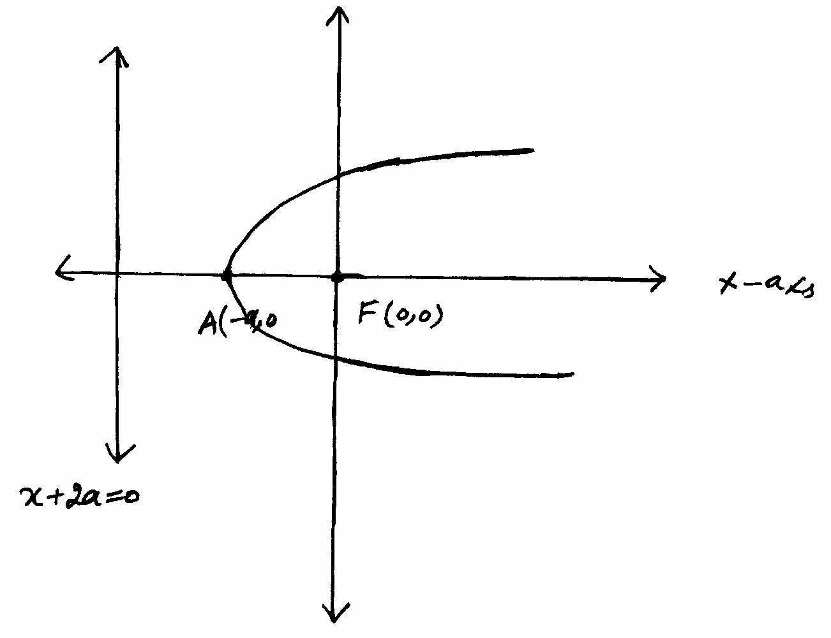
(1 mark)
According to problem F(0, 0) and directrix is x+2a = 0
Let P(x, y) be any point on parabola so (1 mark)
$\left|\text{PF}\right|=\left|\text{PM}\right|$
$\sqrt{(x−0)^{2}+(y−0)^{2}}=\frac{\left|x+2a\right|}{\sqrt{(1)^{2}+(0)^{2}}}$ (1 mark)
Seq on both sides
x²+y² = (x+2a)²
$x^{2}+y^{2}=x^{2}+4\text{ax}+4a^{2}$
y²= 4a(x+a) (1 mark)

Q.14 (4)

F(5, 0) $F^{'}$(-5, 0)  $$2c=\left|\text{FF}\right|$$  $$2c=\sqrt{(\text{10})^{2}+(0)^{2}}$$  $$2c=\text{10}$$  $$c=5$$ | A(3, 0) $A^{'}$(-3, 0)  $$2a=\left|\text{AA}\right|$$  $$2a=6$$  $$a=3$$
(1 mark)
We have
b² = c² – a²
b² = 25 – 9
b² = 16
b = 4 (1 mark)
Hyberbola is along x – axis and its centre is at (0, 0) so its equation is (1 mark)
$\frac{x^{2}}{a^{2}}−\frac{y^{2}}{b^{2}}=1$
$\frac{x^{2}}{9}−\frac{y^{2}}{\text{16}}=1$ (1 mark)

Q.15 (4)
Let $\underline{r}=x\underline{i}+y\underline{i}+z\underline{k}$,
$\left|\underline{r}\right|=\sqrt{x^{2}+y^{2}+z^{2}}$ (1 mark)
Then $\frac{\underline{r}}{\left|r\right|}=\left[\frac{x}{r},\frac{y}{r},\frac{z}{r}\right]$ is unit vector in the direction of $\underline{γ}=\overline{\text{OP}}$ (1 mark)
It is supposed that OAP is right angled length
So $\text{Cos}∝\frac{\text{OA}}{\text{OP}}⇒\text{Cos}∝\frac{x}{r}$
$\text{Cos}β=\frac{y}{r}, \text{Cos}γ=\frac{z}{r}$ (1 mark)
Since Cos, Cosβ, Cosγ are called direction cosins of OP. So
Cos²+Cos²β+Cos²γ = $\frac{x^{2}}{r^{2}}+\frac{y^{2}}{r^{2}}+\frac{z^{2}}{r^{2}}$
= $\frac{x^{2}+y^{2}+z^{2}}{r^{2}}$
= $\frac{r^{2}}{r^{2}}$
= 1 (1 mark)

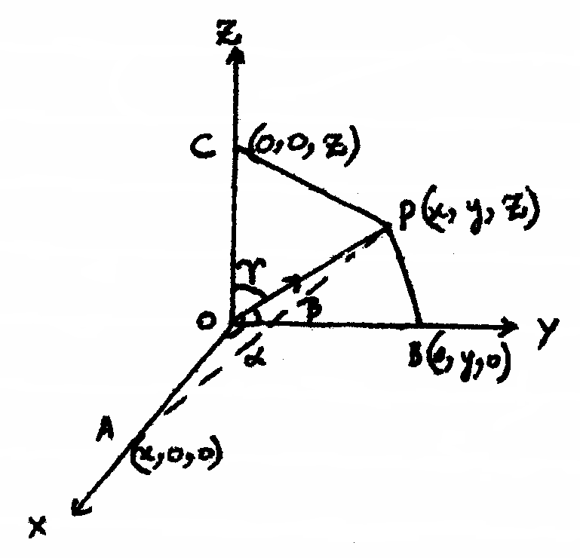 | 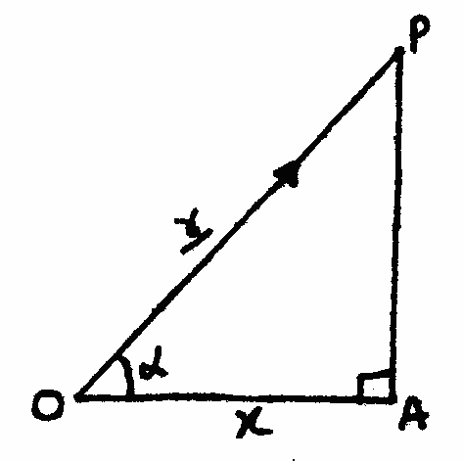

SECTION C

Q.16 (8)
x = Sin2x
Let y = x = Sin2x
y = x, y = Sin2x
y = x is a straight line passing through origin and bisecting Ist & IIIrd quad:
(1 mark)
x | 0° | 15° | 30° | 45° | 60° | 75° | 90° | -90° | -75° | -60° | -45° | -30° | -15°
y | 0 | 0.5 | 0.86 | 1 | 0.86 | 0.5 | 0 | 0 | -0.5 | -0.8 | -1 | -0.86 | -0.5
(4 marks)

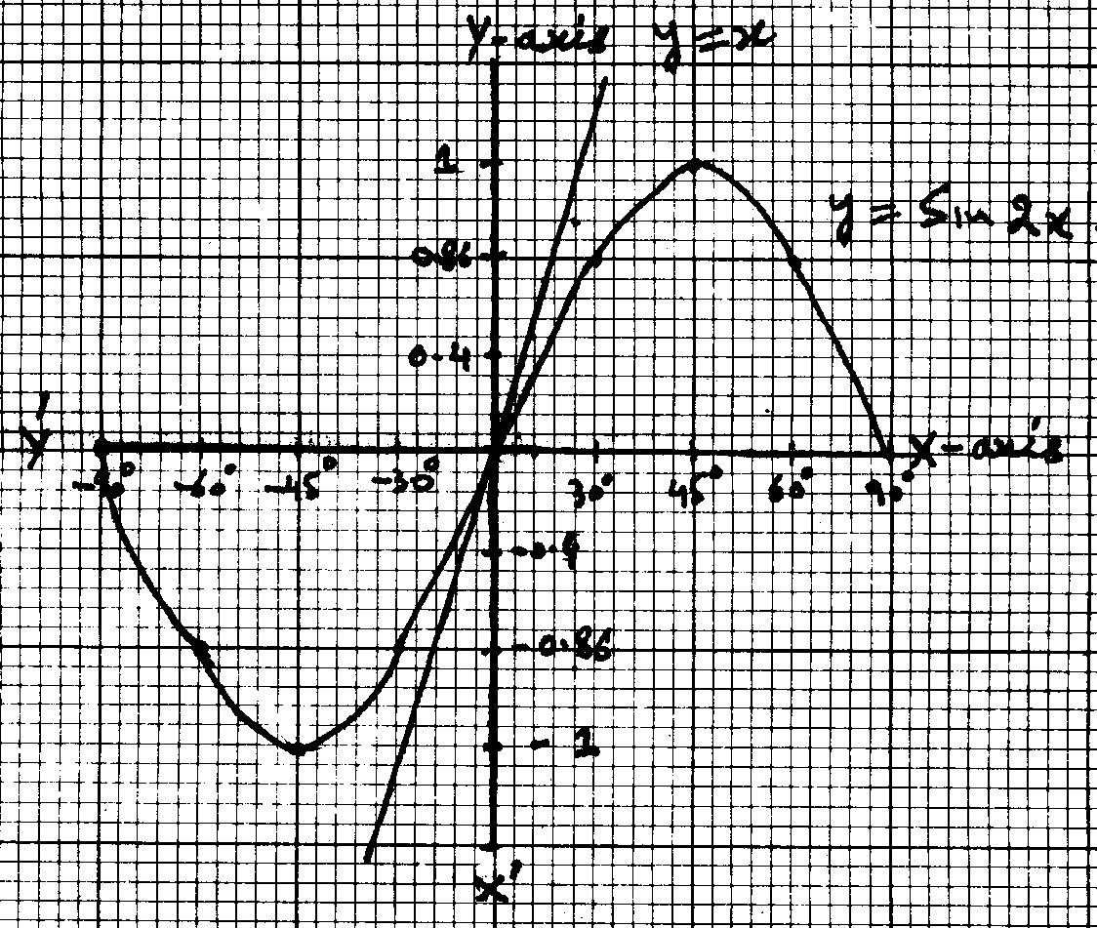
(1 mark)

These two graphs intersect at origin
so x = 0, y = 0 is only solution set (1 mark)

Q.17 (8)
y = a Cos(ln x) + b Sin(ln x)
Diff w.r.t.
$\frac{\text{dy}}{\text{dx}}=a(−\text{Sin} \text{ln} x)\frac{1}{x}+b \text{Cos}(\text{ln} x)\frac{1}{x}$
$\frac{\text{dy}}{\text{dx}}=\frac{1}{x}(b \text{Cos} \text{ln} x−a \text{Sin} \text{ln} x)$ (3 marks)
Diff w.r.t. x again:
$\frac{d^{2}y}{{\text{dx}}^{2}}=\frac{−1}{x^{2}}[b \text{Cos}(\text{ln} x)−a \text{Sin}(\text{ln} x)]+\frac{1}{x}[−b \text{Sin}(\text{ln} x)−a \text{Cos}(\text{ln} x)\frac{1}{x}]$
$=\frac{−1}{x^{2}}[b \text{Cos}(\text{ln} x)−a \text{Sin}(\text{ln} x)+b \text{Sin}(\text{ln} x)+a \text{Cos}(\text{ln} x]$ (3 marks)
Now
$x^{2}\frac{d^{2}y}{{\text{dx}}^{2}}+x\frac{\text{dy}}{\text{dx}}+y=0$
$\begin{aligned}−b \text{Cos}(\text{ln} x)+a \text{Sin}(\text{ln} x)−b \text{Sin}(\text{ln} x)−a \text{Cos}(\text{ln} x)+b \text{Cos} \text{ln} x−a \text{Sin} \text{ln} x \\ +a \text{Cos}(\text{ln} x)+b \text{Sin} \text{ln} x=0\end{aligned}$
Proved: 0 = 0 (2 marks)

Q.18 (8)
y = ax + b (I)
y = 2x–6 (II)
Comparing I&II, a = 2
y = 2x + b, line passing through (-1, 7)
7 = -2 + b $⇒$ b = 9
Hence req. line is y = 2x + 9 (4 marks)
Given that $\frac{x}{3}−y=7$
x-3y = 7
Slop of line m = $\frac{−1}{−3}$
m = $\frac{1}{3}$
Slop of line perpendicular is ‘-3’, line passing through (7, -1) then eq of line is
y – y₁ = m(x – x₁)
y + 1 = -3(x – 7)
y + 1 = -3x + 21
3x + y – 20 = 0 (4 marks)

Q.19 (8)
Given that
$\underline{a}+\underline{b}+\underline{c}=0$
Taking cross mult with $\underline{a}$
$\underline{a}×(\underline{a}+\underline{b}+\underline{c})=0$
$\underline{a}×\underline{a}+\underline{a}×\underline{b}+\underline{a}×\underline{c}=0$
$\underline{a}×b=−(\underline{a}×\underline{c})$
$\underline{a}×\underline{b}=\underline{c}×\underline{a}$ (I) (4 marks)
Let
$\underline{a}+\underline{b}+\underline{c}=0$

Taking $\underline{b}$cross mult
$\underline{b}×(\underline{a}+\underline{b}+\underline{c})=0$
$\underline{b}×\underline{a}+\underline{b}×\underline{b}+\underline{b}×\underline{c}=0$
$\underline{b}×\underline{c}=−(\underline{b}×\underline{a})$
$\underline{b}×\underline{c}=\underline{a}×\underline{b}$ (II)
From (I) & (II) $\underline{a}×\underline{b}=\underline{b}×\underline{c}=\underline{c}×\underline{a}$ (4 marks)

Q.20 (8)
$\frac{d}{\text{dx}}\left[x \text{ln} x−x\right]=\text{ln} x$
L.H.S
$\frac{d}{\text{dx}}\left[x \text{ln} x−x\right]$
$\text{ln} x+x\text{.}1x−1=\text{ln} x=\text{RHS}$ (2 marks)
Now
$\text{ln} x=\frac{d}{\text{dx}}(x \text{ln} x−x)$
$\int{\text{ln} x \text{dx}=\int{\frac{d}{\text{dx}}}(x \text{ln} x−x)\text{dx}}$
$\int{\text{ln} x \text{dx}=x \text{ln} x−x+c}$ (2 marks)
$\int_{1}^{3}{\text{ln} x \text{dx}={\left[x \text{ln} x−x\right]}_{1}^{3}}$ (1 mark)
= (3ln3-3) – (1ln1-1)
= xln3 – 3 + 1
= 3ln3 – 2 (3 marks)

Q.21 (8)
Z = 2x + 3y subject to:
3x + 4y ≤ 12, 2x + y ≤ 4, 2x – y ≤ 4, x ≥ 0, y ≥ 0
Associated eq. are
3x + 4y = 12 (I)
2x + y = 4 (II)
2x – y = 4 (III)
x = 0, y = 0 (1 mark)
X Intercept of I put y = 0 $⇒$ x = 4 A(4, 0)
Y Intercept of I put x = 0 $⇒$ y = 3 B(0, 3)
Put (0, 0) in given inequality 0 < 12 so solution region lies towards origin.
X Intercept of II put y = 0 $⇒$ x = 2 C(2, 0)
Y Intercept of II put x = 0 $⇒$ y = 4 D(0, 4)
Put (0, 0) so 0 < 12 soln region towards origin.
X Intercept of III put y = 0 $⇒$ x = 2 E(2, 0)
Y Intercept of I put x = 0 $⇒$ y = -4 F(0, -4) (3 marks)
Put (0, 0) solution region towards origin as 0 < 12 x ≥ 0 & y ≥ 0 lies on 1st quad.
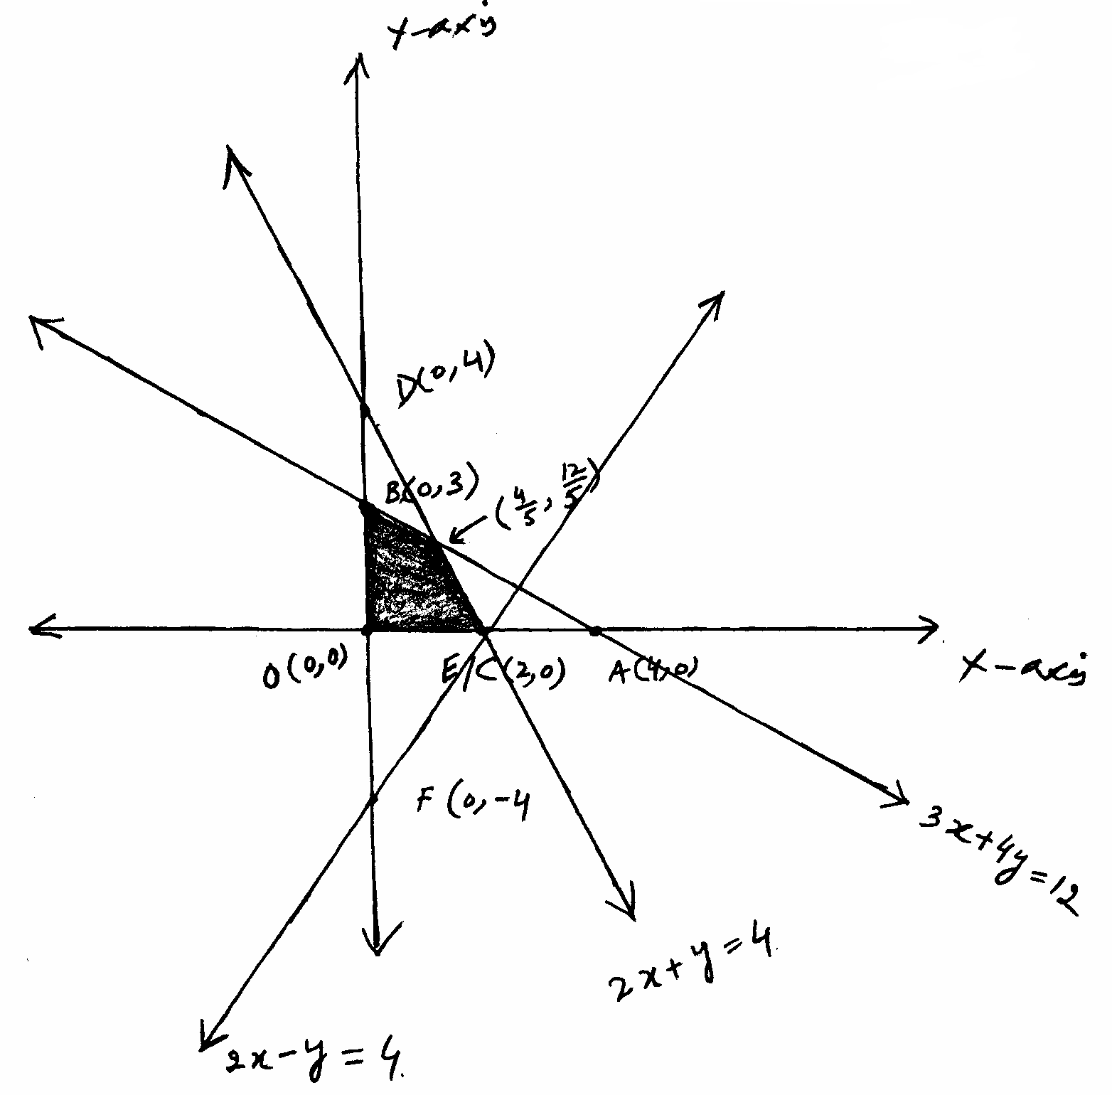
(2 marks)
So corner points are (0, 3) (0, 0) (2, 0) and $\left(45, \text{12}5\right)$

3x + 4y = 12
_ 8x + 4y =_16
-5x = -4
x = $45$ Put in (II)
$85+y=4$
y = $4−85⇒\text{12}5$ (1 mark)
f(x, y) | 2x + 3y
(0, 0) | 0 + 0 = 0
(0, 3) | 0 + 9 = 9
(2, 0 ) | 4 + 0 = 4
$$\left(\frac{4}{5},\frac{\text{12}}{5}\right)$$ | $$\frac{8}{5}+\frac{\text{36}}{5}=\frac{\text{44}}{5}=8\text{.}8$$
So Z = 2x + 3y is maximum at (0, 3) (1 mark)

Q.22 (8)
y² = -6x & 2x + y + 1 = 0
Slope of required line = -2 = m (1 mark)
In parabola
y² = -6x
a = $−64=−32$ (1 mark)
Eq of Tangent to parabola
y = $\text{mx}+\frac{a}{m}$ (1 mark)
y = $−2x+\frac{−32}{−2}⇒y=\frac{−8x+3}{4}$
8x + 4y – 3 = 0 Req. Eq (1 mark)
Put y = $\frac{−8x+3}{4}$ in y² = -6x
${\left(\frac{−8x+3}{4}\right)}^{2}=−6x$
$\frac{\text{64}x^{2}−\text{48}x+9}{\text{16}}=−6x⇒\text{64}x^{2}+\text{48}x+9=0$
$(8x+3)^{2}=0⇒x=−38$ (3 marks)
Putting the value of x in y = $\frac{−8x+3}{4}$
$y=\frac{−8\left(−38\right)+3}{4}$
$y=\frac{3}{2}$ (1 mark)
Hence point of Tangency is $\left(−38,32\right)$ (1 mark)

