SCHEME OF STUDIES
FOR HSSC (CLASSES XI–XII)

COMPULSORY FOR ALL (500 marks)
1. English (Compulsory)/ English (Advance) 2 papers 200 marks

2. Urdu (Compulsory)/ Urdu Salees In lieu of Urdu 2 papers 200 marks
(Compulsory)/ Pakistan Culture for Foreign
Students Part – I and Pakistan Culture Paper-II

3. Islamic Education/Civics (for Non-Muslims) 1 paper 50 marks

4. Pakistan Studies 1 paper 50 marks

SCIENCE GROUP (600 marks)
The students will choose one of the following (A), (B) and (C) Groups carrying 600 marks:

(A) Pre-Medical Group:
Physics, Chemistry, Biology

(B) Pre-Engineering Group:
Physics, Chemistry, Mathematics

(C) Science General Group:
1. Physics, Mathematics, Statistics
2. Mathematics, Economics, Statistics
3. Economics, Mathematics, Computer Science
4. Physics, Mathematics, Computer Science
5. Mathematics, Statistics, Computer Science

HUMANITIES GROUP (600 marks)
Select three subjects of 200 marks each from the following:
S. No. | Subject | S. No. | Subject
1. | Arabic/Persian/French/English (Elective)/Urdu (Elective) | 10.  11. | Sindhi (Elective)  Civics
2. | Economics | 12. | Education
3. | Fine Arts | 13. | Geography
4. | Philosophy | 14. | Sociology
5. | Psychology | 15. | Mathematics
6. | Statistics | 16. | Computer Science
7. | History of Modern World/Islamic History/ History of Muslim India/ History of Pakistan | 17.  18. | Islamic Culture  Library Science
8. | Islamic Studies | 19. | Outlines of Home Economics
9. | Health and Physical Education | 19. | Outlines of Home Economics

COMMERCE GROUP (600 marks)

HSSC – I
1. Principles of Accounting paper – I 100 marks
2. Principles of Economics paper – I 75 marks
3. Principles of Commerce paper – I 75 marks
4. Business Mathematics paper – I 50 marks

HSSC – II
1. Principles of Accounting paper – II 100 marks
2. Commercial Geography paper – II 75 marks
3. Computer Studies/Typing/Banking paper – II 75 marks
4. Statistics paper – II 50 marks

MEDICAL TECHNOLOGY GROUP (600 marks each)
1. Medical Lab Technology Group
2. Dental Hygiene Technology Group
3. Operation Theater Technology Group
4 Medical Imaging Technology Group
5. Physiotherapy Technology Group
6. Ophthalmic Technology Group

AIMS AND OBJECTIVES OF EDUCATION POLICY
(1998 – 2010)

AIMS

Education is a powerful catalyzing agent which provides mental, physical, ideological and moral training to individuals, so as to enable them to have full consciousness of their mission, of their purpose in life and equip them to achieve that purpose. It is an instrument for the spiritual development as well as the material fulfillment of human beings. Within the context of Islamic perception, education is an instrument for developing the attitudes of individuals in accordance with the values of righteousness to help build a sound Islamic society.

After independence in 1947 efforts were made to provide a definite direction to education in Pakistan. Quaid-i-Azam Muhammad Ali Jinnah laid down a set of aims that provided guidance to all educational endeavours in the country. This policy, too has sought inspiration and guidance from those directions and the Constitution of Islamic Republic of Pakistan. The policy cannot put it in a better way than the Quaid’s words:

“You know that the importance of Education and the right type of education, cannot be overemphasized. Under foreign rule for over a century, sufficient attention has not been paid to the education of our people and if we are to make real, speedy and substantial progress, we must earnestly tackle this question and bring our people in consonance with our history and culture, having regard for the modern conditions and vast developments that have taken place all over the world.”

“There is no doubt that the future of our State will and must greatly depend upon the type of education we give to our children, and the way in which we bring them up as future citizens of Pakistan. Education does not merely mean academic education. There is immediate and urgent need for giving scientific and technical education to our people in order to build up our future economic life and to see that our people take to science, commerce, trade and particularly well-planned industries. We should not forget, that we have to compete with the world which is moving very fast towards growth and development.”

“At the same time we have to build up the character of our future generation. We should try, by sound education, to instill into them the highest sense of honour, integrity, responsibility and selfless service to the nation. We have to see that they are fully qualified and equipped to play their part in various branches of national life in a manner which will do honour to Pakistan.”

These desires of the Quaid have been reflected in the Constitution of the Islamic Republic of Pakistan and relevant articles are:

The state shall endeavour, in respect of the Muslims of Pakistan:
- to make the teachings of the Holy Quran and Islamiat compulsory and encourage and facilitate the learning of Arabic language to secure correct and exact printing and publishing of the Holy Quran;

- to promote unity amongst them and the observance of Islamic moral standards;

Provide basic necessities of life, such as food, clothing, housing, education and medical relief for all such citizens irrespective of sex, caste, creed or race as are permanently or temporarily unable to earn their livelihood on account of infirmity, sickness or unemployment;

Remove illiteracy and provide free and compulsory secondary education within minimum possible period.

Enable the people of different areas, through education, training, agricultural and industrial development and other methods, to participate fully in all the forms of national activities including employment in the service of Pakistan;

The State shall discourage parochial, racial, tribal, sectarian and provincial prejudices among the citizens.

Reduce disparity in the income and earnings of individuals, including persons in various classes of the service of Pakistan.

Steps shall be taken to ensure full participation of women in all the spheres of national life.

The vision is to transform Pakistani nation into an integrated, cohesive entity, that can compete and stand up to the challenges of the 21st Century. The Policy is formulated to realize the vision of educationally well-developed, politically united, economically prosperous, morally sound and spiritually elevated nation.

OBJECTIVES

To make the Qur’anic principles and Islamic practices as an integral part of curricula so that the message of the Holy Quran could be disseminated in the process of education as well as training. To educate and train the future generation of Pakistan as true practicing Muslims who would be able to usher in the 21st century and the next millennium with courage, confidence, wisdom and tolerance.

To achieve universal primary education by using formal and informal techniques to provide second opportunity to school drop-outs by establishing basic education community schools all over the country.

To meet the basic learning needs of a child in terms of learning tools and contents.

To expand basic education qualitatively and quantitatively by providing the maximum opportunities to every child of free access to education. The imbalances and disparities in the system will be removed to enhance the access with the increased number of more middle and secondary schools.

To ensure that all the boys and girls, desirous of entering secondary education, get their basic right through the availability of the schools.

To lay emphasis on diversification of curricula so as to transform the system from supply-oriented to demand oriented. To attract the educated youth to world-of-work from various educational levels is one of the policy objectives so that they may become productive and useful citizens and contribute positively as members of the society.

To make curriculum development a continuous process; and to make arrangements for developing a uniform system of education.

To prepare the students for the world of work, as well as pursuit of professional and specialized higher education.

To increase the effectiveness of the system by institutionalizing in-service training of teachers, teacher trainers and educational administrators. To upgrade the quality of pre-service teacher training programmes by introducing parallel programmes of longer duration at post-secondary and post-degree levels.

To develop a viable framework for policy, planning and development of teacher education programmes, both in-service and pre-service.

To develop opportunities for technical and vocational education in the country for producing trained manpower, commensurate with the needs of industry and economic development goals.

To improve the quality of technical education so as to enhance the chances of employment of Technical and Vocational Education (TVE) graduates by moving from a static, supply-based system to a demand-driven system.

To popularize information technology among students of all ages and prepare them for the next century. To emphasize different roles of computer as a learning tool in the classroom learning about computers and learning to think and work with computers and to employ information technology in planning and monitoring of educational programmes.

To encourage private sector to take a percentage of poor students for free education.

To institutionalize the process of monitoring and evaluation from the lowest to the highest levels. To identify indicators for different components of policy, in terms of quality and quantity and to adopt corrective measures during the process of implementation.

To achieve excellence in different fields of higher education by introducing new disciplines/emerging sciences in the universities, and transform selected disciplines into centres of advanced studies, research and extension.

To upgrade the quality of higher education by bringing teaching, learning and research process in line with international standards.
OBJECTIVES OF GEOGRAPHY SYLLABUS

- To emphasize leaning in a way that encourages comprehension, observation, creativity, questioning, application and evaluation skills.
- To create an understanding of the key concepts, ideas, principles, nature and spirit in relation to physical and human activities.
- To provide an understanding and appreciation of the interrelationship between physical environment and human activities and conceptual clarification of man environment system.
- To inculcate in students the qualities of national character, love for country, and sense of national unity, integrity and gratitude to Almighty Allah for having exemplary physical and human resources.
- To provide understanding of the basic geographical character of locality/society and day to day problems faced by human beings in which they live.
- To develop and understanding of physical and human geography through systematic study of various content matter.
- To develop comprehension of interpreting data presented in various forms i.e. models, charts, illustrations, statistics, maps, diagrams, atlas extracts and written materials.
- To improve the abilities of students in practical geographical skills.
- To enhance a positive attitude towards Geography discipline as an intellectual subject relevant to every day life.

SPECIFIC LEARNING OBJECTIVES, TOPIC, SCOPE AND LEARNING OUTCOMES OF GEOGRAPHY SYLLABUS

Specific Learning Objectives | Topics | Scope | Learning Outcomes
I. The Geography of the Continents
1. Create awareness about the salient features of continents | 1. Asia  2. Europe  3. Africa  4. North America  5. South America  6. Antarctica  7. Australia | The Geography of all the Continents with respect to following:  1. Position and extent  2. Area  3. Relief  4. Climate  5. Natural Vegetation  6. Population | 1. Discuss the Geography of all the continents with reference to position & extent. Physical features, Population distribution climate and natural vegetation with specific reference to their effects on human life.
II. Economic Geography of the following Countries
1. Promote comprehension about the various aspects of economic geography of Pakistan, China, Saudi Arabia and Untied States | 1. Pakistan  2. China  3. Saudi Arabia  4. U.S.A. | Economic geography of the countries with respect to:  1. Location  2. Population  3. Agriculture  4. Minerals  5. Power resources  6. Industries  7. Trades | 1. Discuss the economic geography of Pakistan, China, Saudi Arabia and U.S.A. in relation to location demographic aspects and various resources
III. Population Geography
1. Enhance an understanding of the various aspects of Population Geography | 1. Introduction  2. The distribution and density of Population  3. Population growth  4. Some Population characteristics  5. Migration | 1. Meaning  2. Significance  3. The factors affecting distribution and density of Population  4. Meaning of Population growth  5. Population growth in relation to resources and their development  6. Some population characteristics (with reference to Pakistan)  7. Age and gender structures  8. Rural and Urban composition  9. Migration  10. The geographical implications of migration | 1. Describe the nature and significance of Population Geography  2. Discuss distribution and density of Population  3. Explain the factors affecting distribution and density of population  4. Describe the nature of population growth  5. Discuss the resources and their development effects population growth  6. Discuss some population characteristics such as Age & gender structures, rural and Urban composition  7. Describe the geographical impact of migration
IV. The Environment
1. Promote an understanding of the environmental problems of Pakistan | 1. Introduction  2. Some Basic Environmental Problems of Pakistan | 1. Meaning of Environment  2. Inter-relationship between people and their Environmental with reference to Pakistan  3. Resource management and conservation  4. Pollution  5. The Green House effect | 1. Discuss the interrelationship between the people and their environment in Pakistan  2. Discuss resource management and conservation  3. Discuss pollution, the Green House effect and the depletion of O Zone relation to human beings

GEOGRAPHY PRACTICALS

SECTION – II

1. Map Projection
- Basic concept of map projection
- Types of projection, characteristics and uses
- Identification of projection on atlas maps

2. Statistical Diagrams
- Line graph
- Bar Graph
- Pie-graph

3. Distribution Maps
- Shading Method
- Dot Method

4. Map Reading
- Topographical sheets, marginal information, identification of natural and cultural features

Note: The students are required to use sketches, maps and diagrams to illustrate the Geography of an area. They are also required to do exercises of drawing outline map of Pakistan and its provinces and general map reading; however the Globe, physical and political maps of the World, Asia, South Asia and Pakistan should be available in the classrooms.

ESSENTIALS FOR PRACTICAL

The following instruments and materials are essential for doing practical. These should be provided to schools/students, whatever possible.

Good pair of compass fitted with both pencil and pen points. The pencil points should be kept thin and round. |  | Drawing pen and Drawing Box  Ink and Graph Paper
Pencils-H and HB |  | Protector and Ruling Pen, Coloured Crayons or Paint Box.
Dividers, Erasers and ruler.

TEACHING STRATEGIES

The curriculum aims to encourage skills like observation, curiosity, creativity, questioning, application, etc. So the teaching methodology should be adopted in a way that it promotes the higher order skills. To achieve the purpose the following steps in teaching learning process should be kept in view:
- The teacher should plan their lesson keeping in view the objectives of the National Curriculum
- The active involvement of students is the key for successful delivery of the curriculum. So the purposeful learning group for discussion and assignment should be organized.
- The use of audio-visual aids should be organized properly. It should be the part and parcel of classroom activities.
- The National Curriculum is activity oriented. It demands that the teachers should consider the curriculum and other reference materials, keeping in view the following teaching strategies:
  - Investigative approach
  - Activity oriented approach
  - Student centered approach
  - Question/answer approach
  - Group discussions
  - Seminar
  - Role Play
  - Speeches/Debates

ASSESSMENT AND EVALUATION

Assessment, appraisal, or evaluation is a means of determining how far the objectives of the curriculum have been realized. What really matters is the methodology employed for such determination. As is now recognized, performance on the basis of content-oriented tests alone does not provide an adequate measure of a student’s knowledge and ability to use information in a purposeful or meaningful way; the implication, then, is that effective and rewarding techniques should be developed for evaluating the kind and content of teaching and learning that is taking place and for bringing about improvement in both. The following points, while developing the tests/questions may be kept in view:

1. Proper care should be taken to prepare the objective-type and constructed-response questions relating to knowledge, comprehension, application, analysis and synthesis, keeping in view the specific instructional objectives of the syllabus and the command words for the questions.

2. There should be at least two periodic/monthly tests in addition to routine class/tests. Teachers are expected to develop and employ assessment strategies which are dynamic in approach and diverse in design. When used in combination, they should properly accommodate every aspect of a student’s learning.

3. In addition to the final public examination, two internal examinations should be arranged during the academic year for each class.

4. Classroom examinations offer the best and most reliable evaluation of how well students have mastered certain information and achieved the course objectives. Teachers should adopt innovative teaching and assessment methodologies to prepare the students for the revised pattern of examination. The model papers, instructional objectives, definitions of cognitive levels and command words and other guidelines included in this book must be kept in view during teaching and designing the test items for internal examination.

DEFINITION OF COGNITIVE LEVELS

Knowledge:

This requires knowing and remembering facts and figures, vocabulary and contexts, and the ability to recall key ideas, concepts, trends, sequences, categories, etc. It can be taught and evaluated through questions based on: who, when, where, what, list, define, describe, identify, label, tabulate, quote, name, state, etc.

Understanding:

This requires understanding information, grasping meaning, interpreting facts, comparing, contrasting, grouping, inferring causes/reasons, seeing patterns, organizing parts, making links, summarizing, solving, identifying motives, finding evidence, etc. It can be taught and evaluated through questions based on: why how, show, demonstrate, paraphrase, interpret, summarize, explain, prove, identify the main idea/theme, predict, compare, differentiate, discuss, chart the course/direction, report, solve, etc.

Application:

This requires using information or concepts in new situations, solving problems, organizing information and ideas, using old ideas to create new one and generalizing from given facts, analyzing relationships, relating knowledge from several areas, drawing conclusions, evaluating worth, etc. It can be taught and evaluated through questions based on: distinguish, analyze, show relationship, propose an alternative, prioritize, give reasons for, categorize, illustrate, corroborate, compare and contrast, create, design, formulate, integrate, rearrange, reconstruct/recreate, reorganize, predict consequences etc.

DEFINITION OF COMMAND WORDS

The purpose of command words given below is to direct the attention of the teachers as well as students to the specific tasks that students are expected to undertake in the course of their subject studies. Same command words will be used in the examination questions to assess the competence of the candidates through their responses. The definitions of command words have also been given to facilitate the teachers in planning their lessons and classroom assessments.

Give an account of: Spell out a chronology and show in what ways the event or circumstance to be accounted for derives from or is dependent on earlier events.

Analyse: Go beyond the given information to relate and/or differentiate aspects of a situation and draw conclusions on the basis of evidence information.

Define: Provide a precise statement or meaning of words or terms to describe their nature, properties or essential qualities.

Demonstrate: Show or prove by evidence and/or argument.

Describe: Explain in words and/or diagrams (where necessary) to demonstrate knowledge of facts.

Discuss: Express views in a logical and lucid way considering all aspects of a matter under discussion and draw conclusions.

Explain: Give a clear and detailed account of related information with reasons or justification.

Give Examples/Statements: Cite specific instances or cases to demonstrate the occurrence of an event or existence of a situation or phenomenon.

Identify: Pick out, recognizing specified information from a given content, situation.

Illustrate: Give clear examples to state, clarify or synthesize a point of view.

Interpret: Clarify both the explicit meaning and the implications of given information.

List/Name: Name item-by-item, usually in one or two words, precise information such as dates, characteristics, places, names.

Locate: Determine the precise position or situation of an entity in a given context, e.g. in a map.

Show: Indicate by writing, drawing or through graphs/charts.

State: Give a brief and factual answer with no explanation.

Suggest: Apply knowledge in a given situation to give a rational opinion.

Trace the developments of: Mention, list, name information/facts in a sequence.

RECOMMENDED REFERENCE BOOKS

In contrast to the previous practice the examination will not be based on a single textbook, but will now be curriculum based to support the examination reforms. Therefore, the students and teachers are encouraged to widen their studies and teaching respectively to competitive textbooks and other available material.

Following books are recommended for reference and supplementary reading:

1. World Regional Geography
Written by: Nazeer Ahmad Khalid

2. Khatti Geographia (Dunia)
Written by: Riasat Ali Abbasi
Publishers: Capital Book Depot, Rawalpindi

3. Regional Geography
Written by: Goh
Publishers: FEP Series, Singapore

4. World Regional Geography
Written by: Prof Mian Anwar
Publishers: White Rose Publishers, Lahore

5. Physical Geography
Written by: Phillisdink

6. Physical Geography
Written by: FJ Monk House
Publishers: National Book Foundation, Islamabad

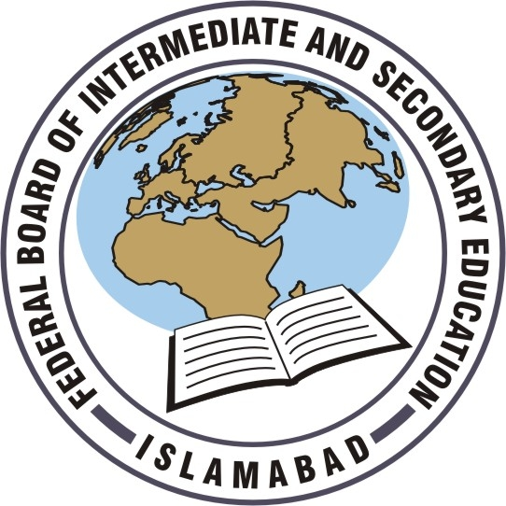
Federal Board HSSC-II Examination  Geography Model Question Paper | Roll No:  Answer Sheet No: ____________  Signature of Candidate: ___________  Signature of Invigilator: ___________

SECTION – A

Time allowed: 20 minutes Marks: 17

Note: Section-A is compulsory and comprises pages 1-4. All parts of this section are to be answered on the question paper itself. It should be completed in the first 20 minutes and handed over to the Centre Superintendent. Deleting/overwriting is not allowed. Do not use lead pencil.

Q.1 Insert the correct option i.e. A/B/C/D in the empty box opposite each part. Each part carries one mark.

i. The Rockies serve as a watershed for rivers that flow:

A. Westward to the pacific
B. Westward to the pacific and eastward to the central land
C. Northward
D. Northward and southward

ii. What approximately is the Population of the World?

A. 6 billion
B. 4 billion
C. 10 billion
D. 8 billion

iii. Which of the two seas/oceans are connected by Suez Canal?

A. Pacific ocean and Arabian Sea
B. Pacific ocean and Atlantic Sea
C. Black sea and Mediterranean Sea
D. Red sea and Mediterranean Sea

Page 1 of 4 Turn Over

DO NOT WRITE ANYTHING HERE

iv. When do flash floods occur in Saudi Arabia?

A. March and April
B. June and July
C. Winter months
D. September and October

v. Warm ocean currents which have a strong influence on the climate of South Asia flow along its:

A. Western coast
B. Eastern coast
C. Western and eastern coast
D. North eastern coast

vi. China is the second largest producer of tea in the world but is not the largest exporter because:

A. It has a large population
B. It has a high internal consumption
C. International market does not favour it
D. India has captured the world market

vii. What is the cause of marshlands in Siberia?

A. Poor drainage
B. High ground water level
C. Freezing northbound river
D. Soft soil in depression

Page 2 of 4 Turn Over
viii. Canadian Shield has a lot of minerals because it is composed of:

A. Old rocks
B. Folded mountains
C. Deserts
D. Sedimentary rocks

ix. What was Africa called the Dark Continent?
Due to:

A. Lack of illiteracy
B. Presence of Negroes
C. Lack of sunlight
D. Thick forests

x. Which of the following continents has greater longitudinal extent?

A. Africa
B. Europe
C. Asia
D. South America

xi. Which of the continents is Rift Valley a prominent earth feature of?

A. Europe
B. South America
C. Australia
D. Africa

xii. Where is the largest Rain forest situated?

A. Amazon Basin
B. Murray Daily Basin
C. Cargo Basin
D. Mekong Basin

xiii. Tsunami did not affect Pakistan due to her:

A. Location
B. Wind direction
C. Distance from the Epicenter
D. Altitude

Page 3 of 4 Turn Over
xiv. Which is the most densely populated zone of the world?

A. Temperate
B. Torrid
C. Frigid
D. Tropical

xv. What is the reason that the USA does not have agricultural belts in the west?

A. Lack of fertile soil
B. Cold current
C. Low population density
D. Uneven terrain

xvi. Which region of the World are Norway, Sweden and Finland located in?

A. Far East
B. Scandinavia
C. West Indies
D. South Asia

xvii. What does SCARP deal with?

A. Promoting irrigation system in Pakistan
B. Running industries
C. Gaining high yields
D. Reclaiming the land from salinity and water logging

____________________

For Examiner’s use only
17
Q. No.1: Total Marks:

Marks Obtained:

Page 4 of 4
Federal Board HSSC-II Examination
Geography Model Question Paper

Time allowed: 2.40 hours Total Marks: 68

Note: Sections ‘B’ and ‘C’ comprise pages 1-3 and questions therein are to be answered on the separately provided answer book. Answer all the questions from section ‘B’ and two questions from section ‘C’. Use supplementary answer sheet i.e., sheet B if required. Write your answers neatly and legibly.

SECTION – B
(42 marks)

Note: Attempt ALL the questions. The answer to each question should not exceed 3 to 4 lines.

Q.2 Why is Antarctica extremely cold? (3)

Q.3 Why is the Sahara Desert located in the west of Africa? (3)
(OR)
Give three major advantages of Panama Canal. (3)

Q.4 Name three mountain ranges of Asia. (3)
(OR)
Name three important exports of Saudi Arabia. (3)

Q.5 What is the significance of monsoon rainfall in Asia? (3)

Q.6 Why is the north western part of Europe more cultivated than other parts? (3)

Q.7 Name the physical divisions of Australia. (3)
(OR)
Name the climatic regions of South America. (3)

Page 1 of 3 Turn Over
Q.8 Europe has a lengthy coastline. Why? (3)

Q.9 Write three conventional OR three non-conventional sources of energy in Pakistan? (3)

Q.10 Why is Hwang Ho called the yellow river in China? (3)
(OR)
Write a few lines about the weather conditions in Rub-ul-Khali. (3)

Q.11 Write three main reasons which have contributed to the industrial growth of Appalachian Region. (3)
(OR)
What are the controlling factors for the density of population in Pakistan? (3)

Q.12 Write names of the deserts marked I-IV in the given world map. (4)
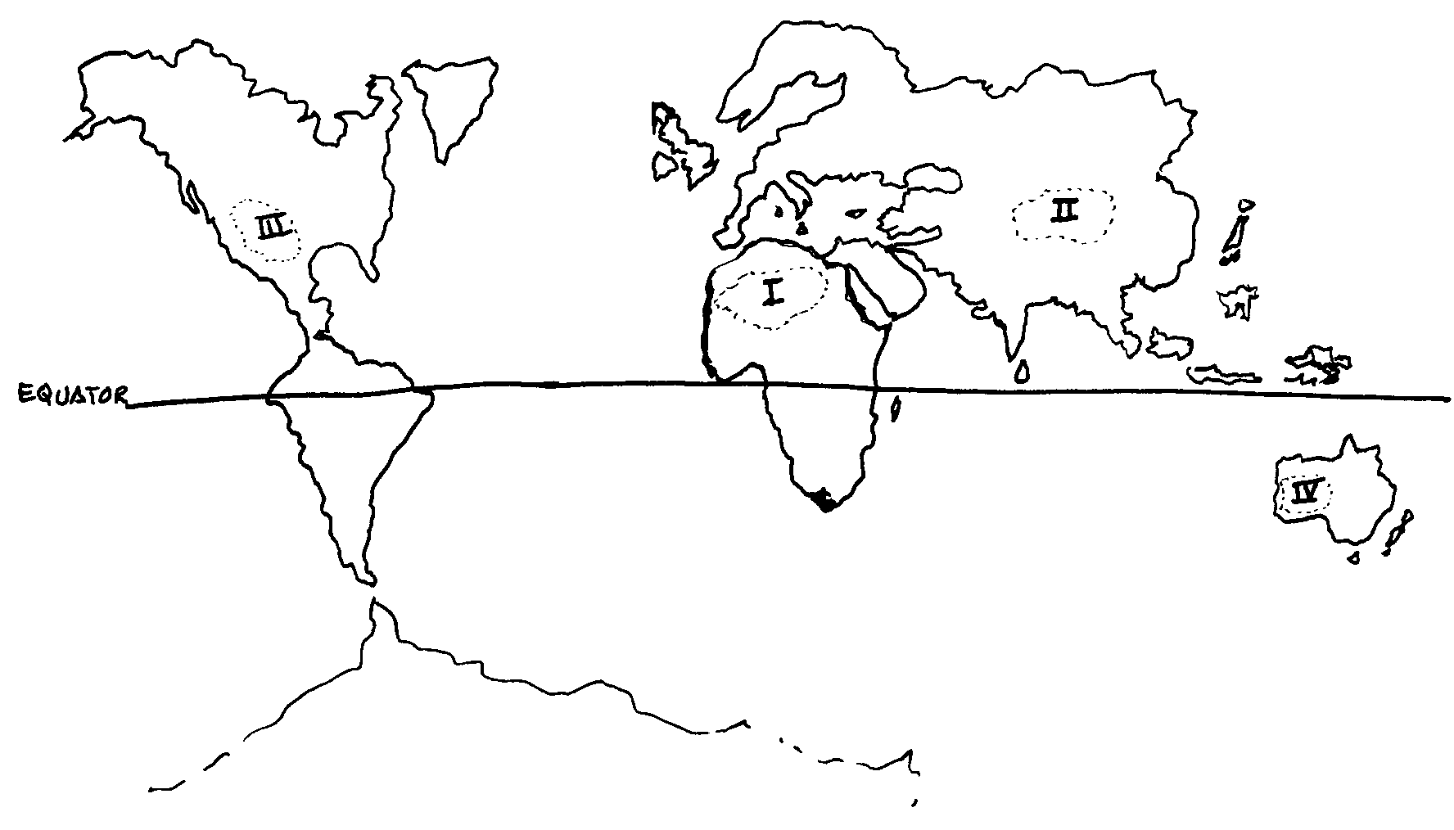
Q.13 Label the mountain ranges marked I-IV in the map given below: (4)

PAKISTAN MOUNTAIN RANGES
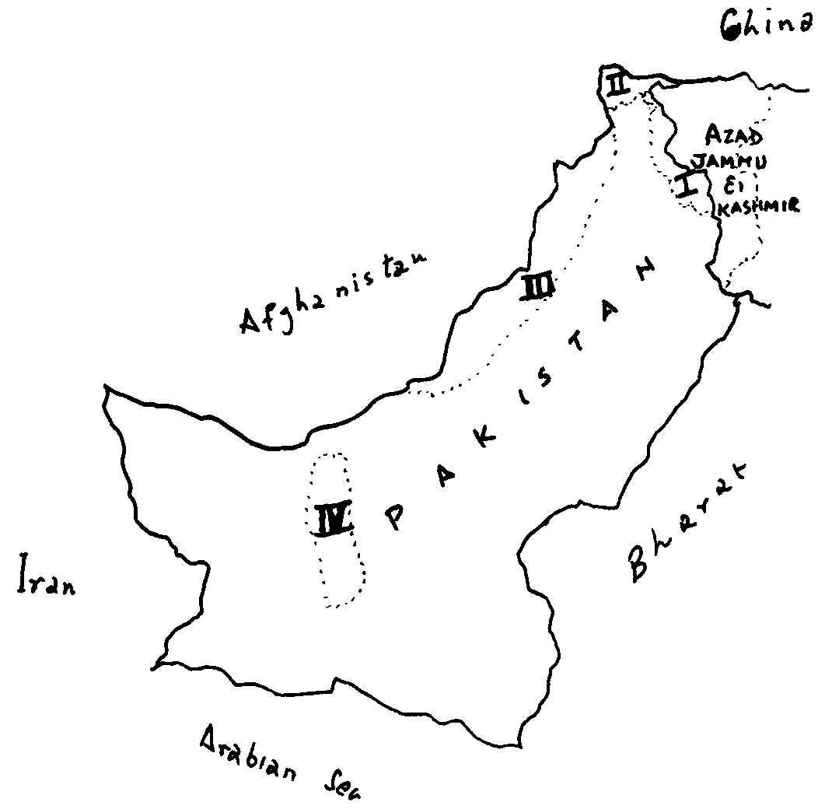

Page 1 of 3 Turn Over
Q.14 Name the water bodies of surrounding the USA. (4)
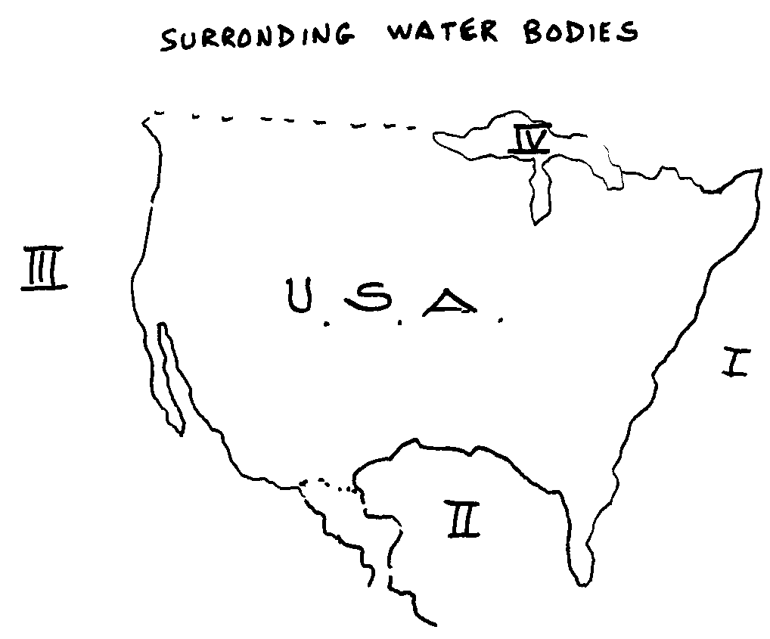

SECTION – C
(Marks: 26)

Note: Attempt any TWO of the following questions.

Q.15 Describe the world population distribution. (13)

Q.16 Discuss the factors which have contributed to the agricultural development of Saudi Arabia. (13)

Q.17 Classify and discuss in detail multifaceted environmental problems of Pakistan. (13)

____________________

Page 3 of 3
Federal Board HSSC-II Examination
Geography Practical
Model Question Paper

Time allowed: 2 hours Marks: 15

Note: Answer any three questions.

1. Construct the graticule of Cylindrical Equal Area Projection with the help of following data: (3)
R.F. 1:250,000,000
Graticule Interval 30°

2. Draw line graph to present temperature of Islamabad by using the following data: (3)
Month | Average temperate in degree cilciur’s | Month | Average temperate in degree cilciur’s
January | 10° | July | 35°
February | 15° | August | 31°
March | 20° | September | 25°
April | 22° | October | 20°
May | 30° | November | 18°
June | 35° | December | 14°

3. What is the importance of distribution maps in presenting geographical data? (3)

4. What are conventional signs used for the following features: (3)
i. River ii. Well iii. Coniferous Trees
iv. Lighthouse v. Post Office vi. Railway Bridge

5. Write down the merits and demerits of zenithal projection. (3)

Practical Note Book (3)

Viva Voce (3)

____________________

Page 1 of 1

