SCHEME OF STUDIES
FOR HSSC (CLASSES XI–XII)

COMPULSORY FOR ALL (500 marks)
1. English (Compulsory)/ English (Advance) 2 papers 200 marks

2. Urdu (Compulsory)/ Urdu Salees In lieu of Urdu 2 papers 200 marks
(Compulsory)/ Pakistan Culture for Foreign
Students Part – I and Pakistan Culture Paper-II

3. Islamic Education/Civics (for Non-Muslims) 1 paper 50 marks

4. Pakistan Studies 1 paper 50 marks

SCIENCE GROUP (600 marks)
The students will choose one of the following (A), (B) and (C) Groups carrying 600 marks:

(A) Pre-Medical Group:
Physics, Chemistry, Biology

(B) Pre-Engineering Group:
Physics, Chemistry, Mathematics

(C) Science General Group:
1. Physics, Mathematics, Statistics
2. Mathematics, Economics, Statistics
3. Economics, Mathematics, Computer Science
4. Physics, Mathematics, Computer Science
5. Mathematics, Statistics, Computer Science

HUMANITIES GROUP (600 marks)
Select three subjects of 200 marks each from the following:
S. No. | Subject | S. No. | Subject
1. | Arabic/Persian/French/English (Elective)/Urdu (Elective) | 10.  11. | Sindhi (Elective)  Civics
2. | Economics | 12. | Education
3. | Fine Arts | 13. | Geography
4. | Philosophy | 14. | Sociology
5. | Psychology | 15. | Mathematics
6. | Statistics | 16. | Computer Science
7. | History of Modern World/Islamic History/ History of Muslim India/ History of Pakistan | 17.  18. | Islamic Culture  Library Science
8. | Islamic Studies | 19. | Outlines of Home Economics
9. | Health and Physical Education | 19. | Outlines of Home Economics

COMMERCE GROUP (600 marks)

HSSC – I
1. Principles of Accounting paper – I 100 marks
2. Principles of Economics paper – I 75 marks
3. Principles of Commerce paper – I 75 marks
4. Business Mathematics paper – I 50 marks

HSSC – II
1. Principles of Accounting paper – II 100 marks
2. Commercial Geography paper – II 75 marks
3. Computer Studies/Typing/Banking paper – II 75 marks
4. Statistics paper – II 50 marks

MEDICAL TECHNOLOGY GROUP (600 marks each)
1. Medical Lab Technology Group
2. Dental Hygiene Technology Group
3. Operation Theater Technology Group
4 Medical Imaging Technology Group
5. Physiotherapy Technology Group
6. Ophthalmic Technology Group

AIMS AND OBJECTIVES OF EDUCATION POLICY
(1998 – 2010)

AIMS

Education is a powerful catalyzing agent which provides mental, physical, ideological and moral training to individuals, so as to enable them to have full consciousness of their mission, of their purpose in life and equip them to achieve that purpose. It is an instrument for the spiritual development as well as the material fulfillment of human beings. Within the context of Islamic perception, education is an instrument for developing the attitudes of individuals in accordance with the values of righteousness to help build a sound Islamic society.

After independence in 1947 efforts were made to provide a definite direction to education in Pakistan. Quaid-i-Azam Muhammad Ali Jinnah laid down a set of aims that provided guidance to all educational endeavours in the country. This policy, too has sought inspiration and guidance from those directions and the Constitution of Islamic Republic of Pakistan. The policy cannot put it in a better way than the Quaid’s words:

“You know that the importance of Education and the right type of education, cannot be overemphasized. Under foreign rule for over a century, sufficient attention has not been paid to the education of our people and if we are to make real, speedy and substantial progress, we must earnestly tackle this question and bring our people in consonance with our history and culture, having regard for the modern conditions and vast developments that have taken place all over the world.”

“There is no doubt that the future of our State will and must greatly depend upon the type of education we give to our children, and the way in which we bring them up as future citizens of Pakistan. Education does not merely mean academic education. There is immediate and urgent need for giving scientific and technical education to our people in order to build up our future economic life and to see that our people take to science, commerce, trade and particularly well-planned industries. We should not forget, that we have to compete with the world which is moving very fast towards growth and development.”

“At the same time we have to build up the character of our future generation. We should try, by sound education, to instill into them the highest sense of honour, integrity, responsibility and selfless service to the nation. We have to see that they are fully qualified and equipped to play their part in various branches of national life in a manner which will do honour to Pakistan.”

These desires of the Quaid have been reflected in the Constitution of the Islamic Republic of Pakistan and relevant articles are:

The state shall endeavour, in respect of the Muslims of Pakistan:
- to make the teachings of the Holy Quran and Islamiat compulsory and encourage and facilitate the learning of Arabic language to secure correct and exact printing and publishing of the Holy Quran;

- to promote unity amongst them and the observance of Islamic moral standards;

Provide basic necessities of life, such as food, clothing, housing, education and medical relief for all such citizens irrespective of sex, caste, creed or race as are permanently or temporarily unable to earn their livelihood on account of infirmity, sickness or unemployment;

Remove illiteracy and provide free and compulsory secondary education within minimum possible period.

Enable the people of different areas, through education, training, agricultural and industrial development and other methods, to participate fully in all the forms of national activities including employment in the service of Pakistan;

The State shall discourage parochial, racial, tribal, sectarian and provincial prejudices among the citizens.

Reduce disparity in the income and earnings of individuals, including persons in various classes of the service of Pakistan.

Steps shall be taken to ensure full participation of women in all the spheres of national life.

The vision is to transform Pakistani nation into an integrated, cohesive entity, that can compete and stand up to the challenges of the 21st Century. The Policy is formulated to realize the vision of educationally well-developed, politically united, economically prosperous, morally sound and spiritually elevated nation.

OBJECTIVES

To make the Qur’anic principles and Islamic practices as an integral part of curricula so that the message of the Holy Quran could be disseminated in the process of education as well as training. To educate and train the future generation of Pakistan as true practicing Muslims who would be able to usher in the 21st century and the next millennium with courage, confidence, wisdom and tolerance.

To achieve universal primary education by using formal and informal techniques to provide second opportunity to school drop-outs by establishing basic education community schools all over the country.

To meet the basic learning needs of a child in terms of learning tools and contents.

To expand basic education qualitatively and quantitatively by providing the maximum opportunities to every child of free access to education. The imbalances and disparities in the system will be removed to enhance the access with the increased number of more middle and secondary schools.

To ensure that all the boys and girls, desirous of entering secondary education, get their basic right through the availability of the schools.

To lay emphasis on diversification of curricula so as to transform the system from supply-oriented to demand oriented. To attract the educated youth to world-of-work from various educational levels is one of the policy objectives so that they may become productive and useful citizens and contribute positively as members of the society.

To make curriculum development a continuous process; and to make arrangements for developing a uniform system of education.

To prepare the students for the world of work, as well as pursuit of professional and specialized higher education.

To increase the effectiveness of the system by institutionalizing in-service training of teachers, teacher trainers and educational administrators. To upgrade the quality of pre-service teacher training programmes by introducing parallel programmes of longer duration at post-secondary and post-degree levels.

To develop a viable framework for policy, planning and development of teacher education programmes, both in-service and pre-service.

To develop opportunities for technical and vocational education in the country for producing trained manpower, commensurate with the needs of industry and economic development goals.

To improve the quality of technical education so as to enhance the chances of employment of Technical and Vocational Education (TVE) graduates by moving from a static, supply-based system to a demand-driven system.

To popularize information technology among students of all ages and prepare them for the next century. To emphasize different roles of computer as a learning tool in the classroom learning about computers and learning to think and work with computers and to employ information technology in planning and monitoring of educational programmes.

To encourage private sector to take a percentage of poor students for free education.

To institutionalize the process of monitoring and evaluation from the lowest to the highest levels. To identify indicators for different components of policy, in terms of quality and quantity and to adopt corrective measures during the process of implementation.

To achieve excellence in different fields of higher education by introducing new disciplines/emerging sciences in the universities, and transform selected disciplines into centres of advanced studies, research and extension.

To upgrade the quality of higher education by bringing teaching, learning and research process in line with international standards.

RATIONALE FOR PHYSICS SYLLABUS

Physics at intermediate level provides students with a contemporary and coherent understanding of energy, matter, and their interrelationship. It focuses on investigating natural phenomena and then applying patterns, models, problem solving techniques, principles, theories and laws to explain the physical behaviour of the universe. It uses an understanding of simple system to make predictions about a range of objects from subatomic particles to the entire universe and aims to reveal the simplicity underlying complexity.

The study of physics relies on the understanding and application of a small number of basic laws and principles that govern the microscopic and macroscopic worlds. The study of physics provides students with an understanding of systems that is the basic of the development of technological applications.

Physics at intermediate level draws and builds on the knowledge and understanding, skills, values and attitudes developed in high school. It further develops students’ understanding of science as a continually developing body of knowledge, the inter disciplinary nature of science, the role of science in deciding between competing theories, the provisional nature of scientific explanations and the complex interrelationship between evidence, ideas and impact of science on society.

The study of physics facilitates learning about the natural environment and man made environment, exploring phenomenon and patterns of events, acquiring scientific skills and relating science to everyday life.

It is expected that students studying physics will apply investigations and problem solving skills, effectively communicate the theoretical concepts, and appreciate the contribution that the study of physics makes to our understanding of the world.

AIMS AND OBJECTIVES OF PHYSICS SYLLABUS

AIMS

The broad aims of the Physics syllabus are to:
- inculcate among the students the habit of scientific and rational thinking and an attitude to search for order and symmetry in diverse phenomena of nature and thereby to appreciate the supreme wisdom and creative powers of the creator;
- lay a foundation for research and development by stimulating interest and developing attitudes relevant to scientific methods;
- equip the students with the knowledge and understanding of concepts rather than the ability to remember facts so that they may have a reasonably comprehensive and complete grasp of principles of physics;
- develop observational skills and relate the student’s knowledge of concepts to quantitative measurements by including a well-balanced practical course;
- make it possible for the students to acquire knowledge, skills, working methods and ways of expression which will contribute to an all round development of individual student;
- promote an awareness that the application of science may be both beneficial and detrimental to the individual, the community and the environment.

GENERAL OBJECTIVES

On the completion of the course the student should be able to:
- acquire the knowledge and understanding of physical concepts rather than the ability to remember facts;
- develop the habit of scientific and rational thinking and an attitude to search order and symmetry in apparently diverse phenomena of nature;
- understand and interpret scientific information presented in verbal, mathematical or graphical form and to translate such information from one form to another;
- describe physical phenomena in terms of models, laws and principles;
- recognize the operation of the scientific principles in established practical applications to apply acquired knowledge, experience and skills to new situations in a novel manner;
- develop observational skills, confidence in using scientific equipment and relate the knowledge of scientific concepts to quantitative and physical measurement;
- understand and appreciate the inter relationship and balance that exists in nature, the problems associated with the over exploitation of the environmental resources and disturbance because of the human activities in the ecological balance, thus taking care of the environment;
- acquire knowledge, skills, working methods and ways of expression which will reflect on all round development of the students’ attitudes towards scientific thinking and its applications;
- help the students feel that the advancement in physics and its extended applications are essential for the healthy growth of national economy and to appreciate that physics is a major part of the modern world;
- develop attitudes such as concern for accuracy and precision, objectivity, and enquiry.

SPECIFIC OBJECTIVES

The specific objectives of the intermediate level physics course are as follows:

A. Knowledge and understanding
Students should be able to recall and show understanding of:
- Physics terminology, definitions and conventions.
- Selected factual knowledge and phenomena.
- Selected experimental methods and related practical techniques.
- Concepts, laws and models.
- Relevant applications of physics in society and everyday life.

B. Practical skills
Students should be able to:
- Plan and execute experiments.
- Handle scientific equipment safely and to the appropriate limit of accuracy.
- Observe, analyze and present experimental results accurately.
- Handle simple treatment of errors.

C. Application
Students should be able to:
- Identify problems in a given situation.
- Apply the knowledge of physics in problem solving and experimental investigation using quantitative, numerical, theoretical and practical techniques.
D. Communication skills
Students should be able to:
- Compile clear and concise accounts of experimental work and theoretical treatments.
- Interpret the recorded data.
- Use modes to explain phenomena and discuss issues relating to the social, economic, environmental and technological implications of physics.

E. Attitudes
Students should acquire
- Inquisitiveness and interest in their study of physics.
- An appreciation of the role of experimental work in the field of science.
- An objective attitude towards judgment of evidence.
- Concern for accuracy and precision.
- Awareness of contribution of physics to society and the consequences of application of physics to meet human needs.

CONTENTS AND SCOPE OF PHYSICS SYLLABUS

CONTENT | SCOPE
1. Measurements (13 periods)
What is Physics?  Physical quantities and SI units  Error and uncertainties  Dimensions of physical quantities | Introduction to Physics (Brief account only)  All physical quantities understood as consisting of a numerical magnitude and units.  Base units: mass, length, time, current, temperature, luminous intensity and amount of substance in terms of number of particles, supplementary units (radian and steradian), other units, use of standard form/scientific notation and prefixes. Use of conventions for indicating units as set out in the S.I units.  Error and uncertainties, systematic and random errors, significant figures, distinction between precision and accuracy, assessment of uncertainty in a derived quantity.  Note:- Quoting answers with correct scientific notation, number of significant figures and units in all numerical and practical work be made compulsory.  Use of dimensions and units to check homogeneity of physical equations and to derive possible formulae in simple cases.
2. Vectors and Equilibrium (13 periods)
Vectors  Equilibrium | Rectangular co-ordinate system. Vectors: Scalars: Magnitude of vector equal vectors negative of vector Unit vector, null vector, position vector. Rule of vector addition by rectangular components. The scalar product of two vectors and its characteristics. The vector product of two vectors and its characteristics.  Equilibrium of forces. Torque and equilibrium of torques.
3. Motion and Force (10 periods)
Displacement  Velocity  Acceleration  Equations of motion  Force, momentum and impulse  Projectile | Definition and illustration with diagram.  Definition and illustration of velocity, average velocity and instantaneous velocity.  Definition and illustration of acceleration, average acceleration and instantaneous acceleration. Velocity-time graph for constant direction, significance of area under velocity-time graph.  Summarized review of equation of uniformly accelerated motion.  Summarized review of Newton’s laws of motion. Newton’s 2nd law of motion in terms of momentum. Impulse. Law of conservation of momentum. Elastic collisions in one dimension with special cases. Force due to water flow, momentum and explosive forces. Rocket propulsion (simple treatment)  Projectile motion in non-resistive medium. Derivation of time of flight, maximum height and horizontal range. Application to ballistic missiles.
4. Work, Power and Energy (11 periods)
Work done by a constant force  Work done by a variable force  Power  Energy  Interconversion of Potential and Kinetic energies  Conservation of energy  Non conventional Energy Sources | Work as a scalar product of force and displacement. Work done in gravitational field near earth’s surface.  Work as area under force displacement graph.  Power as a scalar product of force and velocity, units, examples from every day life.  Brief account of kinetic Energy and Potential Energy. Work-energy principle. Derivation of expression for absolute potential energy. Escape velocity.  Interconversion of Potential and Kinetic energies in a resistive medium.  Conservation of energy with examples from everyday life.  Energy from the tides, energy from waves, solar energy, solar power and intensity at earth’s surface, energy from Biomass, energy from waste products, geo-thermal including aquifers and geysers (descriptive introduction)
5. Circular Motion (11 periods)
Angular motion  Centripetal acceleration and force  Angular momentum  Moment of Inertia  Rotational Kinetic energy  Artificial satellites. Orbital Speed | Angular displacement, radian, the relationship s = rθ, angular velocity, angular acceleration, relation between linear velocity and angular velocity.  Equations of angular motion.  Derivation and use of a_{c}= $rω$²=$\frac{v^{2}}{r}$, F_{c} = $\text{mr}ω$² = $\frac{{\text{mv}}^{2}}{r}$  Definition of angular momentum as an analogue of linear motion. Conservation of angular momentum with examples.  Descriptive treatment as I = $\sum{\underset{i=1}{\overset{n}{}}}m_{i}r_{i}^{2}$  Moment of Inertia of various bodies (rod, disc, sphere, and hoop), no derivation.  Rotational Kinetic energy of a disc and of a hoop on an inclined plane.  Simple introduction, weightlessness in satellites, gravity free system. (Descriptive only), artificial gravity, orbital velocity, geo-stationary orbits, communication satellites and their applications. Simple description of Einstein’s view of gravitation.
6. Fluid Dynamics (10 periods)
Fluid friction  Fluid flow | Viscous drag. Stokes’ law and terminal velocity and its derivation.  Turbulent and stream line flow of fluids. Equation of continuity. Bernoulli’s equation and its applications including blood flow.
7. Oscillations (14 periods)
Simple Harmonic motion  Energy conservation in S.H.M  Free and forced oscillations | Experimental, analytical, graphical treatments and simple examples of motion of projection of circular motion on its diameter, derivation of a =$−ω^{2}$ x. Mass attached to a spring. Simple pendulum. Amplitude, period, frequency, phase recognition and use of a = $−ω^{2}$ x. Knowledge and use of solutions in the form of x = x_{o} Cos $ω$ t or  y = y_{o} sin $ω$t  Conservation of kinetic energy and potential energy in S.H.M.  Free and forced oscillations treated qualitatively, frequency response, sharpness of resonance treated qualitatively, application of damped oscillations, damping in car suspension system.
8. Waves (14 periods)
Propagation of waves  Speed of sound in air  Superposition of waves  Stationary waves  Modes of vibration of strings.  Doppler’s effect | Review of generation and propagation of waves. Nature of motions in transverse and longitudinal progressive waves, wave length, frequency and velocity of wave, Derivation of v= fλ  Newton’s formula, Laplace correction, effect of pressure, density and temperature on speed of sound in air. Derivation of $V$=$V_{0}$+ 0.61t.  Interference and beats. Illustration of these phenomena with the help of sound waves.  Reflection of waves, a graphical and experimental approach is sufficient, stationary waves in strings. Location of nodes and anti-nodes. Vibrating air columns.  Modes of vibration of strings and use of L= nλ /2.  Doppler’s effect. Proof of the relationship between apparent frequency and original frequency for the relative motion between the source and observer on the same straight line in the case of sound. Applications in radar. Sonar, astronomy, satellites and radar speed.
9. Physical Optics (17 periods)
Interference  Diffraction  Polarization | Concept of wavefronts. Huygen’s principle. Interference. Young’s double slit experiment. Conditions for detectable interference. Calculation of wave length from fringe spacing. Colour patterns in thin films. Newton’s rings. Michelson interferometer and its uses.  Simple phenomenon and their qualitative explanation. Single slit diffraction. Diffraction grating, derivation of angular position of first minimum. Derivation and use of d sin Ө = nλ (plane grating normal incidence). Diffraction of X-rays through crystals and its uses, Bragg’s equation.  Polarization as a phenomenon associated with transverse waves. Polarization produced by Polaroids. Qualitative effect of rotation of Polaroid. Production and detection of plane polarized light.
10. Optical Instruments (16 periods)
Magnifying power and resolving power of optical instruments  Spectrometer  Speed of light  Optical fibre systems | Least distance of distinct vision, magnifying power and resolving powers of simple microscope. Compound microscope and astronomical telescope.  Description of spectrometer explaining the function of its various parts, details of mechanical adjustment not required.  Michelson rotating mirror method.  Introduction of optical fibers, fibre optic principles- (i) total internal refraction. (ii) continuous refraction. Types of optical fibers, signal transmission, conversion to sound (descriptive treatment: only), losses of power.
11. Heat and Thermodynamics (22 periods)
Kinetic theory of gases  First law of Thermodynamics  Second law of Thermodynamics  Entropy | Postulates of kinetic theory of gases, derivation of pressure of gas, interpretation of temperature and derivation of gas laws on the basis of kinetic theory.  Internal energy, work and heat, familiarity with a variety of energy conversions in practical devices and processes. Isothermal and adiabatic processes. Molar specific heats of gas at constant pressure C_{p} and at constant volume C_{v} . Application of first law to derive C_{p} - C_{v} =R  Reversible and irreversible cycle. Heat engine, statement of second law of thermodynamics. Carnot Theorem, Thermodynamic Scale of temperature.  Petrol Engine and Diesel engine (Simple Description).  Explanation of entropy. Change of entropy ∆S = $±\frac{ΔQ}{T}$  Entropy and 2nd Law of Thermodynamics. Environmental crisis as an entropy crisis.

LEARNING – TEACHING GUIDELINES
FOR STUDENTS AND TEACHERS

This set of instructional objectives has been compiled to show the level of achievement that is expected of an average pupil on completing the study of specific parts of the syllabus. It aims at assisting the teachers in their selection of course materials, learning activities and instructional methods. It can serve as the learning guidelines for the pupils and the basis of an evaluation program.

In stating the specific objectives there are two groups of terms having very similar meaning. The first group is on achievement in recalling facts, which include ‘define’, describe’, and state. Define refers to a rather formal definition of terms which involves their fundamental concept. ‘Describe’ refers to the recall of phenomena or processes, ‘State’ is used when the objective requires the recall of only some aspects of a phenomenon or a process; it limits the scope of teaching.

The second group is on achievement relating to science experiments. This group includes ‘design’, ‘perform’, ‘demonstrate’. ‘Design’ an experiment would be used when there are more than one acceptable ways of doing it. Pupils are expected to be able to set up the experiment by applying what they have previously learned. These experiments may require the taking of quantitative data or long term observation. ‘Perform’ an experiment, would be used when the objective emphasizes on the demonstration of experimental skill; the detail of the experiment could be found in the teachers’ notes or textbooks. ‘Demonstrate’ a phenomenon by simple experiments is used when the objective emphasizes on the result of the experiment and the experimental skill involved is very simple, such as passing some gas into a solution ‘Describe’ an experiment is used when pupils are expected to know, in principle, how the experiment could be carried out and the expected result.

1. Measurements
The students will be able to:
- Know the impact of advances in Physics on society
- Understand that all physical quantities consist of a numerical magnitude and a unit.
- Recall the following base quantities and their units; mass (kg) length (m), time (s) current (A), temperature (K), luminous intensity (Cd) and amount of substance (mol).
- Describe and use of basic units, derived units, and supplementary units.
- Understand and use of scientific notation.
- Use the standard prefixes and their symbols to indicate decimal sub-multiples or multiples of both base and derived units.
- Understand and use the conventions of indicating units as set out in the SI units.
- Understand the distinctions between systematic errors (including zero errors) and random errors.
- Understand and sue significant figures.
- Understand the distinction between precision and accuracy.
- Assess the uncertainty in a derived quantity by simple addition of actual, fractional or percentage uncertainties.
- Quote answers with correct scientific notation, number of significant figures and units in all numerical and practical work.
- Use dimensionality and base units to check the homogeneity of physical equations.
- Derive formulae in simple cases using dimensions.

2. Vectors and Equilibrium
- Understand and use rectangular coordinate system.
- Understand the idea of unit vector, null vector and position vector.
- Know the rule of vector addition.
- Represent a vector as two perpendicular components (rectangular components)
- Know vector addition using rectangular components.
- Understand multiplication of vectors (scalar and vector product) and solve problems.
- Define the moment of force or the torque.
- Appreciate the use of the moment of force or torque.
- Show an understanding that when there is no resultant force and no resultant torque, a system is in equilibrium.
- Appreciate the applications of the principle of moments.
- Apply the knowledge gained to solve problems on statics.

3. Motion and Force
- Understand displacement from its definition and illustration.
- Understand velocity, average velocity and instantaneous velocity.
- Understand acceleration, average acceleration and instantaneous acceleration.
- Understand the significance of area under velocity-time graph as distance traveled.
- Recall and use equations which represent uniformly accelerated motion in a straight line including falling in a uniform gravitational field without air resistance
- Recall Newton’s Laws of motion.
- Describe Newton’s second laws of motion as rate of change of momentum.
- Know impulse as a product of impulsive force and time.
- Describe law of conservation of momentum.
- Use of law of conservation of momentum in simple applications including elastic collision between two bodies in one dimension.
- Describe the force produced due to flow of water.
- Understand the process of rocket propulsion (simple treatment).
- Know and describe projectile motion in a non-resistive medium.
- Derive time of flight, maximum height and horizontal range of projectile motion.
- Appreciate the motion of ballistic missiles as projectile motion.

4. Work, Power and Energy
- Understand the concept of work in terms of the product of a force and displacement in the direction of the force
- Understand and derive the formula Work = wd = mgh for work done in a gravitational field near earth’s surface.
- Know that work can be calculated from area under the force – displacement graph.
- Define power as the product of force and velocity.
- Relate power to work done and time taken using appropriate examples.
- Quote examples of power from every day life.
- Explain the two types of mechanical energy.
- Understand the work energy principle.
- Drive an expression for absolute potential energy.
- Define escape velocity.
- Understand that in a resistive medium loss of potential energy of a body is equal to gain in kinetic energy of the body plus work done by the body against friction.
- Give examples of conventional sources of energy including
  - Tidal energy
  - Energy from Waves
  - Solar energy
  - Energy from Biomass
  - Energy from waste products
  - Geo thermal energy

5. Circular Motion
- Describe angular motion.
- Define angular displacement, angular velocity and angular acceleration.
- Define radian and convert an angle from radian measure to degree and vice versa.
- Use the equation S = r Ө to convert linear velocity to angular displacement.
- Use the equation $V$= rω to convert linear velocity to angular velocity.
- Describe qualitatively motion in a curved path due to a perpendicular force and understand the centripetal acceleration in case of uniform motion in a circle.
- Derive the equation a = rω = $V^{2}$ /r and Fc = m ωr and m $V^{2}$/r
- Understand the concept of angular momentum.
- Describe examples of conservation of angular momentum
- Understand and describe moment of inertia of a body.
- Know moment of inertia of various bodies. Understand and express rotational kinetic energy of a disc and a hoop on an inclined plane. Know and describe the motion of artificial satellites.
- Express that the objects in satellite appear to be weightless.
- Know about a gravity free system.
- Understand that how and why artificial gravity is produced
- Understand geo-stationary orbits and orbital velocity of satellites
- Know communication satellite and their applications
- Describe Einstein’s view of gravitation.
6. Fluid Dynamics
- Understand the viscous forces in a fluid cause a retarding force on an object moving through it.
- Describe an experiment based on the measurement of terminal velocity to determine the viscosity of a liquid.
- Understand how the magnitude of the viscous force in fluid flow depends on the velocity gradient and on the viscosity of the fluid.
- Use dimensional analysis to confirm the form of the equation F = 6 π η r $V$(Stoke’s law) for the drag force under laminar conditions in a viscous fluid.
- Use Stoke’s law to derive an expression for terminal velocity of spherical body falling through a viscous fluid under laminar conditions.
- Understand the terms steady (laminar, streamline) flow, incompressible flow, non viscous flow as applied to the motion of an ideal fluid.
- Understand how the velocity vector of a particle in an ideal fluid in motion is related to the stream line associated with that particle.
- Understand how steam lines can be used to define a tube of flow.
- Appreciate that a sufficiently high velocity, the flow of viscous fluid undergoes a transition from laminar to turbulent conditions.
- Appreciate that the equation of continuity A$V$ = Constant for the flow of an ideal and incompressible fluid.
- Appreciate that the equation of continuity is a form of the principle of conservation of mass.
- Understand that the pressure difference can arise from different rates of flow of a fluid (Bernoulli effect)
- Derive Bernoulli equation in form P₁ + ½ ${ρv}_{1}^{2}$ = P₂ + ½ ${ρv}_{2}^{2}$ for the case of horizontal tube of flow.
- Explain how Bernoulli effect is applied in the filter pump, in the Venturi meter, in atomizers, in the flow of air over an aerofoil and in blood physics.
- Appreciate that the majority of practical examples of fluid flow and resistance to motion in fluids involve turbulent rather than luminar conditions.
- Give qualitative explanations in terms of turbulence and Bernoulli effect for the swing of a spinning cricket ball and the lift of a spinning golf ball and on an aeroplane.

7. Oscillations
- Investigate the motion of an oscillator using experimental, analytical and graphical methods.
- Understand and describe that when an object moves in a circle the motion of its projection on the diameter of the circle is simple harmonic.
- Show that the motion of mass attached to a spring is simple harmonic
- Know that the motion of simple pendulum is simple harmonic and calculate its time period.
- Understand and use the terms amplitude, time period, frequency, angular frequency and phase difference.
- Express time period in terms of both frequency and angular frequency.
- Know and use of solutions in the form of x = x Cos ω t or y = y Sin ω t
- Describe the interchange between kinetic and potential energy during SHM.
- Describe practical examples of free and forced oscillations.
- Understand and express frequency response of ear.
- Describe practical examples of damped oscillations with particular reference to the effects of the degree of damping and the importance of critical damping in cases such as car suspension system (shock absorbers).

8. Waves
- Recall the generation and propagation of waves.
- Describe the nature of the motions in transverse and longitudinal waves.
- Understand and use the terms wave length, frequency and velocity of wave.
- Understand and use the equation v = f λ
- Understand and describe Newton’s formula of velocity of sound.
- Know Laplace correction in Newton’s formula of velocity of sound for air.
- Derive the formula $v_{t}$ = $v_{0}$ + 0.61t
- Recognize and describe the factors on which speed of sound in air depends.
- Explain and use the principle of superposition.
- Understand the terms interference and beats.
- Describe the phenomena of interference and beats giving examples of sound waves.
- Understand and describe reflection of sound waves.
- Describe experiments which demonstrate stationary waves for stretched strings and vibrating air columns.
- Explain the formation of a stationary wave using a graphical method.
- Understand the terms node and anti-node.
- Understand and describe modes of vibration of strings.
- Understand and describe Doppler’s effect and its causes.
- Recognize the application of Doppler’s effect such as radar, sonar, astronomy, satellite and radar speed traps.

9. Physical Optics
- Understand the concept of wave front.
- State Huygen’s principle
- Use Huygen’s principle to explain linear propagation, reflection and refraction of light.
- Understand interference of light.
- Describe Young’s double slit experiment and the evidence it provided to support wave theory of light. Sin Ө = n λ/ d and Sin Ө = ($\frac{n−1}{2}$) λ/ d = y/L
- Use the equation Sin Ө = n λ/ d and Sin Ө = ($\frac{n−1}{2}$) λ/ d = y/L to solve any one variable given the others.
- Describe the formation of Newton’s rings.
- Recognize and express colour patterns in thin films.
- Understand the working of Michelsorn interferometer and its uses.
- Explain the meaning of the term ‘diffraction’.
- Use the mathematical equations that describe diffraction at a single slit.
- Derive the equation for angular position of first minimum.
- Derive the equation d Sin Ө = m λ
- Derive Bragg’s equation 2d Sin Ө = m λ
- Carry out calculations using the diffraction grating formula.
- Describe the phenomena of diffraction of X-rays through crystals.
- Appreciate the use of diffraction of X-rays by crystals.
- Understand polarization as a phenomenon associated with transverse waves.
- Recognize and express that polarization is produced by a Polaroid.
- Understand the effect of rotation of Polaroid on Polarization.
- Understand how plane polarized light is produced and detected.

10. Optical Instruments
- Recognize the term of least distance of distinct vision.
- State the terms magnifying power and resolving power
- Derive expression for magnifying power and resolving power of simple microscope, compound microscope and astronomical telescope.
- Understand the working of spectrometer.
- Describe to find the speed of light by Michelson rotating mirror method.
- Know and appreciate the principles of optical fibre.
- Identify the types of optical fibre.
- Appreciate the applications of optical fibre.
11. Heat and Thermodynamics
- State the basic postulates of Kinetic theory of gases.
- Explain how molecular movement causes the pressure exerted by a gas and derive the equation P =2/3 N < ½ m $v^{2}$ >, where N is the number of molecules per unit volume of the gas.
- Compare P = 2/3 N < ½ m $v^{2}$ > with PV = nRT and hence deduce that the average translational kinetic energy of a molecule is proportional to temperature.
- Derive gas laws on the basis of kinetic theory.
- Describe that the internal energy of an ideal gas in due to the kinetic energy of its molecules.
- Understand and use the terms work and heat in thermodynamics.
- Understand isothermal and adiabatic processes.
- Know about the molar specific heats of gas.
- Apply first law of thermodynamics to derive Cp – Cv = R
- Explain second law of thermodynamics and its meaning in terms of entropy.
- Understand the concept of reversible and irreversible cycle.
- Understand the term heat engine.
- Understand and describe Carnot theorem.
- Know the thermodynamic scale of temperature.
- Describe the working / function of petrol and diesel engines.
- Explain the term entropy.
- Know that change in entropy ΔS = ΔQ/T
- Appreciate environmental crisis as an entropy crisis.

OBJECTIVES OF PRACTICAL WORK

Through experimental work the students are expected to develop the following skills:

A. Planning B. Implementing C. Interpreting and concluding

Students are required to carry out practical work as an integral part of the course. They are advised to maintain a laboratory record book in which they record, for all their practical work, the experimental arrangements used, the observations made and the analysis of these observations. Particular attention should be placed on the following:

1. Techniques:
i. Reading to the maximum accuracy of linear and angular scales; use of vernier scales; timing by stop-watch or stop-clock.
ii. Accurate focusing and location of images.
iii. Connecting up and checking electrical circuits from a circuit diagram, drawing a circuit diagram for a given simple circuit already connected up.

2. Graphical Methods
i. Display of results in tabular and graphical form.
ii. Translate information between graphical, numerical, algebraic and verbal forms.
iii. Accurate plotting with suitable choice of scales.
iv. For linear graph, determine the slope, intercept and intersection.
v. Choose, by inspection, a straight line which will serve as the best straight line through a set of data points presented graphically.
vi. Recall standard line form y = mx + c and rearrange relationships into linear form where appropriate.
vii. Understand and use of area below a curve where the area has physical significance.
Note: Use of centimeter graph be made compulsory.

3. Procedures:
i. Making rough preliminary measurements and calculations where appropriate, e.g. to assess the best range for accurate measurements.
ii. Careful recording of all actual measurements made.

4. Order of Accuracy
i. Significant figures and decimal places.
ii. Meaning of absolute and relative (or percentage) error.
iii. Estimates of maximum error in simple cases.
iv. Common-sense appreciation of orders of accuracy of common measurements (not merely of scale readings) and ability to quote results to a number of significant figures reasonably in keeping with their estimated accuracy.

5. Error Estimates
Rules for combination of maximum errors in the simple cases:
X + y, xy, x/y, x^{n}.

PHYSICS PRACTICALS

A. Standard experiments

  - To find the volume of a cylinder using Vernier Calliper.
  - To find the area of cross section of a wire or volume of small sphere using micrometer screw gauge.
  - To find the unknown weight of a body by the method of vector addition of forces.
  - Determination of value of ‘g’ by free fall using an electronic timer / ticker timer.
  - Verification of following relations of the simple pendulum:
i. Time period is independent of the amplitude.
ii. Time period is independent of its mass or density of the bob.
iii. Time period is directly proportional to the square root of its length.

  - To find the acceleration due to gravity by oscillating mass spring system.
  - To study the laws of conservation of momentum by colliding trolleys and ticker timer for elastic and inelastic collisions.
  - Verify the second condition of equilibrium using a suspended meter rod.
  - To study the fall of a body through a viscous medium and hence to deduce the coefficient of viscosity of the medium.
  - To determine Young’s modulus of wire by Searle’s apparatus.
  - To find the moment of inertia of a fly- wheel.
  - Determination of frequency of A.C. by Melde’s apparatus/electric sonometer.
  - Investigation of the laws of vibration of stretched strings by sonometer or electromagnetic method.
  - To determine the wave length of sound in air using stationary waves and to calculate the speed of sound.
  - To determine the focal length of a convex lens by displacement method.
  - To determine the focal length of a concave lens using
i. Concave mirror ii. Convex lens
  - To find the refractive index of the material of a prism, using a laser or spectrometer.
  - To find the refractive index of the material of a prism by critical angle method.
  - To find the refractive index of a liquid using a concave mirror.
  - To determine the wave length of sodium light by Newton’s Rings.
  - To determine the wave length of light by diffraction grating using spectrometer or laser.
  - To measure the diameter of a wire or hair using laser.
  - Setting up a telescope and determination of its magnifying power and length.
  - To find the coefficient of linear expansion of the material of a rod by Pullinger’s apparatus.
  - To measure the mechanical equivalent of heat by electrical method.

B. Exercises
At least one exercise based on each of the above mentioned standard experiments making the total experiments equal to 50

TEACHING STRATEGIES

Physics should not be taken as a collection of facts, and teaching of physics should not emphasize memorization of formal statements by rote, mechanical solution of problems by formulae or carrying out measurements by following given detailed instructions.

The teachers should be well acquainted with the aims and objectives of the course. To present physics in a lively, exciting and intelligible way, emphasis should be placed on teaching for understanding by organized investigation, learning and discussion. A good demonstration can be used to stimulate learning. It is intended that consideration of everyday industrial and technological applications should pervade the course. Social, economic and environmental issues should also be considered where appropriate.

Quantitative treatment is a feature of physics. However, teacher must keep the emphasize on the understanding of the physical interpretation of theoretical formulae and experimental data.

An investigation approach to practical work is essential. Individual student project promote creativity and demonstrate the students mastery of scientific principles involved. Independent use of apparatus by the students develop manipulative skills. The development of psychomotor skills such as correctly manipulating various instruments is an important objective of physics course.

Practical work is essential for students to gain personal experience of physics through doing and finding out. Another important objective of science teaching is to develop attitude of thinking in students. Teachers are encouraged to design their lessons in such a way that suitable questions avid activities are incorporated in order to develop various types avid levels of thinking in students, including analysis, evaluation, critical thinking and creative thinking.

Teachers capable in content areas may opt the teaching strategy that matches with psychology of the students. The strategy like posing problems, discussion, investigations, and solving the problems with the involvement of the students may provide an ample opportunity in conceptual clearance of a content.

In general student centred and interactive approaches are useful in providing suitable learning experiences for stimulating and developing higher level thinking and are highly recommended. Teachers may consider to adopt a variety of strategies from the following spectrum which ranges from very teacher-centred methods to very-students centred methods.

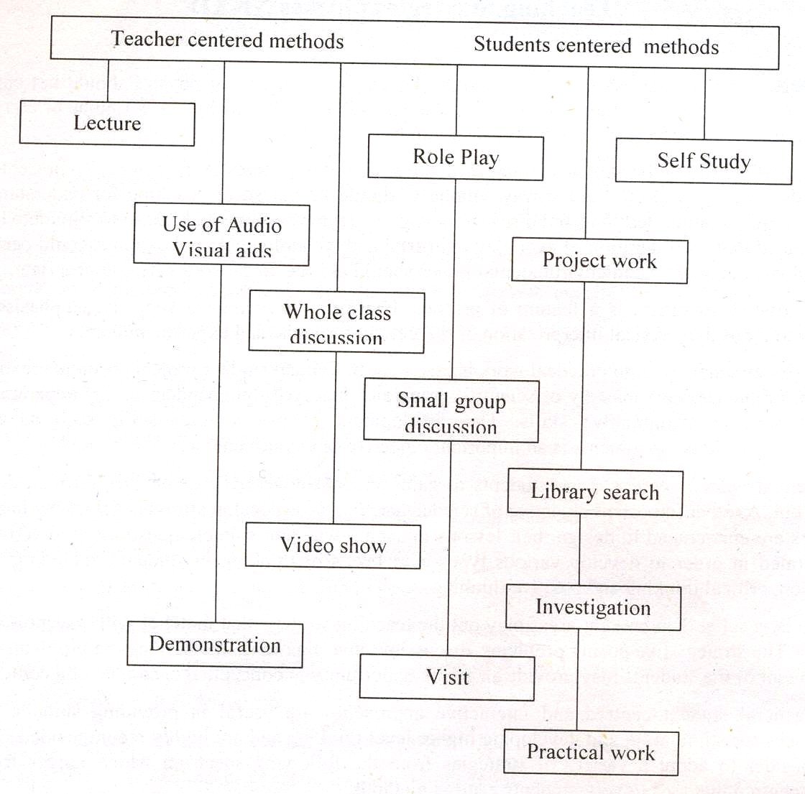

SPECTRUM OF TEACHING METHODS

Teachers should choose appropriate teaching methods in accordance with the topic/skill to be taught as well as the interest and abilities of their students. The following are some factors to be considered when deciding on the teaching methods for a particular topic:
- Learning objectives to be achieved
- Ability of students
- Subject matter
- Availability of resources
- Amount of time available

ASSESSMENT AND EVALUATION

Assessment, appraisal, or evaluation is a means of determining how far the objectives of the curriculum have been realized. What really matters is the methodology employed for such determination. As is now recognized, performance on the basis of content-oriented tests alone does not provide an adequate measure of a student’s knowledge and ability to use information in a purposeful or meaningful way; the implication, then, is that effective and rewarding techniques should be developed for evaluating the kind and content of teaching and learning that is taking place and for bringing about improvement in both. The following points, while developing the tests/questions may be kept in view:

1. Proper care should be taken to prepare the objective-type and constructed-response questions relating to knowledge, comprehension, application, analysis and synthesis, keeping in view the specific instructional objectives of the syllabus and the command words for the questions.

2. There should be at least two periodic/monthly tests in addition to routine class/tests. Teachers are expected to develop and employ assessment strategies which are dynamic in approach and diverse in design. When used in combination, they should properly accommodate every aspect of a student’s learning.

3. In addition to the final public examination, two internal examinations should be arranged during the academic year for each class.

4. Classroom examinations offer the best and most reliable evaluation of how well students have mastered certain information and achieved the course objectives. Teachers should adopt innovative teaching and assessment methodologies to prepare the students for the revised pattern of examination. The model papers, instructional objectives, definitions of cognitive levels and command words and other guidelines included in this book must be kept in view during teaching and designing the test items for internal examination.

DEFINITION OF COGNITIVE LEVELS

Knowledge:

This requires knowing and remembering facts and figures, vocabulary and contexts, and the ability to recall key ideas, concepts, trends, sequences, categories, etc. It can be taught and evaluated through questions based on: who, when, where, what, list, define, describe, identify, label, tabulate, quote, name, state, etc.

Understanding:

This requires understanding information, grasping meaning, interpreting facts, comparing, contrasting, grouping, inferring causes/reasons, seeing patterns, organizing parts, making links, summarizing, solving, identifying motives, finding evidence, etc. It can be taught and evaluated through questions based on: why how, show, demonstrate, paraphrase, interpret, summarize, explain, prove, identify the main idea/theme, predict, compare, differentiate, discuss, chart the course/direction, report, solve, etc.

Application:

This requires using information or concepts in new situations, solving problems, organizing information and ideas, using old ideas to create new one and generalizing from given facts, analyzing relationships, relating knowledge from several areas, drawing conclusions, evaluating worth, etc. It can be taught and evaluated through questions based on: distinguish, analyze, show relationship, propose an alternative, prioritize, give reasons for, categorize, illustrate, corroborate, compare and contrast, create, design, formulate, integrate, rearrange, reconstruct/recreate, reorganize, predict consequences etc.

DEFINITION OF COMMAND WORDS

The purpose of command words given below is to direct the attention of the teachers as well as students to the specific tasks that students are expected to undertake in the course of their subject studies. Same command words will be used in the examination questions to assess the competence of the candidates through their responses. The definitions of command words have also been given to facilitate the teachers in planning their lessons and classroom assessments.

Analyse: Describe with the use of graphs how information on two or more variables is related to other variables.

Apply: Demonstrate the solution of problems by using the specified procedures.

Associate: Show the inter connection of phenomena or facts.

Calculate: Is used when a numerical answer is required. In general, working should be shown, especially where two or more steps are involved.

Define (the term Only a formal statement or equivalent paraphrase is required.
or terms): No examples need to be given.

Demonstrate: Implies that the candidate is expected to show how one thing is related to another, usually it is a reference to theory but sometimes it is physical manipulation or experiment.

Derive: Deduce stepwise of formula from a general from principle or rule.

Describe: To state in words (using diagrams where appropriate) the main points of the topic. It is often used with reference either to particular phenomena or to particular experiments. In the former instance, the term usually implies that the answer should include reference to (visual) observations associated with the phenomena.

Determine: Often implies that the quantity concerned cannot be measured directly but is obtained by calculation, substituting measured or known values of other quantities into a standard formula, e.g. relative molecular mass.

Differentiate: Identify those characteristics which are the defining features of two concepts or phenomena.

Discuss: To give a critical account of the points involved in the topic.

Draw/Sketch: implies a simple freehand sketch or diagram. Care should be taken with proportions and clear labeling of parts.

Explain: May imply reasoning or some reference to theory, depending on the context.
Give examples: Name specific instances or cases to demonstrate the occurrence of an event or existence of a situation or phenomenon.

Identify: Describe with specific examples how a given term or concept is applied in daily life.

List: Requires a number of points, generally each of one word, with no elaboration. Where the number of points are specified, this should not be exceeded.

Name: Mention the commonly used word for an object.

Prove: Demonstrate by logical or numerical evidence.

Recognize: Involves looking at a given example and stating what it most probably is.

Relate: Describe how facts or phenomena depend upon, follow from or are part of another.

Represent: Draw a graph to show the connection between two variables.

Show: Demonstrate with evidence.

Solve: Deduce in simple numerical terms.

State: Implies a concise answer with little or no supporting argument, e.g. a numerical answer that can be obtained ‘by inspection’.

Use: Apply the given information to solve a problem.

RECOMMENDED REFERENCE BOOKS

In contrast to the previous practice the examination will not be based on a single textbook, but will now be curriculum based to support the examination reforms. Therefore, the students and teachers are encouraged to widen their studies and teaching respectively to competitive textbooks and other available material.

Following books are recommended for reference and supplementary reading:

1. Physics 11
Punjab Textbook Board, Lahore

2. Fundamental of Physics for class XI
Sindh Textbook Board, Jamshoro

3. A Textbook of Physics class XI
NWFP Textbook Board, Peshawar.

4. A Textbook of Physics class XI
Baluchistan Textbook Board, Quetta

5. A Textbook of Physics class XI
National Book Foundation, Islamabad


Federal Board HSSC-I Examination  Physics Model Question Paper | Roll No:  Answer Sheet No: ___________  Signature of Candidate: ___________  Signature of Invigilator: ___________

SECTION – A

Time allowed: 25 minutes Marks: 17

Note: Section-A is compulsory and comprises pages 1-6. All parts of this section are to be answered on the question paper itself. It should be completed in the first 25 minutes and handed over to the Centre Superintendent. Deleting/overwriting is not allowed. Do not use lead pencil.

Q.1 Insert the correct option i.e. A/B/C/D in the empty box opposite each part. Each part carries one mark.

i. Which of the following is NOT the unit of pressure?

A. kg m⁻¹s⁻²
B. kg m²s⁻²
C. Nm⁻²
D. Pascal

ii. When the velocity of a moving object is doubled, its

A. acceleration is doubled.
B. centripetal force is doubled.
C. kinetic energy is doubled.
D. momentum is doubled.

iii. What never changes when two or more objects collide?

A. kinetic energy of each one.
B. momentum of each one.
C. total momentum of all the objects.
D. total kinetic energy of all the objects.

Page 1 of 6 Turn Over

DO NOT WRITE ANYTHING HERE

iv. An object in equilibrium may NOT have

A. velocity.
B. acceleration.
C. any forces acting on it.
D. any torques acting on it.

v. The mathematical form of first law of thermodynamics for an isothermal compression is

A. Q = W
B. -Q = W
C. -Q = -W
D. Q = ΔU + W

vi. A point mass moves along a circular arc of length ‘$l$’ and radius ‘r’ in time ‘t’. What is its angular velocity about the centre of the circle?

A. $l$/rt
B. r/$l$t
C. 2π/$l$t
D. 2πr/t

vii. The speed of sound at 0C° is 332ms⁻¹. What is the speed of sound at 10C°?

A. 336.1ms⁻¹
B. 338.1ms⁻¹
C. 392.1ms⁻¹
D. 340.0ms⁻¹

Page 2 of 6 Turn Over
viii. A ruler of length 0.30m is pivoted at its centre. Equal and opposite forces each of magnitude 2N are applied to the ends of the ruler, creating a couple.
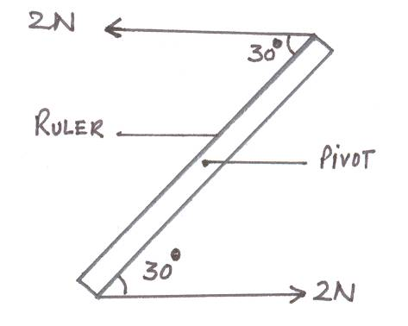
What is the magnitude of the torque of the couple on the ruler when it is in the position shown?

A. 0.15Nm
B. 0.23Nm
C. 0.30Nm
D. 0.60Nm

ix. A body performing SHM has a displacement ‘x’ given by the relation x = 30sin 50t, where ‘t’ is the time in seconds. What is the frequency of its oscillation?

A. 0.13Hz
B. 8.0Hz
C. 30Hz
D. 50Hz

x. In the Young’s double slit arrangement, shown, a pattern of equally spaced parallel fringes appears on a screen placed at S.
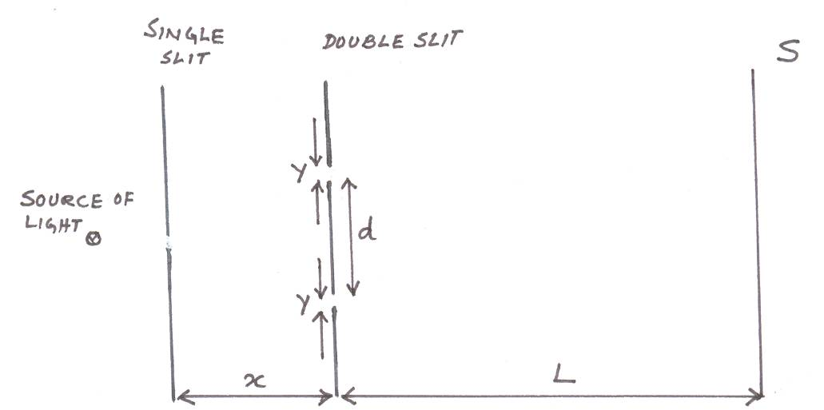

Page 3 of 6 Turn Over
Which quantity, if increased would cause the separation of the fringes to increase?

A. x
B. y
C. d
D. L

xi. Two sources of sound have frequencies f₁ and f₂ respectively, f₁ being slightly greater than f₂, what is the period of the beats heard when the sources operate simultaneously?

A. (f₁-f₂)
B. $\frac{1}{f_{1}−f_{2}}$
C. $\frac{2}{f_{1}−f_{2}}$
D. $\frac{f_{1}−f_{2}}{f_{1}f_{2}}$

xii. In the diagram below, the displacement of an oscillating particle is plotted against time

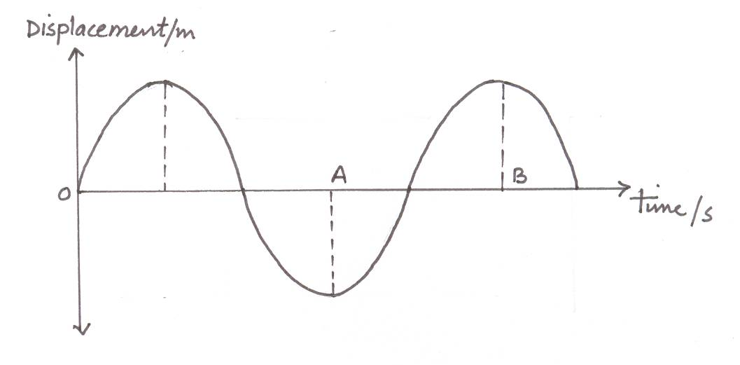

What does the length AB on the time axis represent?

A. half the wavelength.
B. twice the period.
C. half the period.
D. twice the frequency.

Page 4 of 6 Turn Over
xiii. The diagram shows the action of a magnifying glass
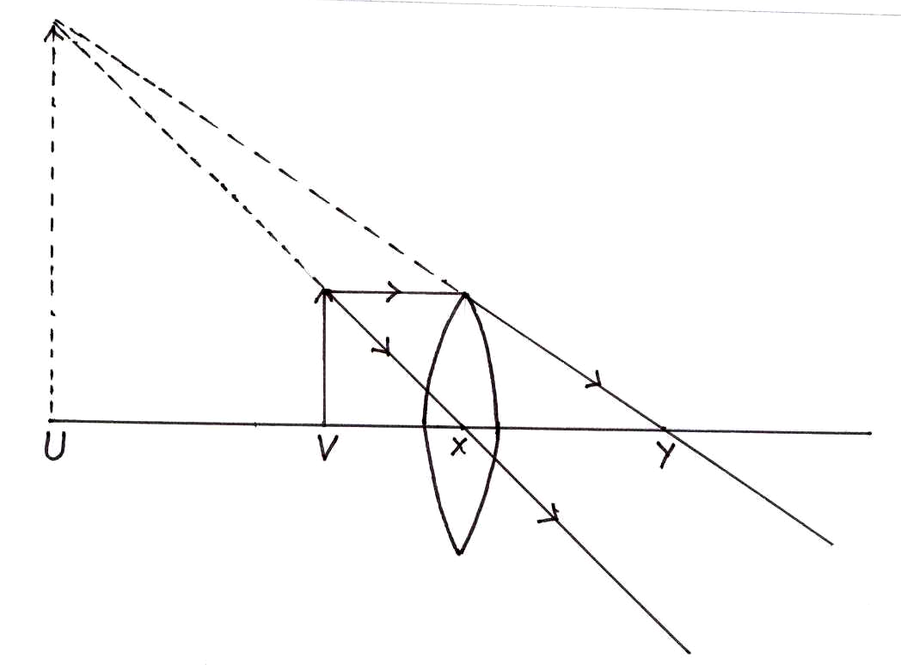
Which point is the principal focus of the magnifying glass?

A. U
B. V
C. X
D. Y

xiv. The minute hand of a large clock is 2.0m long. What is its mean angular speed?

A. 1.0 x 10⁻³ rads⁻¹
B. 1.7 x 10⁻³ rads⁻¹
C. 3.0 x 10⁻³ rads⁻¹
D. 3.5 x 10⁻³ rads⁻¹

xv. An object is acted upon by two forces X and Y. A frictional force F holds the object in equilibrium. Which vector triangle could represent the relationship between these forces?
A. | 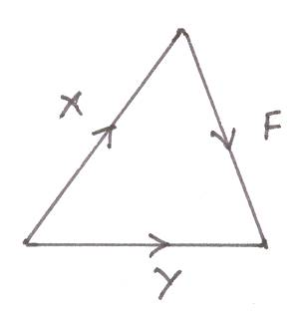 | B. | 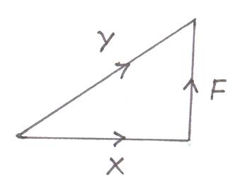
C. | 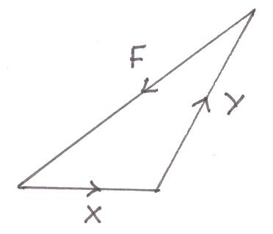 | D. | 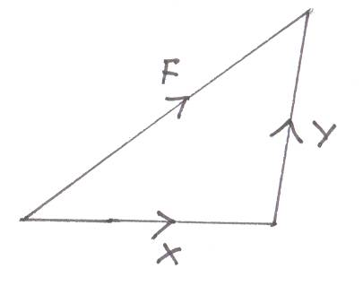

Page 5 of 6 Turn Over
xvi. A sphere has a surface area of 100 sq meters. A second sphere has twice the diameter of the first. Then the ratio
surface area of second sphere | is
surface area of first sphere | is

A. 1/4
B. 1/2
C. 2
D. 4

xvii. A car is moving on a motor way. Point out the correct velocity-time graph which shows zero acceleration of the car.
A. | 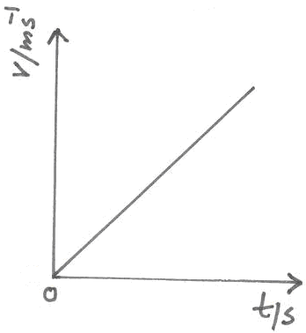 | B. | 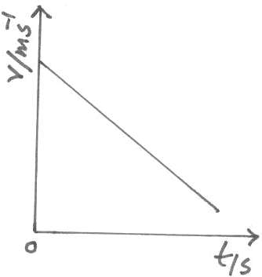
C. | 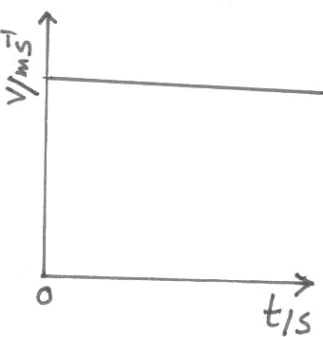 | D. | 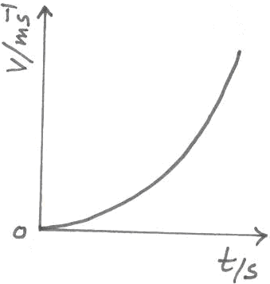

____________________
For Examiner’s use only
17
Q. No.1: Total Marks:

Marks Obtained:

Page 6 of 6
Federal Board HSSC-I Examination
Physics Model Question Paper

Time allowed: 2.35 hours Total Marks: 68

Note: Sections ‘B’ and ‘C’ comprise pages 1-8 and questions therein are to be answered on the separately provided answer book. Answer all the questions from section ‘B’ and section ‘C’. Use supplementary answer sheet i.e., sheet B if required. Write your answers neatly and legibly.

SECTION – B
(42 marks)

NOTE: Attempt ALL the questions. The answer to each question should not exceed 3 to 4 lines.

Q.2 If an object is being moved by a force ‘$\overline{F}$’ through a displacement ‘$\overline{S}$’ in time ‘t’ show that the equation
P | = | work done | can be written as P = $\overline{F}$.$\overline{V}$
P | = | time taken | can be written as P = $\overline{F}$.$\overline{V}$
(2)
Q.3 Can scalar product of two vectors be negative? If your answer is yes, give an example, if no provide a proof. (2)

Q.4 Eating a banana enables a person to perform 4.0 x 10⁴J of work. To what height does eating a banana enable a 60kg man to climb? (2)

Q.5 A man on the ground sees an airplane climbing at an angle of 35° above the horizontal. He gets into his car and by driving at 120kmh⁻¹ is able to stay directly below the airplane. What is the airplane’s speed? (2)

Q.6 What is the weight of a freely falling body? Explain your answer. (2)

Q.7 At what angle, with the horizontal, the range of the projectile becomes half of its R_{max}. (2)

Page 1 of 8 Turn Over
Q.8 Adiabatic process is free of any heat exchange with the surroundings. Yet cooling is produced during adiabatic expansion. Explain. (2)

Q.9 Figure below shows part of a standing wave on a string at t = 0 ms and t = 10 ms, during which time the string has moved from the first position to the second:
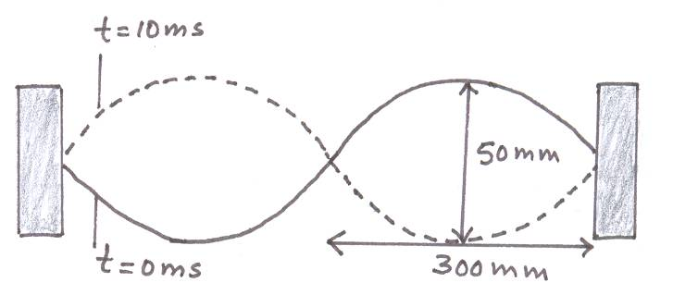

a. What is the period of the oscillation? (1)
b. Calculate the speed of transverse waves on this string. (1)

Q.10 Is the equation v = $\sqrt{\frac{T}{μ}}$dimensionally consistent. (2)
Where
T is the tension in the wire
v is the speed of the wave
$μ$is the mass per unit length of the wire.

Q.11 Water waves of wavelength 4m are produced by two generators S₁ and S₂, as shown. Each generator, when operated by itself, produces waves which have an amplitude A at P, which is 3m from S₁ and 5m from S₂. When the generators are operated in phase, what is the amplitude of oscillation at P? (2)
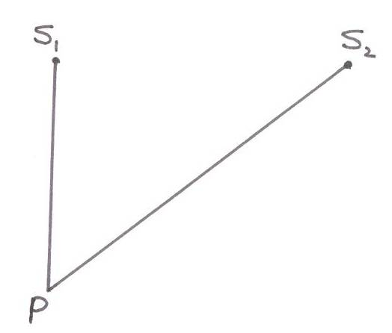

Page 2 of 8 Turn Over
Q.12 Give reasons for the following:
a. A compound microscope should have an objective of short focal length and small aperture. (1)
b. A telescope should have an objective of long focal length and large aperture. (1)

Q.13 The following graph shows the velocity of a sky diver:

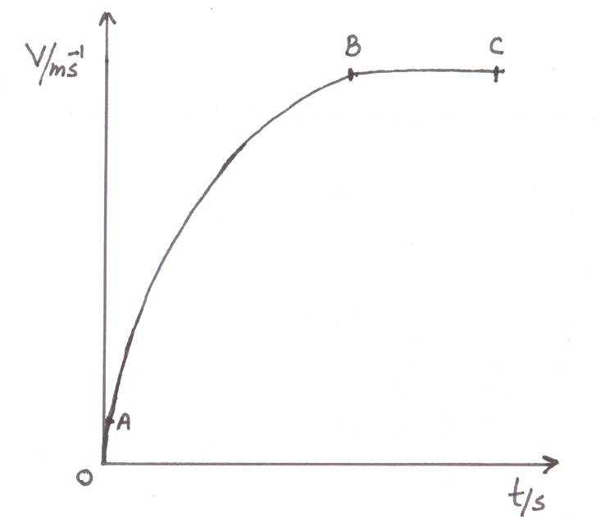

a. What is his acceleration at point ‘A’? (1)
b. Explain the graph from B to C. (1)

Q.14 A 25kg box is pulled up a ramp 10m long and 3.0m high by a constant force of 200N as shown below. If the box starts from rest and has a speed of 2ms⁻¹ at the top, what is the work done against the force of friction? (3)
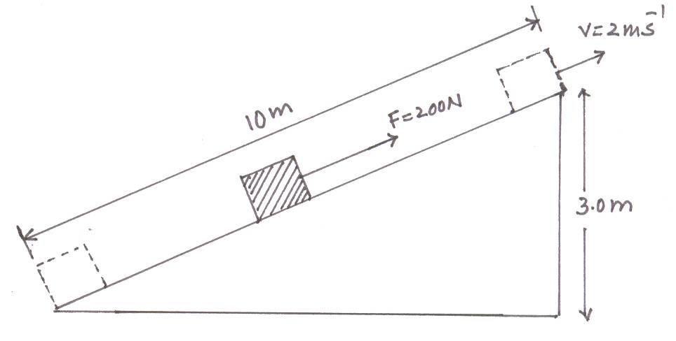
(OR)
A pipe closed at one end is 12cm long. What is the
a. wavelength of 3rd harmonic, (2)
b. frequency of 5th harmonic, (1)
where speed of the sound is 330ms⁻¹.

Page 3 of 8 Turn Over
Q.15 A diffraction grating with 250 lines per mm is placed in front of a monochromatic source of red light. A screen placed 200cm beyond the grating has red light images measured at certain positions on a scale on the screen, as shown in the figure. Use the 1st order spectrum to calculate the wave length of red light. (3)
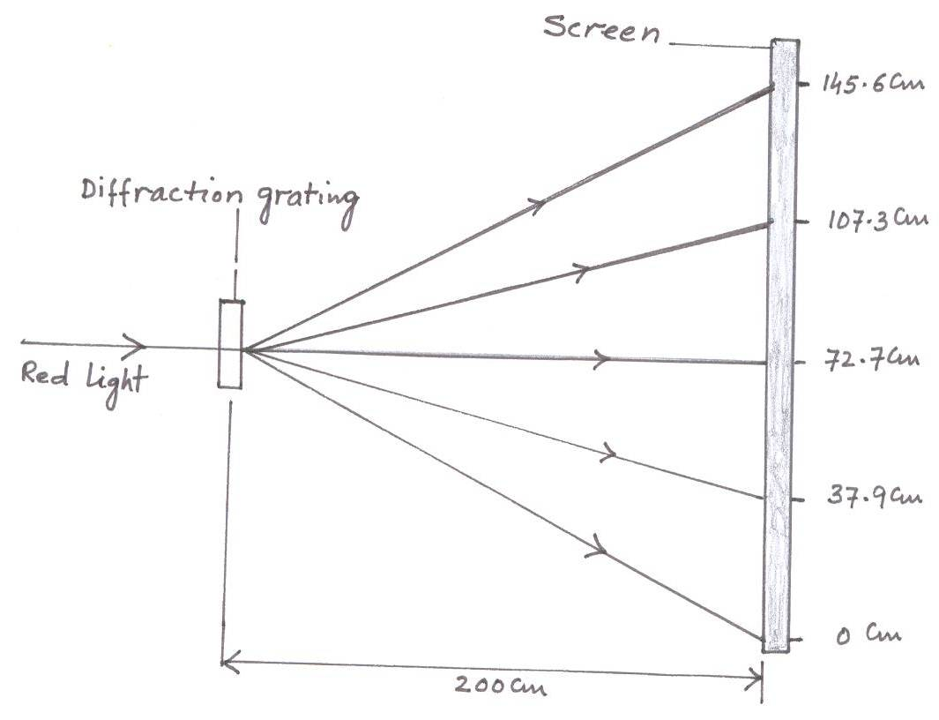
(OR)
Water flows through a hose whose internal diameter is 1cm at a speed of 1ms⁻¹. What should be the diameter of the nozzle if water has to emerge at 21 ms⁻¹? (3)

Q.16 What is the tension ‘T’ in the section of string, as shown in the figure? (3)

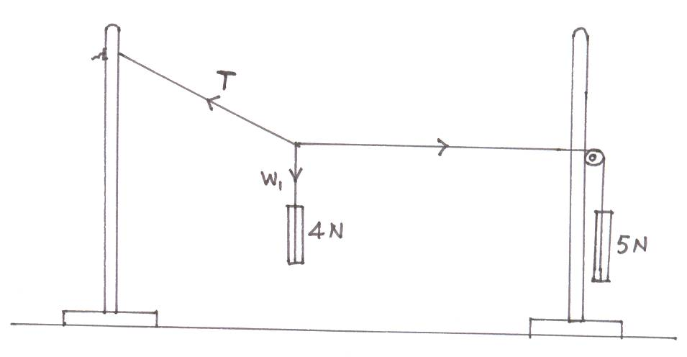
(OR)
For an atom to escape completely from the earth’s gravitational field it must have a speed of approximately 1.1x10⁴ ms⁻¹ at the top of the earth’s atmosphere. Estimate the temperature at the top of the atmosphere, so that helium, assumed to be an ideal gas, escapes from the earth. The mass of helium atom is 6.6x10⁻²⁷kg. (3)

Page 4 of 8 Turn Over
Q.17 Summarize the values of the variables of SHM at different points in the oscillation ABAC, illustrated in the figure for the case of a simple pendulum. (Copy the columns on the answer sheet). (3)

Position  Variable | B | A | C
Displacement
Velocity
Acceleration
Kinetic Energy
Potential Energy

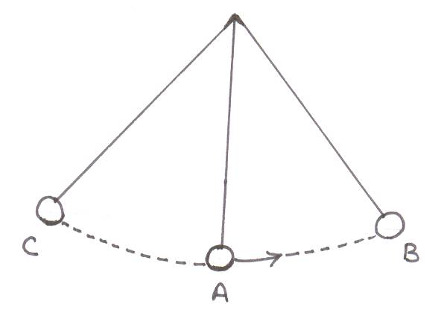
(OR)
A rope whose working strength is 2000N is used to tow a 1000kg car up a 10°incline, as shown in the figure. Find the maximum acceleration that can be given to the car. (3)
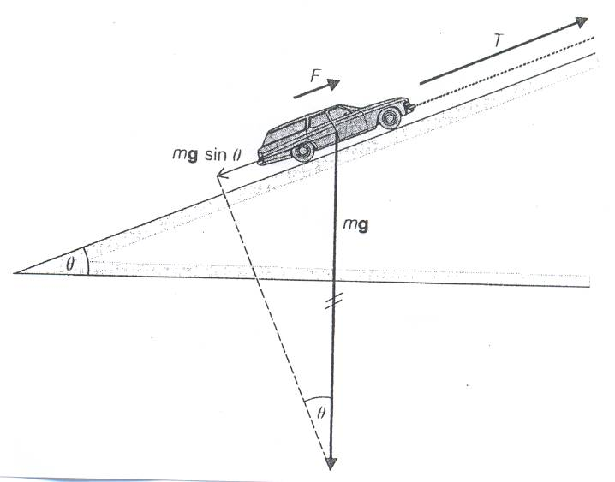

Q.18 A power station has an efficiency of 40% and generates 1000MJ of electrical energy. What is the input and waste energy? (3)
(OR)
An electric motor with an output of 15kw provides power for the elevator of a ten-story building. If the total mass of the loaded elevator is 1000kg, what is the minimum time needed for it to rise the 30m from the ground floor to the top floor? (3)

Page 5 of 8 Turn Over
Q.19 a. Describe the motion from A to B and B to C, shown in the graph. (2)
b. What distance is traveled in first 2 seconds? (1)
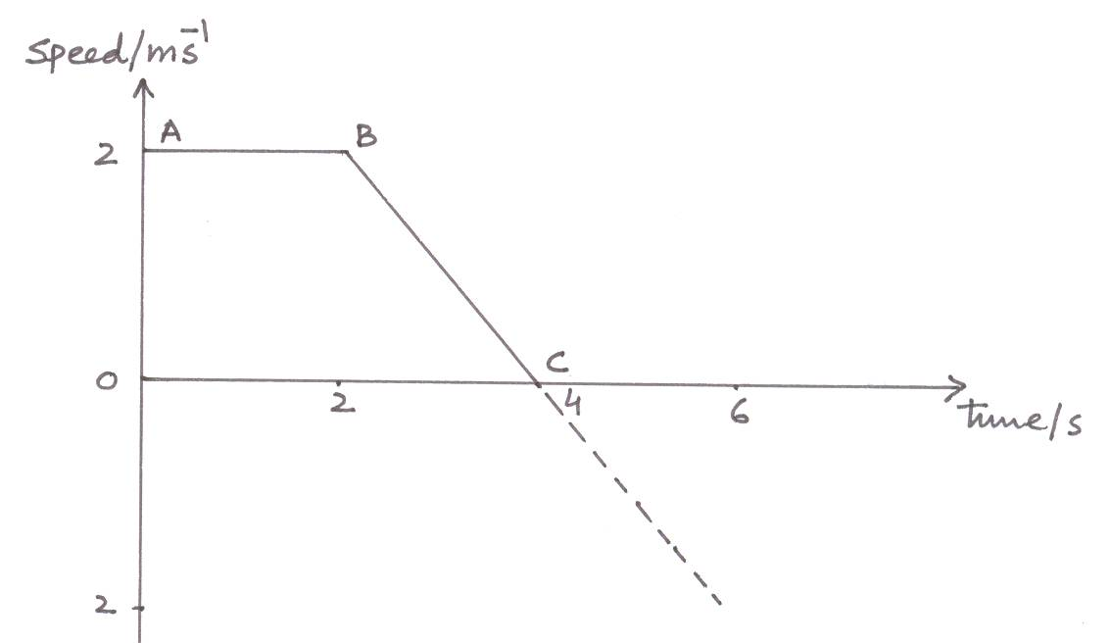
(OR)
What is the critical angle and angle of entry for an optical fibre having core of refractive index 1.50 and cladding of refractive index 1.40, as shown in the figure. (3)
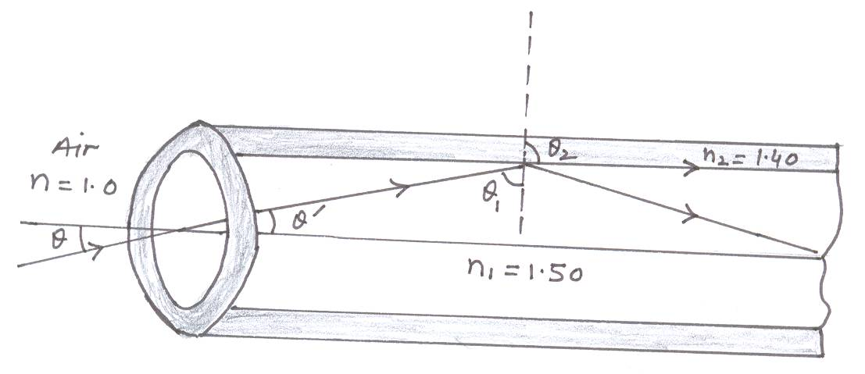

SECTION – C
(Marks: 26)

Note: Attempt ALL the questions.

Q.20 a. Derive expressions for the magnitude and direction of the resultant of two vectors using their rectangular components. (5)
b. If $\overline{A}$ = 3$\overset{}{i}$+ 4$\overset{}{j}$ and $\overline{B}$= 5$\overset{}{i}$ - 3$\overset{}{k}$, show that$|\overline{A}\text{.}\overline{B}|^{2}$+ $|\overline{A}×\overline{B}|^{2}$= $A^{2}B^{2}$ (3)

Q.21 a. Explain projectile motion with suitable examples. Also deduce mathematical expressions for (6)
i. time of flight
ii. range of projectile that has been launched at an angle of 60° with the horizontal.
b. A football is kicked at an angle of 20° with the horizontal giving it a velocity of 50ms⁻¹. Find the maximum horizontal and vertical distances covered by the ball. (2)

Page 6 of 8 Turn Over
Q.22 a. State and explain first law of thermodynamics. (3)
b. Apply first law of thermodynamics to (4)
i. isothermal process
ii. adiabatic process
and draw their P-V graphs.
c. A reversible engine works between two temperatures whose difference is 100°C. If it absorbs 746J of heat from the source and rejects 546J to the sink, calculate the temperature of the source and the sink. (3)
(OR)
a. Define absolute potential energy and derive an expression for the absolute potential energy on the surface of the earth. (6)
b. Derive a relation between orbital radius and period of geostationary satellites. (4)

____________________

Page 7 of 8 Turn Over
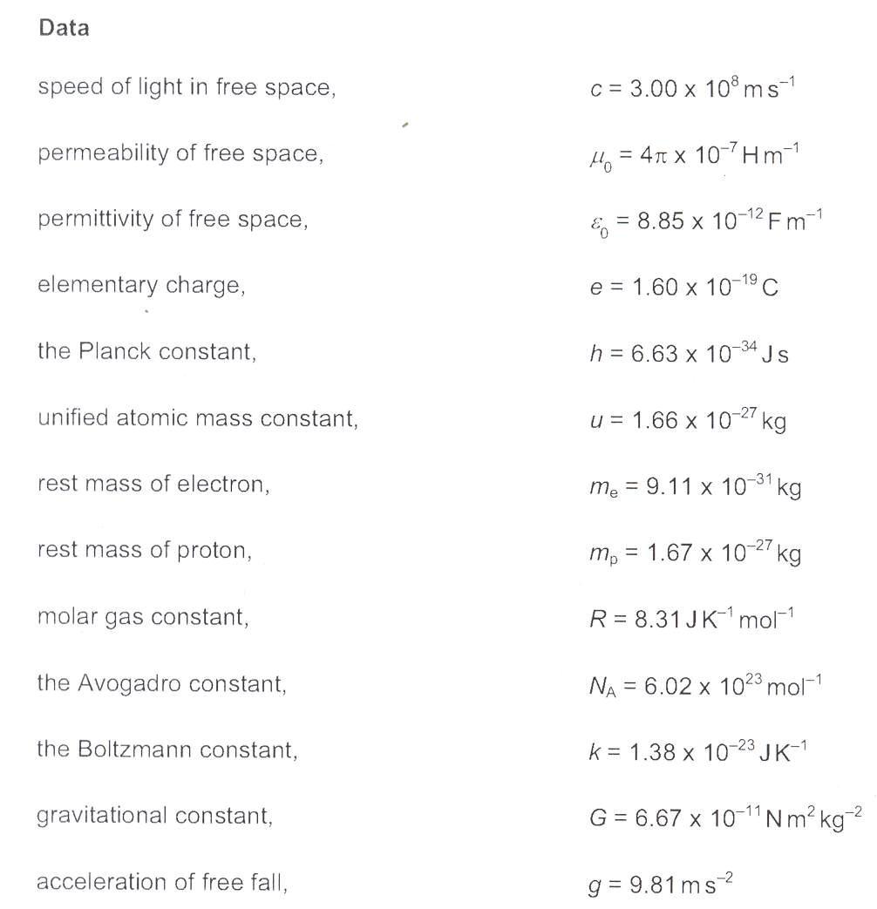

Page 8 of 8
Federal Board HSSC-I Examination
Physics Practical Model Question Paper

Time allowed: 3 hours Marks: 15

NOTE: Perform ONE experiment, as allotted by the examiner. Plot a graph where necessary.

1. To determine the value of ‘g’ by free fall, using an electronic timer/ticker timer. (10)

2. To determine the wavelength of sound in air using stationary waves and to calculate the speed of sound. (10)

3. To find the refractive index of a liquid using a concave mirror. (10)

Practical Notebook (2)

Viva voce (3)

____________________

Page 1 of 1
Federal Board HSSC – I Examination
Physics – Mark Scheme

SECTION A

Q.1
i. B ii. D iii. C
iv. B v. C vi. A
vii. B viii. C ix. B
x. D xi. B xii. C
xiii. D xiv. B xv. C
xvi. D xvii. C
(17x1=17)

SECTION B

Q.2 (2)
Power = | Work done
Power = | time taken
P = $\frac{\overline{F}\text{.}\overline{S}}{t}$ (as work done = $\overline{F}\text{.}\overline{S}$) (1 mark)
P = $\overline{F}\text{.}\frac{\overline{S}}{t}$
as $\frac{\overline{S}}{t}$=$\overline{V}$
then P = $\overline{F}\text{.}\overline{V}$ (1 mark)

Q.3 (2)
Yes, scalar product of two vectors be negative when the angle ‘θ’ between them is 90°< θ≤180°.
(also accept $\overline{A}\text{.}\overline{B}$= $\text{AB}$cos 180° = $−\text{AB}$) (1 mark)
Example i. work done by force of friction
ii. work done by gravity when an object is raised to a certain height. (1 mark)

Q.4 (2)
Energy (PE) = 4.010⁴J
m = 60kg
PE = mgh (1 mark)
h = $\frac{\text{PE}}{\text{mg}}$ = $\frac{4\text{.}0×{\text{10}}^{4}}{\text{60}×9\text{.}8}$= $\frac{4\text{.}0×{\text{10}}^{4}}{\text{588}}$= 68m (1 mark)

Q.5 (2)
Speed of the car = V = 120kmh⁻¹
θ = 35°
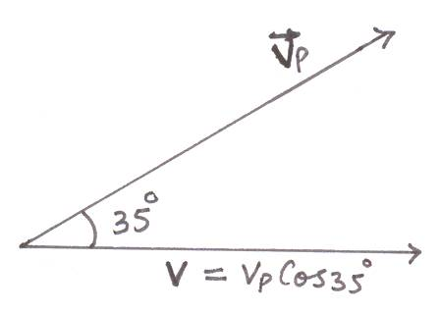 (1 mark)
Let V_{p} is the speed of the airplane
speed of the car = V = V_{p} Cos θ (as V_{x} = V Cos θ)
V_{p} = $\frac{V}{\text{Cos}θ}$= $\frac{\text{120}{\text{kmh}}^{−1}}{\text{Cos}\text{35}°}$= 146.5 km h⁻¹
or 40.7ms⁻¹ (1 mark)

Q.6 (2)
Body will be weightless i.e. T = 0
Equation of motion of a body of mass ‘m’ moving downward in an elevator with acceleration ‘a’ is
T = mg – ma (1 mark)
Where T is the apparent weight of the body
If the body is falling freely then a = g
therefore T = 0 (1 mark)

Q.7 (2)
R = $\frac{R_{\text{max}}}{2}$ (Given condition)
$\frac{{\text{Vi}}^{2}\text{Sin}2θ}{g}$= $\frac{{\text{Vi}}^{2}g}{2}$ (1 mark)
Sin2θ = $\frac{1}{2}$= 0.5
2θ = Sin⁻¹0.5 = 30°
θ = 15° and 75° (because range is same for complementary angles) (1 mark)

Q.8 (2)
According to 1st law of thermodynamics
Q = ΔU + W
$∵$Q = 0 (for an adiabatic process)
$∴$W = – ΔU (1 mark)

Since the gas expands and does external work at the cost of its internal energy so it cools down. (1 mark)

Q.9 (2)
a. Period of oscillation T = 20 ms = 20 ${\text{10}}^{−3}$s = 2 ${\text{10}}^{−2}$s (1 mark)
b. T = 20 ms = 20 10⁻³s
λ = 600mm = 60010⁻³m
V = $fλ$ (as f = $\frac{1}{T}$)
$⇒$V = $\frac{1}{T}×$ λ = $\frac{1}{2×{\text{10}}^{−2}}×$ 60010⁻³
V = 30ms⁻¹ (1 mark)

Q.10 (2)
L.H.S dimensions of v = [LT⁻¹] (1 mark)
R.H.S dimensions of $\sqrt{\frac{T}{μ}}$ = ${\left[\frac{{\text{MLT}}^{−2}}{{\text{ML}}^{−1}}\right]}^{12}$= ${\left[L^{2}T^{−2}\right]}^{12}$ = $\left[{\text{LT}}^{−1}\right]$
L.H.S = R.H.S (1 mark)
also accept
Since v = $\sqrt{\frac{T}{μ}}$
$\left[{\text{LT}}^{−1}\right]$ = ${\left[\frac{{\text{MLT}}^{−2}}{{\text{ML}}^{−1}}\right]}^{12}$ (1 mark)
$\left[{\text{LT}}^{−1}\right]$ = ${\left[L^{2}T^{−2}\right]}^{12}$
$\left[{\text{LT}}^{−1}\right]$ = $\left[{\text{LT}}^{−1}\right]$
L.H.S = R.H.S (1 mark)

Q.11 (2)
Wavelength of the waves = λ = 4m
Path difference = S₂P – S₁P = 5m – 3m = 2m (1 mark)
S₂P – S₁P = 2m = $\frac{2}{2}×2m$ = $\frac{4m}{2}$ = $\frac{λ}{2}$
$⇒$Path difference = $\frac{λ}{2}$ (This is the condition of destructive interference)
Therefore amplitude = 0 (1 mark)

Q.12 (2)
a. For greater resolving power. (1 mark)
b. For brighter image. (1 mark)

Q.13 (2)
a. Acceleration at A = max ≈ g = 9.8 ms⁻² (1 mark)
b. From B to C sky diver moves with uniform velocity i.e. with terminal velocity therefore acceleration is zero. (1 mark)

Q.14 (3)
m = 25kg
d = 10m
h = 3.0m
F = 200N
v at the top = 2 ms⁻¹ (1 mark)
using work energy principle
work done = ΔKE + ΔPE + work done against friction
Fd = $\frac{1}{2}{\text{mv}}^{2}$+ mgh + work done against friction (1 mark)
200 10 = 50 + 25 9.8 3 + work done against friction
Work done against friction = 2000 – 785 = 1215J (1 mark)
(OR)
Speed of the wave = v = 330 ms⁻¹
Length of the pipe = $l$ = 12cm = 0.12m
Wavelength of 3rd harmonic = λ₃ = ?
Frequency of 5th harmonic = f₅ = ? (1 mark)
a. $\frac{λ_{3}}{4}+\frac{λ_{3}}{2}+\frac{λ_{3}}{2}$ = $l$
$\frac{5λ_{3}}{4}$= $l$ $⇒$λ₃ = $\frac{4l}{5}$= 0.096m = 9.6cm (1 mark)
b. v = f₅ λ₅
as $\frac{9λ_{5}}{4}$ = $l$$⇒$ λ₅ = $\frac{4l}{9}$
v = f₅ $\frac{4l}{9}$
f₅ = $\frac{9V}{4l}$ = $\frac{9×\text{330}}{4×0\text{.}\text{12}}$= 6187.5 HZ (1 mark)

Q.15 (3)
N = 250 lines/mm
for 1st order n = 1
screen distance L = 200cm
sin θ = $\frac{(\text{107}\text{.}3−\text{72}\text{.}7)\text{cm}}{\text{200}\text{cm}}$
sin θ = 0.173 (1 mark)
d = $\frac{1}{N}$= $\frac{1}{\text{250}}\text{mm}$ = $\frac{1}{\text{250}}×{\text{10}}^{−3}m$ = 4 10⁻⁶m (1 mark)
since d sin θ = $nλ$
$λ$ = $\frac{d \text{sin} θ}{n}$ = $\frac{4×{\text{10}}^{−6}×0\text{.}\text{173}}{1}$
$λ$ = 6.92 10⁻⁷m
$λ$ = 692nm (1 mark)

(OR)

d₁ = 1 cm = 0.01m
v₁ = 1ms⁻¹
d₂ = ?
v₂ = 21ms⁻¹
Since A₁v₁ = A₂v₂ ($∵ A = π r^{2}$) (1 mark)
$r_{1}^{2}$v₁ = $r_{2}^{2}$v₂
$d_{1}^{2}$ v₁ = $d_{2}^{2}$v₂ $⇒$ d₂ = $\sqrt{\frac{V_{1}}{V_{2}}}$d₁ ($∵ r = \frac{d}{2}$) (1 mark)
d₂ = $\sqrt{\frac{1}{\text{21}}}×0\text{.}\text{01}$ = 2.18 10⁻³m ≈ 0.22 cm (1 mark)

Q.16 (3)
F_{H} = 5N
F_{v} = 4N
T = ?
T = $\sqrt{F_{H}^{2}+F_{v}^{2}}$ (1 mark)
T = $\sqrt{5^{2}+4^{2}}$N
T = $\sqrt{\text{41}}$N
T = 6.4N (1 mark)

Direction of T
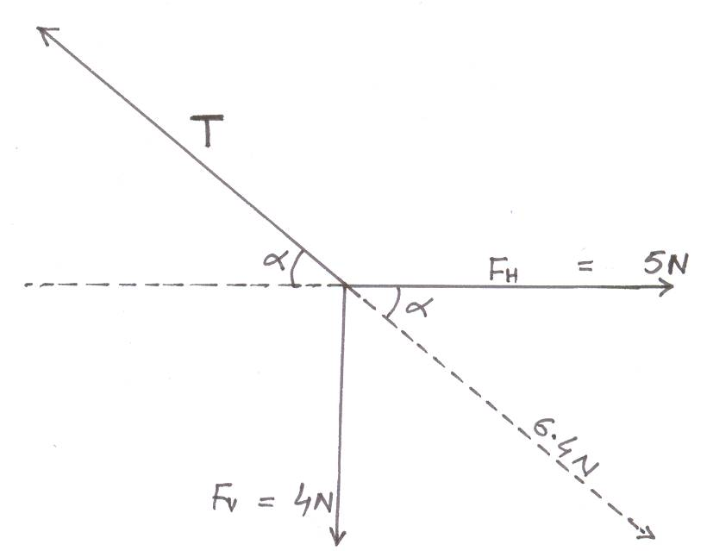
tan= $\frac{4}{5}$ = 0.8 $⇒$ = tan⁻¹0.8
= 38.7⁰ (1 mark)
(OR)
v = 1.1 10⁴ms⁻¹
m = 6.6 10⁻²⁷kg
k = 1.38 10⁻²³Jk⁻¹ (1 mark)
T = $\frac{2}{3k}<\frac{1}{2}{\text{mv}}^{2}>$ (1 mark)
T = $\frac{6\text{.}6×{\text{10}}^{−\text{27}}×(1\text{.}1×{\text{10}}^{4})^{2}}{3×1\text{.}\text{38}×{\text{10}}^{−\text{23}}}$
T = 1.9 10⁴K (1 mark)

Q.17 (3)

Position  Variable | B | A | C
Displacement | max | 0 | max
Velocity | 0 | max | 0
Acceleration | max | 0 | max
Kinetic Energy | 0 | max | 0
Potential Energy | max | 0 | max
Column B, all correct answers (1 mark)
Column A, all correct answers (1 mark)
Column C, all correct answers (1 mark)
(OR)
T = 2000N
m = 1000kg
θ = 10°
T – mg sin θ = F (1 mark)
T – mg sin θ = ma
a = $\frac{T−\text{mg} \text{sin} θ}{m}$ = $\frac{T}{m}−g \text{sin} θ$
a = $\frac{\text{2000}}{\text{1000}}−9\text{.}8 \text{sin} \text{10}°$
a = 2 – 9.8 0.1736 (as sin 10° = 0.1736)
a = 2 – 1.7017
a = 0.298 ms⁻²
a ≈ 0.3 ms⁻² correct answer with correct units (2 marks)

Q.18 (3)
Output = 1000MJ
Efficiency = η (%) = 40%
η = $\frac{\text{40}}{\text{100}}$ = 0.4
input = ?
waste energy = ?
η = $\frac{\text{output}}{\text{input}}$ (1 mark)
input = $\frac{\text{output}}{η}$
input = $\frac{\text{1000}\text{MJ}}{0\text{.}4}$= 2500MJ (1 mark)
waste energy = input – output
= 25000MJ – 1000MJ
= 1500MJ or 1.5 10⁹J (1 mark)
(OR)
output power = P = 15KW = 15 10³W
mass of loaded elevator = m = 1000kg
height of the building = h = 30m
time taken = t = ?
Power = $\frac{\text{work}}{\text{time} \text{taken}}$ = $\frac{\text{mgh}}{t}$ (1 mark)
t = $\frac{\text{mgh}}{P}$
t = $\frac{\text{1000}×9\text{.}8×\text{30}}{\text{15}×{\text{10}}^{3}}$ = 19.6 s
correct answer with correct units (2 marks)

Q.19 (3)
a. From A to B object moves with uniform speed of 2ms⁻¹ (1 mark)
From B to C object moves with uniform deceleration (1 mark)
b. Distance covered = area under v – t graph
Distance covered = 22 = 4m (1 mark)

also accept:
d = V_{av} t = $\left(\frac{\text{Vi}+\text{Vf}}{2}\right) t$ = $\left(\frac{2+2}{2}\right)×2$= 4 m
(OR)
For core and cladding
Using n₁ sin θ₁ = n₂ sin θ₂
n₁ = 1.5
n₂ = 1.4
θ₂ = 90°
θ₁ = θ_{c}
sin θ_{c} = $\frac{n_{2} \text{sin} θ_{2}}{n_{1}}$ = $\frac{1\text{.}4× \text{sin} \text{90}°}{1\text{.}5}$
sin θ_{c} = 0.9333
θ_{c} = sin⁻¹ (0.933) ≈ 69° (1 mark)
For air and core
n sin θ = n₁ sin θ'
n = 1.0
θ = ?
θ' = 90° – 69° = 21°
n₁ = 1.5 (1 mark)
sin θ = $\frac{n_{1} \text{sin} θ^{'}}{n}$ = $\frac{1\text{.}5 \text{sin} \text{21}°}{1}$ = 0.53
θ = sin⁻¹ (0.53)
θ = 32.5° (1 mark)

SECTION C

Q.20 (8)
a. | 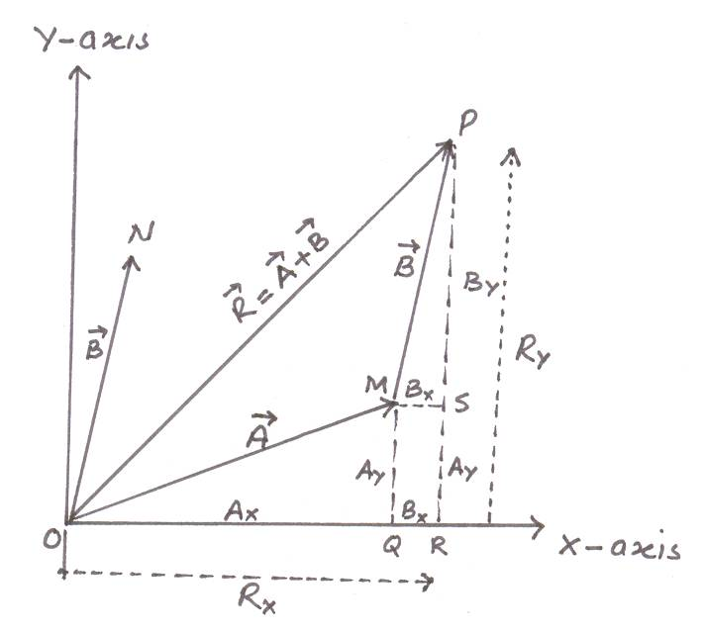
Properly labeled figure and rectangular components of individual vectors (explanation required) (2 marks)
Expression of magnitude of the resultant vector (2 marks)
Direction of the resultant vector (1 mark)
b. $\overline{A}$ = 3$\overset{}{i}$+ 4$\overset{}{j}$ and $\overline{B}$= 5$\overset{}{i}$ - 3$\overset{}{k}$
$\overline{A}\text{.}\overline{B}$ = (3$\overset{}{i}$+ 4$\overset{}{j}$).(5$\overset{}{i}$ - 3$\overset{}{k}$)
= 15
$|\overline{A}\text{.}\overline{B}|^{2}$ = 15² = 225 (1 mark)
$\overline{A}×\overline{B}$ = $\left|\begin{matrix}\overset{}{i} & \overset{}{j} & \overset{}{k} \\ 3 & 4 & 0 \\ 5 & 0 & −3\end{matrix}\right|$
= $\overset{}{i}$(-12) – $\overset{}{j}$(-9) + $\overset{}{k}$(-20)
= -12$\overset{}{i}$ + 9$\overset{}{j}$ - 20$\overset{}{k}$
$|\overline{A}×\overline{B}|^{2}$= (-12)² + (9)² + (-20)²
= 144 + 81 + 400 = 625 (1 mark)
$|\overline{A}\text{.}\overline{B}|^{2}$+ $|\overline{A}×\overline{B}|^{2}$ = 225 + 625 = 850
$A^{2}$ = (3)² + (4)² = 9 + 16 = 25
$B^{2}$ = 5² + (-3)² = 25 + 9 = 34
$A^{2}B^{2}$ = 25 34 = 850
$|\overline{A}\text{.}\overline{B}|^{2}$+ $|\overline{A}×\overline{B}|^{2}$= $A^{2}B^{2}$ (Proved) (1 mark)

Q.21 (8)

a. | 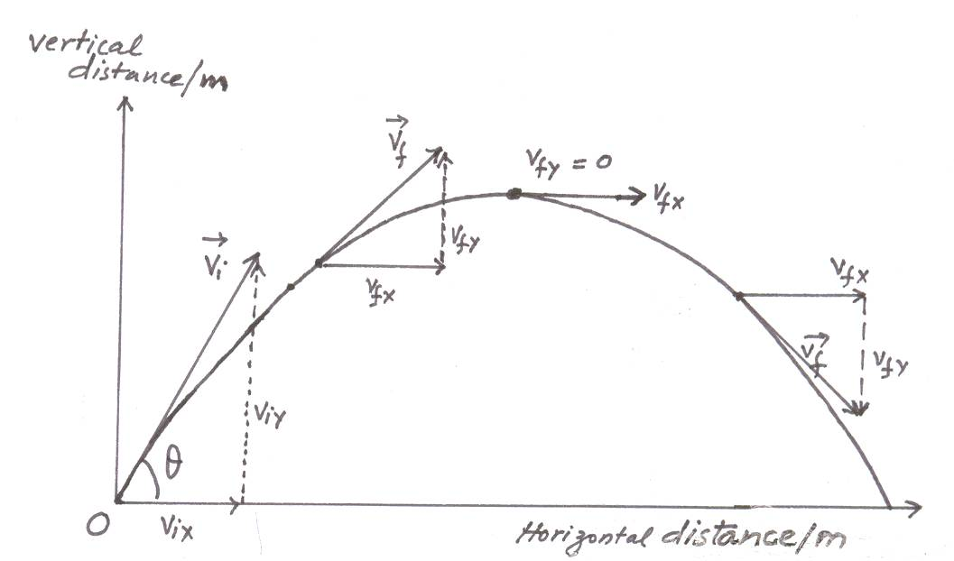
Figure, definition, examples and explanation (2 marks)
Time of flight (2 marks)
Range of the Projectile (2 marks)
b. Angle of inclination = θ = 20°
Initial velocity = v_{i} = 20 m/s
Maximum vertical distance = H = ?
Maximum horizontal distance = R = ?
H = $\frac{V_{i}^{2} {\text{sin}}^{2} θ}{2g}$ = $\frac{(\text{50})^{2}(\text{sin} {\text{20}}^{0})^{2}}{2×9\text{.}8}$ = $\frac{\text{2500}×0\text{.}\text{117}}{2×9\text{.}8}$ = 14.9 ≈ 15m (1 mark)
R = $\frac{{\text{Vi}}^{2}}{g}\text{sin} 2θ$ = $\frac{(\text{50})^{2}}{9\text{.}8}\text{sin}(2×\text{20}°)$ = 163.9 ≈ 164m (1 mark)

Q.22 (10)
a. Statement of 1st law of thermodynamics with mathematical
relation (1 mark)
Explanation of the law (2 marks)
b. Explanation of isothermal process with P–V graph (2 marks)
Explanation of adiabatic process with P–V graph (2 marks)
c. Temperature difference between the source and the sink = T₁ – T₂ = 100°C = 100K
Heat absorbed from the source = Q₁ = 746J
Heat rejected to the sink = Q₂ = 546J

First Method:
η = $\frac{Q_{1}−Q_{2}}{Q_{1}}$ = $\frac{\text{746}−\text{546}}{\text{746}}$
$⇒$ η = 0.268 (1 mark)
Now η = $\frac{T_{1}−T_{2}}{T_{1}}$
Since T₁ – T₂ = 100k
$∴$ η = $\frac{\text{100}}{T_{1}}$ $⇒$ T₁ = $\frac{\text{100}}{0\text{.}\text{268}}$ = 373k = 100°C (1 mark)
and T₂ = T₁ – 100 = 273k = 0°C (1 mark)

Second Method:
$\frac{Q_{1}}{Q_{2}}$ = $\frac{T_{1}}{T_{2}}$$⇒$ T₂ = T₁ $\frac{Q_{2}}{Q_{1}}$ = (T₂ + 100) $\frac{θ_{2}}{θ_{1}}$ (1 mark)
T₂ = T₂ $\frac{Q_{2}}{Q_{1}}$ + 100$\frac{Q_{2}}{Q_{1}}$
T₂ = T₂ $\frac{\text{546}}{\text{746}}$ + 100$\frac{\text{546}}{\text{746}}$
T₂ = 0.73T₂ + 73.2
$⇒$ T₂ (1-0.73) = 73.2 (1 mark)
$⇒$ T₂ = $\frac{\text{73}\text{.}2}{0\text{.}\text{27}}$ $⇒$ T₂ = 271.1 ≈ 271k = -2°C
T₁ = T₂ + 100 = 371k = 98°C (1 mark)
(OR)
a. Definition of absolute potential energy (1 mark)
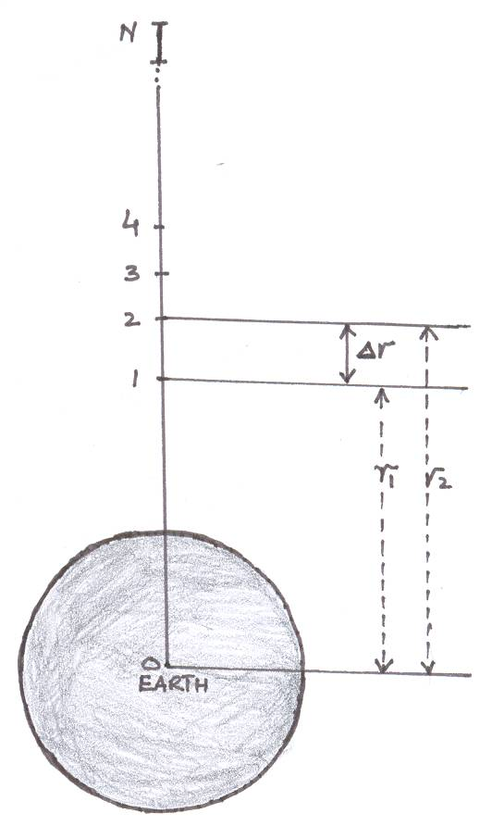
Figure, assumptions and explanation (1 mark)
Derivation steps (3 marks)
Absolute potential energy on the surface of the earth (1 mark)
b. Explanation and derivation of relation for velocity (1 mark)
Derivation for orbital radius (2 marks)
Relationship between orbital radius and the time period
(i.e. r$t^{23}$) (1 mark)

