SCHEME OF STUDIES
FOR HSSC (CLASSES XI–XII)

COMPULSORY FOR ALL (500 marks)
1. English (Compulsory)/ English (Advance) 2 papers 200 marks

2. Urdu (Compulsory)/ Urdu Salees In lieu of Urdu 2 papers 200 marks
(Compulsory)/ Pakistan Culture for Foreign
Students Part – I and Pakistan Culture Paper-II

3. Islamic Education/Civics (for Non-Muslims) 1 paper 50 marks

4. Pakistan Studies 1 paper 50 marks

SCIENCE GROUP (600 marks)
The students will choose one of the following (A), (B) and (C) Groups carrying 600 marks:

(A) Pre-Medical Group:
Physics, Chemistry, Biology

(B) Pre-Engineering Group:
Physics, Chemistry, Mathematics

(C) Science General Group:
1. Physics, Mathematics, Statistics
2. Mathematics, Economics, Statistics
3. Economics, Mathematics, Computer Science
4. Physics, Mathematics, Computer Science
5. Mathematics, Statistics, Computer Science

HUMANITIES GROUP (600 marks)
Select three subjects of 200 marks each from the following:
S. No. | Subject | S. No. | Subject
1. | Arabic/Persian/French/English (Elective)/Urdu (Elective) | 10.  11. | Sindhi (Elective)  Civics
2. | Economics | 12. | Education
3. | Fine Arts | 13. | Geography
4. | Philosophy | 14. | Sociology
5. | Psychology | 15. | Mathematics
6. | Statistics | 16. | Computer Science
7. | History of Modern World/Islamic History/ History of Muslim India/ History of Pakistan | 17.  18. | Islamic Culture  Library Science
8. | Islamic Studies | 19. | Outlines of Home Economics
9. | Health and Physical Education | 19. | Outlines of Home Economics

COMMERCE GROUP (600 marks)

HSSC – I
1. Principles of Accounting paper – I 100 marks
2. Principles of Economics paper – I 75 marks
3. Principles of Commerce paper – I 75 marks
4. Business Mathematics paper – I 50 marks

HSSC – II
1. Principles of Accounting paper – II 100 marks
2. Commercial Geography paper – II 75 marks
3. Computer Studies/Typing/Banking paper – II 75 marks
4. Statistics paper – II 50 marks

MEDICAL TECHNOLOGY GROUP (600 marks each)
1. Medical Lab Technology Group
2. Dental Hygiene Technology Group
3. Operation Theater Technology Group
4 Medical Imaging Technology Group
5. Physiotherapy Technology Group
6. Ophthalmic Technology Group

AIMS AND OBJECTIVES OF EDUCATION POLICY
(1998 – 2010)

AIMS

Education is a powerful catalyzing agent which provides mental, physical, ideological and moral training to individuals, so as to enable them to have full consciousness of their mission, of their purpose in life and equip them to achieve that purpose. It is an instrument for the spiritual development as well as the material fulfillment of human beings. Within the context of Islamic perception, education is an instrument for developing the attitudes of individuals in accordance with the values of righteousness to help build a sound Islamic society.

After independence in 1947 efforts were made to provide a definite direction to education in Pakistan. Quaid-i-Azam Muhammad Ali Jinnah laid down a set of aims that provided guidance to all educational endeavours in the country. This policy, too has sought inspiration and guidance from those directions and the Constitution of Islamic Republic of Pakistan. The policy cannot put it in a better way than the Quaid’s words:

“You know that the importance of Education and the right type of education, cannot be overemphasized. Under foreign rule for over a century, sufficient attention has not been paid to the education of our people and if we are to make real, speedy and substantial progress, we must earnestly tackle this question and bring our people in consonance with our history and culture, having regard for the modern conditions and vast developments that have taken place all over the world.”

“There is no doubt that the future of our State will and must greatly depend upon the type of education we give to our children, and the way in which we bring them up as future citizens of Pakistan. Education does not merely mean academic education. There is immediate and urgent need for giving scientific and technical education to our people in order to build up our future economic life and to see that our people take to science, commerce, trade and particularly well-planned industries. We should not forget, that we have to compete with the world which is moving very fast towards growth and development.”

“At the same time we have to build up the character of our future generation. We should try, by sound education, to instill into them the highest sense of honour, integrity, responsibility and selfless service to the nation. We have to see that they are fully qualified and equipped to play their part in various branches of national life in a manner which will do honour to Pakistan.”

These desires of the Quaid have been reflected in the Constitution of the Islamic Republic of Pakistan and relevant articles are:

The state shall endeavour, in respect of the Muslims of Pakistan:
- to make the teachings of the Holy Quran and Islamiat compulsory and encourage and facilitate the learning of Arabic language to secure correct and exact printing and publishing of the Holy Quran;

- to promote unity amongst them and the observance of Islamic moral standards;

Provide basic necessities of life, such as food, clothing, housing, education and medical relief for all such citizens irrespective of sex, caste, creed or race as are permanently or temporarily unable to earn their livelihood on account of infirmity, sickness or unemployment;

Remove illiteracy and provide free and compulsory secondary education within minimum possible period.

Enable the people of different areas, through education, training, agricultural and industrial development and other methods, to participate fully in all the forms of national activities including employment in the service of Pakistan;

The State shall discourage parochial, racial, tribal, sectarian and provincial prejudices among the citizens.

Reduce disparity in the income and earnings of individuals, including persons in various classes of the service of Pakistan.

Steps shall be taken to ensure full participation of women in all the spheres of national life.

The vision is to transform Pakistani nation into an integrated, cohesive entity, that can compete and stand up to the challenges of the 21st Century. The Policy is formulated to realize the vision of educationally well-developed, politically united, economically prosperous, morally sound and spiritually elevated nation.

OBJECTIVES

To make the Qur’anic principles and Islamic practices as an integral part of curricula so that the message of the Holy Quran could be disseminated in the process of education as well as training. To educate and train the future generation of Pakistan as true practicing Muslims who would be able to usher in the 21st century and the next millennium with courage, confidence, wisdom and tolerance.

To achieve universal primary education by using formal and informal techniques to provide second opportunity to school drop-outs by establishing basic education community schools all over the country.

To meet the basic learning needs of a child in terms of learning tools and contents.

To expand basic education qualitatively and quantitatively by providing the maximum opportunities to every child of free access to education. The imbalances and disparities in the system will be removed to enhance the access with the increased number of more middle and secondary schools.

To ensure that all the boys and girls, desirous of entering secondary education, get their basic right through the availability of the schools.

To lay emphasis on diversification of curricula so as to transform the system from supply-oriented to demand oriented. To attract the educated youth to world-of-work from various educational levels is one of the policy objectives so that they may become productive and useful citizens and contribute positively as members of the society.

To make curriculum development a continuous process; and to make arrangements for developing a uniform system of education.

To prepare the students for the world of work, as well as pursuit of professional and specialized higher education.

To increase the effectiveness of the system by institutionalizing in-service training of teachers, teacher trainers and educational administrators. To upgrade the quality of pre-service teacher training programmes by introducing parallel programmes of longer duration at post-secondary and post-degree levels.

To develop a viable framework for policy, planning and development of teacher education programmes, both in-service and pre-service.

To develop opportunities for technical and vocational education in the country for producing trained manpower, commensurate with the needs of industry and economic development goals.

To improve the quality of technical education so as to enhance the chances of employment of Technical and Vocational Education (TVE) graduates by moving from a static, supply-based system to a demand-driven system.

To popularize information technology among students of all ages and prepare them for the next century. To emphasize different roles of computer as a learning tool in the classroom learning about computers and learning to think and work with computers and to employ information technology in planning and monitoring of educational programmes.

To encourage private sector to take a percentage of poor students for free education.

To institutionalize the process of monitoring and evaluation from the lowest to the highest levels. To identify indicators for different components of policy, in terms of quality and quantity and to adopt corrective measures during the process of implementation.

To achieve excellence in different fields of higher education by introducing new disciplines/emerging sciences in the universities, and transform selected disciplines into centres of advanced studies, research and extension.

To upgrade the quality of higher education by bringing teaching, learning and research process in line with international standards.

OBJECTIVES OF ECONOMICS SYLLABUS

OBJECTIVES
- To enable the students to become responsible and productive citizens.
- To familiarize the students with the basic philosophy of Islamic Economics System Zakat, Usher and Charity in poverty alleviation and income generation.
- To highlight factors, which further the economics development of Pakistan thereby ensuring better quality of life, greater employment opportunities and increased output.
- To develop amongst the students a sense of responsibility, spirit of honesty, dignity of labour and earning one’s living by fair means.
- To enable the students to appreciate the difference between the various economics system and comprehend the basic economic philosophy of Islam.
- To inculcate among students the spirit of honesty, taking care of the dignity of labour, and their civic responsibilities i.e. to earn their living by fair means which will ultimately lead towards the society based on equity, positive attitude towards National cohesion and State Integrity.
- To inculcate in students the gratitude to Allah Almighty for His all blessings.

OBJECTIVES, CONCEPTS, CONTENTS, ACTIVITIES AND EVALUATION OF ECONOMICS SYLLABUS

I. Nature and Scope of Economics

Objectives | Concepts | Contents | Activities | Evaluation
Cognitive:  To define Economics.  Affective:  To become efficient about basic concepts of economics.  Psychomotor:  To take part in economics discussion effectively | - Nature and scope of economics.  - Definition and law of Economics | A. Introduction  1. Wants and satisfaction  2. Goods and services  3. Utility and scarcity  4. Economic problems and its nature.  5. Definition by:  a) Adam Smith  b) Alfred Marshall  c) Loonier Robbins.  B. Meaning of:  1. Micro Economics, Macroeconomics, Positive and normative economics.  2. Economic laws and their nature. | - Group discussion.  - Quiz  - Open book test.  - Homework.  - Debate on the importance of Economics. | - Teacher should take frequent class tests queries and inform the students about their mistakes.  - Question/ answer techniques  - Essay/ objective type tests.

II. Consumer’s Behaviour and its Analysis

Objectives | Concepts | Contents | Activities | Evaluation
Cognitive:  To understand the consumer’s behaviour concepts.  Affective:  To familiarize with economizing behaviour.  Psychomotor:  - To make/  Charts, tables and figures.  - To represent the concepts graphically. | - Consumer’s behaviour.  - Utility approach.  - Indifference curve. | - Definition  - Meaning  - Rationale  - The law of administrative marginal utility with table and graph.  - The law of equimarginal utility or law of substitution with formula and diagram.  - Indifference curve.  - Definitions and Characteristics (graphical presentation). | - General discussion.  - Graphical explanation on blackboard by students.  - Preparation of tables and graphs. Presentation tables and graphs. | - Observing attitudes of the students doing general discussion.  - Observing the accuracy and interest of the students in drawing tables and graphs.

III. Basic Tools of Statistics and Mathematics in Economics

Objectives | Concepts | Contents | Activities | Evaluation
Cognitive:  To understand the relationship of economics with mathematics.  Affective:  To realize the importance of mathematics in economics.  Psychomotor:  To use and apply tools of mathematics in relevant topics. | - Basic tools of statistics and Mathematics in economics.  - Equation. | - Variables:  Continuous discontinuous, independent dependent.  - Liner equation with group.  - Quadratic equation.  - Simultaneous equations.  - Statistical data its collection and tabulation. | - Oral plus  written exercises  - To collect relevant data from schools/colleges and apply on different economics aspects/ approaches.  - Preparation of tables and graphs. | - Observing the attitude of the student while collecting data, making tables and graphs  - Assessing their skills in application of these basic tools in economics.

IV. Demand

Objectives | Concepts | Contents | Activities | Evaluation
Cognitive:  - To define and understand demand.  - To explain the law of demand and the concept of elasticity.  Affective:  To appreciate the law of demand.  Psychomotor:  - To apply the law in daily life, where necessary.  - To evaluate the law of demand critically.  - To draw diagram and graphs related to the topic. | - Law of demand and practical uses.  - Demand elasticity. | - Definition.  - Law of demand.  - Demand function and functional equation of demand.  - Movement along the demand curve and shift in demand curve.  - Price elasticity of demand (Arc & point) and methods of measurement.  - Concepts of income elasticity and cross-elasticity of demand.  - Factors influencing the elasticity of demand.  - Practical uses of the concept of elasticity of demand. | - To ask students to make tables and diagram etc on the blackboard/ copy.  - Visit any near by market to observe the processing and submit brief report.  - To solve the question given at the end of chapter.  - Group discussion.  - Classroom competition on arranging graphs/ diagrams fairly. | - Home assignments.  - Question/ answer Techniques.  - Repeat the summary of chapter.  - Objective types tests (MCQs, fill in the blanks, column matching, short answers).

V. Supply

Objectives | Concepts | Contents | Activities | Evaluation
Cognitive:  To know the definition of supply  Affective:  To appreciate and respond the law of supply.  Psychomotor:  - To apply the law in daily life.  - To explain the law of supply and the supply curve.  - To draw diagram and graphs etc.  - To evaluate the law of supply critically. | - Law of supply and practical uses.  - Elasticity. | - Definitions stock and supply.  - Law of supply.  - Supply functional equation of supply.  - Movement along the supply curve and shift in supply curve.  - Elasticity of supply and its measurement.  - Factors influencing the elasticity of supply.  - Practical uses of the concepts. | - Students will make tables and diagrams etc on the blackboard.  - Visit any nearby market and observe the proceedings. Submit brief report.  - Solve the questions given at the end of chapter.  - Classroom competition on drawing diagram/ graphs fairly. | - Evaluate through questions/ answer techniques.  - Group discussions.  - Repeat the summary of the chapter.  - Objective type test (MSQs, fill in the blanks matching short answers).

VI. Equilibrium

Objectives | Concepts | Contents | Activities | Evaluation
Cognitive:  To get acquaint with the concept.  Affective:  To appreciate and respond equilibrium of demand and supply.  Psychomotor:  - To apply equilibrium in daily life.  - to explain the equilibrium in different areas. | Equilibrium in demand and supply etc. | - Concept of equilibrium.  - Equilibrium of demand and supply.  - Equilibrium in price and equilibrium in output.  - The effects on equilibrium in price and output due to change in demand and supply. | - Students explain equilibrium with diagram on the blackboard.  - Students make equilibrium in demand and supply graphs and diagrams.  - Solve objective and essay type tests.  - Group discussions. | - Observing keenness of the student in preparing diagrams.  - Observing the interest of students while discussing equilibrium.  - Evaluation through question and answer techniques.  - Presentation of graphs and tables.

VII. Theory of Production

Objectives | Concepts | Contents | Activities | Evaluation
Cognitive:  To understand the meaning of factors of production.  To get acquainted with the characteristics and importance of factors of production.  Affective:  To appreciate and organize the proper utilization of factors of production.  Psychomotor:  To skillfully use factor of production | - Theory of Production.  - Factors of Production. | - Meaning of production.  - Characteristics and importance of FOP.  - Factors of production.  - Land  - Labour  - Capital Organization. | Solve class test based on restricted response.  Answer the Questions.  Compare and contrast factors of production.  Students describe the cost production in Pakistan. | - Evaluate the attitude of students by giving them objective/ essay test.  - Conduct debate about significance and use of factors of production.  - Home assignment offers them given in the book.
VIII. Scales of Production and Laws of Returns

Objectives | Concepts | Contents | Activities | Evaluation
Cognitive:  To know the meaning of production.  Affective:  To appreciate and respond the application of laws of returns with reference to agriculture and industry.  Psychomotor:  - To prepare/ draw the graphs accordingly.  - To explain the laws of returns | - Scales of Production.  - Laws of returns | Meaning.  - Scale of production.  - Economics and diseconomies internal and external.  - Merits and demerits of large scale and small scale production (increasing constant. Diminishing ) and their relation with the cost of production.  - Laws of production (increasing, constant diminishing ) and their relation with the cost of production | - Solve class test based on restricted response.  - The students draw graphs etc on the blackboard.  - Group discussion  - Classroom competition on drawing covers/ diagrams/ graphs. | - Assign homework.  - Draw graphs in the light of their own experience.  - Observe the students’ interests while drawing and discussing the topic and guide them if needed.

IX. Cost of Production

Objectives | Concepts | Contents | Activities | Evaluation
Cognitive:  To understand the concept.  Affective:  To appreciate different cost of production.  Psychomotor:  - To draw diagram/graphs skillfully.  - To critically make comparison between the different costs.  - To explain the relationship between total cost, average cost, and marginal cost. | - Cost of production.  - Relationships of different cost curves. | - Definition, classification, Fixed and variable.  - Total, average and marginal cost.  - Relationship between total average and marginal cost. | - Analyze different cost curves through diagram.  - Explain the concept through sketching the curves on the blackboard and encourage them for questions. | Evaluate the concept through :  Home assignments.  Arranging open book test.  Question/Answer and discussions.

X. Revenue Analysis

Objectives | Concepts | Contents | Activities | Evaluation
Cognitive:  To understand the revenue analysis.  Affective:  To appreciate revenue covering in price and output determination.  Psychomotor:  - To draw diagram/graphs skillfully and apply them accordingly.  - To do critical comparison between price and output determination in different aspects.  - To explain the relationship between different revenue curves. | Application of Revenue curves in Price and output determination. | - Definition.  - total marginal and average revenue under perfect competition and monopoly.  - Price and output determination and short and long run under perfect competition and monopoly. | - Analyze different revenue curves through diagram.  - Explain the concept through sketching the curves on the blackboard. | Evaluate the concept through:  Home assignments.  Arranging open book test.  Group discussions.  Question/answers.  Presentation.

IX. Market

Objectives | Concepts | Contents | Activities | Evaluation
Cognitive:  To understand the terms market clearly.  Affective:  To appreciate buying and selling process.  Psychomotor:  To define the market mechanism.  To explain the kinds of market. | Market  Kinds of market | Meaning and significance of market.  - Perfect competition and monopoly.  - Short run and long run in perfect competition and monopoly. | Visit of market and class discussions.  Question and assessment with reference to last visit | Observing the students interest in market in market visit and their observations about it.  Oral test  Group discussions on market mechanism.  Class tests based on restricted response.  Question/ answer.

XII. Distribution: Factors Pricing

Objectives | Concepts | Contents | Activities | Evaluation
Cognitive:  - To know the concept of distribution.  - To understand the importance of factors pricing.  - To understand marginal production theory.  Affective:  To express good feelings for due reward of factors.  Psychomotor:  To take part in discussion related to factors pricing. | Factors pricing  Productivity | - Rent, meaning, kinds and Recardian theory of rent.  - Wages definition, meaning and kinds Marginal Productivity theory.  - Interest meaning and kinds.  - Profit: meaning and kinds.  - Difference between profit and interest. | Analysis of factors price from daily life experience and teacher should guide the student how it is applicable on distribution.  Oral test.  To get information about factors price of their productivity. | - Evaluation through question and answer techniques.  - Group discussion.  - Class test.  - Price analysis competition among students.

TEACHING STRATEGIES

The curriculum aims to encourage skills like observation, curiosity, creativity, questioning, application, etc. So the teaching methodology should be adopted in a way that it promotes the higher order skills. To achieve the purpose the following steps in teaching learning process should be kept in view:
- The teacher should plan their lesson keeping in view the objectives of the National Curriculum.
- The active involvement of students is the key for successful delivery of the curriculum. So the purposeful learning group for discussion and assignment should be organized.
- The use of audio-visual aids should be organized properly. It should be the part and parcel of classroom activities.
- The National Curriculum is activity oriented. It demands that the teachers should consider the curriculum and other reference materials, keeping in view the following teaching strategies:
- Investigative approach.
- Activity oriented approach.
- Student centered approach.
- Question/answer approach.
- Group discussions.
- Seminar.
- Role Play.
- Speeches/Debates.

ASSESSMENT AND EVALUATION

Assessment, appraisal, or evaluation is a means of determining how far the objectives of the curriculum have been realized. What really matters is the methodology employed for such determination. As is now recognized, performance on the basis of content-oriented tests alone does not provide an adequate measure of a student’s knowledge and ability to use information in a purposeful or meaningful way; the implication, then, is that effective and rewarding techniques should be developed for evaluating the kind and content of teaching and learning that is taking place and for bringing about improvement in both. The following points, while developing the tests/questions may be kept in view:

1. Proper care should be taken to prepare the objective-type and constructed-response questions relating to knowledge, comprehension, application, analysis and synthesis, keeping in view the specific instructional objectives of the syllabus and the command words for the questions.

2. There should be at least two periodic/monthly tests in addition to routine class/tests. Teachers are expected to develop and employ assessment strategies which are dynamic in approach and diverse in design. When used in combination, they should properly accommodate every aspect of a student’s learning.

3. In addition to the final public examination, two internal examinations should be arranged during the academic year for each class.

4. Classroom examinations offer the best and most reliable evaluation of how well students have mastered certain information and achieved the course objectives. Teachers should adopt innovative teaching and assessment methodologies to prepare the students for the revised pattern of examination. The model papers, instructional objectives, definitions of cognitive levels and command words and other guidelines included in this book must be kept in view during teaching and designing the test items for internal examination.

DEFINITION OF COGNITIVE LEVELS

Knowledge:

This requires knowing and remembering facts and figures, vocabulary and contexts, and the ability to recall key ideas, concepts, trends, sequences, categories, etc. It can be taught and evaluated through questions based on: who, when, where, what, list, define, describe, identify, label, tabulate, quote, name, state, etc.

Understanding:

This requires understanding information, grasping meaning, interpreting facts, comparing, contrasting, grouping, inferring causes/reasons, seeing patterns, organizing parts, making links, summarizing, solving, identifying motives, finding evidence, etc. It can be taught and evaluated through questions based on: why how, show, demonstrate, paraphrase, interpret, summarize, explain, prove, identify the main idea/theme, predict, compare, differentiate, discuss, chart the course/direction, report, solve, etc.

Application:

This requires using information or concepts in new situations, solving problems, organizing information and ideas, using old ideas to create new one and generalizing from given facts, analyzing relationships, relating knowledge from several areas, drawing conclusions, evaluating worth, etc. It can be taught and evaluated through questions based on: distinguish, analyze, show relationship, propose an alternative, prioritize, give reasons for, categorize, illustrate, corroborate, compare and contrast, create, design, formulate, integrate, rearrange, reconstruct/recreate, reorganize, predict consequences etc.

DEFINITION OF COMMAND WORDS

The purpose of command words given below is to direct the attention of the teachers as well as students to the specific tasks that students are expected to undertake in the course of their subject studies. Same command words will be used in the examination questions to assess the competence of the candidates through their responses. The definitions of command words have also been given to facilitate the teachers in planning their lessons and classroom assessments.

Give an account of: Spell out a chronology and show in what ways the event or circumstance to be accounted for derives from or is dependent on earlier events.

Analyse: Go beyond the given information to relate and/or differentiate aspects of a situation and draw conclusions on the basis of evidence information.

Define: Provide a precise statement or meaning of words or terms to describe their nature, properties or essential qualities.

Demonstrate: Show or prove by evidence and/or argument.

Describe: Explain in words and/or diagrams (where necessary) to demonstrate knowledge of facts.

Discuss: Express views in a logical and lucid way considering all aspects of a matter under discussion and draw conclusions.

Explain: Give a clear and detailed account of related information with reasons or justification.

Give Examples/Statements: Cite specific instances or cases to demonstrate the occurrence of an event or existence of a situation or phenomenon.

Identify: Pick out, recognizing specified information from a given content, situation.

Illustrate: Give clear examples to state, clarify or synthesize a point of view.

Interpret: Clarify both the explicit meaning and the implications of given information.

List/Name: Name item-by-item, usually in one or two words, precise information such as dates, characteristics, places, names.

Locate: Determine the precise position or situation of an entity in a given context, e.g. in a map.

Show: Indicate by writing, drawing or through graphs/charts.

State: Give a brief and factual answer with no explanation.

Suggest: Apply knowledge in a given situation to give a rational opinion.

Trace the developments of: Mention, list, name information/facts in a sequence.

RECOMMENDED REFERENCE BOOKS

In contrast to the previous practice the examination will not be based on a single textbook, but will now be curriculum based to support the examination reforms. Therefore, the students and teachers are encouraged to widen their studies and teaching respectively to competitive textbooks and other available material.

Following books are recommended for reference and supplementary reading:

1. Fundamentals of Economics
Written by: Habibullah Vaseer

2. Economics
Written by: Abdul Haleem Khawaja

3. 
Written by: Prof Abdul Ghani Chaudhry

4. Economics
Written by: Mcconel
Brue

5. Micro Economy Today
Written by: Bradley R Schiller


Federal Board HSSC-I Examination  Economics Model Question Paper | Roll No:  Answer Sheet No: ____________  Signature of Candidate: ___________  Signature of Invigilator: ___________

SECTION – A

Time allowed: 20 minutes Marks: 20

Note: Section-A is compulsory and comprises pages 1-6. All parts of this section are to be answered on the question paper itself. It should be completed in the first 20 minutes and handed over to the Centre Superintendent. Deleting/overwriting is not allowed. Do not use lead pencil.

Q.1 Insert the correct option i.e. A/B/C/D in the empty box opposite each part. Each part carries one mark.

i. The basic economic problem common to all societies is

A. the elimination of scarcity
B. what, how and for whom to produce
C. equal distribution of wealth
D. the achievement of full employment

ii. The validity of economic theories can never be proved with hundred percent certainty, because

A. ceteris paribus clause
B. limited number of observation is possible
C. some observation will be made in future which refute the theory
D. B and C

Page 1 of 6 Turn Over

DO NOT WRITE ANYTHING HERE

iii. Economic activity means derivation of

A. welfare
B. respect
C. satisfaction
D. justice

iv. Scarcity means

A. non availability of goods
B. high price of goods
C. less supply than demand
D. less imports than exports

v. Indifference curves are convex to the origin because

A. two goods are perfect substitutes
B. two goods are imperfect substitutes
C. two goods are perfect complementary goods
D. none of the above

vi. The basic goal of a firm is to

A. maximize revenues
B. maximize welfare of its employees
C. maximize profit
D. maximize output

Page 2 of 6 Turn Over
vii. A rise in supply and demand in equal proportion will result in

A. increase in equilibrium price and decrease in equilibrium quantity
B. decrease in equilibrium price and increase in equilibrium quantity
C. no change in equilibrium price and increase in equilibrium quantity
D. increase in equilibrium price and no change in equilibrium quantity

viii. During a particular year farmers experienced a dry weather, if all other factors remain constant, farmers supply curve for wheat will shift to

A. rightward
B. leftward
C. downward
D. no direction

ix. In May 2006, firm was supplying 500kg of sugar at market price of Rs.30/- per kg. During June 2006, firm’s supply of sugar had decreased to 450kg at price Rs.20/- per kg. These changes show that supply of sugar is

A. perfectly elastic
B. perfectly inelastic
C. less elastic
D. more elastic

x. Which one is the assumption of law of demand?

A. Price of the commodity should not change.
B. Quantity demanded should not change.
C. Income of the consumer should not change.
D. None of the above.

xi. Which of the following is a demand function?

A. Q + 4P = 20
B. 35 + 3P
C. Q – 2P – 15 = 0
D. 5P – Q = 4

Page 3 of 6 Turn Over
xii. Zaheer has a special taste for college canteen is hotdogs. The owner of the canteen doubles the prices of hotdogs. Zaheer did not respond to the increase in prices and kept on demanding the same quantity of hotdogs. His demand for hotdogs is

A. perfectly elastic
B. perfectly inelastic
C. elastic
D. less elastic

xiii. Price and demand are positively correlated in case of

A. necessities
B. comports
C. giffen goods
D. luxuries

xiv. Marginal revenue is always less than price at all levels of output in

A. perfect competition
B. monopoly
C. both A and B
D. None of the above

xv. Which of the following is NOT a characteristic of perfect competition?

A. Free entry and exit of the firms.
B. The demand curve of a firm is horizontal.
C. The marginal revenue curve is horizontal.
D. An individual firm can influence the price.

xvi. When a firm using a fixed amount of land and capital takes on more workers, it finds that marginal product (MP) of labour falls but the average product (AP) of labour rises. This an be explained by the factors that

A. the MP of labour is greater than AP of labour
B. the additional workers are more efficient
C. MP and AP always moves in opposite directions
D. B and C

Page 4 of 6 Turn Over
xvii. The following diagram shows the short run equilibrium of a firm working under perfect competition:

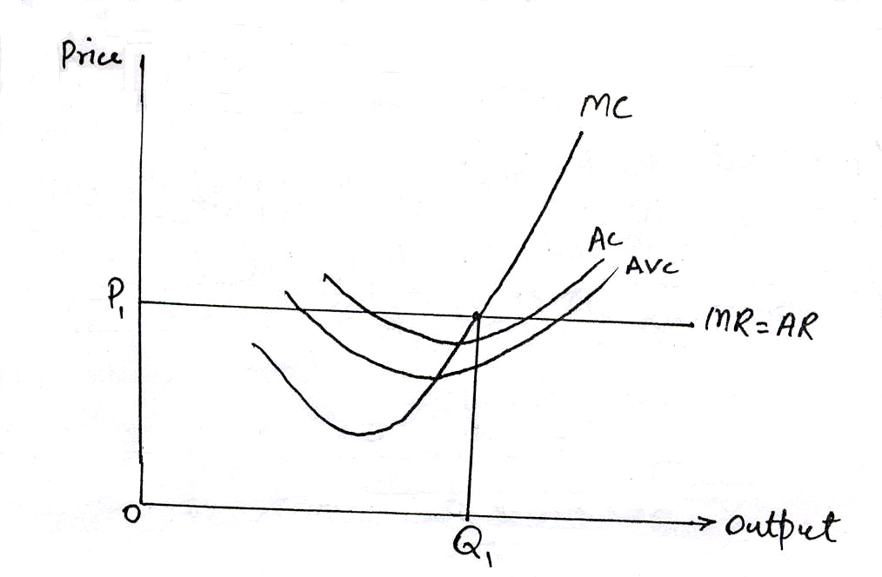
Which of the following is true according to the diagram?

A. The firm is facing loss.
B. The firm is earning only normal profit.
C. The marginal revenue of the firm is less than its marginal cost.
D. The firm is earning super-normal profit.

xviii. Following figure shows the changes in output when different units of labour are combined with fixed units of land and capital:

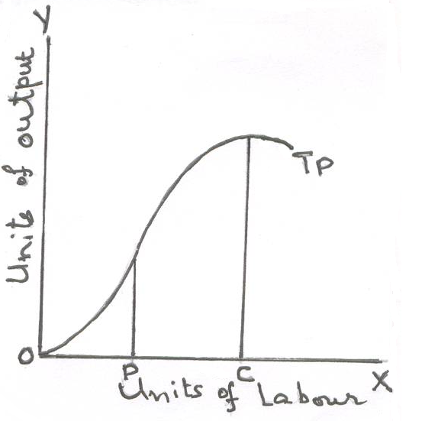
Increasing return to labour is experienced

A. over the range of employment OP
B. over the range of employment OC
C. over the range of employment PC
D. over the range of employment OP

Page 5 of 6 Turn Over
xix. Which of the following is example of external economies of scale?

A. Discount on purchases of raw materials.
B. Technical progress leads to development of machines at low price
C. Hiring of specialized staff due to increase in scale of production.
D. A firm starts producing by products.

xx. In an economy government constructed a new water reservoir for the purpose of irrigation; this might be taken as

A. increase in supply of capital
B. increase in supply of land
C. increase in supply of land and supply of capital
D. None of the above.

____________________

For Examiner’s use only
20
Q. No.1: Total Marks:

Marks Obtained:

Page 6 of 6
Federal Board HSSC-I Examination
Economics Model Question Paper

Time allowed: 2.40 hours Total Marks: 80

Note: Sections ‘B’ and ‘C’ comprise pages 1-4 and questions therein are to be answered on the separately provided answer book. Answer all the questions from section ‘B’ and section ‘C’. Use supplementary answer sheet i.e., sheet B if required. Write your answers neatly and legibly.

SECTION – B
(50 marks)

Note: Attempt ALL the questions. The answer to each question should not exceed 3 to 5 lines.

Q.2 Why indifference curves in an indifference curve map will never intersect? (3)

Q.3 “Economics is a science which studies human behaviour as a relation between ends and scarce means which have alternative uses.” (4)
a. What are the scarce means?
b. How this definition makes reference to idea of opportunity cost?

Q.4 Find the total revenue, average revenue and marginal revenue from the following table: (3)

Output (Q) | Price (P)
1  2  3  4  5  6  7 | 10  9  8  7  6  5  4

Page 1 of 4 Turn Over
Q.5 Identify the factors that differentiate supply with stock. (3)
(OR)
Following diagram shows the equilibrium in market at point E with the demand and supply curves of coffee:
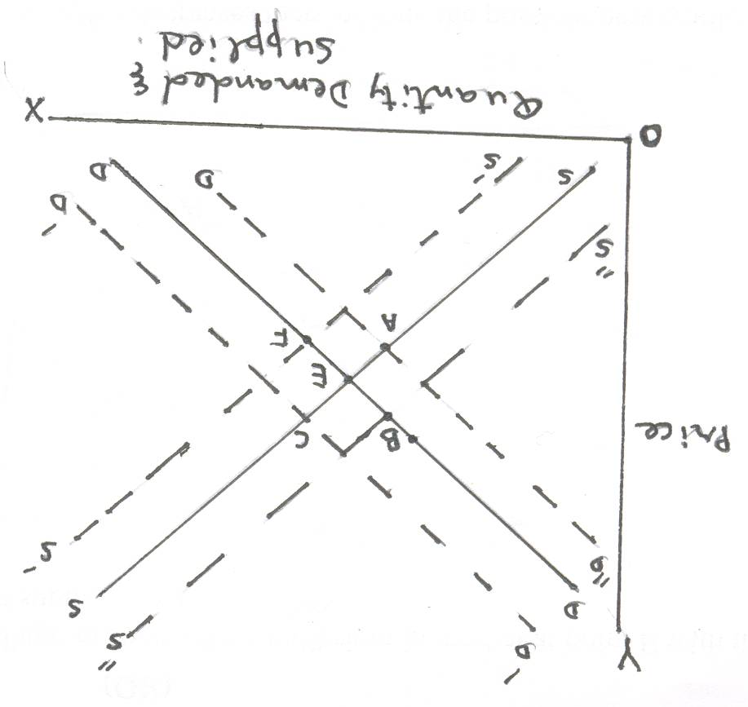
If demand for coffee decreases then indicate the possible new equilibrium point in coffee market. Also write down the determinants of demand for coffee. (3)

Q.6 Derive the functional equation of demand with the help of given data. (3)
P | Qd
2  3 | 15  12
(OR)
How income and price effects result in negative sloping demand curve? (3)

Q.7 Suppose there are four kinds of lands in the country A, B, C and D whose marginal products are 40, 30, 20, and 10 respectively and the cost of each land is 20 per unit. Answer the following question keeping in mind the “Ricardiaw theory of Rent”: (4)
a. Which land is termed as “marginal land”?
b. Calculate the rent of land ‘B’.
(OR)
Differentiate between Net Rent and Gross Rent. (4)

Page 2 of 4 Turn Over
Q.8 Following table shows the changes in total cost as output varies: (4)

Unit of Output | Total cost (Rs)
0  1  2  3  4  5 | 10  14  20  32  50  70

a. Calculate average variable cost when output is three units and marginal cost when output is 4 units.
b. Is the firm experiencing increasing or decreasing return?
c. Is firm in short-run or long-run?

Q.9 During a year (1999-2000) ZAP company had just covered her average cost by selling 2000 units of output. According to economic theory, the company had earned just a normal profit, why? (3)

Q.10 Who is an entrepreneur? How is he different from an ordinary businessman? (3)
(OR)
Mr Abdi, a chartered accountant working in Karachi, was offered high position in the same company with company transfer to company’s Gilgit office. Mr Abdi refused to accept the offer and preferred to work in the same position at Karachi. Identify the four possible factors behind his decision. (3)

Q.11 The following table shows the inputs and outputs of a particular firm over different time periods: (3)

Table A |  |  |  | Table B
No of labour | Units of capital | Units of output |  | No of labour | Units of capital | Units of output
1  2  3  4  5  6 | 2  2  2  2  2  2 | 50  75  95  110  125  130 |  | 1  2  3  4  5  6 | 1  2  3  4  5  6 | 200  240  400  550  700  850

Provide brief explanation of your answer to questions:
a. Which table shows operation of economies of scale?
b. Which table shows short run production?

Page 3 of 4 Turn Over
Q.12 State the economic meaning of zero cross elasticity of demand and cross elasticity of demand having negative sign. (3)
(OR)
Differentiate between Point elasticity of demand and Arc elasticity of demand. (3)

Q.13 Make a graph of the following: (4)
Q = 20 – P²

Q.14 Why do we study statistics in economics? (3)

Q.15 Identify from worker’s point of view, advantages of the division of labour. (3)

Q.16 Why, under perfect competition, the demand curve facing the firm is perfectly elastic while the demand curve facing the industry is downward sloping? (4)
(OR)
Write down the equilibrium conditions of a firm under monopoly. (4)

SECTION – C
(Marks: 30)

Note: Attempt ALL the questions.

Q.17 Total utility of a consumer is maximum when he purchases different goods according to the following principle:
$\frac{M∪A}{\text{PA}} = \frac{M∪B}{\text{PB}}−−−−−−\frac{M∪n}{\text{Pn}}$.
Explain with the help of table and graph. (10)

Q.18 What is meant by the term Real Wages? Explain the factors which affect real wages? (10)

Q.19 What do you understand by market price? How market price is determined in case of: (10)
a. Perishable goods
b. Durable goods
(OR)
Elasticity of demand helps to maximize the total revenue of government as well as of business firm. Do you agree? Give arguments. (10)

____________________

Page 4 of 4

