SCHEME OF STUDIES
FOR HSSC (CLASSES XI–XII)

COMPULSORY FOR ALL (500 marks)
1. English (Compulsory)/ English (Advance) 2 papers 200 marks

2. Urdu (Compulsory)/ Urdu Salees In lieu of Urdu 2 papers 200 marks
(Compulsory)/ Pakistan Culture for Foreign
Students Part – I and Pakistan Culture Paper-II

3. Islamic Education/Civics (for Non-Muslims) 1 paper 50 marks

4. Pakistan Studies 1 paper 50 marks

SCIENCE GROUP (600 marks)
The students will choose one of the following (A), (B) and (C) Groups carrying 600 marks:

(A) Pre-Medical Group:
Physics, Chemistry, Biology

(B) Pre-Engineering Group:
Physics, Chemistry, Mathematics

(C) Science General Group:
1. Physics, Mathematics, Statistics
2. Mathematics, Economics, Statistics
3. Economics, Mathematics, Computer Science
4. Physics, Mathematics, Computer Science
5. Mathematics, Statistics, Computer Science

HUMANITIES GROUP (600 marks)
Select three subjects of 200 marks each from the following:
S. No. | Subject | S. No. | Subject
1. | Arabic/Persian/French/English (Elective)/Urdu (Elective) | 10.  11. | Sindhi (Elective)  Civics
2. | Economics | 12. | Education
3. | Fine Arts | 13. | Geography
4. | Philosophy | 14. | Sociology
5. | Psychology | 15. | Mathematics
6. | Statistics | 16. | Computer Science
7. | History of Modern World/Islamic History/ History of Muslim India/ History of Pakistan | 17.  18. | Islamic Culture  Library Science
8. | Islamic Studies | 19. | Outlines of Home Economics
9. | Health and Physical Education | 19. | Outlines of Home Economics

COMMERCE GROUP (600 marks)

HSSC – I
1. Principles of Accounting paper – I 100 marks
2. Principles of Economics paper – I 75 marks
3. Principles of Commerce paper – I 75 marks
4. Business Mathematics paper – I 50 marks

HSSC – II
1. Principles of Accounting paper – II 100 marks
2. Commercial Geography paper – II 75 marks
3. Computer Studies/Typing/Banking paper – II 75 marks
4. Statistics paper – II 50 marks

MEDICAL TECHNOLOGY GROUP (600 marks each)
1. Medical Lab Technology Group
2. Dental Hygiene Technology Group
3. Operation Theater Technology Group
4 Medical Imaging Technology Group
5. Physiotherapy Technology Group
6. Ophthalmic Technology Group

AIMS AND OBJECTIVES OF EDUCATION POLICY
(1998 – 2010)

AIMS

Education is a powerful catalyzing agent which provides mental, physical, ideological and moral training to individuals, so as to enable them to have full consciousness of their mission, of their purpose in life and equip them to achieve that purpose. It is an instrument for the spiritual development as well as the material fulfillment of human beings. Within the context of Islamic perception, education is an instrument for developing the attitudes of individuals in accordance with the values of righteousness to help build a sound Islamic society.

After independence in 1947 efforts were made to provide a definite direction to education in Pakistan. Quaid-i-Azam Muhammad Ali Jinnah laid down a set of aims that provided guidance to all educational endeavours in the country. This policy, too has sought inspiration and guidance from those directions and the Constitution of Islamic Republic of Pakistan. The policy cannot put it in a better way than the Quaid’s words:

“You know that the importance of Education and the right type of education, cannot be overemphasized. Under foreign rule for over a century, sufficient attention has not been paid to the education of our people and if we are to make real, speedy and substantial progress, we must earnestly tackle this question and bring our people in consonance with our history and culture, having regard for the modern conditions and vast developments that have taken place all over the world.”

“There is no doubt that the future of our State will and must greatly depend upon the type of education we give to our children, and the way in which we bring them up as future citizens of Pakistan. Education does not merely mean academic education. There is immediate and urgent need for giving scientific and technical education to our people in order to build up our future economic life and to see that our people take to science, commerce, trade and particularly well-planned industries. We should not forget, that we have to compete with the world which is moving very fast towards growth and development.”

“At the same time we have to build up the character of our future generation. We should try, by sound education, to instill into them the highest sense of honour, integrity, responsibility and selfless service to the nation. We have to see that they are fully qualified and equipped to play their part in various branches of national life in a manner which will do honour to Pakistan.”

These desires of the Quaid have been reflected in the Constitution of the Islamic Republic of Pakistan and relevant articles are:

The state shall endeavour, in respect of the Muslims of Pakistan:
- to make the teachings of the Holy Quran and Islamiat compulsory and encourage and facilitate the learning of Arabic language to secure correct and exact printing and publishing of the Holy Quran;

- to promote unity amongst them and the observance of Islamic moral standards;

Provide basic necessities of life, such as food, clothing, housing, education and medical relief for all such citizens irrespective of sex, caste, creed or race as are permanently or temporarily unable to earn their livelihood on account of infirmity, sickness or unemployment;

Remove illiteracy and provide free and compulsory secondary education within minimum possible period.

Enable the people of different areas, through education, training, agricultural and industrial development and other methods, to participate fully in all the forms of national activities including employment in the service of Pakistan;

The State shall discourage parochial, racial, tribal, sectarian and provincial prejudices among the citizens.

Reduce disparity in the income and earnings of individuals, including persons in various classes of the service of Pakistan.

Steps shall be taken to ensure full participation of women in all the spheres of national life.

The vision is to transform Pakistani nation into an integrated, cohesive entity, that can compete and stand up to the challenges of the 21st Century. The Policy is formulated to realize the vision of educationally well-developed, politically united, economically prosperous, morally sound and spiritually elevated nation.

OBJECTIVES

To make the Qur’anic principles and Islamic practices as an integral part of curricula so that the message of the Holy Quran could be disseminated in the process of education as well as training. To educate and train the future generation of Pakistan as true practicing Muslims who would be able to usher in the 21st century and the next millennium with courage, confidence, wisdom and tolerance.

To achieve universal primary education by using formal and informal techniques to provide second opportunity to school drop-outs by establishing basic education community schools all over the country.

To meet the basic learning needs of a child in terms of learning tools and contents.

To expand basic education qualitatively and quantitatively by providing the maximum opportunities to every child of free access to education. The imbalances and disparities in the system will be removed to enhance the access with the increased number of more middle and secondary schools.

To ensure that all the boys and girls, desirous of entering secondary education, get their basic right through the availability of the schools.

To lay emphasis on diversification of curricula so as to transform the system from supply-oriented to demand oriented. To attract the educated youth to world-of-work from various educational levels is one of the policy objectives so that they may become productive and useful citizens and contribute positively as members of the society.

To make curriculum development a continuous process; and to make arrangements for developing a uniform system of education.

To prepare the students for the world of work, as well as pursuit of professional and specialized higher education.

To increase the effectiveness of the system by institutionalizing in-service training of teachers, teacher trainers and educational administrators. To upgrade the quality of pre-service teacher training programmes by introducing parallel programmes of longer duration at post-secondary and post-degree levels.

To develop a viable framework for policy, planning and development of teacher education programmes, both in-service and pre-service.

To develop opportunities for technical and vocational education in the country for producing trained manpower, commensurate with the needs of industry and economic development goals.

To improve the quality of technical education so as to enhance the chances of employment of Technical and Vocational Education (TVE) graduates by moving from a static, supply-based system to a demand-driven system.

To popularize information technology among students of all ages and prepare them for the next century. To emphasize different roles of computer as a learning tool in the classroom learning about computers and learning to think and work with computers and to employ information technology in planning and monitoring of educational programmes.

To encourage private sector to take a percentage of poor students for free education.

To institutionalize the process of monitoring and evaluation from the lowest to the highest levels. To identify indicators for different components of policy, in terms of quality and quantity and to adopt corrective measures during the process of implementation.

To achieve excellence in different fields of higher education by introducing new disciplines/emerging sciences in the universities, and transform selected disciplines into centres of advanced studies, research and extension.

To upgrade the quality of higher education by bringing teaching, learning and research process in line with international standards.
AIMS AND OBJECTIVES OF BIOLOGY SYLLABUS

AIMS

The broad aims of the biology course are to:
- enable the student to appreciate that Allah (SWT) is Creator and Sustainer of the universe;
- broaden and stimulate student’s interest in and enjoyment of learning Biology and to help them to acquire self initiative in the study of biology;
- develop an understanding of biological facts, concepts and principles and an appreciation of their significance;
- develop appreciation of Importance of experimental and investigatory work in the study of Biology;
- develop awareness for application of Biology in personal, social, economic environmental and technological contexts;
- be complete in itself and perform useful educational functions for students not intending to study Biology at a higher level;
- suitably prepare for higher education courses in Biology, for biological studies in other educational establishments and for professional courses which require students to have a knowledge of Biology;
- develop feeling for living things;
- become well informed, confident and responsible citizen in a modern technological advanced changing world.

OBJECTIVES

Objectives of intermediate Biology are:

A. Knowledge and Understanding
Students should be able:
1. To recall
a. Biological facts
b. Biological terms
c. Biological concepts and principles
d. Biological techniques.
2. To recall some of the ways in which biological knowledge is applied in daily life.
3. To organize interpret data from various sources and draw inferences from it.
4. To use appropriate instruments and to take accurate and precise measurements.
5. To recognize biological problems.
6. To devise methods for testing the hypotheses, using controls where appropriate.

B. Attitude
Student should acquire:
1. An interest and enjoyment in studying living organisms and their interrelationship.
2. A feeling for living organisms.
3. A critical and inquiring mind.
4. An objective attitude towards evidence.
5. A positive attitude in discussing biological issue in personal, social, environmental and technological contexts
6. An awareness that the body of biological knowledge is not static; and that experimental and investigatory work are important for its advancement.
7. An awareness for the need of appropriate safety procedures.
8. An awareness of both the usefulness and limitations of hypotheses in making predictions and describing biological phenomena.

C. Practical skills
Students should be able:
1. To use instruments and apparatus to the limits of accuracy appropriate to a given problem.
2. To observe and describe objects and phenomena accurately.
3. To perform common laboratory techniques and handle chemicals, apparatus and biological materials carefully and safely.

CONTENTS AND SCOPE OF BIOLOGY SYLLABUS

Contents | Scope
1. The Biology (06 periods)  Biology and some major fields of specialization in Biology  Levels of biological Organization  Biological methods  Applications of Biology for welfare of mankind | - Review of definition of Biology and its branches.  - Molecular Biology, Microbiology, Environmental Biology, Marine Biology, Fresh water Biology, Parasitology, Human Biology, Social Biology, Biotechnology.  - Sub atomic particles, atoms, molecules, macromolecules, organelles, cells, tissues, organs, systems, individual whole organism, population, Phyletic, lineages, communities, living world in space and time.  - Deductive/inductive reasoning, developing a hypothesis, theory and law.  - A few examples of historical and recent current endeavours: Immunization, Antibiotics, Radiotherapy, Chemotherapy, Hydroponics, Cloning, Protection and conservation of environment. Concept of Biological Control & Integrated Disease management.
2. Biological molecules  (12 periods)  Water  Organic Molecules  Carbon  Proteins  Carbohydrates  Lipids  Nucleic acids  Conjugated molecules | - Introduction to biochemistry, chemical composition of cell, relationship between structure and function of molecules. Complex structural formulae and details are not required.  - Properties of biological importance  - Synthesis of large molecules from small molecules by condensation and their break down by hydrolysis.  - Importance of tetravalent nature of carbon, ability of carbon to form different kind resulting in formation of complex shapes of organic molecules.  - Amino acids, and general structure of amino acid, chains of amino acids. Four levels of structure of protein molecule, significance of sequence of amino acids and shape of protein molecule.  - Functions of Proteins.  - Monosaccharides, oligosaccharides and polysaccharides.  - Functions of carbohydrates.  - Chemically diverse groups of hydrocarbons.  - Acylglycerols (fats & oils): energy storage, saturated and unsaturated fatty acids and their importance.  - Phospholipids: hydrophobic and hydrophilic portions, phosolipids in biological membranes.  - Terpenoids: steroids, carotenoids, terpenes and their important roles.  - Waxes: their protective role.  - Nucleic acids as polymers of nucleotides.  - Structure of a nucleotide. Mononucleotide: ATP as energy rich compound.  - Dinucleotide: NAD as coenzyme.  - Polynucleotides: Nucleic acids as informational macromolecules.  - Two main kinds of nucleic acids i.e., DNA and RNAs  - DNA as hereditary material and significance of its nucleotides base sequence.  - RNA as carrier of information.  - Glycolipids, Glycoproteins, Lipoproteins, Nucleoproteins.
3. Enzymes (03 periods) | - Enzymes are organic catalysts, energy of activation. Characteristics of enzymes, mode of action, concept of active site and specificity, Apoenzyme, cofactor and holoenzyme.  - Factors affecting enzyme activity.
4. The Cell (12 periods) Introduction  The Eukaryotic Cell Structure and function Surface structures.  Nucleus  Cytoplasmic organelles and Membrane system | - Cells as units of life. Emergence and implications of Cell Theory.  - Microscopes: Resolution vs magnification of microscope, techniques to isolate components of cell.  - Eukaryotes and Prokaryotes.  - Detailed structure of a generalized eukaryotic cell as seen under light microscope and electron microscope.  - Plasma membrane: Fluid Mosaic Model, Characteristic properties and function of cell membrane.  - Cell Wall  - Nuclear envelop, nucleolus, nucleoplasm, chromatin and chromosomes.  - Endoplasmic Reticulum: Smooth and Rough Endoplasmic Reticulum, Ribosomes,.  - Golgi Apparatus  - Lysosomes, lysosomal storage diseases, peroxisomes, Glyoxosomes.  - Vacuoles  - Mitochondria as energy converting organelle.  - Plastids, proplastids, Chloroplasts as energy converting organelles.  - Cytoskeleton: micro filaments intermediate filament, microtubules, centrioles.
5. Variety of life (06 period)  Classification  Viruses | - Needs and bases of biological classification-homologies, comparative biochemistry, cytology, genetics.  - Concepts of species and hierarchy of biological classification.  - Two to five kingdom systems of classification, including five kingdom systems by Robert Whittaker (1969), Margulis and Schwartz (1998).  - Discovery of Viruses  - Characteristics, structure and classification of viruses  - Life cycle of a bacteriophage  - Viral diseases: Transmission / spread and control of viral diseases.  - Human immune deficiency virus (HIV) – a Retrovirus. Acquired Immune Deficiency Syndrome (AIDS) –symptoms, transmission, and its control Hepatitis B & C – symptoms, transmission and control.
6. The Kingdom  Prokaryotae (Monera)  Bacteria (09 period)  Cyanobacteria | - Discovery, Structure, Diversity: Occurrence, Nutrition, Respiration *aerobes and anaerobes). Locomotion, Growth and Reproduction.  - Importance and control.  - Immunization and vaccination. Use and misuse of antibiotics.  - General account with reference to Nostoc.  - Importance.
7. The Kingdom Protista  (06 period) (Protoctista) | - General account  - Plant-like protoctists: Algae (Chlorella, Ulva)  - Fungi-like protoctists: slime molds and oomycotes (phytophthora infestans)  - Animal-like Protoctists: Protozoa-Plasmodium (malarial parasite)  - Importance
8. The Kingdom Fungi  (06 period) | - General characteristics and classification of fungi into major groups. Brief account of major groups with special reference to the diseases they cause  - Land adaptations of Fungi  - Economic importance.
9. The kingdom Plantae  (15 period)  Bryophytes  Tracheophytes | - An outline of classification of plant kingdom  - General Characteristics, amphibious nature,  - Adaptations to land habitat. Liverworts, hornworts and mosses.  - Introduction  - Major groups of vascular plants (psilopsida, Lycopsida, Sphenopsida and pteropsida)  - General characteristics of each group with examples emphasizing evolutionary adaptive advancements i.e., evolution of leaf and seed.  - Vascular Plants as successful group of land plants.  - General account of Rosaceae, Solanaceae, legume family (Fabaceae, Caesalpilliaseas, Mimoceae) Poaceae with emphasis on floral parts in technical terms.
10. The Kingdom Animalia  (15 period)  Introduction  Porifera  Cnidaria (Coelenterata)  Platyhelminthes  Nematoda (Aschelminthes)  Annelida  Arthropoda  Mollusca  Echinodermata  Chordata  Pisces  Amphibia  Reptilia  Aves  Mammalia | - An outline of classification of Animal Kingdom into major phyla.  - Development of complexity: unicellular to multicellular, Radial and bilateral symmetry, Diploblasic and Triploblastic organization, Acoelomates and Coelomates.  - Protostomes and Deuterostomes.  - Basic characteristics of sponges, exhibiting simplest multicellular organization, origin, importance.  - General characteristics, origin of diploblastic organization, Radial symmentry, poloymorphism, alternation of generations, coral reefs.  - General characters, triploblastic acoelomate organization, bilateral symmetry, Adaptations for parasitic mode of life. Importance tapeworm infestation and disinfestations.  - General characters, Importance – Parasitc diseases.  - General characters, Segmentation and its advantages, coelom and its advantages.  - Major groups polychaetes, oligochaetes and leeches.  - Importance  - General characters.  - Skeleton, appendages and body parts. A successful group.  - Diversity: major groups - Crustaceans, insects, arachnids, myriapods.  - Economic importance.  - General characters, Broad classification, Bivalve, Gastropods, Cephalopods.  - Economic importance  - General characters. Affinites.  - General Characteristics and classifications.  - General characteristics and various groups. Adaptations for aquatic life.  - Origin, General characteristics, Trends for land habitat. Amphibians as unsuccessful land vertebrates.  - General characteristics and past history. Reptiles as successful land vertebrates.  - General characteristics and adaptations for aerial mode of life. Flightless birds and flying birds. Evolutionary origin.  - General characteristics and diversity: Prototheria, Metatheria and Eutheria.  - Evolutionary origin.
11. Bioenergetics (15 periods)  Introduction  Photosynthesis  Cellular Respiration  Energy flow through the ecosystem | - Need for energy in living organisms.  - Role of ATP as energy currency and its role in metabolism.  - Photosynthesis and Respiration as main energy processing processes.  - Photosynthesis as energy trapping/energy converting process.  - Reactants and products of photosynthesis.  - Role of Chlorophyll and other pigments, light, carbon dioxide and water in photosynthesis.  - Light dependent reactions: photosphorylation and reduction of NADP.  - Light independent reactions: Calvin Benson cycle – fixation and Cellular Respiration, reduction of CO₂  - Cellular respiration as energy releasing process, oxidative phosphorylation.  - Aerobic and anaerobic respiration, comparison of two with reference to energy yield and products. Fermentation and its economic importance.  - Glycolysis  - Formation of Acetyl Co A  - Krebs cycle  - Respiratory electron transport chain, role of O₂ as hydrogen acceptor  - The sun as ultimate source of energy.  - Unidirectional flow of energy and its subsequent losses.  - Trophics levels, Pyramid of energy  - The efficiency of energy flow and its significance: advantages of short food chains and their application in solving food problems in relation to man.
12. Nutrition (15 period)  Introduction  Autotrophic Nutrition  Mineral Nutrition in Plants  Heterotrophic and Special mode of nutrition in plants  Heterotrophic nutrition in animals  Holozoic Nutrition  Digestion and absorption  Human Digestive system  Parasitic Nutrition | - Concept of nutrition and nutrients: use of nutrients for energy and for carbon skeleton.  - Autotrophic and heterotrophic nutritions.  - Phototrophic and chemotrophic nutrition  - Refer to details of photosynthesis in Section IV Chapter –11 and Chemosynthesis in Chapter -6.  - Role of some important mineral (N, P, K, Mg) and their deficiency symptoms.  - Review of parasitic and saprophytic nutrition. Carnivorous plants.  - Introduction of modes of acquiring food in animals: saprotrophs, detritivores, predators, herbivores, carnivores, omnivores, filter feeders, fluid feeders.  - Microphagous and macrophagous feeders.  - Typical mode of animal nutrition  - Definition need and types of digestion Intracellular and extra cellular digestion. Sac like and tubular digestive system.  - Ingestion, mechanical breakdown, chemical breakdown, absorption, assimilation and egestion.  - Nutrition in Amoeba, Hydra, Planaria and cockroach.  - Structure of different parts of human alimentary canal. Various digestive processes occurring in digestive tract.  - Oral cavity: mechanical break down of food, adaptation of different types of teeth to different diets, plaque and its effects, chemical breakdown of food (starch) role of components of saliva secretion of saliva.  - Pharynx and swallowing.  - Oesophagus: pharynx to stomach, peristalsis and antiperistalsis.  - Stomach structure and functions, protein digestion, mechanism of secretion of gastric juice, storage of food and discontinuous feeding.  - Small intestine: Digestion and absorption, structure and function of villi, role of liver and pancreas in digestion, mechanism of secretion pancreatic juice.  - Large intestine: Absorption of water and other functions. Diarrhoea, Dysentery and Constipation.  - Anus and Egestion  - Dyspepsia, Ulcer, food poisoning; malnutrition (over and under nutrition) Bulimia nervosa, overweight and obesity, Anorexia nervosa, Piles.  - Examples of some endoparasites and ectoparasites of man
13. Gaseous Exchange  (09 periods)  Introduction  Gaseous Exchange in plants  Gaseous Exchange in animals  Respiratory System of man  Breathing in man  Transport of gases in man | - Respiratory gases and need of respiratory gas exchange. Air and water as respiratory medium  - Exchange of O₂ and CO₂ by diffusion in leaves, stem and roots. Photorespiration and its consequences.  - Properties of respiratory surfaces. Respiratory organs of aquatic and terrestrial animals (Hydra Earthworm, Cockroach, Fish, Frog, Bird)  - Air passage ways, lungs  - Mechanism of breathing, rate of breathing and its involuntary and voluntary control,.  - Disorders of respiratory tract: lung cancer, tuberculosis, asthma emphysema  - O₂ carrying and CO₂ carrying capacities of blood and factor affecting these capacities. Lung capacities. Role of hemoglobin and myoglobin.
14. Transport (01 period)  Introduction  Transport in Plants Introduction  Uptake and transport of water and minerals  Water and mineral uptake by the roots.  Ascent of sap  Transpiration  Translocation of organic solutes  Transport in Animals  Circulatory system  Transport in Man Blood circulatory system  Blood  Human Heart  Blood vessels  Lymphatic system  Cardiovascular  Disorder  The Immune System | - Need for transported of materials.  - Materials to be transported in plants  - Process involved in the uptake: diffusion, Osmosis, Facilitated Diffusion. Active Transport, Imbibition.  - Water status in plants: Water Potential, Osmotic Potential and Pressure, Potential, Plasmolysis and Deplasmolysis.  - Movement of water and minerals from the soil to the xylem by way of apoplast and symplast and through vacuoles.  - Path of movement of water and salts, features of xylem in relation to its role in transport.  - Mechanism of Ascent of sap: Root pressure, guttation, Transpiration pull, (Cohesion Tension Theory), TACT, Forces.  - Definition, types and mechanism of transpiration. Stomatal control of transpiration and opening and closing of stomata, Factors affecting rate of transpiration.  - Role of transpiration as a necessary evil.  - Path of movement of organic solutes and features of phloem in relation to their transport. Pressure flow Mechanism and its limitation.  - General characteristics: Transport without special circulatory system-Hydra and Planaria: and Transport by special circulatory systems.  - General characteristics of a circulatory system.  - Open circulatory system and closed circulatory system explained by transport in cockroach and earthworm.  - Single circuit plan as in fish. Double circuit plan: Pulmonary and systematic circulation as in birds and mammals.  - Brief reference to evolution of number of heart chambers in fish, amphibians, reptiles, birds and mammals.  - Composition of blood and functions of its components.  - Leukemia. Thalassaemia  - Structure of human heart, Cardiac cycle, heartbeat, pacemaker, S-A node and A-V node.  - Artificial pacemaker. Blue babies.  - Arteries. Capillaries, veins and their relationship, exchange of materials in capillary beds by filtration, osmosis and diffusion.  - Blood Pressure and Blood Flow  - Lymph vessels, lymph, lymph nodes.  - Lymphatic system as a drainage system. Some other function of lymphatic system. Edema.  - Atherosclerosis – its causes and effects. Hypertension, thrombus formation coronay thrombosis, myocardial infraction – heart attack, stroke and their prevention hemorrhage.  - Immunity and its types.

BIOLOGY PRACTICALS

1. Identification of bio-chemicals from biological materials
i. Iodine test for starch
ii. Benedict’s test for reducing sugars
iii. Millon’s test for Proteins/Biuret test for proteins
iv. Sudan III test for fats and oils and emulsion test
v. Test for DNA (only demonstration)
2. Study of starch break down in germinating gram seeds
3. Study of effect of temperature, PH value and enzyme and substrate concentration of the activity of enzyme (Pepsin)
4. Study of animal cells (frog’s epithelial cell, human cheek cell) and plant cells (leaf epidermal cells, onion epidermal cells) by staining with safranine, acid fuchsin, methylene blue, eosine.
5. To find out the effects of different concentrations of salt or sugar solutions on animals and plant cells.
6. Laboratory safety techniques and use of microscope and measurement of microscopic objects by micrometry.
7. Microbiological techniques: Preparation and sterilization of culture media and equipment, growing cultures of non-pathogenic bacteria, Gram staining and microscopic examination of stained bacteria and bacteria from prepared slides
8. Investigation of bacterial content of fresh and stale milk
9. Study of Nostoc from fresh material and prepared slides.
10. Identification of Chlorella, Paramecium, Amoeba, Entamoeba, Plasmodium (malarial parasite) Euglena, Volvox and Ulothrix from fresh materials or prepared slides.
11. Study of yeast, Ustilago tritici and Pencillium from fresh materials and slides.
12. Examination of Marchantia and Funaria (external morphology) from fresh material and of sex organs from prepared slides.
13. Study of Adiantum: Sporophyte plant body, preparation of slide of sporangia from fresh material, Prothallus (gametophyte) from fresh material or preserved material/slide.
14. Study of Pinus: male and female cones from fresh or preserved materials.
15. Study of different types of inflorescence of: Cassia, Achyranthus, Morus, Iberis, Brassica, Foeniculum, Avena, Helianthus, Tradescantia/Ipomoea and Euphoriba
16. Description in technical terms of commonly available flowers (e.g. rose, Solanum, Cassia/Lathyrus odoratus, oat) of following families of angiosperms: Rosaceae, Solanaceae, legume family (Fabaceae/Caeselpiniaceae/Mimosaceae) and Poaceae.
17. General Survey of major animal phyla; invertebrates upto phylum and vertebrates upto class level.
18. Extraction and chromatography of leaf chloroplast pigments.
19. Investigation of effect of different concentrations of glucose solution on Opening and closing of stomata.
20. Study of T.S. of liver, stomach, small intestine and large intestine of man from prepared slides.
21. Demonstration of osmosis in living plant cells, (manifested by plasmolysis and deplasmolysis) of onion cells or spirogyra.
22. Determination of mean solute potential of the cell sap using method of incipient plasmolysis
23. Investigation and measurement of factors affecting rate of transpiration using Potometer (Factors include wind, removal of some leaves, covering lower epidermis with Vaseline).
24. Study from prepared slides of internal structure of monocot and dicot root, stem and leaf.
25. Investigation of stomatal distribution (using clear nail varnish or epidermis peel).
26. Study of prepared, stained slide of human blood including identification of phagocytes and lymphocytes and preparation of slide of blood smear of frog.
27. Study of structure of artery, vein, Capillary from their T.S. (Prepared Slides).
28. Measurement of blood pressure during rest and after exercise with B.P. apparatus.

LEARNING – TEACHING GUIDELINES
FOR STUDENTS AND TEACHERS

This set of instructional objectives has been compiled to show the level of achievement that is expected of an average pupil on completing the study of specific parts of the syllabus. It aims at assisting the teachers in their selection of course materials, learning activities and instructional methods. It can serve as the learning guidelines for the pupils and the basis of an evaluation program.

In stating the specific objectives there are two groups of terms having very similar meaning. The first group is on achievement in recalling facts, which include ‘define’, describe’, and state. Define refers to a rather formal definition of terms which involves their fundamental concept. ‘Describe’ refers to the recall of phenomena or processes, ‘State’ is used when the objective requires the recall of only some aspects of a phenomenon or a process; it limits the scope of teaching.

The second group is on achievement relating to science experiments. This group includes ‘design’, ‘perform’, ‘demonstrate’. ‘Design’ an experiment would be used when there are more than one acceptable ways of doing it. Pupils are expected to be able to set up the experiment by applying what they have previously learned. These experiments may require the taking of quantitative data or long term observation. ‘Perform’ an experiment, would be used when the objective emphasizes on the demonstration of experimental skill; the detail of the experiment could be found in the teachers’ notes or textbooks. ‘Demonstrate’ a phenomenon by simple experiments is used when the objective emphasizes on the result of the experiment and the experimental skill involved is very simple, such as passing some gas into a solution ‘Describe’ an experiment is used when pupils are expected to know, in principle, how the experiment could be carried out and the expected result.

1. The Biology | - Review definition of biology and its division and describe major fields of specialization in biology.  - State levels of biological organization from sub atomic particles to organism level and living world in space and time  - Differentiate between deductive and inductive reasoning.  - Distinguish between hypothesis, theory and law and explain with the help of example how they are developed.  - Develop an awareness of importance of biology, with examples, for the welfare of mankind.
2. Biological molecules | - Introduce Biochemistry.  - Describe chemical composition of cell and relationship between structures and functions of molecules in the cell.  - State biological importance of water and carbon  - Describe synthesis and break down of organic molecules in the cell.  - Define amino acid and describe general structure of amino acid.  - Explain four levels of structure and specificity (Sequence of amino acids and shape of protein molecules with special reference to hemoglobin.  - State functions of Proteins.  - Define carbohydrates and distinguish between different classes of carbohydrates. Monosaccharides, oligosaccharides and polysaccharides.  - State functions of carbohydrates.  - Define lipids and state their diverse nature.  - Classify lipids and give main features and functions of each group.  - Acylglyccrols, Phospholipids, Terpenoids, Waxes.  - Define nucleic acids and nucleotides.  - Explain structure and functions of a mononucleotide (ATP), a dinucleotide (NAD) and polynucleotide (Nucleic Acids)  - Describe chemical composition, types and functions of nucleic acids-DNA and RNAs.  - Define conjugated molecules and state their common types: Goycolipids, Glycoproteins, Lipoproteins and Nucleoproteins.  - Detect different biochemical’s i.e., starch, reducing sugars, proteins. Fats and oils, DNA (only demonstrations) from different biological materials with the help of biochemical tests.
3. Enzymes | - Define enzyme, apo-enzyme, cofactor and holoenzyme.  - Describe characteristics of enzyme, mode of their action and factors affecting enzyme activity.  - Demonstrate enzymatic break down of starch in germinating seeds.  - Investigate the effect of temperature and PII value on the activity of enzymes (pepsin).
4. The Cell | - Discuss cell as unit f life  - Discuss emergence of cell theory and its implications.  - Differentiate between resolution and magnification of microscope.  - Know techniques to isolate components of cell e.g., cell fractionation.  - Distinguish between Eukaryotes and Prokaryotes.  - Describe microscopic and ultra-microscopic structure and function of generalized Eukaryotic cell and of its components.  - Prepare and examine stained slides of some animal cells and plant cells.  - Investigate the effect of different concentration of salt/sugar solution on animal and plant cell.
5. Variety of life | - Define classification and explain need and bases of biological classification.  - Define and explain species and state the hierarchical levels of biological classifications.  - Outline two to five kingdoms system of classification and point out justification for the formulation of different systems.  - List important characteristics and examples of each kingdom.  - Describe discovery, characteristics and classification of viruses.  - Illustrate lytic and lysogenic phases of as DNA bacteriophage.  - List general symptoms, methods of spread / transmission and control measures of viral diseases.  - State structural features of HIV and outline its life cycle, symptoms, transmission and control of AIDS.  - State symptoms, transmission and control of Hepatitis B & C.
6. Kingdom Prokaryotae (Monera) | - Describe discovery and occurrence of bacteria.  - Explain structure, diversity and life processes of bacteria.  - Discuss importance of bacteria and approaches for bacterial control. Immunization and vaccination and use and misuse of antibiotics.  - Characterize cyanobacteria with reference to Nostoc and compare them with bacteria.  - Tell economic importance of cyanobacteria.  - Acquire and apply the knowledge of laboratory techniques/ microbiological techniques and laboratory safety techniques.  - Manipulate compound microscope.  - Measure microscopic object by micrometry.  - Prepare and sterilize culture medium and equipment and grow culture of non-pathogenic bacteria.  - Prepare and examine microscopic slides of related biological materials: gram positive and Gram negative bacteria, bacterial content of fresh and stale milk, Nostoc.
7. The kingdom Protista | - Characterize protista and state diversity within Protista – plant like (algae) fungi like (slime molds and oomycotes) and animal like (protozoa) protists.  - Characterize algae and classify them up to major groups indicating evolutionary sequence in structure and reproduction with reference to appropriate examples specially chorella and Ulva. State economic importance of algae.  - State distinguish features of slime molds and oomycotes and their economic importance with special reference to Phytophthora infestans.  - Describe salient features of Protozoa with special reference to Plasmodium (Mlarial parasite) and its economic importance with examples.  - Identify related biological materials from prepared slides/fresh materials; chlorella, Volvox, Ulothrix, Ulva, Euglena, Paramecium, Entamoeba and Plasmodium (malarial parasite)
8. Kingdom Fungi | - Characterize fungi and classify them into major groups giving their brief account  - List the land adaptations of fungi.  - Describe economic importance of fungi including pathogenic fungi.  - Prepare/identify/examine yeast, Ustligo and Penicillin from fresh materials/prepared slides.
9. Kingdom Plante | - Outline the classification of plant kingdom according to five kingdom system of classification.  - Describe characteristics of bryophytes with reference to a liverwort, hornwort and a moss with special emphasis on amphibious nature and adaptations to land habitat.  - Describe distinguishing features of tracheophytes and classify them into major groups. Psilopsida Lycopsida, Sphenopsida and Pteropsida (Filicineae, gymnospermae, Angiospermae)  - Describe general characteristics of each of the above mentioned groups with some examples (Rhynia / Psilotum, a fern-Adianitum, Pinus, and an angiosperm, emphasizing evolutionary adaptive advancements i.e., evolution of leaf and seed.  - Discuss vascular plants as successful group of land plants.  - Describe characteristics and economic importance of Rosaceae, Solanaceae, legume family (Fabaceae, Caesalpiniceae, Mimosaeaca and Poaceae)  - Describe different types of Inflorescence and flowers in technical terms as mentioned in practical 9,2,3, and 9, 2, 4.  - Prepare / identify /exmine the materials /specimens /prepared slides mentioned in practical 9.1, 9.2, and 9.2.2.
10. Kingdom Animalia | - Outline the classification of Animal Kingdom according to five kingdom system of classification.  - Discuss development of organizational complexity in animals, unicellular to multi cellular, radial and bilateral symmetry, diploblastic and triploblastic organization, acoelomates and coelomates, protostomes and deuterostomes.  - Describe characteristics, adaptive features, significant evolutionary consideration and economic importance of major phyla of invertebrates, Porifera, Cnidaria (Coelenterata), Plathyelminthes, Aschelminthes (Nematoda, Annelida, Arthropoda, Mollusca, Echinodermata.  - Explain general characteristics of chordate and classify it up to class level.  - Discuss salient features, adaptations and evolutionary origin/affinities of various classes of vertebrates, Pisces, Amphibia, Reptilia, Aves, and Mammalia.  - Examine and identify animals (especially local examples) belonging to different groups of invertebrates and vertebrates.
11. Bioenergetics | - Understand the concept of bioenergetics and energy transformation related with life processes.  - Discuss the role of ATP in overall energy metabolism of the cell.  - State role of photosynthesis as energy-capturing and respiration as energy – releasing processes.  - Define photosynthesis and state its reactants and products.  - Explain the role of chlorophyll and other photosynthetic pigments, light carbon dioxide and water in photosynthesis.  - Distinguish between light –dependent reactions (energy conversion ) and light-independent reactions (carbon dioxide fixation reaction).  - Explain photolysis of water, photophosphorylation and reduction of NADP.  - Summarize the chemical reactions involved in the conversion of carbon dioxide to carbohydrates in Calvin cycle and indicate the roles of ATP and NADPH in the process.  - Extract leaf chloroplast pigments and separate them by paper chromatography.  - Investigate effect of different concentrations of glucose solution on opening and closing of stomata.  - Define respiration, cellular respiration, oxidative phosphorylation, aerobic respiration and fermentation.  - Write summary reaction for aerobic respiration and describe stages of aerobic respiration and place of their occurrence in eukaryotic cell.  - Glycolysis, formation of Acetyl COA Kerb s Cycle, Electron. Transport Chain, State role of oxygen as hydrogen acceptor.  - Compare aerobic and anaerobic respiration with reference to products and energy yields.  - Discuss linear flow of energy through the ecosystem. loss of energy at successive trophic levels and advantage of short food chain.
12. Nutrition | - Define nutrition and nutrients  - State roles of nutrients for energy and carbon skeleton  - Differentiate between autotrophic and heterotrophic nutrition.  - Differentiate between phototrophic and chemotrophic nutrition  - Describe photosynthesis and chemosynthesis (refer to sections-IV-II and Section III-6)  - State role of some important mineral nutrients in plant, and their deficiency symptoms: N, P, K, Mg.  - Recall heterotrophic and special modes of nutrition in plants.  - Define different modes of acquiring food in animals /corresponding animals: saprotrophs, detritivores, predators, herbivores, carnivores, omnivores, filter feeders, fluid feeders, microphagous and macrophagous feeders. Define holozoic nutrition as typical mode of animal nutrition.  - Define digestion and discuss its need.  - Differentiate between main types of digestion and of digestive systems, intracellular and extra cellular digestion, saclike and tubular digestive system.  - Describe the processes involved in nutrition in animals.  - Describe nutrition in animals.  - Describe nutrition in some invertebrates; Amoeba, hydra, Planaria, and cockroach.  - Explain structure and functions of different parts of human alimentary canal and associated glands.  - Familiarize with some common abnormalities related to human digestive system; Plague, diarrboea, Dysentery, Constipation, Piles, Dyspepsia, ulcer, Food poisoning, Mal-nutrition (over and under nutrition, overweight and Obesity, Bulimia nervosa and Anorexia nervosa.  - State examples of some endo-parasites and ecto-parasites of man  - Identify transverse sections of liver, stomach, small intestine and large intestine of man from prepared slides.  - Dissect frog and cockroach to expose and identify different parts of their digestive systems.
13. Gaseous exchange | - State the need of respiratory gas exchange, compare the advantages and disadvantages of gas exchange in air and in water  - Understand the concepts and processes of gaseous exchange in plants  - Familiarize with the concept of photo respiration and its consequences  - Describe properties of respiratory surfaces in animals.  - Compare respiratory organs of representative aquatic and terrestrial animals.  - Compare respiratory organs of representative aquatic and terrestrial animals: Hydra, earthworm, cockroach, fish, frog and bird.  - Trace the passage of respiratory gases through human respiratory system and describe structure of air passage ways and lungs.  - Explain the mechanics and voluntary regulation of breathing in humans.  - Familiarize with some disorders of respiratory system of humans; lung cancer, tuberculosis, asthma, emphysema.  - Describe how respiratory gases are transported within human body and emphasize the role of blood and respiratory pigment-hemoglobin and myoglobin. Introduce lung capacities.  - Dissect frog and expose and identify respiratory organs of frog.
14. Transport | - State need for transport of different types of materials in plants and animals.  - Name different types of material that are transported inside the plant and between plant and environment.  - Describe various processes involved in the uptake of water and mineral and movement of water, minerals and organic solutes in plants: Diffusion, osmosis, facilitated diffusion, active transport, imbibitions.  - Understand the concepts of water potential, osmotic potential and pressure potential, apoplast and symplast and Deplasmolysis.  - Define Ascent of Sap  - Trace route of water and salts from soil to leaves.  - State features of xylem in relation to its role in transport  - Describe root pressure and its relative role in ascent of sap, guttation and its differences from bleeding and transpiration.  - Explain transpiration pull, Cohesion-Tension Theory of ascent of sap and discuss its merits.  - Define transpiration, stomatal transpiration, cuticular transpiration and lenticular transpiration.  - State involvement of evaporation and diffusion of water vapours in transpiration.  - Describe mechanism of opening and closing of stomata.  - Enlist the factors affecting rate of transpiration and state their effect on the rate of transpiration.  - Discuss transpiration as a necessary evil.  - Trace path of movement of organic solutes and state features of phloem in relation to transport of organic solutes.  - Explain Pressure Flow Mechanism of translocation of organic solutes and point out its limitation.  - Demonstrate osmosis in living plant cells.  - Determine mean solute potential of the cell Sap using method of incipient Plasmolysis.  - Investigates factors affecting rate of transpiration.  - Study from prepared slides internal structure of monocot and dicot root, stem and a bifacial leaf.  - Investigate stomatal distribution in a leaf.  - Compare and contrast transport of products of digestion and other nutrients, excretory products, respiratory gases and homones in animals without special circulatory system (in Hydra and Planaria) and by special circulatory system.  - State 3 characteristics of circulatory system in animals: circulatory fluid, pumping organ and vessels.  - Compare open and closed circulatory systems with reference to transport in cockroach and earthworm.

ASSESSMENT AND EVALUATION

Assessment, appraisal, or evaluation is a means of determining how far the objectives of the curriculum have been realized. What really matters is the methodology employed for such determination. As is now recognized, performance on the basis of content-oriented tests alone does not provide an adequate measure of a student’s knowledge and ability to use information in a purposeful or meaningful way; the implication, then, is that effective and rewarding techniques should be developed for evaluating the kind and content of teaching and learning that is taking place and for bringing about improvement in both. The following points, while developing the tests/questions may be kept in view:

1. Proper care should be taken to prepare the objective-type and constructed-response questions relating to knowledge, comprehension, application, analysis and synthesis, keeping in view the specific instructional objectives of the syllabus and the command words for the questions.

2. There should be at least two periodic/monthly tests in addition to routine class/tests. Teachers are expected to develop and employ assessment strategies which are dynamic in approach and diverse in design. When used in combination, they should properly accommodate every aspect of a student’s learning.

3. In addition to the final public examination, two internal examinations should be arranged during the academic year for each class.

4. Classroom examinations offer the best and most reliable evaluation of how well students have mastered certain information and achieved the course objectives. Teachers should adopt innovative teaching and assessment methodologies to prepare the students for the revised pattern of examination. The model papers, instructional objectives, definitions of cognitive levels and command words and other guidelines included in this book must be kept in view during teaching and designing the test items for internal examination.

DEFINITION OF COGNITIVE LEVELS

Knowledge:

This requires knowing and remembering facts and figures, vocabulary and contexts, and the ability to recall key ideas, concepts, trends, sequences, categories, etc. It can be taught and evaluated through questions based on: who, when, where, what, list, define, describe, identify, label, tabulate, quote, name, state, etc.

Understanding:

This requires understanding information, grasping meaning, interpreting facts, comparing, contrasting, grouping, inferring causes/reasons, seeing patterns, organizing parts, making links, summarizing, solving, identifying motives, finding evidence, etc. It can be taught and evaluated through questions based on: how, show, demonstrate, paraphrase, interpret, summarize, explain, prove, identify the main idea/theme, predict, compare, differentiate, discuss, chart the course/direction, report, solve, etc.

Application:

This requires using information or concepts in new situations, solving problems, organizing information and ideas, using old ideas to create new ones, generalizing from given facts, analyzing relationships, relating knowledge from several areas, drawing conclusions, evaluating worth, etc. it can be taught and evaluated through questions based on: differentiate, Analyse, show relationship, propose an alternative, prioritize, give reasons for, categorize, illustrate, corroborate, compare and contrast, create, design, formulate, integrate, rearrange, reconstruct/recreate, reorganize, predict consequences etc.

DEFINITION OF COMMAND WORDS

The purpose of command words given below is to direct the attention of the teachers as well as students to the specific tasks that students are expected to undertake in the course of their subject studies. Same command words will be used in the examination questions to assess the competence of the candidates through their responses. The definitions of command words have also been given to facilitate the teachers in planning their lessons and classroom assessments.

Classify: To state a basis for categorization of a set of related entities and assign examples to categories.

Collect: To gather specimens or information about plants or animals and arrange them in a meaningful way.

Compare: To list the main characteristics of two entities clearly identifying similarities (and differences).

Define: Refers to a rather formal definition of terms, which involves their fundamental concepts

Demonstrate/ To show how one thing is related to another, usually it is reference to
Carryout/Design: theory but sometimes it is by physical manipulation or experiment.

Describe: To recall the phenomenon or process

Differentiate: To identify those characteristics which always or sometimes differentiate two categories.

Discuss: To give a critical account of the points involved in the topic.

Draw: To make a simple freehand sketch or diagram. Care should be taken with proportions and the clear labeling of parts.

Examine: To identify and explain different aspects of a problem or concept.

Explain: To reason or use some reference to theory, depending on the context.

Give an account: Give an account of should be interpreted more generally, i.e. the candidate has greater discretion about the nature and the organization of the material to be included in the answer.

Identify: Describe with specific examples of how a given term or concept is applied in daily life.

Investigate: To examine systematically a situation or problem in order to come to a rational conclusion.

List: Requires a number of points, generally each of one word, with no elaboration. Where a given number of points is specified, this should not be exceeded.

Name: Mention the commonly used word for an object.

Narrate: To write down the facts and explanation as given or provided in the text.

Outline: Implies brevity, i.e. restricting the answer to giving essentials.

Predict or Implies that the candidate is not expected to produce the required

Deduce: answer by recall but by making a logical connection between other pieces of information. Such information may be wholly given in the question or may depend on answers extracted in an early part of the question.

Prepare: A practical activity in which choice of equipment, order of procedure and accuracy of measurement all play a part.

Purify: A practical activity in which the candidate is expected to apply an approved methodology with appropriate safety precautions.

Recall: To bring back to mind and write down, as it is given in the text that you have already memorized.

Recognize: Involves looking at a given example and stating what it most probably is.

Relate: To describe how things are dependent upon each another and follow from one to the other or is part of another.

Show: Demonstrate with evidence.

State: To use when the objective requires the recall of only some aspects of a phenomenon or a process.

RECOMMENDED REFERENCE BOOKS

In contrast to the previous practice the examination will not be based on a single textbook, but will now be curriculum based to support the examination reforms. Therefore, the students and teachers are encouraged to widen their studies and teaching respectively to competitive textbooks and other available material.

Following books are recommended for reference and supplementary reading:

1. Biology 11
Punjab Textbook Board, Lahore

2. A Textbook of Biology for class X1
Sindh Textbook Board, Jamshoro

3. A Textbook of Biology class XI
NWFP Textbook Board, Peshawar

4. A Textbook of Biology class 11th
Baluchistan Textbook Board, Quetta.

5. A Textbook of Biology class 11th
National Book Foundation, Islamabad


Federal Board HSSC-I Examination  Biology Model Question Paper | Roll No:  Answer Sheet No: ____________  Signature of Candidate: ___________  Signature of Invigilator: ___________

SECTION – A

Time allowed: 20 minutes Marks: 17

Note: Section-A is compulsory and comprises pages 1-5. All parts of this section are to be answered on the question paper itself. It should be completed in the first 20 minutes and handed over to the Centre Superintendent. Deleting/overwriting is not allowed. Do not use lead pencil.

Q.1 Insert the correct option i.e. A/B/C/D in the empty box opposite each part. Each part carries one mark.

i. In light dependent reaction, the excited electron from primary acceptor of photosystem-II reaches photosystem-I through a respiratory chain. Which of the following represents the correct sequence of electron carriers in that respiratory chain?

A. | Plastoquinone Cytochrome Plastocyanin
B. | Plastocyanin Plastoquinone Cytochrome
C. | Cytochrome Plastocyanin Plastoquinone
D. | Plastoquinone Cytochrome complex Plastocyanin

ii. Which bond in the organic compounds is the potential source of chemical energy?

A. H – H
B. C – H
C. C – N
D. C – C

Page 1 of 5 Turn Over

DO NOT WRITE ANYTHING HERE

iii. If the polypeptide chains in a protein molecule exist in - helix pattern, the protein shows

A. Primary structure
B. Secondary structure
C. Tertiary structure
D. Quarternary structure

iv. Which of the following labeled parts is a bronchiole?

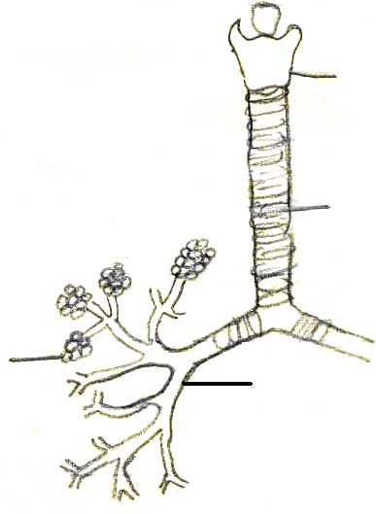
A
B
C
D

Page 2 of 5 Turn Over
v. The magnification power of a microscope with 10X ocular lens and 40X objective lens would be

A. 4000X
B. 40000X
C. 400X
D. 400000X

vi. The Golgi vesicles containing processed enzymes are budded off as

A. Glyoxysome
B. Primary Lysosome
C. Ribosome
D. Peroxisome

vii. The correct botanical name of potato is

A. Tuberosum solanum
B. Solanum Tuberosum
C. Solanum tuberosum
D. solanum Tuberosum

viii. Food kept in refrigerator is safe from the effect of bacteria. The low temperature has an effect on bacteria present in the food and this effect can be considered as

A. Microbicidal effect
B. Microbistatic effect
C. Chemotherapeutic effect
D. Antiseptic effect

ix. One of the following groups has the cell wall of the organisms consisting of two shells that overlap and silica gets deposited in the shell making patterns

A. Euglenoids
B. Dinoflagellates
C. Diatoms
D. Brown Algae

Page 3 of 5 Turn Over
x. Sexual reproduction in yeast takes place through

A. Budding
B. Ascospores
C. Basidiospores
D. Both B & C

xi. Taxonomy is a branch of Biology which deals with classification. The living things are classified into groups and sub-groups. Which of the following represents the correct sequence of taxonomic group?

A. | Phylum Order Class Family Genus Species
B. | Phylum Class Order Family Genus Species
C. | Phylum Class Family Order Genus Species
D. | Class Phylum Order Family Genus Species

xii. Which one of these is not structurally related to other three?

A. Trout
B. Perch
C. Goldfish
D. Starfish

xiii. Why is aerobic respiration of a molecule of glucose considered more efficient than anaerobic respiration?

A. More ATP is produced
B. More carbon dioxide is produced
C. More water is produced
D. More oxygen is used

xiv. This figure shows part of a green leaf in cross section. Which labeled part is responsible for exchange of gases?

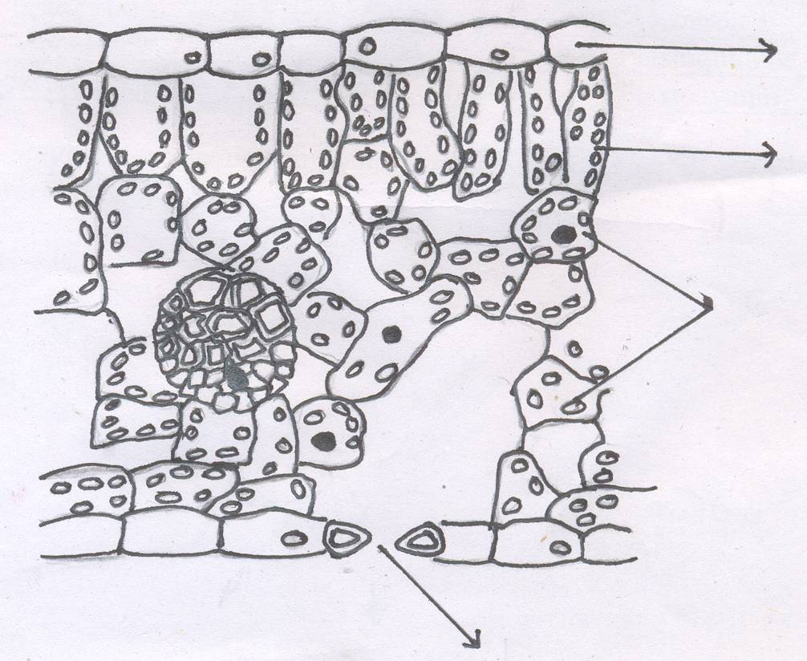
A
B
C
D

Page 4 of 5 Turn Over
xv. Holding your breath before exhaling would most likely have which of the following effects on gases in exhaled air

A. Concentration of carbon dioxide would be high
B. Concentration of oxygen would be high
C. Water vapours lost would be less
D. Total volume of exhaled air would be less

xvi. When ribulose-bi-phosphate reacts with oxygen during photorespiration a two carbon compound is produced. The compound is

A. Lactate
B. Glycolate
C. Glycerate
D. Gluterate

xvii. The type of immunity developed as a result of injecting antibodies to make a person immune against certain diseases is

A. Active immunity
B. Artificially induced active immunity
C. Auto immune response
D. Passive immunity

____________________

For Examiner’s use only
17
Q. No.1: Total Marks:

Marks Obtained:

Page 5 of 5
Federal Board HSSC-I Examination
Biology Model Question Paper

Time allowed: 2.40 hours Total Marks: 68

Note: Sections ‘B’ and ‘C’ comprise pages 1-5 and questions therein are to be answered on the separately provided answer book. Answer all the questions from section ‘B’ and two questions from section ‘C’. Use supplementary answer sheet i.e., sheet B if required. Write your answers neatly and legibly.

SECTION – B
(42 marks)

Note: Attempt ALL the questions. The answer to each question should not exceed 3 to 4 lines.

Q.2 Out of 92 naturally occurring elements only 16 are commonly found in organisms which are known as bio-elements. Name four such bio-elements which occur as ‘trace elements’ in human beings. (2)

Q.3 Red colour of blood in humans is due to haemoglobin present in erythrocytes. Write the number of polypeptide chains and number of amino acids in each polypeptide chain of a haemoglobin molecule. (2)

Q.4
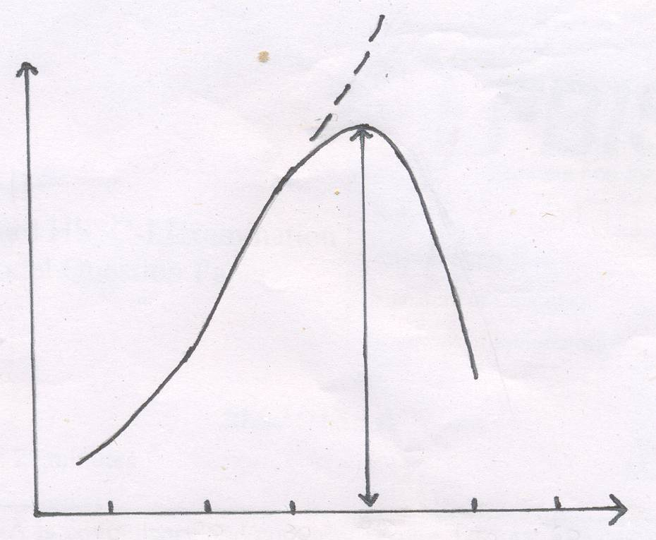
Reaction Rate
10 20 30 37 50 60
Temperature °C

Explain the effect of temperature on enzyme catalyzed reactions with reference to the graph shown in the above diagram. (3)

Page 1 of 5 Turn Over
Q.5 The rate of enzyme action can be stopped/slowed down by the addition of chemical substances known as inhibitors which are of two types. Distinguish between the two. (2)
(OR)
Enzymes can work only in specific conditions. Why does a change in pH effect the enzyme action? (2)

Q.6 Mitosis is a type of cell division which helps in growth. During mitosis spindle fibers are formed. Write about the structure and chemical nature of these fibers. (2)
(OR)
Write about the chemical nature and structure of fibers involved in movement inside the cell. (2)

Q.7 Virus is considered to be on the border line of living and non-living things. Capsid is a structural component of virus. Write about the sub-units of capsid in two different viruses and function of capsid. (2)

Q.8 a. Name the most significant characteristic of annelids. (1)
b. Moisture in the soil is very significant for the earthworms. Where do the earthworms go during dry summers? (1)
c. Why is earthworm termed as ‘natural plough’? (1)

Q.9 Bacteria reproduce both by sexual and asexual methods. Bacterial growth refers to increase in number of bacterial cells. In bacterial growth curves various distinct phases can be recognized. Name these phases. (2)
(OR)
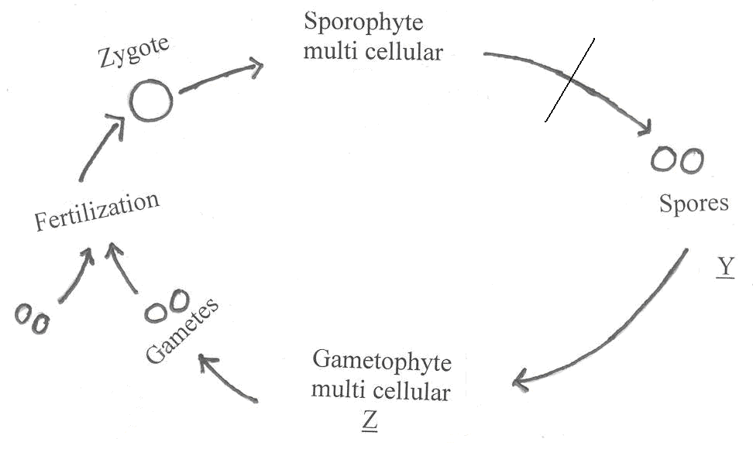
U
V
W
X
a. What phenomenon is shown in this figure? (1)
b. When does meiosis take place in the above cycle? (1)

Page 2 of 5 Turn Over
Q.10 The things kept in a refrigerator are considered safe from microbial attack, but some molds can grow on oranges and jam in a refrigerator while generally bacteria can not. Why? (2)
(OR)
Why do bottom dwelling fishes like skates and rays not have swim bladder? (2)

Q.11 Bryophytes are commonly known as amphibious plants. What features in them, with respect to their body structure, made their life possible on land? (2)
(OR)
Like other plants, Bryophytes also reproduce both by sexual and asexual methods. What features in them, with respect to their reproduction, made their life possible on land? (2)

Q.12 Chloroplasts are abundantly present in mesophyll cells along with mitochondria. How do mitochondria resemble the chloroplast? (3)

Q.13 A metabolic pathway which is completed in cytoplasm of cell is called glycolysis. Write the types of products and their number produced by the break down of one glucose molecule during glycolysis. (3)
(OR)
The disaccharide called sucrose is cane sugar.
a. Name the two monosaccharides that make up sucrose. (1)
b. Which type of linkage connects the two monosaccharides? (1)
c. Why can sucrose not be administered intravenously? (1)

Q.14 Trypsin is an enzyme which helps in digestion. In which inactive form is it secreted? How is it activated? (2)

Q.15 How does myoglobin delay anaerobic respiration during intense muscular activity in human beings? (2)

Q.16 Respiration is a characteristic of living things. During respiration, what is meant by decarboxylation? In which type of respiration decarboxylation takes place? (2)
(OR)
Rubisco is the most abundant protein in the world. What does Rubisco stand for? Write its function. (2)

Page 3 of 5 Turn Over
Q.17 Rate of transpiration in plants is affected by different factors.

Rate of Transpiration
Rate of Transpiration

A. B.

Humidity Humidity

Rate of Transpiration
Rate of Transpiration
C. D.

Humidity Humidity
i. Which of the graphs shows the effect of increased humidity on the rate of transpiration of a plant? (1)
ii. Give one reason for choosing that graph. (1)

Q.18 Give two features which the respiratory surface of an insect and a mammal have in common. (2)

Q.19 The following diagram shows a female gametophyte of an angiosperm:
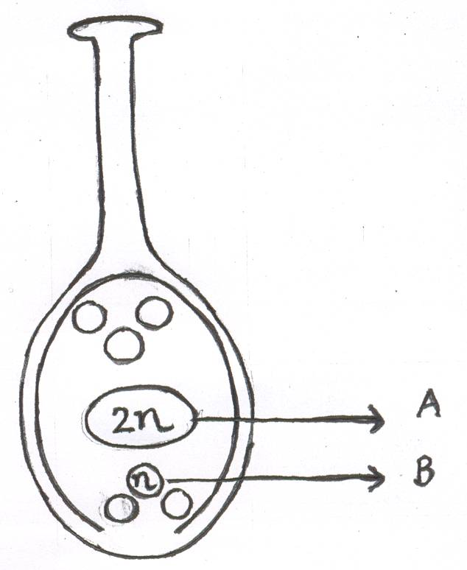
i. Name the structures labeled “A” and “B” before fertilization. (1)
ii. Name the structures labeled “A” and “B” after fertilization. (1)

Q.20 The water molecules due to their kinetic energy can move from one cell to another and this tendency of water molecules is called water potential.
Describe how plant cells respond to immersion in solutions with water potentials above the water potential of the cell. (2)

Page 4 of 5 Turn Over
SECTION – C
(Marks: 26)

Note: Attempt any TWO questions.

Q.21 Circulatory system is of two types: open and closed.
a. Describe the open circulatory system. (4)
b. How is efficiency in blood transport achieved by mammalian circulatory system? (5)
c. What is cardiac cycle? List its distinct stages. (4)

Q.22 a. What is the significance of discovery of Archaeopteryx? Write its unique character. (4)
b. Enlist the features which help the birds adapt to aerial mode of life. (6)
c. Discuss the various feeding habits of birds. (3)

Q.23 a. Algae and fungi are thallophytes, but algae is restricted to aquatic environment while fungi is mostly found on terrestrial environment. What makes fungi thrive on land? (7)
b. Draw the life cycle of a loose smut of wheat. (4)
c. What is parasexuality? In which group of fungi is it found? (2)

____________________

Page 5 of 5
Federal Board HSSC-I Examination
Biology Practical Model Question Paper

Time allowed: 3 hours Marks: 15

1. Answer the questions pertaining to material “A – D”. (2)
i. Name the locomotory organ of specimen “A”. (½)
ii. What is the purpose of the given equipment/chemical “B”. (½)
iii. Identify the Slide “C”. (½)
iv. Write the name of phylum to which specimen “D” belongs. (½)

2. Describe the following of the specimen provided: (5)
i. Name of plant and family (½ + ½ = 1)
ii. Description of Flower (½)
iii. Calyx (½)
iv. Corolla (½)
v. Androecium (½)
vi. Gynoecium (½)
vii. Floral formula (½)
viii. Floral diagram (½)
ix. L.S. of flower (½)

3. Prepare a temporary mount of the material provided. Identify and draw a labelled sketch. (2)

4. Demonstrate and describe the experiment given by the examiner. (2)

5. Practical Note Book (2)

6. Viva Voce. (2)

____________________

Page 1 of 1
Federal Board HSSC – I Examination
Biology – Mark Scheme

SECTION A

Q.1
i. D ii. B iii. B
iv. C v. C vi. B
vii. C viii. B ix. C
x. D xi. B xii. D
xiii. A xiv. D xv. A
xvi. B xvii. D
(17x1=17)

SECTION B

Q.2 (2)
Cu, Mn, Zn, I 0.5 4 = 2

Q.3 (2)
$\frac{\text{04} \text{chains}}{0\text{.}5}, \frac{2α+2β}{0\text{.}5}, \frac{\text{141}}{0\text{.}5}+\frac{\text{146}}{0\text{.}5}$ 0.5 4 = 2

Q.4 (3)
i. Rate of reaction rises with every 10°C rise in temperature. (1 mark)
ii. Maximum rate at optimum temperature. (1 mark)
iii. Rate of reaction retards due to denaturation. (1 mark)

Q.5 (2)
a. i. Irreversible enzymes occupy active site by forming covalent bonds. (½ mark)
ii. They destroy globular structure of the enzyme. (½ mark)
b. i. Reversible enzymes form weak linkages with enzymes. (½ mark)
ii. An increase in substrate concentration can neutralize the effect of reversible inhibitor. (½ mark)
(OR)
i. pH can change the ionization. (1 mark)
ii. Extreme pH changes break the bonds and cause denaturation. (1 mark)

Q.6 (2)
Spindle fiber – long (½ mark)
Unbranched (½ mark)
Tubulin (½ mark)
Protein (½ mark)
(OR)
Microfilaments (1 mark)
Contractile actin protein linked to inner face of plasma membrane. (1 mark)

Q.7 (2)
a. i. 162 capsomeres in herpes virus (½ mark)
ii. 252 capsomeres in adenovirus (½ mark)
b. Shape (1 mark)

Q.8 (3)
a. Metameric segmentation. (1 mark)
b. Into the deeper layers of soil. (1 mark)
c. Aeration, mixing and churning of soil. (1 mark)

Q.9 (2)
i. Lag phase (½ mark)
ii. Log phase (½ mark)
iii. Stationary phase (½ mark)
iv. Death/decline phase (½ mark)
(OR)
a. Alternation of Generations (1 mark)
b. At the time of spore formation at X (1 mark)

Q.10 (2)
Fungi are more tolerant to:
i. Hyperosmotic conditions. (1 mark)
ii. Temperature extremes –5°C below freezing. (1 mark)
(OR)
i. Bottom dwelling nature. (1 mark)
ii. Do not rapidly change their position (1 mark)
Q.11 (2)
Any two of the following characteristics: (1+1 marks)
i. Multicellular plant body
ii. Rhizoids
iii. Cuticle
iv. Absorption of CO₂
(OR)
Any two of the following: (1+1 marks)
i. Heterogamy
ii. Multicellular antheridia and archegonia
iii. Retention of embryo in archegonia
iv. Alternation of Generations

Q.12 (3)
i. Double membrane structure. (1 mark)
ii. DNA (1 mark)
iii. Self-replicating (1 mark)

Q.13 (3)
i. ATP = 04 molecules (1 mark)
ii. NADH = 02 molecules (1 mark)
iii. Pyruvate = 02 molecules (1 mark)
(OR)
a. Glucose and fructose (1 mark)
b. Glycosidic linkage (1 mark)
c. Sucrose being disaccharide cannot release energy instantly. (1 mark)

Q.14 (2)
i. Trypsinogen (1 mark)
ii. By Enterokinase (1 mark)

Q.15 (2)
i. Stores oxygen (1 mark)
ii. Releases O₂ when its concentration is low (1 mark)

Q.16 (2)
i. Removal of carbon as CO₂ (1 mark)
ii. Both aerobic and anaerobic respiration (1 mark)
(OR)
i. Ribulose biphosphate carboxylase (1 mark)
ii. Conversion of RUBP(5-c) into unstable (6-c) molecule (1 mark)
Q.17 (2)
i. Graph ‘C’ (1 mark)
ii. Higher the humidity lower is the rate of transpiration (1 mark)

Q.18 (2)
i. Large surface area (1 mark)
ii. Moist (1 mark)

Q.19 (2)
i. “A” fusion nucleus/secondary nucleus and “B” egg/ oosphere (½+½ mark)
ii. “A” endosperm cell (nucleus) and “B” zygote/oospore (½+½ mark)

Q.20 (2)
Cell will become turgid as water moves inside. (1+1 marks)

SECTION C

Q.21 (13)
a. At least four characteristics of open circulatory system with examples from those phyla in which this system is found. (14=4 marks)
b. i. Separation of oxygenated and deoxygenated blood. (1 mark)
ii. Strong muscular heart (1 mark)
iii. Presence of valves (1 mark)
iv. Structure of arteries and veins (1 mark)
v. Capillary circulation for exchange of material. (1 mark)
c. i. Definition (1 mark)
ii. Three phases (13=3 marks)

Q.22 (13)
a. Significance – connecting link between birds and reptiles. (1 mark)
Avian characters (1.5 marks)
Reptilian characters (1.5 marks)
b. 06 features which help in flight (16=6 marks)
c. i. Carnivorous – e.g. Eagle (1 mark)
ii. Herbivorous – e.g. Parrot, Sparrow (1 mark)
iii. Omnivorous – e.g. Domestic fowl, crow etc (1 mark)

Q.23 (13)
a. Any seven adaptive characteristics of fungi to live on land (17=7 marks)
b. Diagram (2 marks)
Labeling (2 marks)
c. Definition (1 mark)
Name of group (Imperfect fungi) (1 mark)

