OFFICE OF THE CONTROLLER EXAMINATIONS
HAZARA UNIVERSITY, MANSEHRA

Phone# 0997-414177, 414176

Date Sheet for M.Com (Previous & Final) Annual Examination, 2020

Date | Day | M.Com (Previous) | M.Com (Final)
09/12/2020 | Wednesday | Principles of Management | ******
10/12/2020 | Thursday | ****** | Strategic Management
11/12/2020 | Friday | Principles of Marketing | ******
14/12/2020 | Monday | ****** | Organizational Behavior
15/12/2020 | Tuesday | System Analysis & Design | *****
16/12/2020 | Wednesday | ****** | Business Research Methods
17/12/2020 | Thursday | Industrial & Commercial Law | ******
18/12/2020 | Friday | ****** | Advance Cost & Management Accounting/Consumer Behaviour
21/12/2020 | Monday | Business Mathematics | ******
22/12/2020 | Tuesday | ****** | Financial Management
23/12/2020 | Wednesday | Financial Accounting- III | ******
24/12/2020 | Thursday | ****** | E. Commerce
28/12/2020 | Monday | Human Resource Management | ******
29/12/2020 | Tuesday | ****** | Advance Financial Accounting/Sales Management
Time to Start: 09.30 AM to 01-30 PM

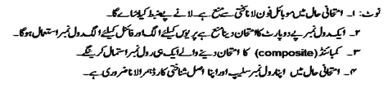

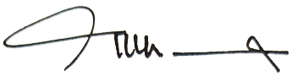
Mohabat Khan
Controller of Examinations

Note:- Safety protocols, precautionary measures and SOP,s against COVID-19 for working environments notified by the Government of Khyber Pakhtunkhwa & Higher Education Commission Islamabad shall be followed in true letter and spirit please.

